**PHASE: Disaster Recovery with IBM Cloud Virtual Servers**

**PROBLEM STATEMENT:**

In this phase, we will focus on implementing an effective disaster recovery solution using IBM Cloud Virtual Servers. The goal is to ensure the availability and resilience of your critical applications and data in the face of unexpected disruptions.

**SOLUTION:**

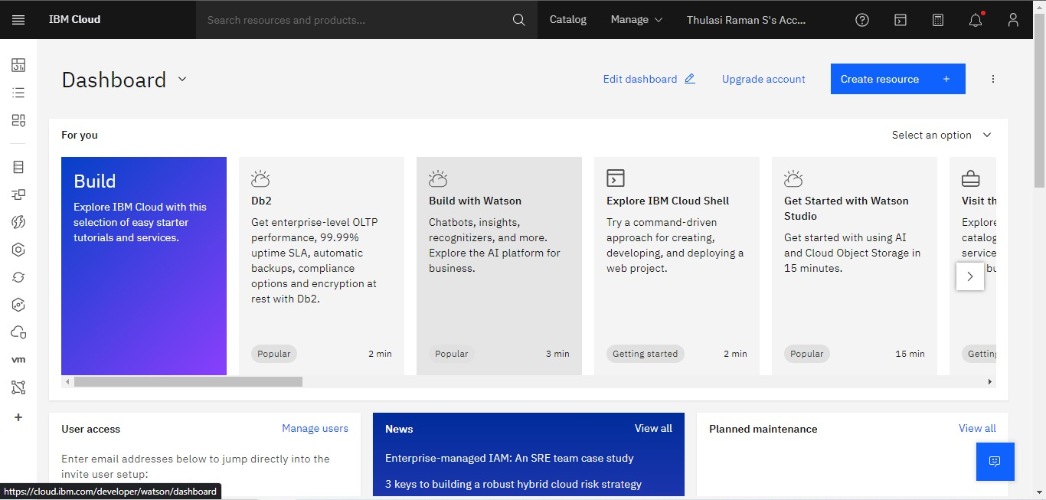

1. **Assessment and Planning:**

Before diving into the technical details, it's essential to assess your organization's specific needs and requirements for disaster recovery. Consider factors such as RTO (Recovery Time Objective) and RPO (Recovery Point Objective). Determine the critical applications and data that need protection.

1. **Selecting Disaster Recovery Strategies:**

Depending on your assessment, choose the appropriate disaster recovery strategy. Common strategies include:

* 1. **Backup and Restore:** Regularly back up your data and configurations, ensuring you can restore them in case of a disaster.
  2. **Pilot Light:** Maintain a minimal version of your infrastructure, ready to be scaled up in case of a disaster.
  3. **Warm Standby:** Keep a partially active secondary environment that can quickly take over in case of failure.
  4. **Hot Standby:** Maintain a fully active and synchronized secondary environment, ready for immediate failover.

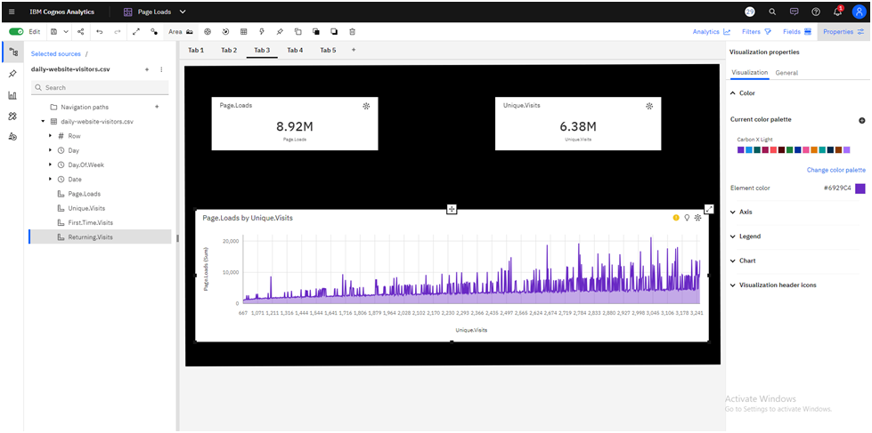

1. **IBM Cloud Virtual Servers Configuration:**

Configure your virtual servers in IBM Cloud according to your chosen disaster recovery strategy. Ensure that your primary and secondary servers are synchronized and can failover seamlessly.

1. **Data Replication:**

Implement data replication mechanisms to keep your critical data synchronized between primary and secondary environments. Use tools like IBM Db2 HADR (High Availability Disaster Recovery) for databases, and IBM Cloud Object Storage for non-database data.

1. **Monitoring and Alerting:**

Set up continuous monitoring for your virtual servers, networks, and data replication processes. Configure alerting systems to notify you of any anomalies or failures.

1. **Testing and Validation:** Regularly test your disaster recovery setup to ensure it functions as expected. Perform both planned tests and surprise drills to assess

your team's preparedness.

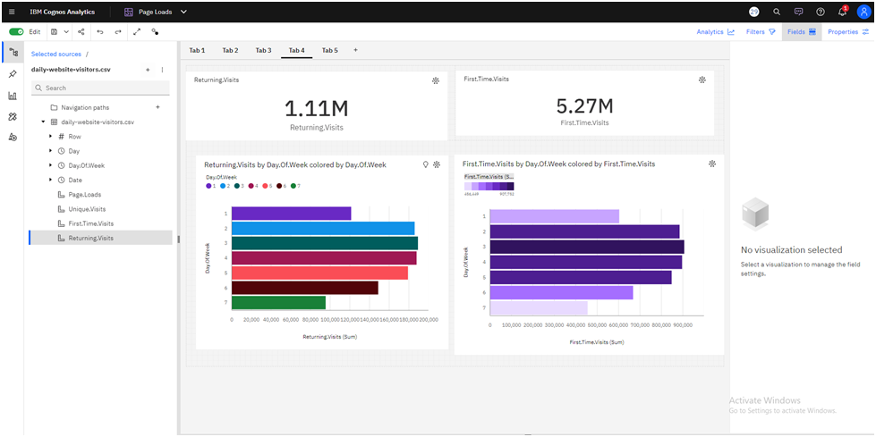

1. **Documentation and Runbooks:** Document the entire disaster recovery process, including configurations, procedures, and contact information for key personnel. Create runbooks that guide your team through recovery steps.
2. **Training:** Train your IT staff in disaster recovery procedures and ensure they are familiar with the runbooks. Regular training and awareness are crucial for a successful recovery.
3. **Communication Plan:** Develop a communication plan that outlines how you will inform stakeholders, employees, and customers in case of a disaster. Ensure a clear and coordinated approach to minimize confusion.
4. **Regular Updates and Improvements:** Disaster recovery is an ongoing process. Regularly review and update your disaster recovery strategy to accommodate changes in your infrastructure, applications, or business needs.
5. **Automation and Orchestration:** Explore automation and orchestration tools to streamline your disaster recovery processes. This can help reduce RTO and improve recovery efficiency.
6. **Compliance and Legal Considerations:** Ensure that your disaster recovery solution complies with industry regulations and legal requirements. This is especially important for businesses in highly regulated sectors like healthcare or finance.
7. **Third-Party Disaster Recovery Services:** Consider partnering with third-party disaster recovery service providers for added redundancy and expertise in disaster recovery planning and execution.
8. **Cost Management:** Keep an eye on the costs associated with your disaster recovery solution. Optimize resource allocation to balance cost-effectiveness with resilience.Remember, disaster recovery is a critical aspect of ensuring business continuity. Tailor your approach to your organization's unique needs and stay vigilant in maintaining and testing your disaster recovery plan to be prepared for any unexpected disruptions.

**Flowchart:**

Start

|

|--> Assessment and Planning

| |

| |--> Assess organization's needs, RTO, RPO

| |

| |--> Identify critical applications and data

|

|--> Selecting Disaster Recovery Strategy

| |

| |--> Choose strategy based on assessment

| | |

| | |--> Backup and Restore

| | |--> Pilot Light

| | |--> Warm Standby

| | |--> Hot Standby

|

|--> IBM Cloud Virtual Servers Configuration

| |

| |--> Configure primary and secondary servers

| |

| |--> Ensure synchronization

|

|--> Data Replication

| |

| |--> Implement data replication mechanisms

| | |

| | |--> Use IBM Db2 HADR for databases

| | |--> Use IBM Cloud Object Storage for non-database data

|

|--> Monitoring and Alerting

| |

| |--> Set up continuous monitoring

| | |

| | |--> Monitor virtual servers

| | |--> Monitor networks

| | |--> Monitor data replication

| |

| |--> Configure alerting systems

|

|--> Testing and Validation

| |

| |--> Regularly test disaster recovery setup

| | |

| | |--> Perform planned tests

| | |--> Perform surprise drills

|

|--> Documentation and Runbooks

| |

| |--> Document disaster recovery process

| | |

| | |--> Include configurations and procedures

| | |--> Include contact information for key personnel

| |

| |--> Create runbooks for guidance

|

|--> Training

| |

| |--> Train IT staff in disaster recovery procedures

|

|--> Communication Plan

| |

| |--> Develop a communication plan

| | |

| | |--> Outline how to inform stakeholders, employees, customers

| |

| |--> Ensure a clear and coordinated approach

|

|--> Regular Updates and Improvements

| |

| |--> Regularly review and update the disaster recovery strategy

|

|--> Automation and Orchestration

| |

| |--> Explore automation and orchestration tools

|

|--> Compliance and Legal Considerations

| |

| |--> Ensure compliance with industry regulations and legal requirements

|

|--> Third-Party Disaster Recovery Services

| |

| |--> Consider partnering with third-party providers

|

|--> Cost Management

| |

| |--> Optimize resource allocation

|

End