



**SHA-256 in Action – Cryptographic Hashing**  
  
**Objective/Aim:**

**Apparatus/Software Used:**

* Laptop/PC
* PowerPoint/Word for documentation
* Internet for research
* Github

**Theory/Concept:**

* This SHA256 online tool helps you calculate hashes from strings.
* You can input UTF-8, UTF-16, Hex, Base64, or other encodings.
* It also supports HMAC

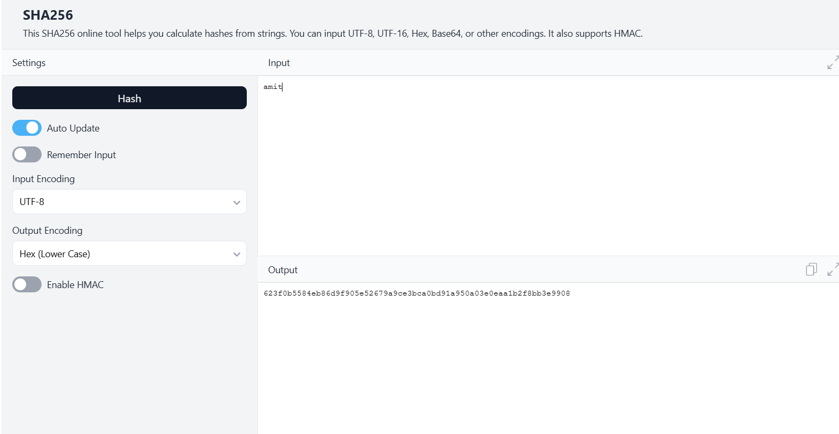



**Procedure:**

* On Windows, you can use PowerShell by typing Get-FileHash followed by the file name.
* Alternatively, you can use the CertUtil -hash file [FILENAME] SHA256 command in the Command Prompt.
* Additionally, there are online tools available where you can upload a file to get its SHA-256 hash.

**Observation Table:**

| * SHA-256 is a one-way function, * Regardless of the input size, SHA-256 always produces a fixed-size output of 32 bytes (256 bits). * SHA-256 is designed to be collision-resistant, meaning it is extremely difficult to find two different inputs that produce the same hash value. |  |  |
| --- | --- | --- |
|  |  |  |
|  |  |  |
|  |  |  |
|  |  |  |
|  |  |  |
|  |  |  |
|  |  |  |
|  |  |  |
|  |  |  |
|  |  |  |
|  |  |  |
|  |  |  |

|  |  |  |  |
| --- | --- | --- | --- |
|  |  |  |  |
|  |  |  |  |
|  |  |  |  |
|  |  |  |  |
|  |  |  |  |
|  |  |  |  |
|  |  |  |  |



