

**LA GRANDEE INTERNATIONAL COLLEGE**

**Simalchaur, Pokhara, Nepal**

Assignment III

**Submitted to**

Mr. Ashwin Poudel

La Grandee International College

Bachelor of Computer Application (BCA) Program

In partial fulfillment of the requirements for the degree of Program Name under

Pokhara University

**Submitted by**

|  |  |  |  |
| --- | --- | --- | --- |
| **Name:** | **Course** | **Semester** | **P.U. Registration Number** |
| Subash Gurung | BCA | 6th | 2022-1-53-0147 |

**Date: 20th May 2025**

**Question 1:**

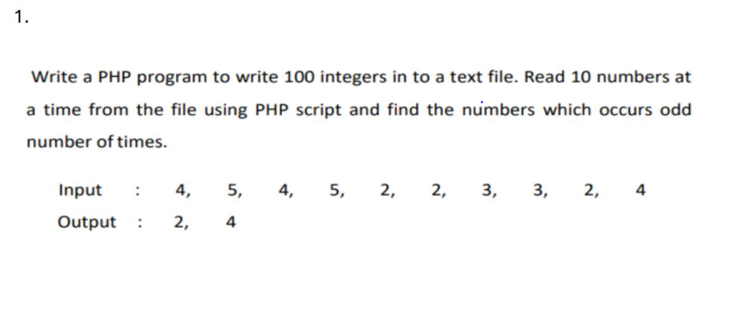

1. **Introduction**

This submission contains two PHP programs:

1. **Odd Numbers Counter** – A file handling program that writes 100 random numbers to a text file, reads them in chunks of 10, and displays numbers that occur an odd number of times.
2. **Resume & Photo Upload System** – A PHP-based file upload form that validates file types, size limits, and ensures secure storage of user-submitted resumes and photographs.

**2.index.php**

<?php

// *Step 1: Write 100 random numbers (1–10) to a file*

$file = fopen("nums.txt", "w");

for ($i = 0; $i < 100; $i++) {

    fwrite($file, rand(1, 10) . " ");

}

fclose($file);

// *Step 2: Read numbers from file*

$data = file_get_contents("nums.txt");

$all = explode(" ", trim($data));

$count = [];

// *Step 3: Read 10 at a time and count*

for ($i = 0; $i < count($all); $i += 10) {

    $chunk = array_slice($all, $i, 10);

    foreach ($chunk as $n) {

        if ($n !== "") $count[$n] = ($count[$n] ?? 0) + 1;

    }

}

// *Step 4: Print numbers with odd occurrences*

echo "Odd occurring numbers: ";

foreach ($count as $num => $times) {

    if ($times % 2 != 0) echo "$num ";

}

?>

**3.resume_upload.html**

<!DOCTYPE html>

<html>

<head>

  <title>Resume and Photo Upload</title>

</head>

<body>

  <h2>Submit Your Resume and Photograph</h2>

  <form action="upload.php" method="POST" enctype="multipart/form-data">

    <fieldset style="width: 300px;">

      <legend>Upload Details</legend>

      <label for="resume">Resume (PDF/DOC, max 500KB):</label><br>

      <input type="file" id="resume" name="resume" accept=".pdf,.doc" required><br><br>

      <label for="photo">Photograph (JPG/JPEG, max 1MB):</label><br>

      <input type="file" id="photo" name="photo" accept=".jpg,.jpeg" required><br><br>

      <input type="submit" value="Submit">

    </fieldset>

  </form>

</body>

</html>

**4.upload.php**

<?php

$resumeDir = "resumes/";

$photoDir = "photos/";

// *Create directories if not exist*

if (!is_dir($resumeDir)) mkdir($resumeDir);

if (!is_dir($photoDir)) mkdir($photoDir);

// *Resume*

if (isset($_FILES['resume']) && is_uploaded_file($_FILES['resume']['tmp_name'])) {

    $resume = $_FILES['resume'];

    $name = basename($resume['name']);

    $path = $resumeDir . $name;

    $ext = strtolower(pathinfo($name, PATHINFO_EXTENSION));

    $size = $resume['size'];

    if (file_exists($path)) {

        echo "Resume already exists.<br>";

    } elseif (!in_array($ext, ['pdf', 'doc'])) {

        echo "Resume must be PDF or DOC.<br>";

    } elseif ($size > 512000) {

        echo "Resume must be under 500KB.<br>";

    } else {

        move_uploaded_file($resume['tmp_name'], $path);

        echo "Resume uploaded.<br>";

    }

}

// *Photo*

if (isset($_FILES['photo']) && is_uploaded_file($_FILES['photo']['tmp_name'])) {

    $photo = $_FILES['photo'];

    $name = basename($photo['name']);

    $path = $photoDir . $name;

    $ext = strtolower(pathinfo($name, PATHINFO_EXTENSION));

    $size = $photo['size'];

    if (file_exists($path)) {

        echo "Photo already exists.<br>";

    } elseif (!in_array($ext, ['jpg', 'jpeg'])) {

        echo "Photo must be JPG or JPEG.<br>";

    } elseif ($size > 1048576) {

        echo "Photo must be under 1MB.<br>";

    } else {

        move_uploaded_file($photo['tmp_name'], $path);

        echo "Photo uploaded.<br>";

    }

}

**5.Snapshots**



**ii.**



