1. **SCHEMATIC DESIGN DOCUMENTS:**

* CIRCUIT DIAGRAM:

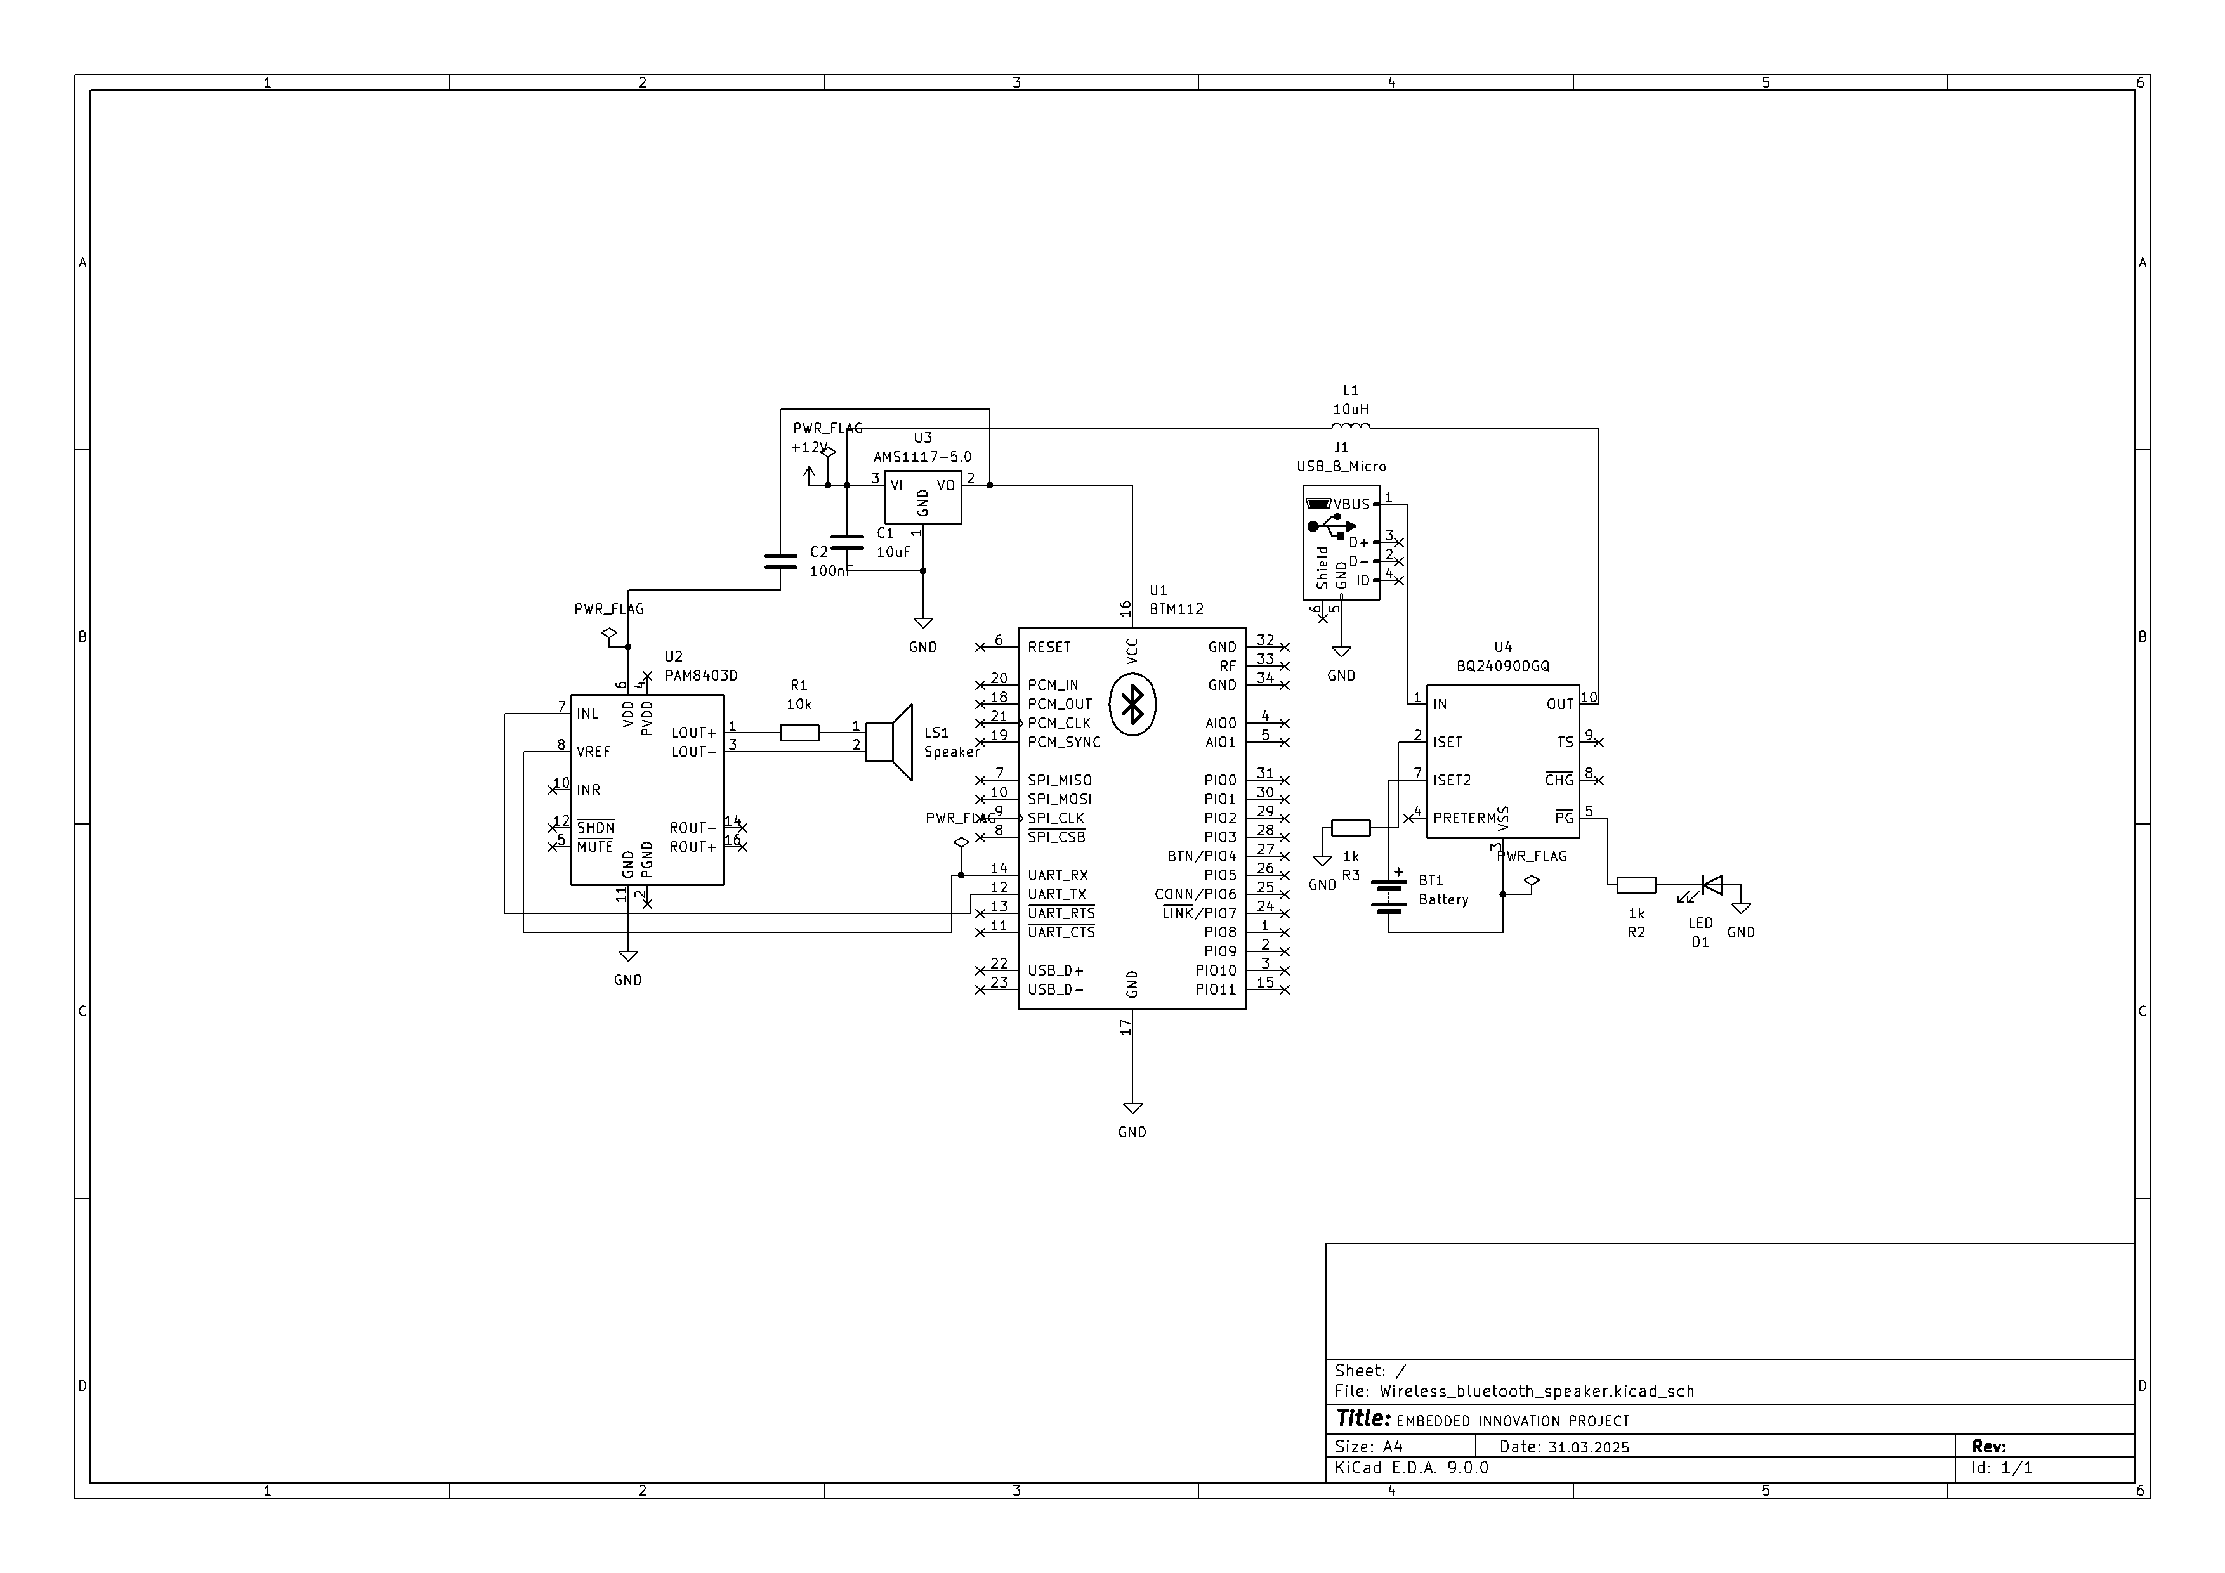

* BILL OF MATERIAL(BOM):

|  |  |  |  |  |
| --- | --- | --- | --- | --- |
| Item no | Component name | Part Number | value | Quantity |
| 1. | Bluetooth Module | BTM112 | Bluetooth v2.0 | 1 |
| 2. | Audio Amplifier | PAM8403 | 3W Stereo Class-D | 1 |
| 3. | Micro USB | USB_B_Micro | 5V DC | 1 |
| 4. | Battery management | BQ24090DGQ | 1A Charging Current | 1 |
| 5. | Voltage dropout regulator | AMS1117-5.0 | 5V Output | 1 |
| 6. | Speaker | General | - | 1 |
| 7. | Capacitor | C1,C2 | 10uF,100nF | Each 1 |
| 8. | Resistor | R1,R2 | 1k,10k | Each 1 |
| 9. | Inductor | L1 | 100uH | 1 |
| 10. | LED | D1 | - | 1 |
| 11. | Battery | BAT_CONN | 3.7V Li-ion | 1 |

* NETLIST FILE:



1. **PCB LAYOUT FILE:**
2. **ASSEMBLY DOCUMENTATION:**

* ASSEMBLY DRAWINGS:

FRONT VIEW :

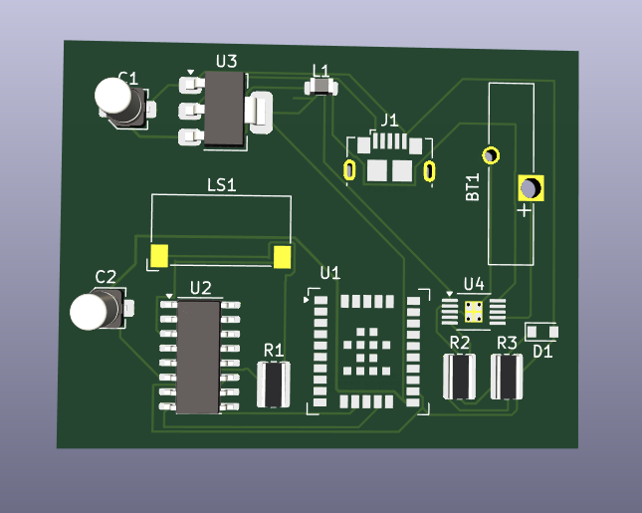

BACK VIEW:

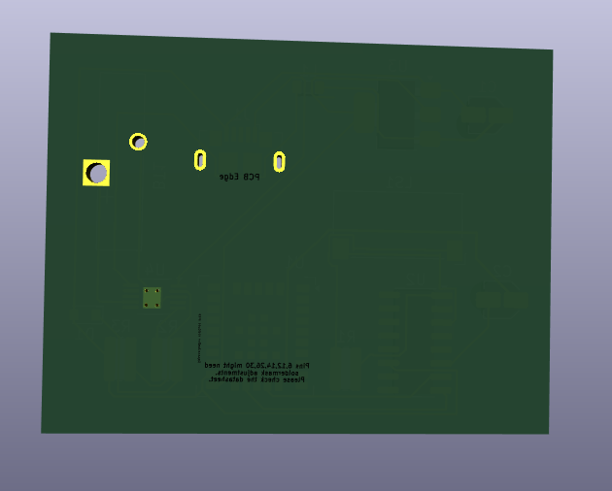

* SOLDER MASK AND SILKSCREEN DETAIL:

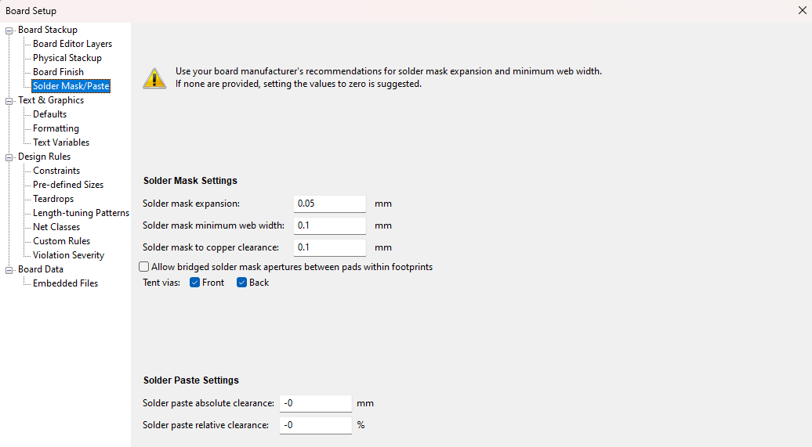

1. **TESTING AND VALIDATION REPORT:**

* ERC:

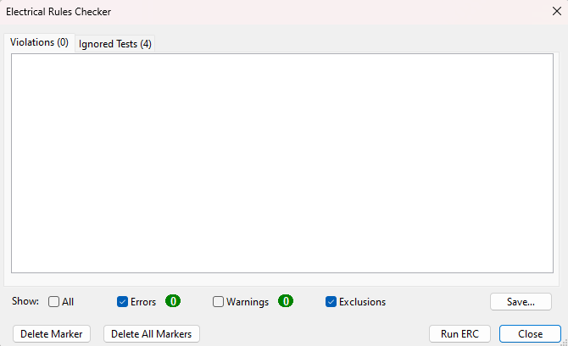

* DRC:

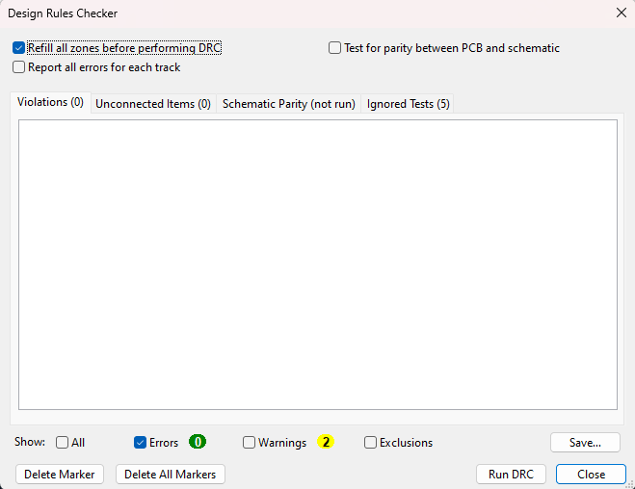

1. **TRACK WIDTH CALCULATION:**

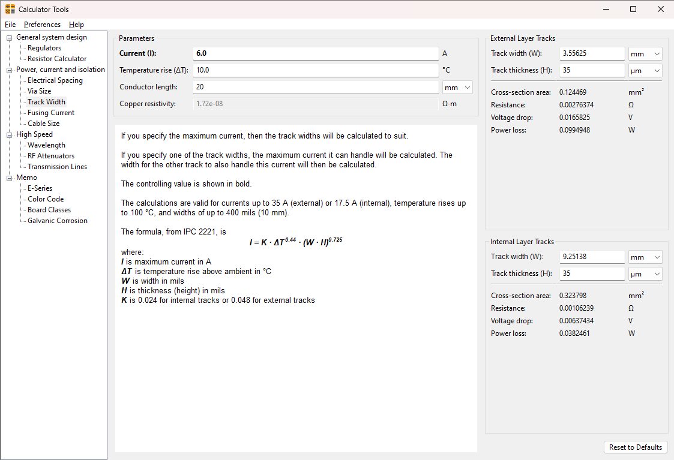

1. **PCB design constraints with PCBway capabilities:**

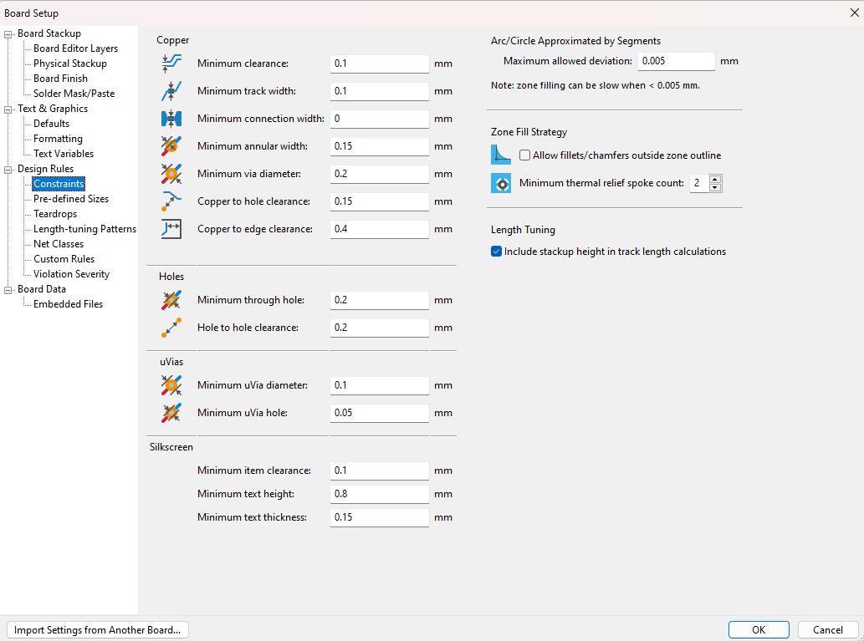

1. **Answer the Following Questions:**

**1. Explain the role of passive and active components in a PCB circuit.**

In a PCB circuit, components are divided into two main types: passive and active.

Passive Components:

don’t need any power to work. They just **store or dissipate energy**. Examples include resistors, capacitors, and inductors. These are used to control current, filter signals, or store energy temporarily.

Active Components:

on the other hand, need an external power source to function. They’re used for things like amplifying signals, processing data, or switching circuits**. Examples include transistors, diodes, and integrated circuits (ICs).

**2. Describe the function of resistors, capacitors, and inductors in a PCB.**

Resistors:

These are like traffic cops for electric current. They control how much current flows through the circuit and help in dividing voltage. You often see them used to protect components from too much current.

Capacitors:

These little guys store electrical energy and can quickly release it when needed. They’re great at filtering out noise, smoothing power supply fluctuations, and coupling signals between different stages of a circuit.

Inductors:

These components store energy in a magnetic field when current passes through them. They’re good at blocking high-frequency signals while allowing low frequencies to pass. You often find them in power supplies and radio-frequency applications.

**3. What are Surface Mount Devices (SMD) and Through-Hole Components? Compare their advantages and disadvantages.**

Surface Mount Devices (SMD) are tiny components that sit directly on the surface of the PCB. They don’t have long leads and are placed using automated machines.

- Advantages:

- Super compact and lightweight.

- Great for automated production and high-speed assembly.

- Ideal for high-frequency applications due to shorter leads.

- Disadvantages:

- Hard to solder manually because of their small size.

- Difficult to replace or repair.

- Through-Hole Components have long leads that pass through holes drilled in the PCB. These are soldered on the opposite side.

- Advantages:

- Strong physical connection, making them durable.

- Easier to solder by hand, so they’re great for prototyping.

- Disadvantages:

- Take up more space on the PCB.

- Slower and more labor-intensive assembly.

**4. How do integrated circuits (ICs) contribute to PCB functionality? Give examples**.

Integrated circuits (ICs) are like tiny powerhouses on a PCB. They pack tons of tiny components like transistors, resistors, and capacitors into one small chip. This way, they can perform complex functions without taking up much space.

For example:

- A microcontroller (like ATmega328P) handles data processing and control tasks.

- An operational amplifier (Op-Amp) amplifies weak signals to make them usable.

- A voltage regulator (like AMS1117-5.0) ensures that the output voltage stays stable, even when input voltage varies.

**5. Explain the importance of connectors and their types used in PCBs.**

Connectors in PCBs are basically the bridge between the board and the outside world. They make it easy to connect different parts of a device or other external devices without soldering every time.

Some common types are:

- Pin Headers: For connecting jumpers or other boards.

- USB Connectors: To transfer data and power (like the USB_B_Micro in your project).

- Battery Connectors: For plugging in batteries, especially Li+ cells.

- Terminal Blocks: Useful for connecting high-power lines.