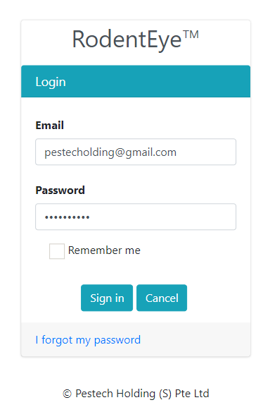
- Login Page

New Login Page design introduced.

- New Left Hand Side Navigation implemented

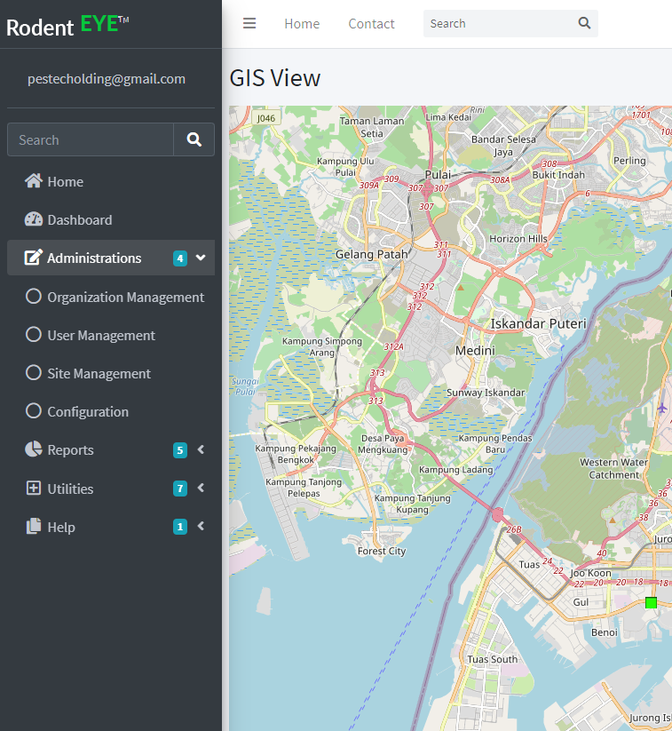

- New Dashboard Page implemented
  - During Selecting the Site, Floor, Date Range – Dashboard will update automatically
  - Site Monitoring Concept Implemented on the Right Side (Trigger Count, Rodent Count and Gateway Live Status)
  - Battery Status implemented with Doughnut Chat method (Like Pie Chart)
  - In Legend will stated Number of Various type of Sensor implemented at the Site

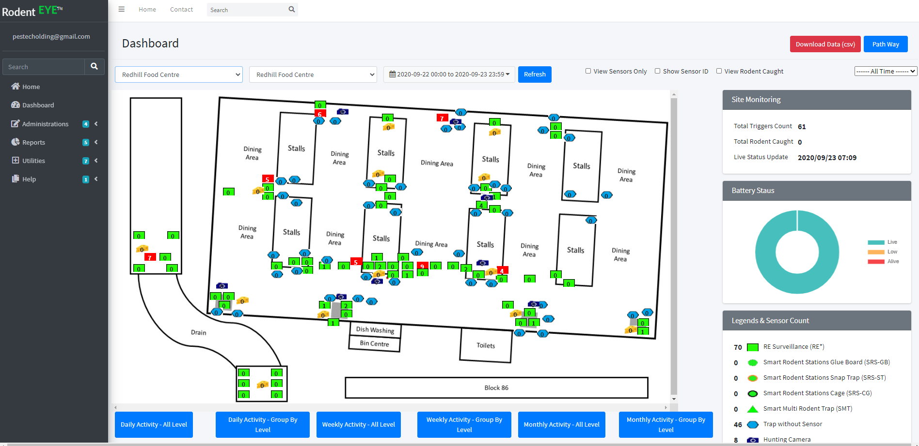

- New Grid Summary Introduced with Paging, Search and Sorting for Organization management, User Management, Site Management, Battery Status Trigger Status, Non Responsive Gateway Status and Etc…,
