IFET COLLEGE OF ENGINEERING
(AN AUTONOMOUS INSTITUTION)

AUTOMATIC ACCELERATION CONTROL SYSTEM BASED ON DRIVER FATIGUE

Submitted by
VIGNESH.D (421118104095)
SUBASH SURYA.E (421118104084)

DEPARTMENT OF COMPUTER SCIENCE AND ENGINEERING


STUDENT PROJECTS SCHEME (2021-2022)

TAMILNADU STATE COUNCIL FOR SCIENCE AND TECHNOLOGY
FORMAT FOR STUDENT PROJECT PROPOSAL
1. | Name of the Student (s) | : | VIGNESH D, SUBASH SURYA.E
 | one valid e-mail id | : | ess2152001@gmail.com
2. | Name of the Guide | : | Ms. P. Divya
 | Designation | : | Assistant Professor  Computer Science and Engineering
 | Institutional Address | : | IFET College of Engineering  (An Autonomous Institution), Villupuram
 | Phone number | : |  | 6382713504
3. | Project Title | : | Automatic speed reduction system of drowsiness driver vehicle
4. | Sector in which your Project proposal is to be Considered | : | Engineering& Tech(Computer Science)
5. | Has a similar project been carried out in your college / elsewhere? If so furnish details of the previous project and highlight the improvements suggested in the present one | : | No

CERTIFICATE
This is to certify that Mr. VIGNESH D & SUBASH SURYA E is a bonafide final year student of U.G.Computer Science and Engineering of our college and it is also certified that two copies of utilization certificate and final report along with seminar paper will be sent to the Council after completion of the project by the end of September 2021.

Signature of the Guide Signature of the HOD Signature of the Principal

AUTOMATIC ACCELERATION CONTROL SYSTEM BASED ON DRIVER FATIGUE

ABSTRACT

Automatic acceleration control system is a technology that can prevent the accidents that are caused by drivers who fell asleep while driving. Many number of people drive on the highway day and night. Many drivers and people traveling long-distance suffer from lack of sleep. The majority of accidents happen due to the driver’s drowsiness. When the drowsiness of the driver is detected it alerts the driver and slows down the speed of the vehicle and warns driver to awake him from his fatigue condition. Implementing Haar cascade technique in this project helps in retrieving accurate feature extraction. This model is built with Keras using Convolutional Neural Networks (CNN).

INTRODUCTION
Automatic acceleration control system is a vehicle safety technology that helps prevent the accidents caused by the drowsiness of the driver. Various studies have suggested that around 20% of all road accidents are fatigue-related, up to 50% on certain roads. Some of the current systems learn driver patterns and can detect when a driver is becoming drowsy. The majority of accidents happen due to the drowsiness of the driver. This system is built using Python, OpenCV, and Keras which will alert the driver when he feels sleepy and the speed of the vehicle will be decreased.

OBJECTIVE
A countless number of people drive on the highway day and night. Taxi drivers, bus drivers, truck drivers and people travelling long-distance suffer from lack of sleep. Due to which it becomes very dangerous to drive when feeling sleepy. The majority of accidents happen due to the drowsiness of driver. So this model is built to prevent accidents.
The objective of this project is to build a automatic speed reduction system that will detect that a person’s eyes are closed for a few seconds and reduces the vehicle speed.

SYSTEM ARCHITECTURE
This model is built with Keras using Convolutional Neural Networks (CNN). A convolutional neural network is a special type of deep neural network which performs extremely well for image classification purposes. A CNN basically consists of an input layer, an output layer and a hidden layer which can have multiple layers. A convolution operation is performed on these layers using a filter that performs 2D matrix multiplication on the layer and filter.

SYSTEM REQUIREMENTS
The requirement for this Python project is a webcam through which we will capture images. You need to have Python (3.6 version recommended) installed on your system, then using pip, you can install the necessary packages.
OpenCV – pip install opencv-python (face and eye detection).
TensorFlow – pip install tensorflow (keras uses TensorFlow as backend).
Keras – pip install keras (to build our classification model).
Pygame – pip install pygame (to play alarm sound).
IMPLEMENTATION
1.Take image as input from a camera.
2.Detect the face in the image and create a Region of Interest(ROI).
3.Detect the eyes from ROI and feed it to the classifier.
4.Classifier will categorize whether eyes are open or closed.
5.Calculate score to check whether the person is drowsy.
6.The speed of the vehicle will be reduced if the score is increased rapidly than 15.
The score is basically a value we will use to determine how long the person has closed his eyes. So if both eyes are closed, we will keep on increasing score and when eyes are open, we decrease the score. We are drawing the result on the screen using cv2.putText() function which will display real time status of the person. A threshold is defined for example if score becomes greater than 15 that means the person’s eyes are closed for a long period of time. This is when we beep the alarm using sound.play().
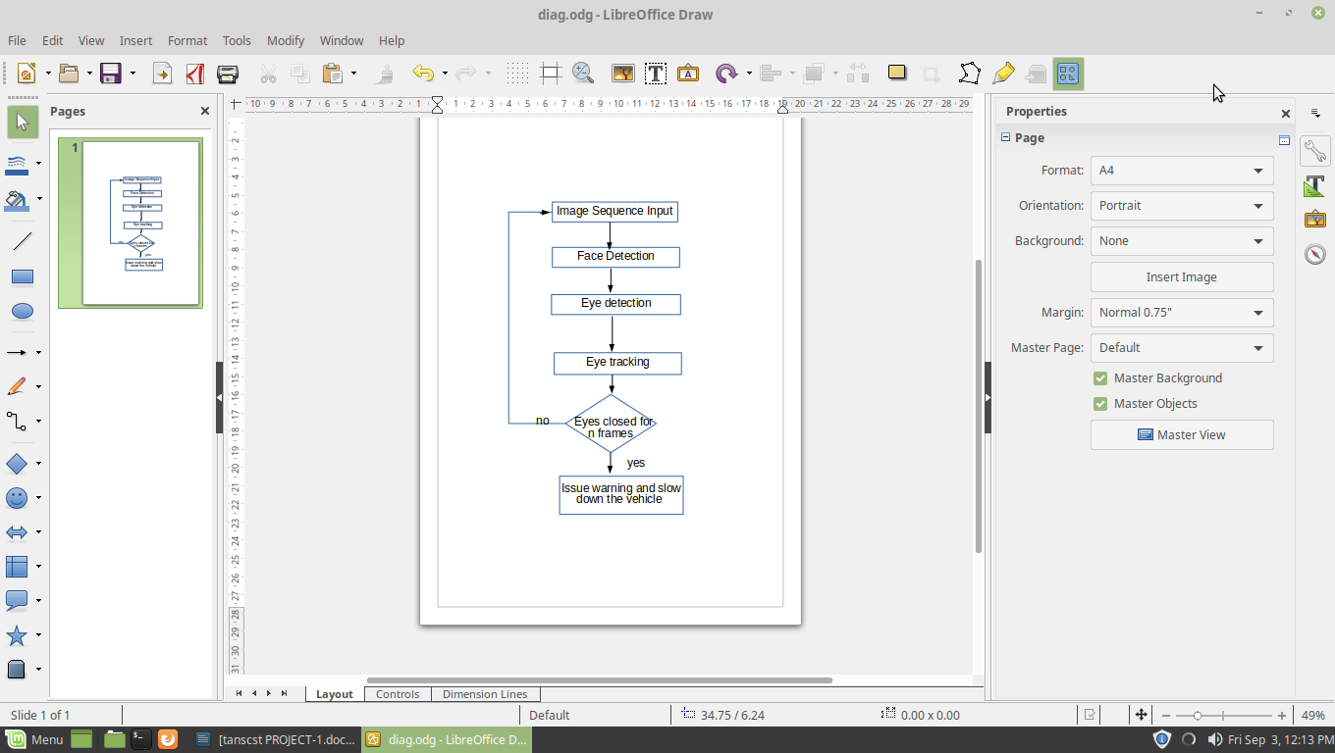

BUDGET
S.No | COMPONENT | QUANTITY | COST(Rs)
1 | Raspberry Pi3 model | 1 | 550
2 | Camera | 1 | 350
3 | Speaker | 1 | 150
4 | Stepper motor | 1 | 1200
5 | Crash sensor | 1 | 200
Total cost |  |  | 2450

ADVANTAGE
• Component establishes interface with other drivers very easily.
• Life of the driver can be saved by alerting him using the alarm system and by automatic speed reduction.
• Traffic management can be maintained by reducing accidents.
• Practically applicable.
• If found drowsy, the alarm system gets activated and alerts the driver and the speed of the vehicle is reduced.
- Cost effective comparing existing methods.
CONCLUSION
The automatic acceleration control system is capable of detecting drowsiness in quickly. The system which can differentiate normal eye blink and drowsiness can prevent the driver from entering the state of sleepiness while driving. During the monitoring, the system is able to decide if the eyes are closed or opened. When the eyes have been closed for too long a warning signal is issued. The ultimate goal of the system is to check the drowsiness condition of the driver and slow down the speed of the vehicle. Based on the eye movements and face movements of the driver, the drowsiness is detected & according to eye close, the alarm will be generated to alert the driver and to reduce the speed of the vehicle.

