Name : S.Subashini

Nm Id : au621421106050

**Air Quality Monitoring**

# Abstract

This paper deals with measuring Air Quality using MQ135 sensor along with Carbon Monoxide CO using MQ7 sensor. Measuring Air Quality is an important element for bringing lot of awareness in the people to take care of the future generations a healthier life. Based on this, Government of India has already taken certain measures to ban ‘Single Stroke’ and ‘Two Stroke’ Engine based motorcycles which are emitting high pollutions comparatively. We are trying to implement the same system using IoT platforms like Thingspeak or Cayenne, we can bring awareness to every individual about the harm we are doing to our environment. Already, New Delhi is remarked as the most pollution city in the world recording Air Quality above 300PPM. We have corrected the other papers where they have wrongly calibrated the sensor and wrongly projecting the PPM values. We have also used easiest platform like Thingspeak and set the dashboard to public such that everyone can come to know the Air Quality at the location where the system is installed. Also, we have reduced the cost of components used on comparing with the papers referred.

# INTRODUCTION

Air is getting polluted because of release of toxic gases by industries, vehicle emissions and increased concentration of harmful gases and particulate matter in the atmosphere. The level of pollution is increasing rapidly due to factors like industries, urbanization, increasing in population, vehicle use which can affect human health. Particulate matter is one of the most important parameter having the significant contribution to the increase in air pollution [2]. This creates a need for measurement and analysis of realtime air quality monitoring so that appropriate decisions can be taken in a timely period. This paper presents a real-time standalone air quality monitoring. Internet of Things is nowadays finding profound use in each and every sector, plays a key role in our air quality monitoring system too. The setup will show the air quality in PPM in webpage so that we can monitor it very easily. In this IoT project, you can monitor the pollution level from anywhere using your computer or mobile [1]. The setup will show the air quality in PPM in webpage so that we can monitor it very easily. In this IoT project, you can monitor the pollution level from anywhere using your computer or mobile. Air condition is much polluted. In recent years, car emissions, chemicals from factories, smoke and dust are everywhere. That is the reason why now air condition is much polluted. The effect of air pollution is very bad for our health, especially for place where the air in our body is taken for breathing. In our lungs may cause some diseases, such as asthma, cough, lung disorders [1].The air pollution cannot be detected by human feelings. The air pollution may contain a lot of dangerous substances, such as LPG gas, carbon monoxide, and methane [2]. Substances in the polluted air are very dangerous. For example, if the carbon monoxide is above 100ppm, it makes human feel dizzy, nauseous, and within minutes they could die.

This research makes human find out which content of the air is polluted. With module node mcu esp8266, we can monitor the air pollution remotely, because there is a Wi-Fi in nodemcu esp8266. This makes the air condition can be monitored every time.

# LITERATURE REVIEW 1. IOT Based Air Pollution Monitoring Using Node MCU

Arduino Poonam Pal1, Ritik Gupta2, Sanjana Tiwari3, Ashutosh Sharma4

The level of pollution has increased with times by lot of factors like the increase in population, increased vehicle use, industrialization and urbanization which results in harmful effects on human wellbeing by directly affecting health of population exposed to it. In order to monitor In this project we are going to make an IOT Based Air Pollution Monitoring System in which we will monitor the Air Quality over a web server using internet and will trigger a alarm when the air quality goes down beyond a certain level, means when there are sufficient amount of harmful gases are present in the air like CO2, smoke, alcohol, benzene and NH3. It will show the air quality in PPM on the LCD and as well as on webpage so that we can monitor it very easily. In this IOT project, you can monitor the pollution level from anywhere using your computer or mobile.

# 2. IOT Based Air Pollution Monitoring

Harsh N. Shah 1 , Zishan Khan 2 , Abbas Ali Merchant 3 , Moin Moghal 4 , Aamir Shaikh 5 , Priti Rane 6 1, 2, 3, 4,5Student, Diploma in Computer Engineering, BGIT, Mumbai Central, India 6Assistant Professor, BGIT, Mumbai Central, India

Air pollution is the biggest problem of every nation, whether it is developed or developing. Health problems have been growing at faster rate especially in urban areas of developing countries where industrialization and growing number of vehicles leads to release of lot of gaseous pollutants. Harmful effects of pollution include mild allergic reactions such as irritation of the throat, eyes and nose as well as some serious problems *Air Quality Monitoring*

like bronchitis, heart diseases, pneumonia, lung and aggravated asthma. According to survey, due to air pollution 50,000 to 100,000 premature deaths per year occur in the U.S. alone. Whereas in EU number reaches to 300,000 and over 3,000,000 worldwide. IOT Based Air Pollution Monitoring System monitors the Air quality over a web server using Internet and will trigger an alarm when the air quality goes down beyond a certain threshold level, means when there are sufficient amount of harmful gases present in the air like CO2, smoke, alcohol, benzene, NH3, LPG and NOx. It will show the air quality in PPM on the LCD and as well as on webpage so that it can monitor it very easily.

# 3) IOT Based Air Quality Monitoring

The main objective of this project is to monitor the air eminence in industrial and urban areas. The proposed outline includes a set of gas sensors (CO, and NO2) that are positioned on masses and structure of a IOT (Internet of things) and a dominant server to support both short-range realtime incident management and a continuing deliberate planning. In this Arduino platform is used to communicate the data simply and quickly. WSN (Wireless sensor network) acts as the trans receiver. This provide a real-time low rate monitoring system over the use of low rate, low information rate, and little control wireless communication technology. The projected monitoring system can be transferred to or shared by different applications. Through IOT we can able to visualize the values from the globe.

The problem in this paper is they haven’t calibrated the sensor and not even converted the sensor output value into PPM. As per the guidelines by UN Data, 0-50 is SAFE value and 51-100 is moderate. Delhi is the most polluted city in the world recorded 350PPM. While using two sensors, as both sensors have internal heat element, it draws more power(P= VxI), so though the both sensors are turned ON, its output voltage levels varies and shows unpredicted values due to insufficient drive. So we used a 9V battery and a 7805 family REGULATOR for the CO sensor MQ7. For MQ135 we have given the power from Arduino only.

# (4) Arduino Based Weather Monitoring

This Paper makes use of 3 sensors to measure the weather/environment factors such as temperature, humidity, light intensity, dew point and heat index. The values read from the sensors are processed by the Arduino micro-controller and stored in a text file which can be processed upon to derive analysis. The readings are also displayed on an on board LCD for quick viewing. All these readings can be analyzed to get the weather characteristics of a particular area and record the weather pattern. These recorded parameters are essential and vary from places to places.

# (5) IoT Based Air Pollution Monitoring

The level of pollution has increased with times by lot of factors like the increase in population, increased vehicle use, industrialization and urbanization which results in harmful effects on human wellbeing by directly affecting health of population exposed to it. In order to monitor In this project we are going to make an IOT Based Air Pollution Monitoring System in which we will monitor the Air Quality over a web server using internet and will trigger a alarm when the air quality goes down beyond a certain level, means when there are sufficient amount of harmful gases are present in the air like CO2, smoke, alcohol, benzene and NH3. It will show the air quality in PPM on the LCD and as well as on webpage so that we can monitor it very easily. we have used MQ135 sensor which is the best choice for monitoring Air Quality as it can detects most harmful gases and can measure their amount accurately. In this IOT project, you can monitor the pollution level from anywhere using your computer or mobile.

This paper assumed completely wrong assumption where they have showed the output 997PPM as the fresh air, where Delhi which is the most polluted city recording 350PPM. Its clear understanding that they haven’t calibrated the sensor and didn’t even convert the raw sensor data into PPM using derivations we did. They have used LocalHost which is limited where they are able to see the output only on the laptop within the experimental setup connected. But we have used premium iot platforms which are highly secured and open source IoT platform.

# PROPOSED METHODOLOGY

We used Thingspeak IoT platform and we clearly defined the derivations that mentions the correct ppm on the screen with correct calibration. We have implemented it with less cost i.e., when we are pushing the data to the cloud, no need to see the output on LCD which adds more cost to the project [1]. When we are targeting IoT as a platform, our intension should be to present the idea on internet using the platforms like thinger.io or thingspeak or Cayenne website which are beautifully designed to present the output and even able to download the dataset. When doing an experiment air quality monitoring, no need to use LPG or methane detecting sensors as it is used for Home/office safety. We have used WiFi to push the data onto the cloud rather using GSM or GPRS module [2]. The problem in another paper that cited at [3] hasn’t calibrated the sensor and not even converted the sensor output value into PPM. As per the guidelines by UN Data, 0-50 PPM is SAFE value, 51-100 is moderate as shown in figure 1. Delhi is the most polluted city in the world recorded around 250PPM. As we are using two sensors, both of them have internal heat element, it draws more power(P= V*I), so though the both sensors are turned ON, its output voltage levels varies and shows unpredictable values due to insufficient power drive. So we used a 9V battery and a 7805 family LM7805 Regulator for the CO sensor MQ7.

We have used Arduino Uno Development kit that comes with ATMega328P microcontroller. In order to provide WiFi Support for it, we have used cost effective *Air Quality Monitoring*

ESP-01 WiFi module which helps us to connect to the ThingSpeak Platform. The connections between them is mentioned in the connections diagram.

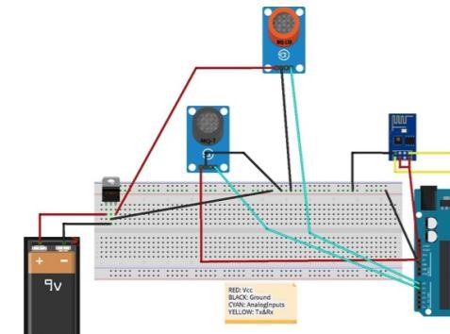

DIAGRAM MADE THROUGH FRITZIG

The most important step is to calibrate the sensor in fresh air and then draw an equation that converts the sensor output voltage value into our convenient units PPM (parts per million). Here are the mathematical calculations derived [6]. Fig 5: Internal circuit diagram of MQ135 sensor RS and RL combined From Ohm’s Law, at constant temperature, we can derive I as follows:

I = V/ R (1)

From fig , equation 1 is equivalent to

I = Vc / Rs + Rl (2)

From , we can obtain the output voltage at the load resistor using the value obtained for I and Ohm’s Law at constant temperature. V = I*R

VRl = [ Vc/ Rs + Rl ]  RL (3)

VRl = [ Vc  Rl [Rs + Rl ] (4)

(VRl  Rs) + (VRl  Rl) = Vc  RL (5)

VRl  Rs = (Vc  Rl) − (VRl  Rl) (6)

Rs = (Vc  Rl) − (VRl  Rl) VRl (7)

Rs = (Vc  Rl) VRl – Rl (8)

Equation 9 help us to find the internal sensor resistance for fresh air

Rs = (Vc  Rl)/ VRl – Rl (9)

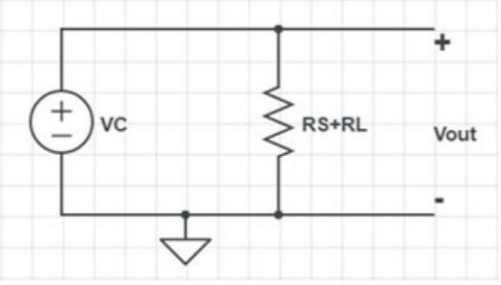

**Fig. 3.** Internal circuit diagram of MQ135

Equation 10 is depicted from the datasheet mentioned in Fig 6. To calculate R0, we will need to find the value of the Rs in fresh air. This will be done by taking the analog average readings from the sensor and converting it to voltage. Then we will use the Rs formula to find R0. First of all, we will treat the lines as if they were linear. This way we can use one formula that linearly relates the ratio and the concentration. By doing so, we can find the concentration of a gas at any ratio value even outside of the graph’s boundaries. The formula we will be using is the equation for a line, but for a log-log scale. The formula for a line is [9]: From above Figure 3, we try to derive the following calculations.

y = mx + b (11)

For a log-log scale, the formula looks like this:

log10y = m  log10x + b

Now that we have m, we can calculate the y intercept. To do so, we need to choose one point from the graph (once again from the CO2 line). In our case, we chose (5000,0.9) log(y) = m  log(x) + b (17)

b = log(0.9) − (−0.318)  log(5000) (18) b = 1.13 (19)

Now that we have m and b, we can find the gas concentration for any ratio with the following formula:

log(x) = log(y) − b m (20)

However, in order to get the real value of the gas concentration according to the loglog plot we need to find the inverse log of x: x = 10 / m

*Air Quality Monitoring*

Using equations 9 and 21, we will be able to convert the sensor output values into PPM (Parts per Million). Now we developed the Code and flashed into the Arduino Uno giving proper connections as mentioned

# RESULTS

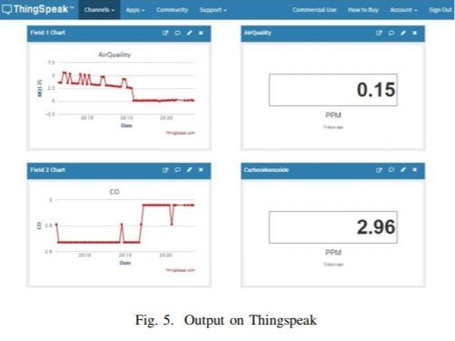

After connecting the wifi successfully to the ESP-01, it gets established with Thingspeak account with the help of the API key of our account provided. Thingspeak needs 15 seconds of refresh interval to push to the data. Fig 7 shows the field charts of MQ135 and MQ7 sensor values which made to convert to PPM [7] [8]. Fig 8 showing the graphical analysis of the values collected with time on X axis and AirQuality PPM on Y axis.

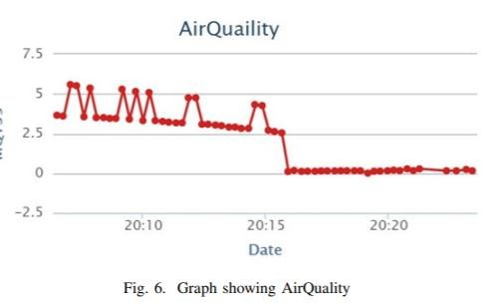

# CONCLUSION

Air quality monitoring systems are designed using different sensors for indoor and outdoor air quality monitoring in the previous works by using Bluetooth, GPS, GPRS wireless technologies. In a previous work WASP module is used which is costly. Instead of that different sensors can be used. The proposed system is developed for indoor air quality monitoring remotely. It is cost and energy efficient request and respond protocol is used along with combination of address and data centric protocols. Paper presents the summary of various techniques of air quality monitoring. These techniques are elaborately discussed in the paper. In the proposed system, one of the most preferred technique is cloud based air quality monitoring system. Using the same cloud data, website is hosted and data is displayed on the website.

# REFERENCES

1. Poonam Paul, Ritik Gupta, Sanjana Tiwari, Ashutosh Sharma, “IoT based Air Pollution Monitoring System with Arduino”, IJART, May 2005.
2. Zishan Khan, Abbas Ali, Moin Moghal, ”IoT based Air Pollution using NodeMCU and Thingspeak”, IRANS, pp. 11-16, March 2014.
3. SaiKumar, M. Reji, P.C. KishoreRaja ”AirQuality Index in India”, IEEE conference Chennai, August 2014.
4. Mohan Joshi, ”Research Paper on IoT based Air and Sound Pollution monitoring system”, IETS Journal, pp. 11-17, September 2015.
5. ”Malaya Ranjan, Rai kumar, ”Understanding Parts per million in real time air quality index”, Journal of Mathematics and advanced sciences, pp. 23-29, September 2009
6. D. Bandyopadhyay and J. Sen, “Internet of Things: Applications and Challenges in Technology and Standardization,” Wirel. Pers. Commun., vol. 58, no. 1, pp. 49–69, May 2011.
7. L. Atzori, A. Iera, and G. Morabito, “The Internet of Things: A Survey,” Comput. Netw., vol. 54, no. 15, pp. 2787–2805, October 2010.
8. H. Kopetz, Real-Time Systems: Design Principles for Distributed Embedded Applications. Boston, MA: Springer US, 2011, ch. Internet of Things, pp. 307– 323.
9. A. Gluhak, S. Krco, M. Nati, D. Pfisterer, N. Mitton, and T. Razafindralambo, “A Survey on Facilities for Experimental Internet of Things Research,” IEEE Communications Magazine, vol. 49, no. 11, pp. 58–67, November 2011.
10. J. Kim, J. Lee, J. Kim, and J. Yun, “M2M Service Platforms: Survey, Issues, and Enabling Technologies,” IEEE Communications Surveys Tutorials, vol. 16, no. 1, pp. 61–76, January 2014.
11. Jen-Hao Liu, Yu-Fan Chen, Tzu-Shiang Lin, And Da-Wei Lai ,Tzai-Hung Wen, Chih-Hong Sun, And Jehn-Yih Juang,Joe-Air Jiangdeveloped Urban Air Quality Monitoring System Based On Wireless Sensor Networks 2011 IEEE.
12. Srinivas Devarakonda, Parveen Sevusu, Hongz Hang Liu, Ruilin Liu, Liviu Iftode, Badri Nath Urbcomp Real-Time Air Quality Monitoring Through Mobile Sensing In Metropolitan Areas13, August 2013 Acm.
13. Fouzi Harrou, Mohamed Nounou,Hazem Nounou “Detecting Abnormal Ozone Levels Using Pca Based Glr Hypothesis Testing”2013 Ieee Symposium On Computational Intelligence And Data Mining.
14. Elias Yaacoub,Abdullah Kadri,Mohammad Mushtaha,And Adman AbuDayya,”Air Quality Monitoring And Analysis In Qatar Using A Wireless Sensor Network Deployment”596-601,2013 IEEE.
15. Parr, T. W., Ferretti, M., Simpson, I. C., Forsius, M., & Kovács-Láng, E. (2002). Towards a long-term integrated monitoring programme in Europe: network design in theory and practice. *Environmental monitoring and assessment*, *78*(3), 253-290.
16. Jerrett, M., Arain, A., Kanaroglou, P., Beckerman, B., Potoglou, D., Sahsuvaroglu, T., ... & Giovis, C. (2005). A review and evaluation of intraurban air pollution exposure models. *Journal of Exposure Science and Environmental Epidemiology*, *15*(2), 185.