Assignment – 1

Refactoring of HTML/CSS/Accessibility

1. In some of the pages the header tags like h2,h3 are used without h1.

This can be refactored by changing the h2 🡪 h1 and h3 🡪 h2 as follows.

1. In order to clearly indicate the role of the content the HTML contain, we should use more semantic HTML tags like <header>,<article>,<footer> etc. Below is the screenshot of a page where the semantic HTML tags are not used adequately.

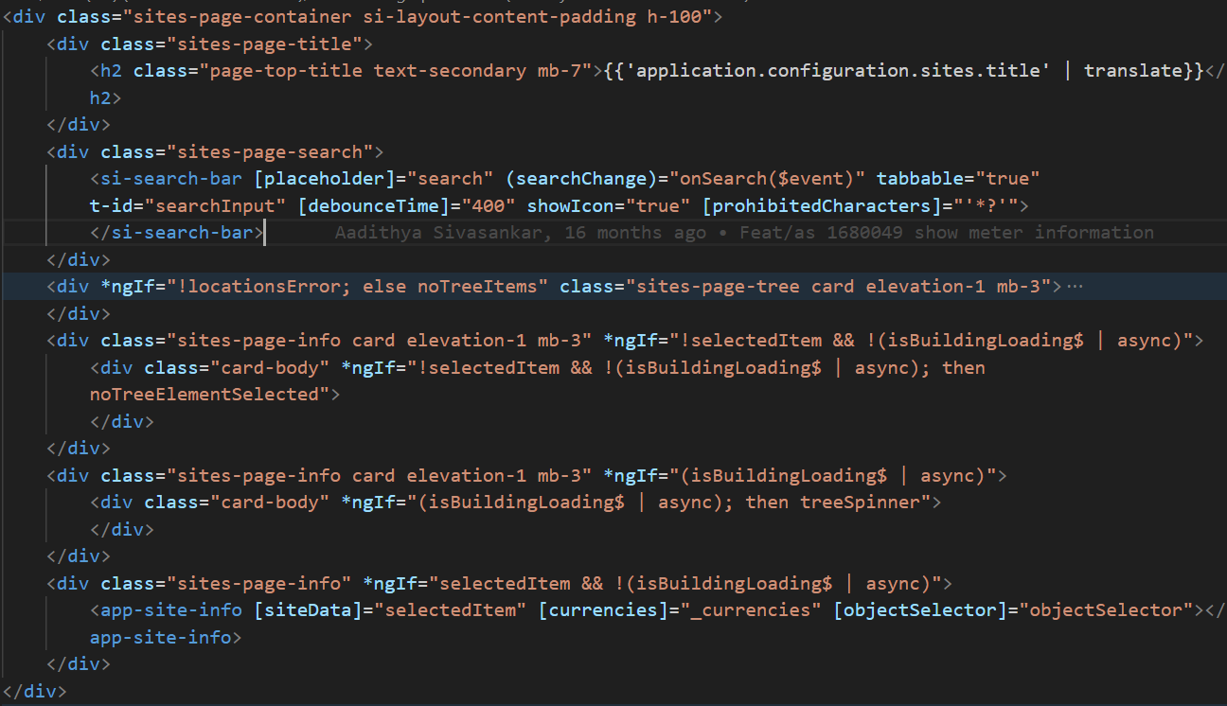

The above screen is the HTML code for the below page

So, the HTML code for this page can be refactored as below. We can use,

* <section> tag for the whole content
* <header> tag for the title
* <nav> tag for the search part
* <aside> tag for the card with tree structure on the left
* <main> tag for the card with building details

1. As a part of improving the semantics, the below page can also be refactored

The HTML code for this page is show below. The <div> tag is used for all the card.

Each Card has header and its own content.

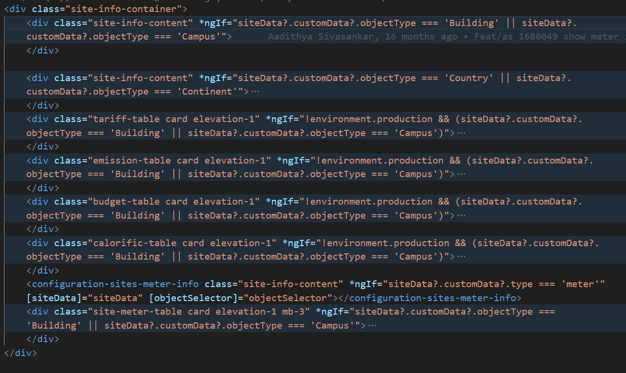

The above code can be refactored by using <article> and <section> tags.

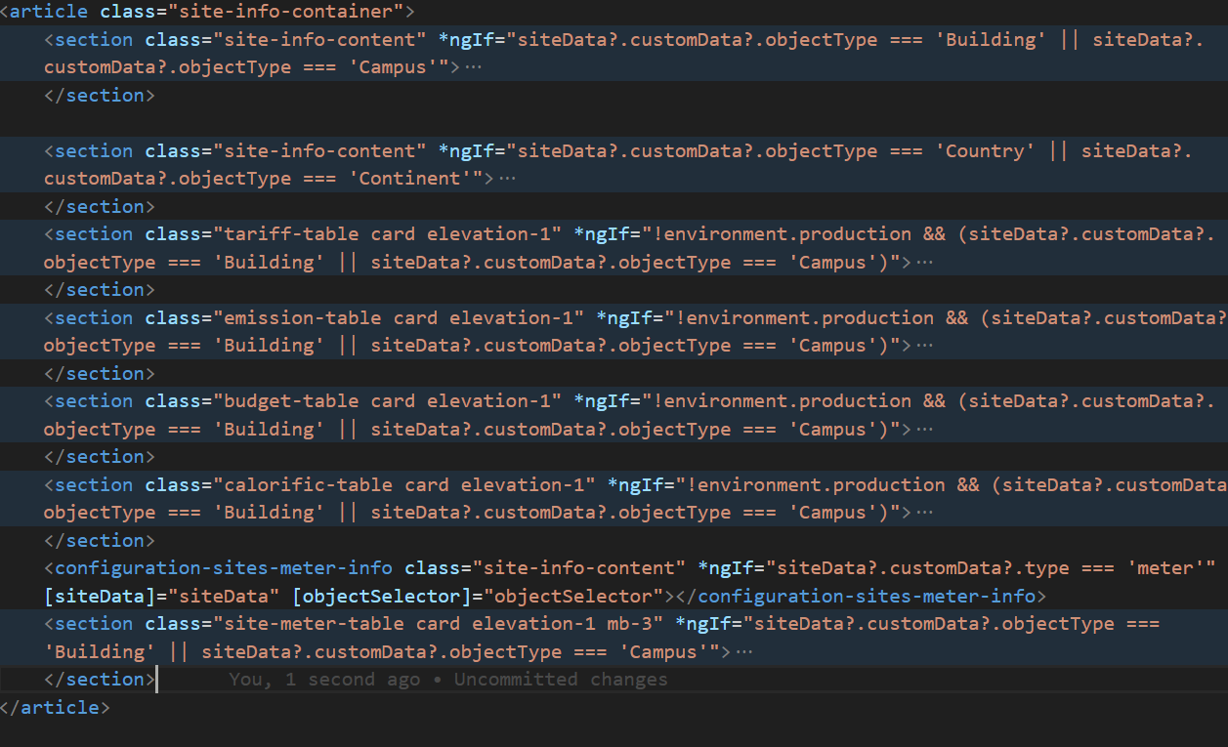

1. The below shown screenshot is a modal, which is used to create a calorific value.

The semantics can be improved by adding tags like header, main, and footer.

This HTML code for a modal can be improved as follows.

1. The accessibility of an input field can be improved by adding,

* ‘required’ text can be added along with the label instead of ‘\*’.

When we use some patterns to convey the user that the input is required, it won’t be understandable by a screen reader.

* ‘Aria-invalid = true’ can be used to specify an invalid input field
* We can make an inline alert message more accessible by adding the ‘role=” alert”’ attribute, tabIndex = 0.

