Steps:

1) Flight Ticket Booking:

Implementation:

login page.please use this login credential. Userid:1001, Firstname:SUBASHINI, Lastname:SAMPATH, Password:subashini

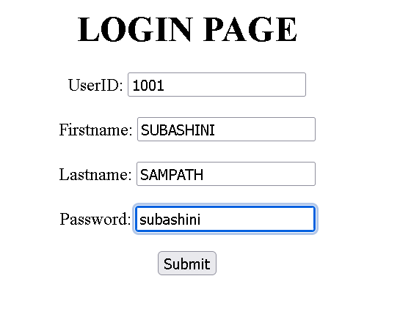

2) Now the page will ask for date, departure and arrival details.

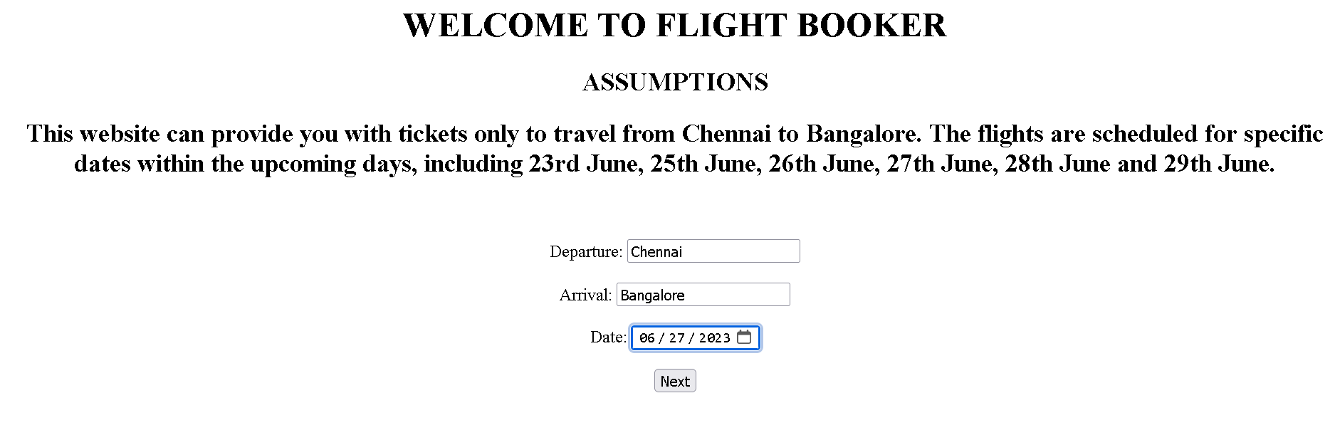

3) The next page will show flight details . Select one from that.

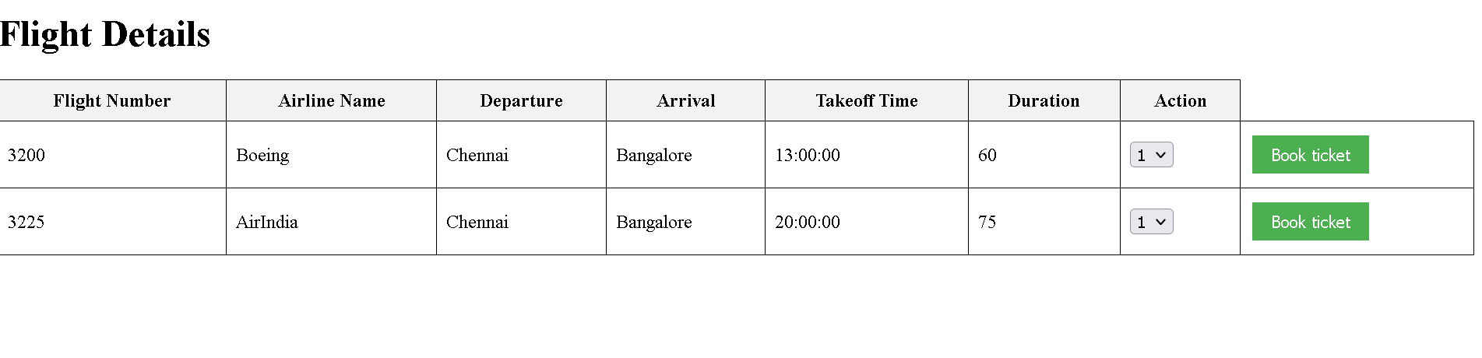

4) Ticket will get generated.

