**KIRUTHIGA M**

*Phone:* **6385359883**

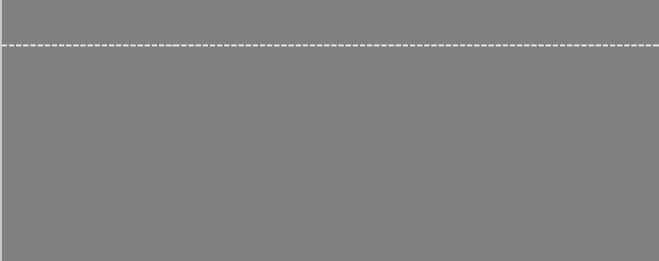

*Address:* **No. 237, Kulathumettu Street,**

**Konalur (Village & Post),**

**Tiruvannamalai - 606 755,**

**Tamil Nadu, India.**



*Email:* [**keerthikeerthi0711@gmail.com**](mailto:keerthikeerthi0711@gmail.com)



*Education* **Kamban College of Arts & Science for**

**Women**

Bachelor of Science - Computer Science

Holding 89.99 % upto 5th Semester



**S.R.V Girls Higher Secondary School**

Higher Secondary

Completed Higher Secondary School - 79.4%



**Scared Heart Matriculation School**

SSLC

Completed Secondary School - 89.5%



APRIL 2019



APRIL 2014



APRIL 2012



|  |  |  |  |
| --- | --- | --- | --- |
| *Skills* | **Technical Skills:** |  |  |
|  | Programming Language | C, C++, Java |  |
|  | OS Platform | Windows 7, 10, Linux |  |
|  | Database | MySQL |  |
|  | Office Suite | MS Office, Libre Office |  |
|  | Web Development | HTML, CSS, Javascript, PHP, WAMP / |  |
|  | LAMP |  |
|  |  |  |



**Personal Skills:**

Good Communication Skills



Excellent Presentation Skills



Ability to Work Independently



**Other Skills:**

Type Writing (Junior Typist)





|  |  |
| --- | --- |
| *Co - Curricular* | Participated in Paper Presentation, Quiz and Won Many Certificates. |
| *Activities* |  |



|  |  |  |  |
| --- | --- | --- | --- |
| *Personal Details* | **Name** | Kiruthiga M |  |
|  | **Fathers Name** | Murugan D |  |
|  | **Date of Birth** | 10/06/1997 |  |
|  | **Languages Known** | Tamil, English |  |
|  | **Hobbies** | Web Surfing |  |
|  | **Mobile No** | 8056422163, 6385359883 |  |
|  | **Address for Communication** | No. 237, Kulathumettu Street, Konalur (Village & |  |
|  | Post), Tiruvannamalai - 606 755, Tamil Nadu, India. |  |
|  |  |  |

I hereby Inform you that these information which are provided by myself which is true to my knowledge.

Thanking You,

Your's Sincerely,

M. Kiruthiga

