**LASER SECURITY ALARM**

**INTRODUCTION :**

A laser security system can act as a standalone system,which makes noise or sound when it detects any irregular activity.It is an alarm system that uses light sensor . A security system protects our homes,banks,lockers etc. from intrusion and unauthorised access.

**Step 1: Gathering the Required Electronic Components**

The components you will require for making this circuit are as follows:-

COMPONENTS REQUIRED:- LDR (Light Dependant Diode)

L.E.D (Light Emitting Diode)

BC547 Transistor (1)

100 ohm or 330 ohm resistor (1)

Buzzer (1)

9v Battery with holder

Breadboard

**Step 2: Circuit Diagram**

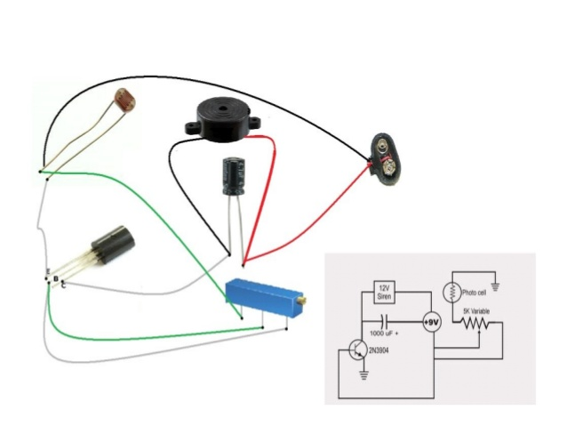

This is the circuit diagram of our "Laser Alarm System.

**Step 3: Steps for Construction of the Circuit**

The BC547 Transistor has 3 pins. When the flat side is facing you that time the 1st pin is called the **collector**, the 2nd pin is called the **base**and the 3rd pin is called the **emitter.**

now lets get started;

1. Place the BC547 Transistor on the breadboard.

2. Then connect the LDR from the **base**and **emitter**of the BC547 Transistor.

3. Now connect one end of the 330/100 ohm resistor to the**base** of the BC547 Transistor and the other end of the resistor to a blank space on the breadboard.

4. Connect the **anode** of the L.E.D to the resistor and the **cathode** of the L.E.D to the **collector**.

5. Connect the buzzer in the same way you connected the L.E.D.

6. Now connect the Battery; *positive side of the battery to the resistor* and *negative part of the battery to one side of the LDR*

**Sensor**

As soon as you connect the battery the L.E.D and buzzer will come "ON" (if you're in a dark room). Focus the Laser diode/light on the LDR and you will see the L.E.D and Buzzer going "OFF" If you interrupt the laser light focusing on the LDR the circuit will trigger and the alarm will ring!

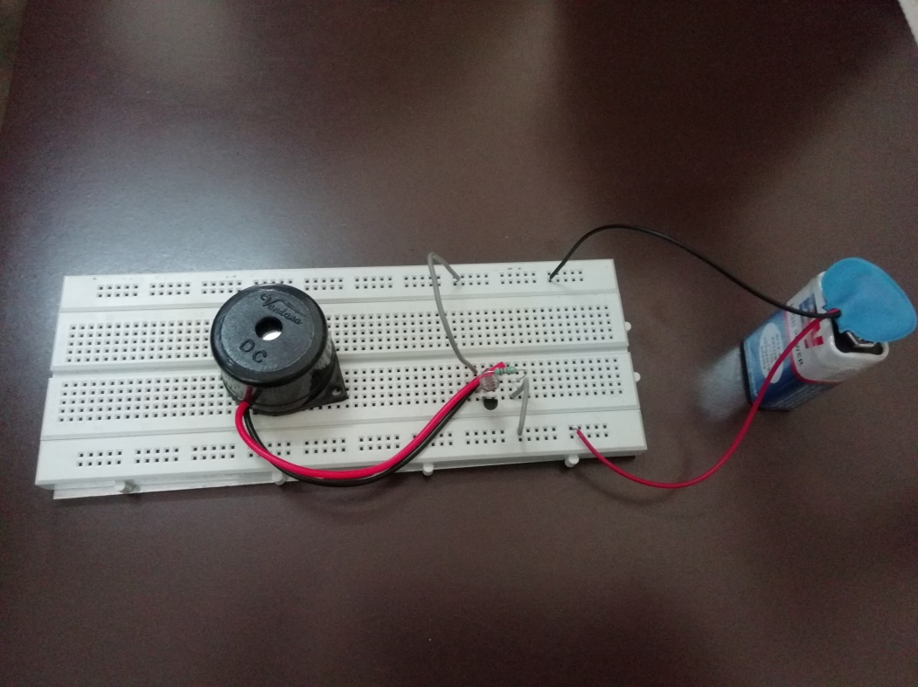

**WIRELESS SENSOR NETWORKS**

**( ASSIGNMENT-2 )**

**PROJECT REPORT**

**BY :**

**SHIVAPRIYA.RM(150071601065)**

**MOHAMMAD AMEENA(150071601044)**

**MOBILE AND PERVASIVE COMPUTING**

**( ASSIGNMENT-2 )**

**PROJECT REPORT**

**BY :**

**SHIVAPRIYA.RM(150071601065)**

**MOHAMMADAMEENA(150071601044)**