IT SUPPORT TICKET & PERFORMANCE ANALYTICS DASHBOARD

Project Overview
The IT Support Ticket & Performance Analytics Dashboard is a Power BI-based data analytics project developed to analyze IT support tickets, identify common issues, monitor ticket status, and evaluate Support Engineer performance.

The dashboard provides an interactive view of support operations using data from Departments, Employees, Support Engineers, Tickets, and Ticket History tables. It helps users understand ticket trends, issue patterns, priorities, resolution performance, and engineer-level performance.

Project Objectives
The main objectives of this project are:

- To analyze the overall IT support ticket volume.
- To identify common issue types and categories.
- To analyze tickets based on priority and status.
- To monitor ticket resolution performance.
- To evaluate Support Engineer performance.
- To calculate Average Resolution Time.
- To provide interactive and easy-to-understand dashboards.
- To support data-driven decision-making in IT support operations.

Dataset
The project uses five CSV datasets:

1. Departments
2. Employees
3. Support Engineers
4. Tickets
5. Ticket History

Tickets Table
The main ticket-related fields used in the analysis include:

- Ticket ID
- Employee ID
- Category
- Priority
- Issue Type
- Created Date
- Resolved Date
- Status
- Assigned To
- Resolution Time Hours

The "Tickets" table acts as the primary table for ticket-level analysis.

Tools and Technologies Used

MySQL
MySQL was used for working with the dataset, checking data, performing queries, joins, and validating relationships between tables.

Power Query
Power Query in Power BI was used for data preparation and transformation, including checking data types, handling data quality issues, and preparing the data for analysis.

Power BI
Power BI Desktop was used to create the interactive dashboard, visuals, KPI cards, filters, and navigation between report pages.

DAX
DAX (Data Analysis Expressions) was used to create calculated measures and KPIs such as ticket counts and Average Resolution Time.

CSV
CSV files were used as the source data for the project.

Data Preparation

The following data preparation activities were performed:
- Imported the CSV files into Power BI.
- Checked the structure of each table.
- Verified column names and data types.
- Checked date and numeric fields.
- Established relationships between related tables.
- Validated ticket and employee-related information.
- Prepared the data for visualization and analysis.

Data Model

The dashboard uses multiple related tables to create a structured data model.

Main Tables
Departments → Employees → Tickets

Support Engineers → Tickets

Tickets → Ticket History

Relationships between the tables allow information from different datasets to be used together for analysis.

The "Assigned To" field in the Tickets table is used to identify the assigned Support Engineer through the Support Engineers table.

Dashboard Design
The dashboard follows a professional Black and Red theme.

The report consists of three main pages:

1. IT Support Overview
2. Ticket & Issue Analysis
3. Support Engineer Performance

Navigation buttons are provided to move between the report pages.

Page 1 – IT Support Overview

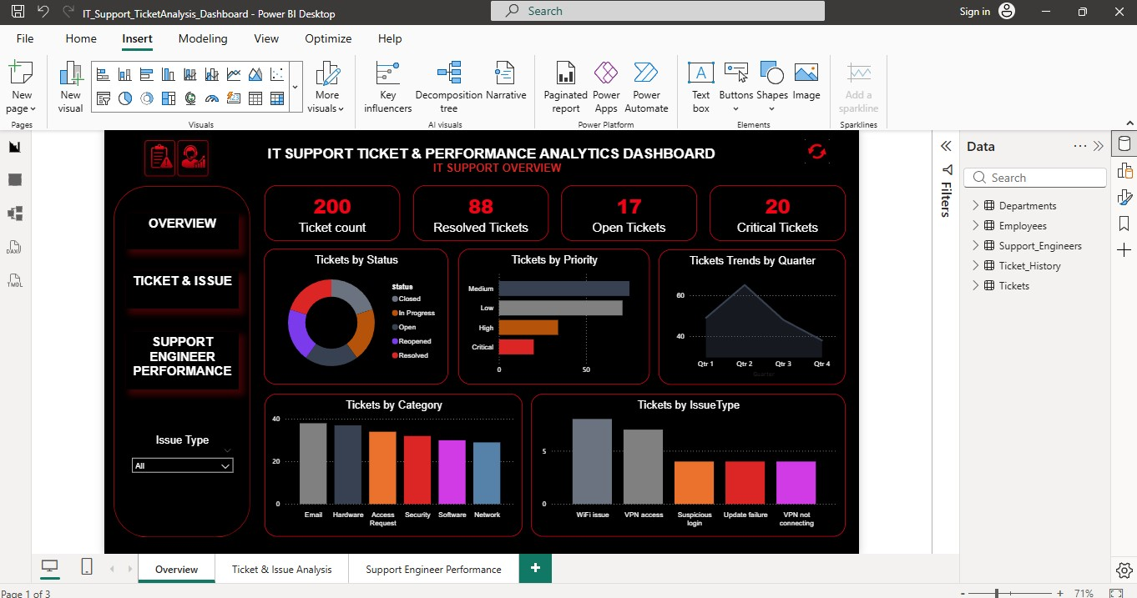

Purpose

The Overview page provides a high-level summary of the IT support operation.

KPI Cards

The following KPIs are displayed:

- Ticket Count
- Open Tickets
- Resolved Tickets
- Critical Tickets

Visualizations

Tickets Trend Over Time
A line chart is used to understand how ticket volume changes over time.

Tickets by Status
A donut chart shows the distribution of tickets based on their current status.

Tickets by Priority
A chart is used to compare tickets across different priority levels.

Tickets by Department
A bar chart is used to understand ticket volume across departments.
This page gives users a quick understanding of the overall support workload and performance.

Page 2 – Ticket & Issue Analysis
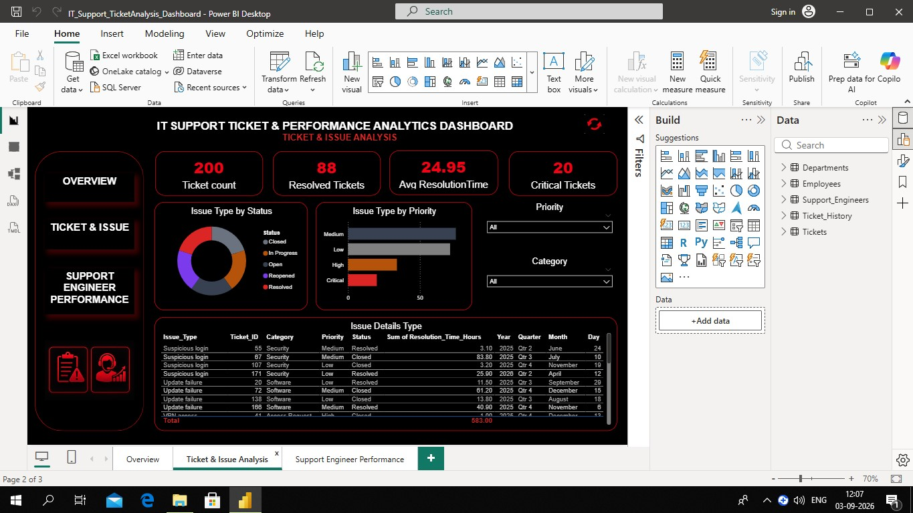

Purpose

The Ticket & Issue Analysis page focuses on understanding the types of problems reported by employees.
Visualizations

Tickets by Issue Type

This chart identifies the most frequently reported issue types.

Issue Type by Status

This visual compares issue types based on their ticket status.

Issue Type by Priority

This visual shows the relationship between issue types and ticket priorities.

Issue Details Table

The table provides detailed ticket-level information.

The table includes:

- Ticket ID
- Issue Type
- Category
- Priority
- Status
- Created Date
- Resolution Time (Hours)

Slicers

The page includes relevant filters such as:

- Date
- Priority
- Category

These filters allow users to interactively analyze specific ticket segments.

Page 3 – Support Engineer Performance

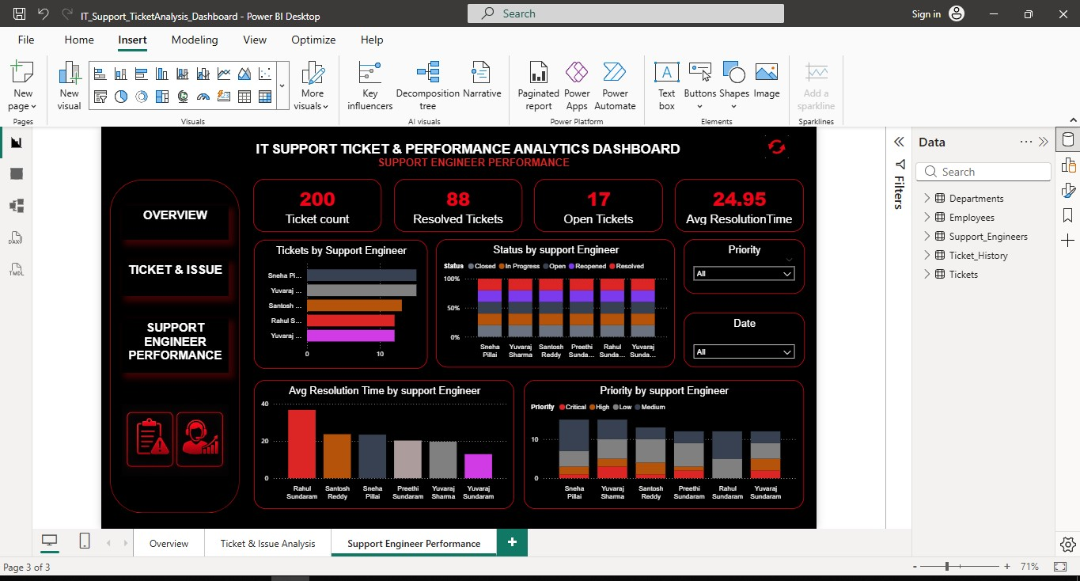
Purpose

The Support Engineer Performance page evaluates how effectively support engineers handle assigned tickets.

KPI Cards

- Total Tickets
- Resolved Tickets
- Open Tickets
- Average Resolution Time

Visualizations

Tickets by Support Engineer

A bar chart compares the number of tickets handled by each Support Engineer.

Status by Support Engineer

A stacked bar chart compares ticket statuses across Support Engineers.

Average Resolution Time by Support Engineer

A bar chart compares the average time taken by each Support Engineer to resolve tickets.

Priority by Support Engineer

A stacked chart shows the distribution of ticket priorities handled by each Support Engineer.
Engineer Performance Table

The detailed table contains:

- Support Engineer
- Total Tickets
- Resolved Tickets
- Open Tickets
- Average Resolution Time

This page helps identify workload distribution and differences in resolution performance among Support Engineers.

DAX Measures

DAX measures were created to calculate important performance indicators.

Total Tickets

Total Tickets =
COUNT(Tickets[Ticket ID])

Resolved Tickets

Resolved Tickets =
CALCULATE(
COUNT(Tickets[Ticket ID]),
Tickets[Status] = "Resolved"
)

Open Tickets

Open Tickets =
CALCULATE(
COUNT(Tickets[Ticket ID]),
Tickets[Status] = "Open"
)

Average Resolution Time

Avg Resolution Time =
AVERAGE(Tickets[Resolution TimeHours])

These measures are used in KPI cards and visualizations throughout the dashboard.

Key Analysis Performed
The dashboard provides insights into:

- Overall ticket workload.
- Ticket status distribution.
- Ticket priority distribution.
- Frequently reported issue types.
- Category-wise ticket patterns.
- Ticket trends over time.
- Average ticket resolution time.
- Support Engineer workload.
- Engineer-wise ticket status.

Interactive Features
The dashboard provides interactive features including:

- KPI Cards
- Charts
- Slicers
- Cross-filtering
- Drill/filter interactions
- Page navigation buttons
- Interactive tables

These features allow users to explore the data according to their requirements.

Benefits of the Dashboard
The dashboard helps IT support teams to:

- Monitor support workload.
- Identify frequently occurring issues.
- Track unresolved tickets.
- Understand priority-wise ticket volume.
- Monitor resolution time.
- Compare Support Engineer performance.
- Identify areas requiring improvement.
- Make data-driven operational decisions.

Conclusion
The IT Support Ticket & Performance Analytics Dashboard transforms raw IT support data into meaningful and interactive visual insights.

By combining multiple datasets and using MySQL, Power Query, Power BI, and DAX, the project provides a structured view of ticket trends, issue patterns, priorities, statuses, resolution times, and Support Engineer performance.

The three-page dashboard enables users to move from an overall support summary to detailed issue analysis and finally to engineer-level performance analysis.

Overall, the project demonstrates practical skills in Data Analysis, SQL, Power BI, Power Query, DAX, Data Modeling, Data Visualization, and Dashboard Development.

