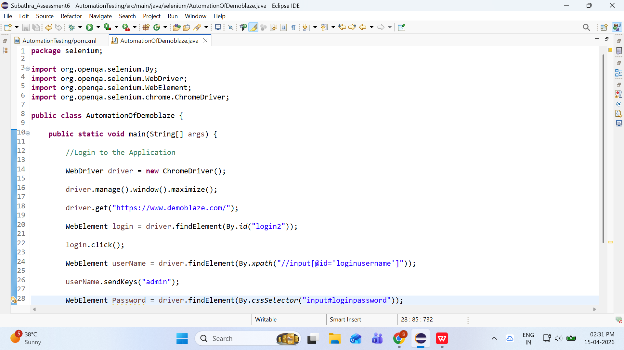

Exception in thread "main" org.openqa.selenium.ElementNotInteractableException: element not interactable
(Session info: chrome=147.0.7727.56)
Build info: version: '4.43.0', revision: 'dd0f534'
System info: os.name: 'Windows 11', os.arch: 'amd64', os.version: '10.0', java.version: '21.0.8'
Driver info: org.openqa.selenium.chrome.ChromeDriver
Command: [fd04631ab71eac2766014a8d0c43c172, sendKeysToElement {id=f.88C661C7896D3B22BE8AAA2BD6A92567.d.08EB9DCD1AFED8A31904F4534DE4E910.e.18, value=[Ljava.lang.CharSequence;@6e6f2380}]
Capabilities {acceptInsecureCerts: false, browserName: chrome, browserVersion: 147.0.7727.56, chrome: {chromedriverVersion: 147.0.7727.56 (b28eac7a1a97..., userDataDir: C:\Users\ADMIN\AppData\Loca...}, fedcm:accounts: true, goog:chromeOptions: {debuggerAddress: localhost:59660}, goog:processID: 8256, networkConnectionEnabled: false, pageLoadStrategy: normal, platformName: windows, proxy: Proxy(), se:cdp: ws://localhost:59660/devtoo..., se:cdpVersion: 147.0.7727.56, setWindowRect: true, strictFileInteractability: false, timeouts: {implicit: 0, pageLoad: 300000, script: 30000}, unhandledPromptBehavior: dismiss and notify, webauthn:extension:credBlob: true, webauthn:extension:largeBlob: true, webauthn:extension:minPinLength: true, webauthn:extension:prf: true, webauthn:virtualAuthenticators: true}
Element: [[ChromeDriver: chrome on windows (fd04631ab71eac2766014a8d0c43c172)] -> xpath: //input[@id='loginusername']]
Session ID: fd04631ab71eac2766014a8d0c43c172
at org.openqa.selenium.remote.ErrorCodec.decode(ErrorCodec.java:169)
at org.openqa.selenium.remote.codec.w3c.W3CHttpResponseCodec.decode(W3CHttpResponseCodec.java:142)
at org.openqa.selenium.remote.codec.w3c.W3CHttpResponseCodec.decode(W3CHttpResponseCodec.java:49)
at org.openqa.selenium.remote.HttpCommandExecutor.execute(HttpCommandExecutor.java:223)
at org.openqa.selenium.remote.service.DriverCommandExecutor.invokeExecute(DriverCommandExecutor.java:216)
at org.openqa.selenium.remote.service.DriverCommandExecutor.execute(DriverCommandExecutor.java:174)
at org.openqa.selenium.remote.RemoteWebDriver.execute(RemoteWebDriver.java:606)
at org.openqa.selenium.remote.RemoteWebElement.execute(RemoteWebElement.java:223)
at org.openqa.selenium.remote.RemoteWebElement.sendKeys(RemoteWebElement.java:110)
at selenium.AutomationOfDemoblaze.main(AutomationOfDemoblaze.java:26)

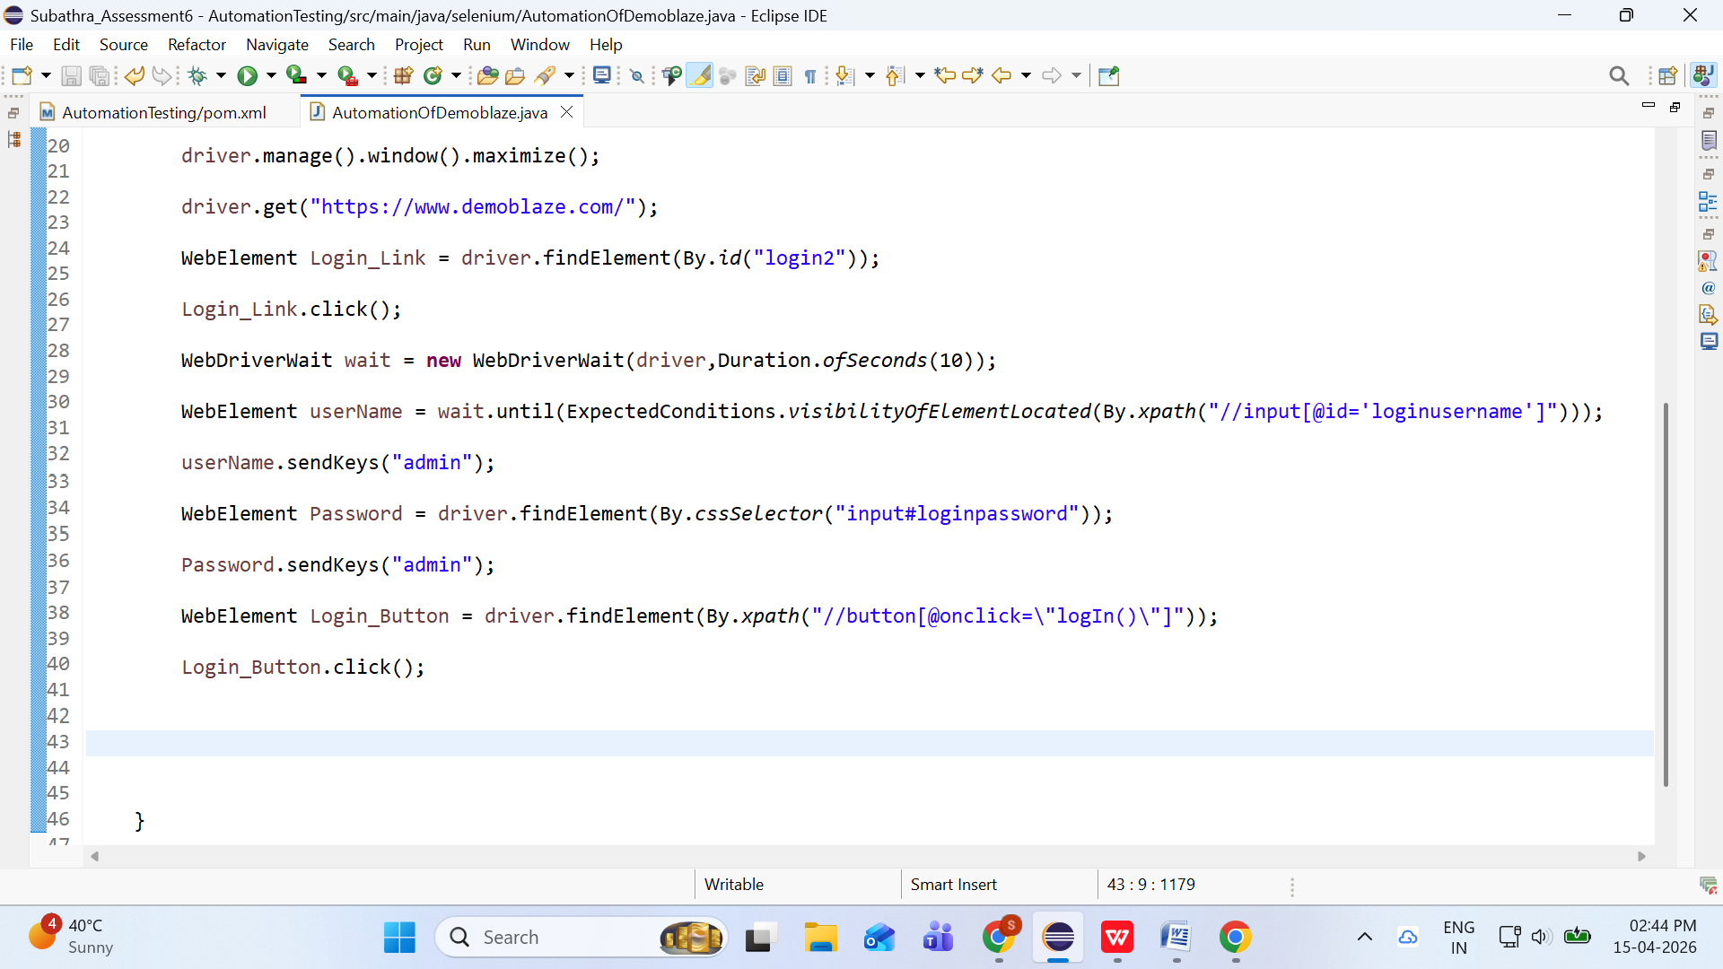

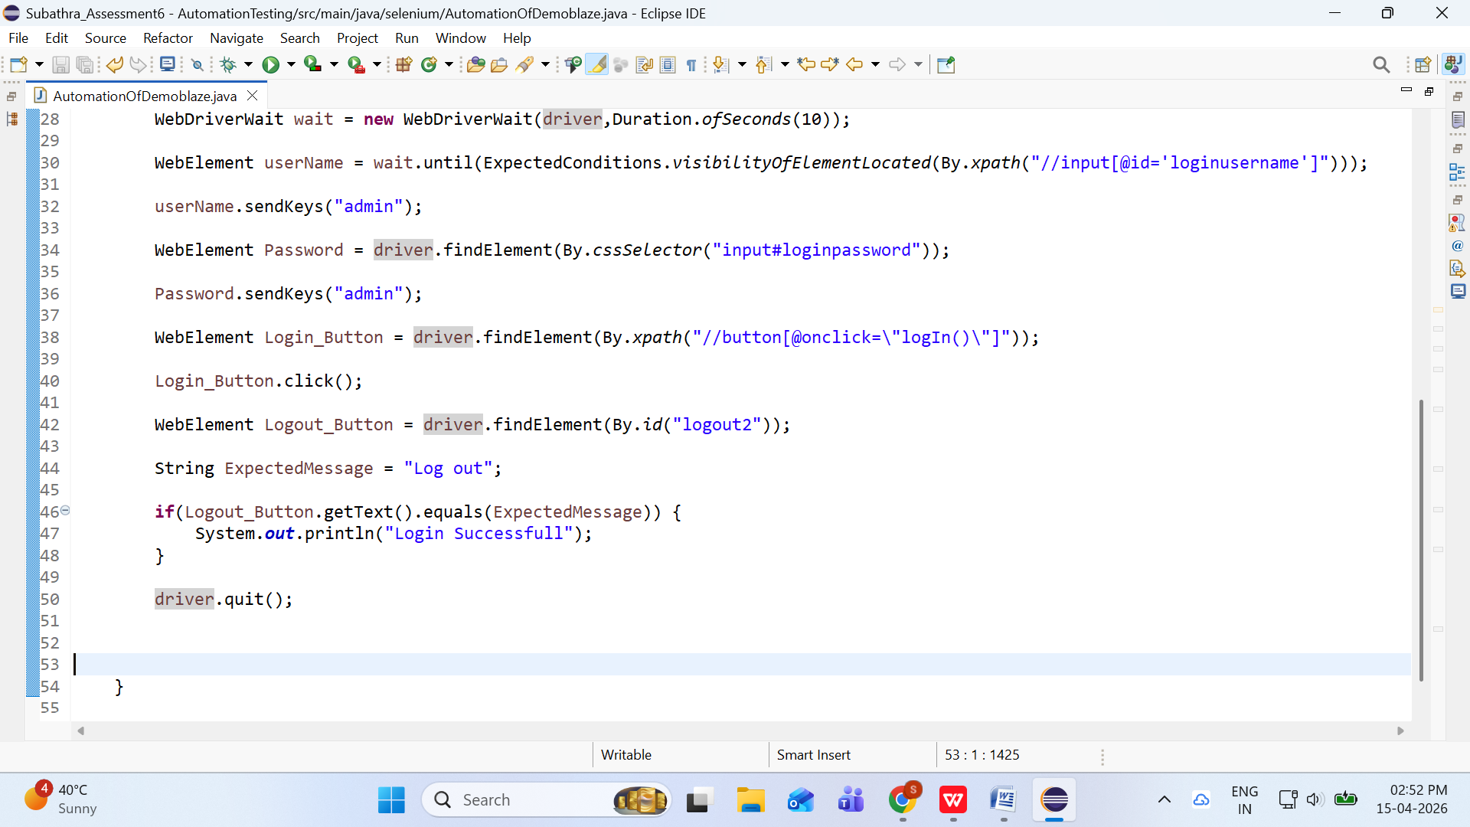

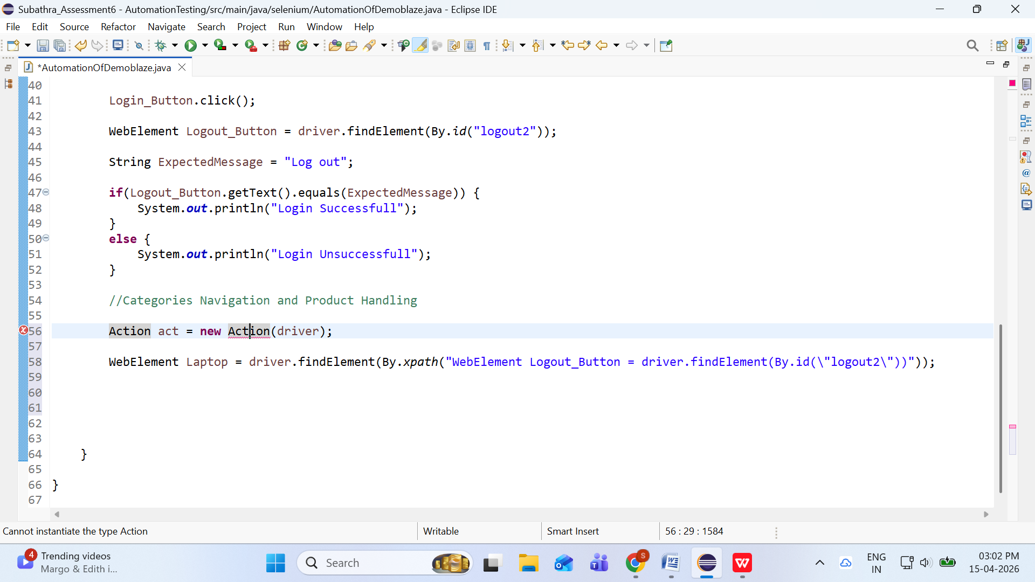

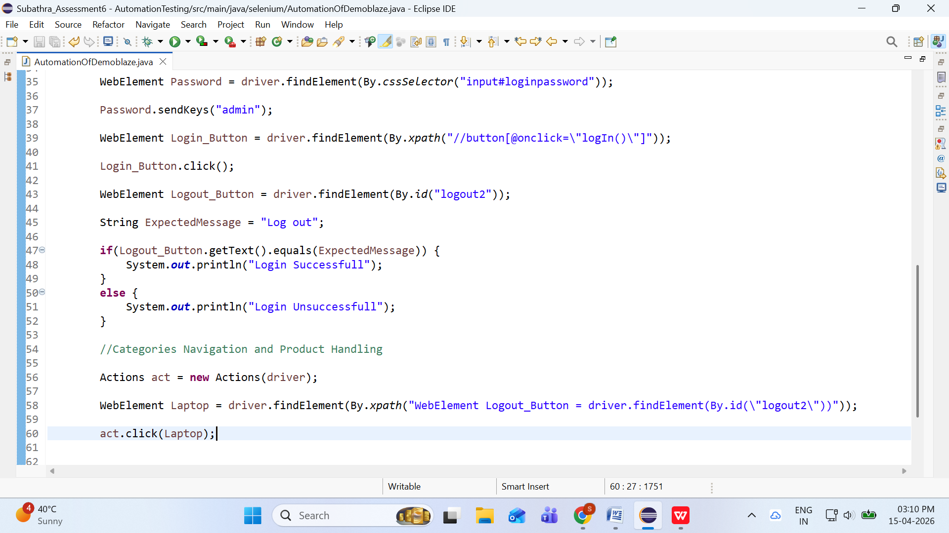

Login Successfull
Exception in thread "main" java.lang.ClassCastException: class org.openqa.selenium.remote.RemoteWebElement cannot be cast to class java.lang.Comparable (org.openqa.selenium.remote.RemoteWebElement is in unnamed module of loader 'app'; java.lang.Comparable is in module java.base of loader 'bootstrap')
at java.base/java.util.TreeMap.compare(TreeMap.java:1604)
at java.base/java.util.TreeMap.addEntryToEmptyMap(TreeMap.java:811)
at java.base/java.util.TreeMap.put(TreeMap.java:820)
at java.base/java.util.TreeMap.put(TreeMap.java:569)
at java.base/java.util.TreeSet.add(TreeSet.java:259)
at java.base/java.util.AbstractCollection.addAll(AbstractCollection.java:338)
at java.base/java.util.TreeSet.addAll(TreeSet.java:313)
at java.base/java.util.TreeSet.<init>(TreeSet.java:164)
at selenium.AutomationOfDemoblaze.main(AutomationOfDemoblaze.java:64)

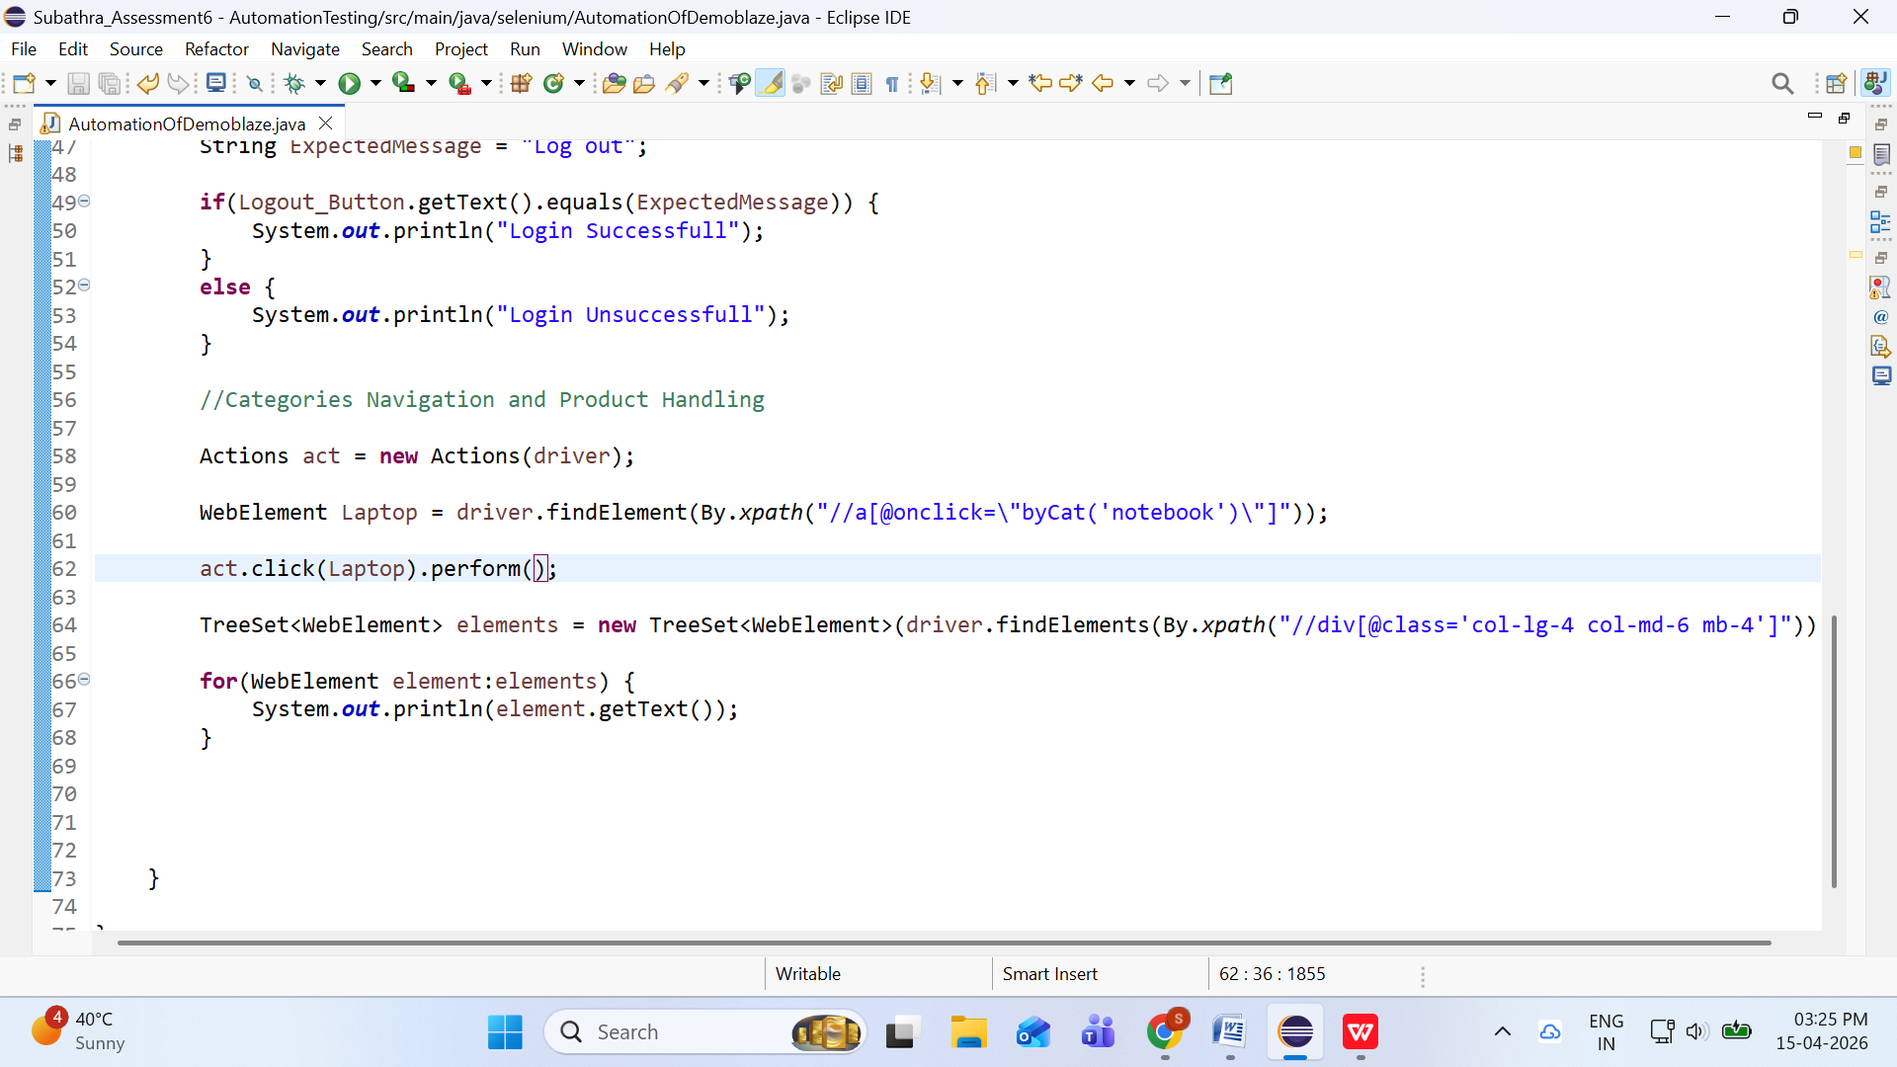

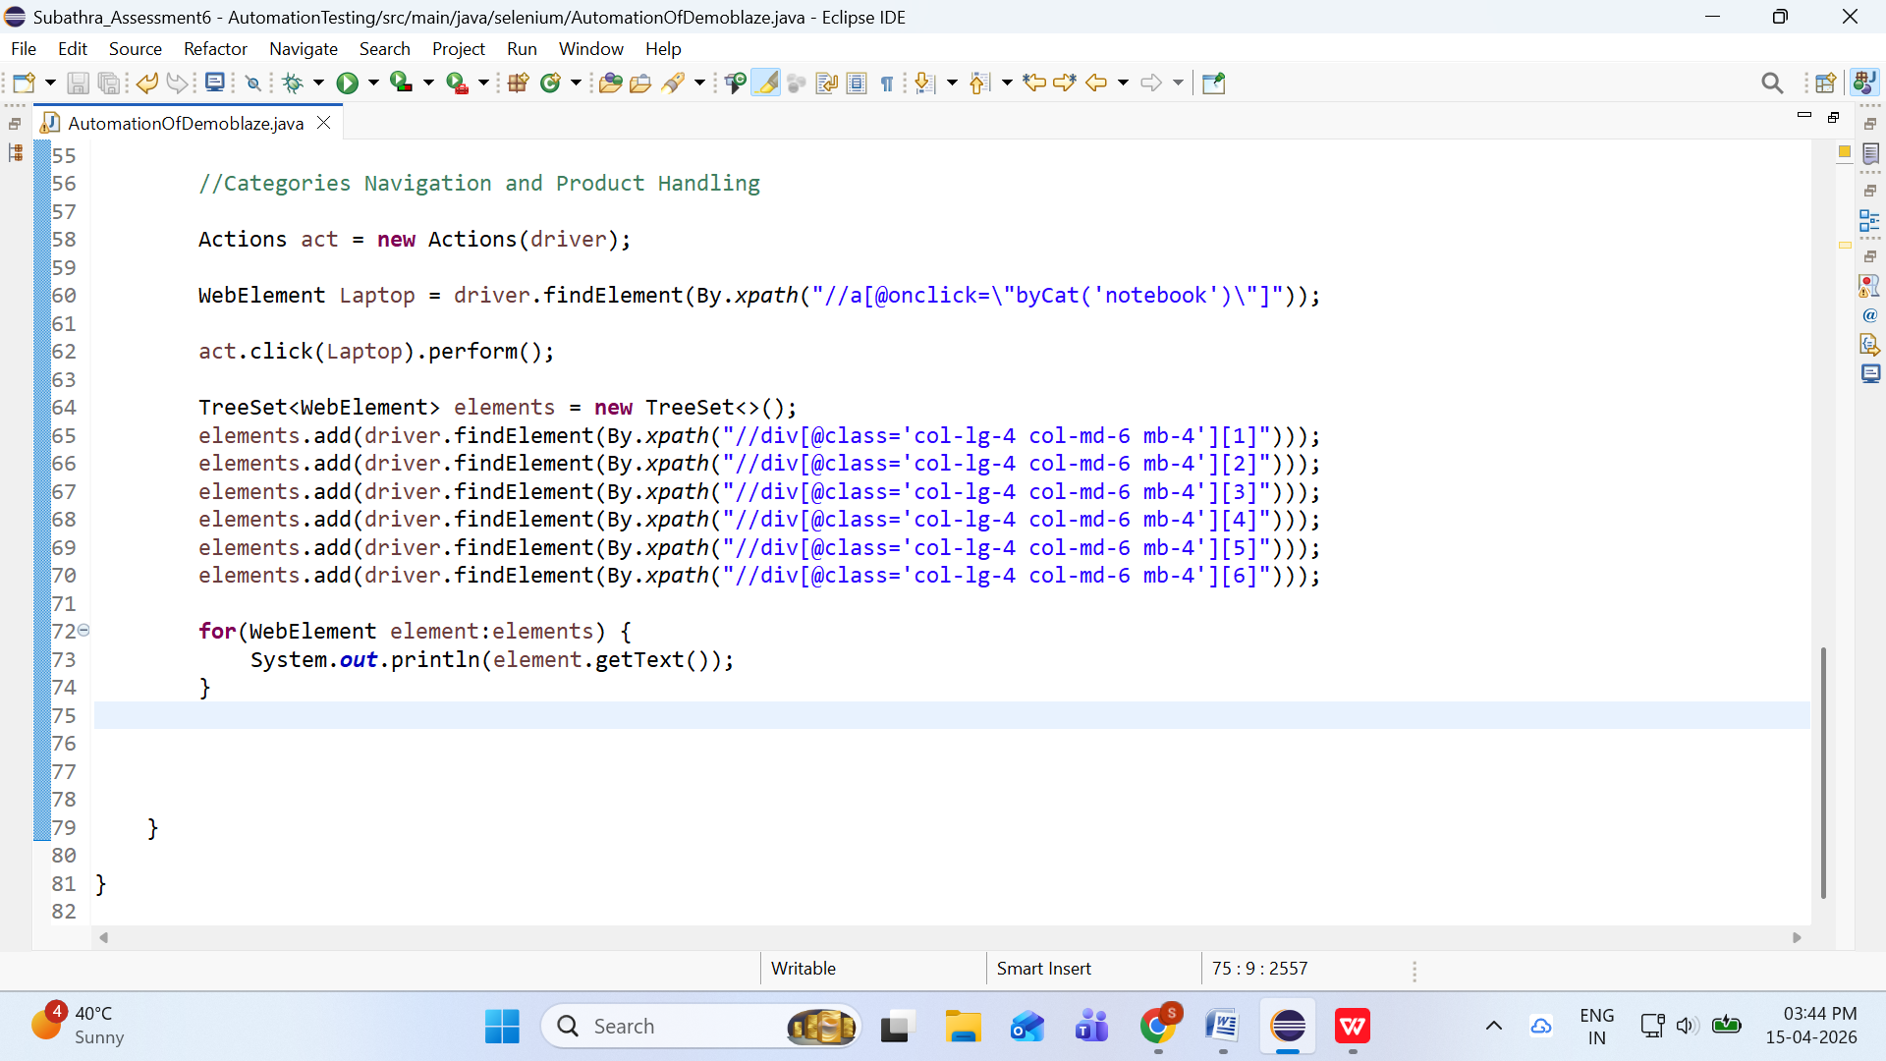

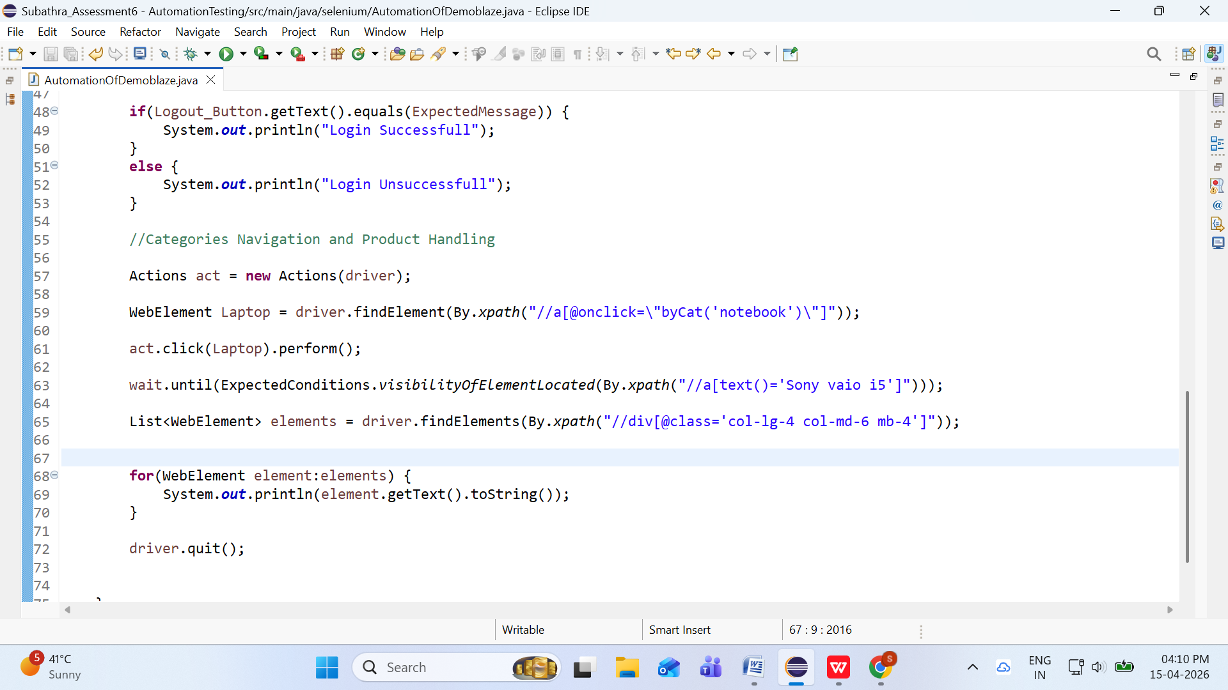

Login Successfull
Samsung galaxy s6
$360
The Samsung Galaxy S6 is powered by 1.5GHz octa-core Samsung Exynos 7420 processor and it comes with 3GB of RAM. The phone packs 32GB of internal storage cannot be expanded.
Nokia lumia 1520
$820
The Nokia Lumia 1520 is powered by 2.2GHz quad-core Qualcomm Snapdragon 800 processor and it comes with 2GB of RAM.
Nexus 6
$650
The Motorola Google Nexus 6 is powered by 2.7GHz quad-core Qualcomm Snapdragon 805 processor and it comes with 3GB of RAM.
Samsung galaxy s7
$800
The Samsung Galaxy S7 is powered by 1.6GHz octa-core it comes with 4GB of RAM. The phone packs 32GB of internal storage that can be expanded up to 200GB via a microSD card.
Iphone 6 32gb
$790
It comes with 1GB of RAM. The phone packs 16GB of internal storage cannot be expanded. As far as the cameras are concerned, the Apple iPhone 6 packs a 8-megapixel primary camera on the rear and a 1.2-megapixel front shooter for selfies.
Sony xperia z5
$320
Sony Xperia Z5 Dual smartphone was launched in September 2015. The phone comes with a 5.20-inch touchscreen display with a resolution of 1080 pixels by 1920 pixels at a PPI of 424 pixels per inch.
HTC One M9
$700
The HTC One M9 is powered by 1.5GHz octa-core Qualcomm Snapdragon 810 processor and it comes with 3GB of RAM. The phone packs 32GB of internal storage that can be expanded up to 128GB via a microSD card.
Sony vaio i5
$790
Sony is so confident that the VAIO S is a superior ultraportable laptop that the company proudly compares the notebook to Apple's 13-inch MacBook Pro. And in a lot of ways this notebook is better, thanks to a lighter weight.
Sony vaio i7
$790
REVIEW Sony is so confident that the VAIO S is a superior ultraportable laptop that the company proudly compares the notebook to Apple's 13-inch MacBook Pro. And in a lot of ways this notebook is better, thanks to a lighter weight, higher-resolution display, more storage space, and a Blu-ray drive.

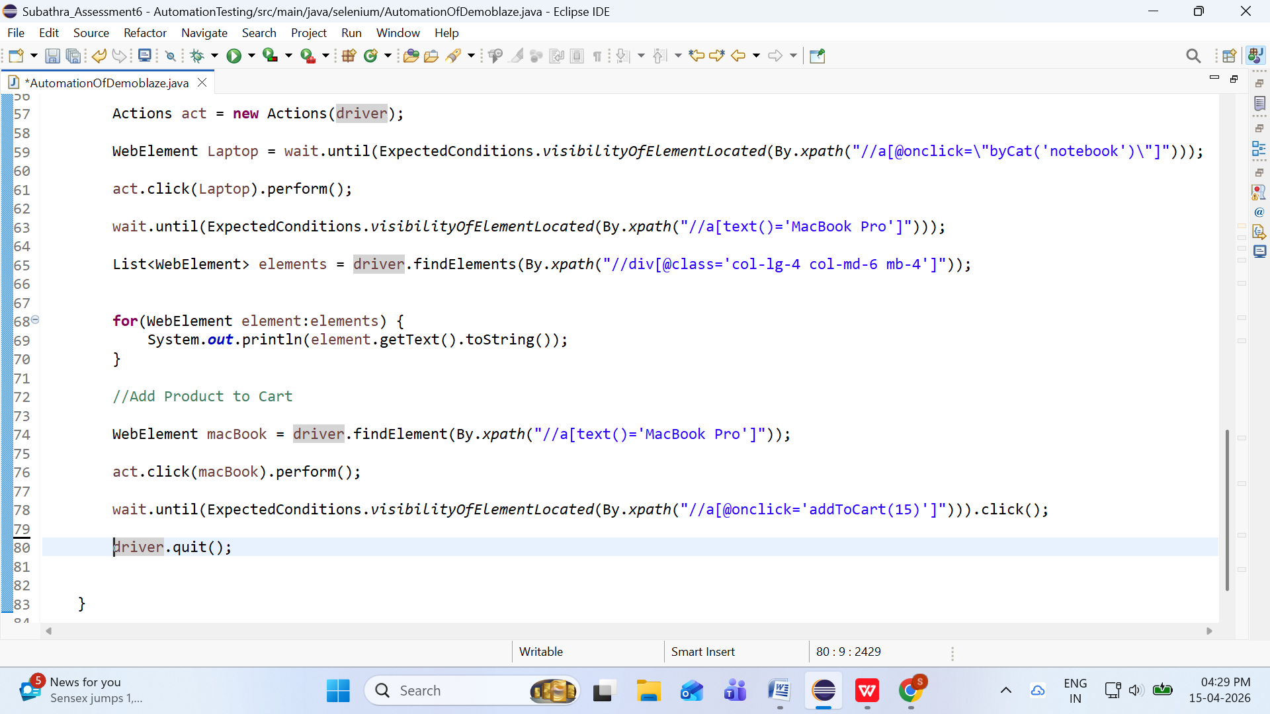

Login Successfull
Sony vaio i5
$790
Sony is so confident that the VAIO S is a superior ultraportable laptop that the company proudly compares the notebook to Apple's 13-inch MacBook Pro. And in a lot of ways this notebook is better, thanks to a lighter weight.
Sony vaio i7
$790
REVIEW Sony is so confident that the VAIO S is a superior ultraportable laptop that the company proudly compares the notebook to Apple's 13-inch MacBook Pro. And in a lot of ways this notebook is better, thanks to a lighter weight, higher-resolution display, more storage space, and a Blu-ray drive.
MacBook air
$700
1.6GHz dual-core Intel Core i5 (Turbo Boost up to 2.7GHz) with 3MB shared L3 cache Configurable to 2.2GHz dual-core Intel Core i7 (Turbo Boost up to 3.2GHz) with 4MB shared L3 cache.
Dell i7 8gb
$700
6th Generation Intel Core i7-6500U Dual-Core Processor 2.5 GHz (max boost speed up to 3.1GHz) 4MB L3 Cache, 8GB DDR4 1600 MHz, 1TB 5400 RPM HDD15.6 in Full HD LED-backlit touchscreen with Truelife (1920 x 1080), 10-finger multi-touch support, Intel HD Graphics 520 with shared graphics memory
2017 Dell 15.6 Inch
$700
7th Gen Intel Core i7-7500U mobile processor 2.70 GHz with Turbo Boost Technology up to 3.50 GHz, Intel HD Graphics 62015.6 inch Full HD IPS TrueLife LED-backlit touchscreen (1920 x 1080), 10-finger multi-touch support, 360° flip-and-fold design,8GB DDR4 2400 MHz Memory, 1TB 5400 RPM HDD, No optical drive, 3 in 1 card reader (SD SDHC SDXC)
MacBook Pro
$1100
Apple has introduced three new versions of its MacBook Pro line, including a 13-inch and 15-inch model with the Touch Bar, a thin, multi-touch strip display that sits above the MacBook Pro's keyboard.

