Naan Mudhalvan Phase 3 Assessment

Course Name : Internet Of Things

Project Title : Smart Water Fountain

Team Name : Nanotrons

Team Members :

|  |  |  |
| --- | --- | --- |
| Name | Register number | Nan Mudhalvan ID |
| Vignesh V S | 721221106117 | au721221106117 |
| Nethaji Naveen Prasath S | 721221106062 | au721221106062 |
| Nithishkumar A | 721221106064 | au721221106064 |
| Suvathy K | 721221106109 | au721221106109 |
| Subathra M | 721221106106 | au721221106106 |

Simulator used :  **WOKWI Simulator .**

Components used :

|  |  |  |
| --- | --- | --- |
| Component Name | Specifications | Quantity |
| Raspberry | Pi Pico | 1 |
| Relay Module | - | 1 |
| LCD Display | 60*2 | 1 |
| Water pump | - | 1 |
| Node MCU | ESP32 | 1 |
| Ultrasonic sensor | 16 x 2 | 1 |

Libraries Used :

1. 1 . RPi. GPIO Library ( Rasperry pi )
2. Adafruit _SSD1306
3. Wire Library
4. Microwire
5. Machine Control

**Circuit Diagram :**

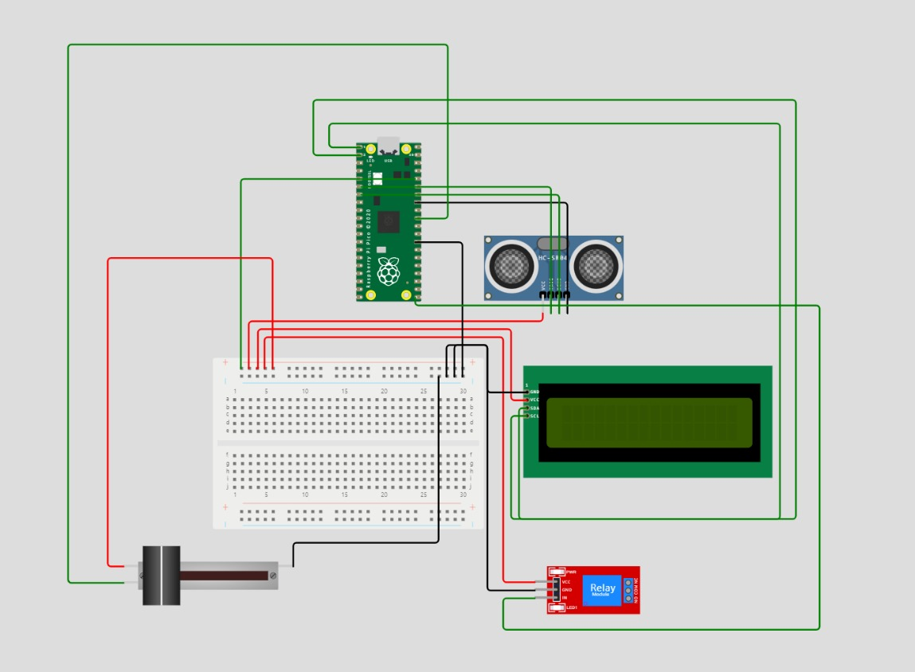

**APP Interface**

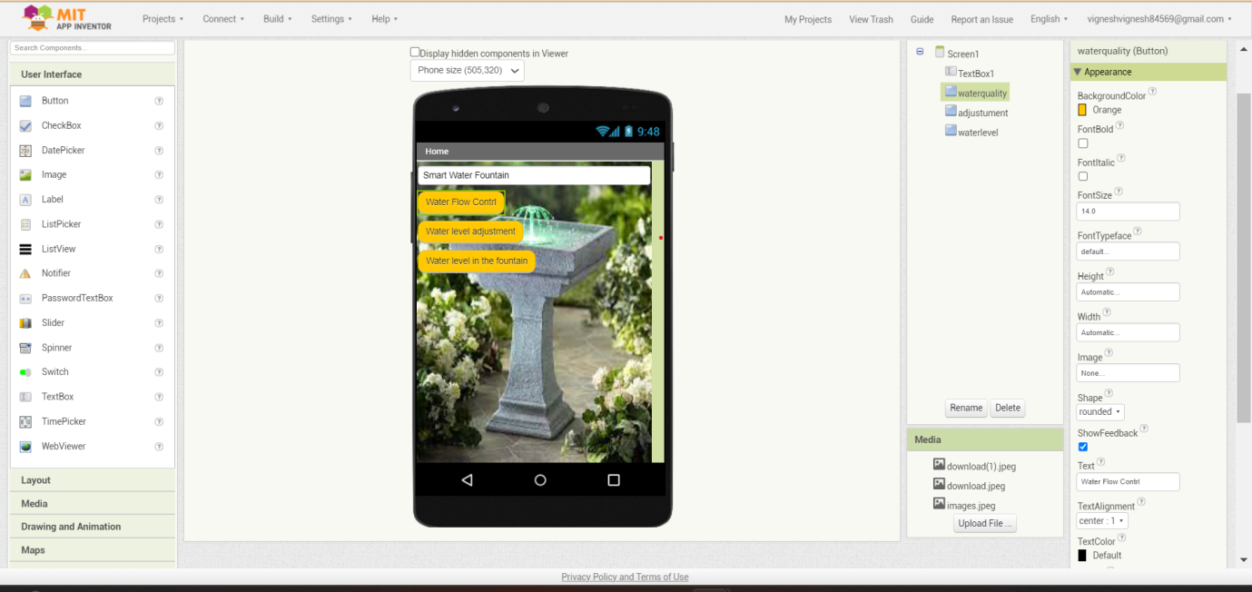

**Block code**

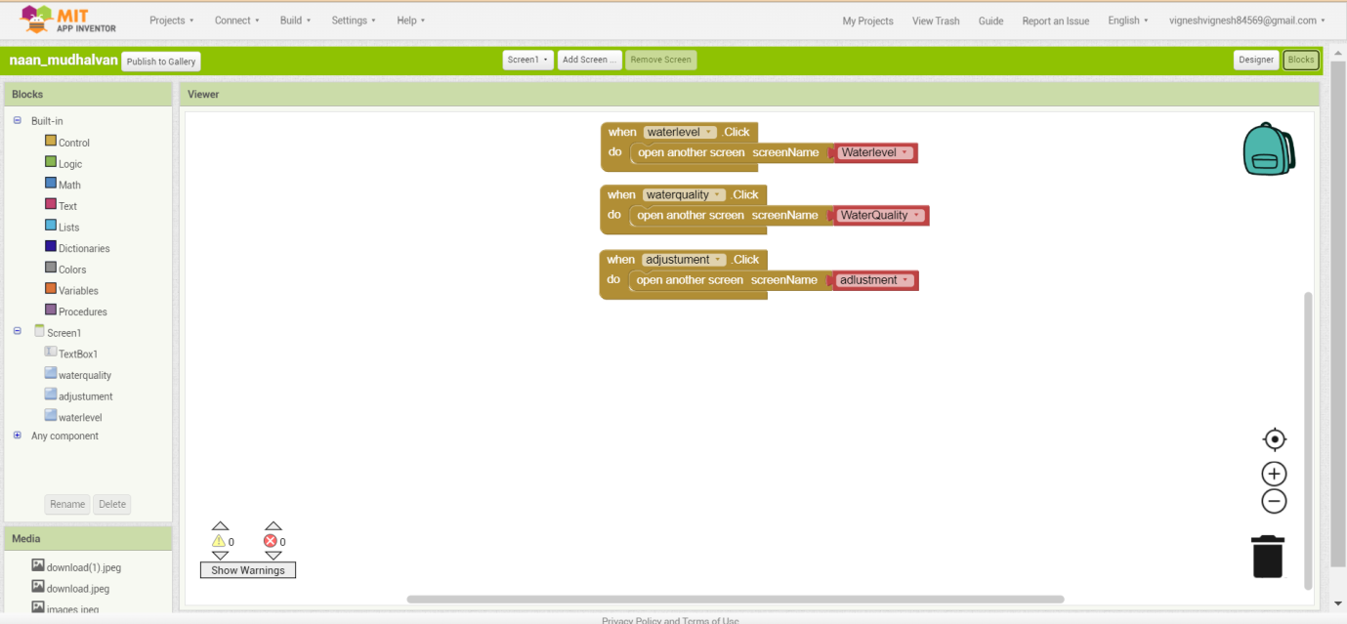

**Source Code :**

import machine

import ssd1306

from machine import Pin, I2C, ADC

import time

//# Initialize the I2C display

i2c = I2C(0, sda=Pin(0), scl=Pin(1), freq=400000)

oled = ssd1306.SSD1306_I2C(128, 32, i2c)

//# Ultrasonic Sensor Setup

trigger = Pin(2, Pin.OUT)

echo = Pin(3, Pin.IN)

//# Potentiometer Setup

potentiometer = ADC(Pin(26))

def read_distance():

trigger.value(0)

time.sleep_us(2)

trigger.value(1)

time.sleep_us(10)

trigger.value(0)

while echo.value() == 0:

pulse_start = time.ticks_us()

while echo.value() == 1:\

pulse_end = time.ticks_us()

pulse_duration = pulse_end - pulse_start

distance = (pulse_duration * 0.0343) / 2

return distance

def read_potentiometer():

return potentiometer.read_u16() // 256 # Scale the value to match your needs

while True:

distance = read_distance()

pot_value = read_potentiometer()

oled.fill(0)

oled.text("Distance: {} cm".format(distance), 0, 0)

oled.text("Potentiometer: {}".format(pot_value), 0, 12)

oled.show()

time.sleep(1) //# Update the display every second

**JASON Code**

{

"version": 1,

"author": "Nanotrons",

"editor": "wokwi",

"parts": [

{ "type": "wokwi-breadboard-half", "id": "bb1", "top": 45, "left": -35.6, "attrs": {} },

{

"type": "wokwi-slide-potentiometer",

"id": "pot1",

"top": 254.6,

"left": -145,

"attrs": { "travelLength": "30" }

},

{ "type": "wokwi-pi-pico", "id": "pico", "top": -223.95, "left": 138, "attrs": {} },

{ "type": "wokwi-relay-module", "id": "relay1", "top": 297.8, "left": 355.2, "attrs": {} },

{ "type": "wokwi-hc-sr04", "id": "ultrasonic1", "top": -104.1, "left": 293.5, "attrs": {} },

{

"type": "wokwi-lcd1602",

"id": "lcd1",

"top": 54.4,

"left": 341.6,

"attrs": { "pins": "i2c" }

}

],

"connections": [

[ "ultrasonic1:GND", "pico:GND.7", "black", [ "v0" ] ],

[ "ultrasonic1:TRIG", "pico:GP4", "green", [ "v0" ] ],

[ "ultrasonic1:ECHO", "pico:GP5", "green", [ "v0" ] ],

[ "pico:3V3", "bb1:tp.1", "green", [ "h0" ] ],

[ "ultrasonic1:VCC", "bb1:tp.2", "red", [ "v9.6", "h-355.2" ] ],

[ "lcd1:VCC", "bb1:tp.3", "red", [ "h-19.2", "v-86.3", "h-307.2", "v0" ] ],

[ "relay1:VCC", "bb1:tp.4", "red", [ "h-38.4", "v-297.6", "h-288" ] ],

[ "pot1:VCC", "bb1:tp.5", "red", [ "h-19.2", "v-374.4", "h240" ] ],

[ "pico:GND.6", "bb1:tn.25", "black", [ "h49.2" ] ],

[

"lcd1:SDA",

"pico:GP0",

"green",

[ "h-9.6", "v134.6", "h316.8", "v-480", "h-547.2", "v28.8" ]

],

[ "lcd1:GND", "bb1:tn.24", "black", [ "h-48", "v-57.6", "h-38.4" ] ],

[

"lcd1:SCL",

"pico:GP1",

"green",

[ "h-19.2", "v125.1", "h345.6", "v-508.8", "h-585.6", "v67.2", "h-9.6" ]

],

[ "relay1:GND", "bb1:tn.23", "black", [ "h-57.6", "v-298", "h-57.6" ] ],

[

"relay1:IN",

"pico:GP16",

"green",

[ "h-38.4", "v-0.2", "h0", "v38.4", "h384", "v-393.6", "h-9.6" ]

],

[ "pot1:GND", "bb1:tn.22", "black", [ "v-28.8", "h168.4" ] ],

[ "pot1:SIG", "pico:GP26", "green", [ "h-67.2", "v-653.6", "h460.8", "v211.2" ] ]

],

"dependencies": {}

}