Cu-Based DeePMD Model Reconstruction

Abstract

This study presents the construction of a machine learning interatomic potential model for copper (Cu) systems based on Ab Initio Molecular Dynamics (AIMD) and the DeePMD-kit framework. Using Quantum ESPRESSO, we performed SCF and NVT AIMD simulations of the Cu system at 800 K, generating a total of 500 frames containing energy and atomic force information. These were converted into standard .traj trajectory files using ASE. The trajectory data were then processed with the dpdata tool into the .raw format required by DeePMD, and further divided into a training set of 400 frames and a validation set of 100 frames, while also being converted into .npy format for training purposes. The model employed the se_e2_a descriptor and a multilayer neural network architecture [25, 50, 100], with initial loss weights for energy and forces set to 0.02 and 1000, respectively. The training loss began to converge after 2000 steps, with the energy prediction error stabilizing at approximately 0.01 eV on the training set and 0.1 eV on the validation set. The force prediction error was within ±0.2 eV/Å, satisfying the accuracy requirements for metallic systems. Further analysis via error histograms and fitting curves showed that energy predictions aligned linearly with DFT reference values, with most errors concentrated within ±0.05 eV, indicating strong accuracy and consistency. After model freezing and compression, the potential demonstrated good deployability and computational efficiency. Despite some fluctuations in force predictions, the main reasons were identified as insufficient sampling of high-stress frames and the intrinsic sensitivity of force gradients. Future improvements may include optimizing thermostat schemes, expanding coverage of non-equilibrium configurations, and increasing the weight of high-force samples, thereby enhancing the model’s generalization capability under complex atomic environments. This work provides a complete workflow and quantitative benchmarks for constructing DeePMD potentials in metallic systems.

- Preparation of Cu AIMD Data

- AIMD：
In this section, following the tutorial, we focus on generating Cu-related AIMD data to serve as the training dataset for the DeePMD model. But what exactly is AIMD data? AIMD (Ab Initio Molecular Dynamics) refers to a simulation method where each frame’s energy and atomic forces are computed using Density Functional Theory (DFT), such as via Quantum ESPRESSO. These computed properties are then used to update the atomic positions, and all frame-wise "features" are subsequently used as training input for the model. The calculation of energy and forces for a single frame is known as an SCF calculation—SCF (Self-Consistent Field) refers to the process of solving for the total energy, charge density, and wavefunctions of a system with fixed atomic positions, or essentially at a specific "time step." Each SCF step forms the core of AIMD, since every forward step in the AIMD trajectory requires a new SCF calculation. Thus, the AIMD dataset ultimately generated for a system serves as the training label set for DeePMD.

When running AIMD, the typical workflow involves loading an initial atomic configuration (in POSCAR or CIF format), followed by the following loop:
02
01
03
04

Perform an SCF calculation to obtain data such as energy (E) and forces (F)

Fix the current atomic positions
Update atomic positions based on the calculated forces (F)
Apply the Verlet integration method
Recalculate forces (F), energy (E), and related data based on the updated positions
Figure1：Main loop in AIMD; utilizing different types of Quantum ESPRESSO modules such as cp.x or pw.x

Based on the above content, we can give a simple example. When performing the AIMD loop, certain parameters need to be specified, such as the number of steps and the time step. For input settings, a time step of dt = 1.0 × 10⁻³ and a total simulation step count of nstep = 500 are defined. As for the output, the file xx.aimd.out contains data for each frame of the system, including energy (E), forces (F), temperature (T), and kinetic energy (K), amounting to, for example, 500 frames in total; in this study, the corresponding file is named Cu.aimd.out. Another important file is the .traj trajectory file, which is generated by parsing xx.aimd.out using ASE or similar tools. Although this file is not produced automatically during the simulation, it plays a crucial role in preparing the training labels for DeePMD and must be generated as part of the workflow.

- Cu AIMD Data Generation Process：
In the tutorial example using CH₄, the AIMD data for CH₄ is readily available and can be directly processed and used for model training. However, for our case, no complete AIMD/DFT dataset for Cu is currently available on major materials databases. Therefore, we need to generate the Cu AIMD dataset ourselves by starting from more basic Cu data and using tools like Quantum ESPRESSO (QE) to carry out the required simulations. Our initial approach involved downloading raw Cu-related files from the Materials Project, including .cif, POSCAR, INCAR, KPOINTS, etc. Among these, only the .cif file is generally compatible and can be converted into a QE-readable format using simple scripts. The remaining files are in VASP format, so we had to write our own Cu.scf.in and Cu.aimd.in input scripts by referencing information contained in the VASP files—e.g., POSCAR provides CELL_PARAMETERS and ATOMIC_POSITIONS, KPOINTS provides K_POINTS automatic, and INCAR offers precision settings, electronic temperature, and exchange-correlation functionals. The required pseudopotential file Cu.pbe-spn-kjpaw_psl.1.0.0.UPF was obtained from the QE official repository. Once all the raw Cu data were converted into QE-compatible files, we proceeded with SCF and NVT AIMD simulations using QE (with relevant parameters manually defined, which will be elaborated later).

After the simulation was completed, we generated the output file and used it to extract and create .traj trajectory files or atomic simulation data, which were then saved in .raw format. The dpdata tool was then used to process the .raw files, dividing them into training and validation sets at an 8:2 ratio. During this process, the .raw files were also converted into .npy format and stored in separate folders for training and validation. At this point, both the AIMD data for Cu and the DeePMD training datasets had been preliminarily prepared, making the model ready for training.

Before proceeding with training, however, we detailed the full process carried out in JupyterLab for Cu AIMD data generation, data splitting, and format conversion (including key code implementations). At the start of the Cu project, we organized our workspace in Jupyter following the directory structure shown in Figure 2,
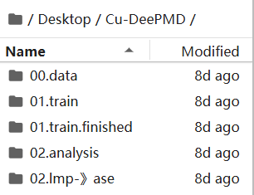
Figure2：Cu-DeePMD Project Directory Structure
All subsequent path references in this document are based on this directory structure. In the initial 00.data folder, we mainly stored the raw Cu-related data (as explained in the previous section), including the input and output files for Cu. After downloading the raw data, we made simple format adjustments to Cu.cif (which can be done using just a few lines of ASE code). The input files Cu.aimd.in and Cu.scf.in were written manually based on information extracted from VASP-format files such as POSCAR, INCAR, and KPOINTS. Specifically, POSCAR provides CELL_PARAMETERS and ATOMIC_POSITIONS, KPOINTS provides K_POINTS automatic, and INCAR contains settings related to precision, electronic temperature, and exchange-correlation functionals—i.e., the content under the &SYSTEM section. The required pseudopotential file Cu.pbe-spn-kjpaw_psl.1.0.0.UPF was downloaded directly from the official QE library. All of these files were placed in the directory Desktop/Cu-DeePMD/00.data/Cu_raw/Cu_inputs_bak as the prepared dataset to be used for QE calculations.

After preparing the necessary files—Cu.cif, Cu.pbe-spn-kjpaw_psl.1.0.0.UPF, Cu.scf.in, and Cu.aimd.in—we entered the corresponding directory in the terminal and first executed the command pw.x < Cu.scf.in > Cu.scf.out. The reason for running the SCF input file first is that SCF calculations are performed on a single static structure, while AIMD involves multiple sequential SCF steps. Therefore, SCF can be seen as a preparatory stage for AIMD, providing an initial electronically stable structure, which helps to avoid restarting self-consistent convergence from scratch at every MD step, speeds up the convergence process, and prevents AIMD crashes or divergence. It also allows us to verify energy consistency and trajectory stability—that is, to check whether the SCF input settings are correct. Once the SCF step is completed, we can proceed with the AIMD calculation using a similar terminal command on the .aimd.in file. It's important to note that the .aimd.in file differs from .scf.in in several key ways. For instance, it must include MD control parameters such as ion_temperature = "rescaling" to apply an NVT thermostat. In AIMD, temperature control must be explicitly defined; otherwise, the system will not reach thermal equilibrium. The tempw = 800 parameter sets the target temperature to 800 K, indicating that we aim to study the structural evolution of Cu at this temperature. Consequently, the DeePMD model will learn the potential energy surface of Cu under 800 K conditions. The parameter dt = 20.0 defines the time step, which generally ranges from 1.0 to 50.0 fs. Since DeePMD requires a sufficient number of frames for effective learning and training, the values of dt and nstep directly determine the quantity of data available for model construction.

After obtaining the Cu.scf.out and Cu.aimd.out files, we edited the notebook generate_mdtrj_from_qe.ipynb, in which we primarily used ASE’s read_espresso_out() function to read the AIMD structural information from Cu.aimd.out and then saved it as a .traj file. The purpose of this step was to standardize and format the AIMD trajectory, saving it in an ASE-compatible .traj format to enable consistent access to and processing of all frames. This format facilitates the extraction of structure, energy, and force information and prepares the data for the DeePMD training dataset in .raw format. Using the dpdata tool, we converted the .traj file into a DeePMD-compatible training set directory such as set.000. In AIMD, the .traj file represents the structural evolution of the system, with each frame recording atomic species, atomic positions, unit cell parameters, and corresponding energy and force values. In DeePMD, .traj files serve as one of the standard inputs for building training datasets. By loading the .traj into a dpdata.LabeledSystem, we were able to export .raw files such as coord.raw (atomic coordinates), energy.raw (total energy), force.raw (atomic forces), and virial.raw (stress tensor). These .raw files constitute the full set of input data required for training the Deep Potential model and were saved under the path Desktop/Cu-DeePMD/00.data/Cu_raw/Cu_dataset/set.000.

After generating the corresponding .raw files, we had to perform some data cleaning and formatting—for instance, ensuring consistency in file structure, frame count, and property types across all .raw files. Due to the hand-edited nature of the initial dataset, the extracted data could not be directly used for dataset splitting and .npy conversion via dpdata. Therefore, before splitting the data, we wrote validation code in the notebook check_valid_frames.ipynb under the path Desktop/Cu-DeePMD/00.data/Cu_raw/Cu_dataset/set.000 to check whether all .raw files contained the correct number of frames. After confirming that all files contained exactly 500 frames, we proceeded to perform a series of dataset extraction and correction tasks in extract_dataset.ipynb. This ultimately allowed us to successfully extract and correct 500 valid frames of data and repair all malformed .raw files. Finally, in the notebook prepare_dataset.ipynb, located in Desktop/Cu-DeePMD/00.data/, we performed dataset splitting—dividing the data into 400 training frames and 100 validation frames—and completed the conversion of .raw data into .npy format for both subsets (see extract_dataset.ipynb in the GitHub repository for detailed implementation).

In summary, this concludes the full process of Cu-AIMD data generation and establishes a solid foundation for subsequent DeePMD model training.

- Cu-DeePMD Model Training

- Writing the input_json Script
We first wrote a .json file, which essentially serves as a "training manual" for DeePMD, instructing the model on how to perform training—what procedures to follow, what functions to use, and under what conditions to operate. This script was written directly within a .ipynb Jupyter Notebook, rather than renaming a .txt file to .json, which can cause format recognition issues due to the underlying file type still being text. In the parameter section of the script, we primarily edited the content shown in the figure below (from left to right),
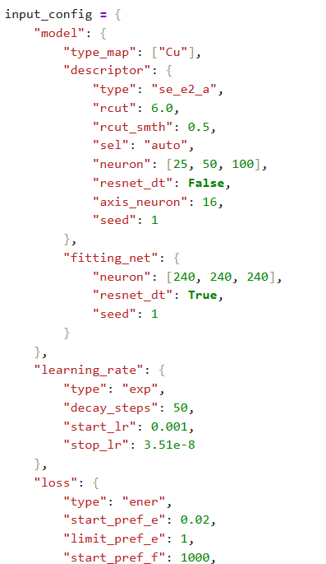
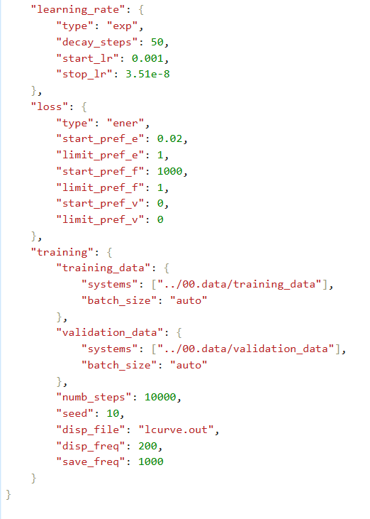

Figure3：input_json

There are strict rules regarding the placement of these parameters—for example, parameters under the model section cannot be mistakenly placed under fitting, as doing so would cause errors in the DeePMD training process. Since this was our first time performing such a simulation, we made multiple adjustments during the testing phase and ultimately compiled a .json file that could be correctly recognized and used by DeePMD, as seen in the file located at Desktop/Cu-DeePMD/01.train/input_json.ipynb in our GitHub directory. Regarding the selection of parameters and their values, we aimed to accurately fit the energy and force distribution of Cu atoms in AIMD, so we chose the se_e2_a descriptor, which is well-suited for modeling the local structure of metallic systems. The cutoff radius rcut was set to 6.0 Å to include a sufficient number of neighboring atoms, and rcut_smth was set to 0.5 Å to ensure smooth boundary behavior and prevent discontinuities in the potential energy. The neuron structure [25, 50, 100] allows progressive abstraction of atomic environments, while the fitting_net architecture [240, 240, 240] enhances the model’s capacity for nonlinear regression of energy and forces. An exponential decay learning rate schedule (type: exp) was used, with the learning rate decreasing from start_lr = 0.001 to stop_lr = 3.51e-8, controlled by decay_steps = 50 to ensure stable yet efficient convergence. In the loss function configuration, we emphasized force accuracy (type: force) by assigning it a high initial weight (start_pref_f = 1000), consistent with DeePMD’s training strategy of focusing on accurate force learning in the early stage, followed by gradually balancing energy and force contributions (e.g., start_pref_e = 0.02). Training and validation datasets were pointed to their respective paths, and batch_size was set to auto to allow for adaptive memory management. The training step count was set to 10,000, a reasonable balance for a relatively small Cu system. Additionally, loss values were output every 200 steps (disp_freq = 200), and models were saved every 1000 steps (save_freq = 1000) to facilitate monitoring and checkpoint recovery. Overall, the design of this input.json file comprehensively considered the physical characteristics of the Cu system (e.g., metallic bonding neighborhood), the expressive power of the neural network, training stability, and computational efficiency—ensuring that DeePMD can effectively learn the potential energy surface from AIMD trajectories and support subsequent molecular dynamics simulations. The finalized file was saved under the path Desktop/Cu-DeePMD/01.train/input.json.。

- Formal Model Training with dp train and Loss Function Visualization
After running the command dp train input.json in the terminal under the 01.train directory, a series of output and intermediate files were generated, including the model.ckpt checkpoint files, out.json, and lcurve.out. These files represent the results of the initial training stage of our DeePMD model. Since the lcurve.out file is a structured dataset, we followed the tutorial's approach for visualizing the training process to evaluate the model's initial performance. The visualization code can be found in the notebook located at Desktop/Cu-DeePMD/01.train/monitor_training.ipynb. The purpose of this code is to visualize key performance metrics during DeePMD training, helping us determine whether the model has converged and whether the energy and force fitting are proceeding effectively. The script first reads the lcurve.out file and extracts the training steps along with four root-mean-square error (RMSE) values: energy errors on the training and validation sets (rmse_e_trn, rmse_e_val) and force errors on the training and validation sets (rmse_f_trn, rmse_f_val). It then plots these four curves using a logarithmic scale to provide a clear view of training dynamics.

As shown in Figure 5, the energy error decreases significantly during the early stages of training. The training set energy RMSE eventually stabilizes around 0.01 eV, while the validation set energy RMSE remains around 0.1 eV. The small gap between the two indicates that the model exhibits strong fitting accuracy and good generalization. The force error converges around 0.1 eV/Å, with no obvious deviation between training and validation sets, although the force curves show slightly larger oscillations—suggesting that the model’s learning on forces is less stable. Overall, the model demonstrates excellent performance in energy prediction and reasonably good reliability in force prediction. The training process shows no signs of overfitting and provides a solid foundation for subsequent molecular dynamics simulations.
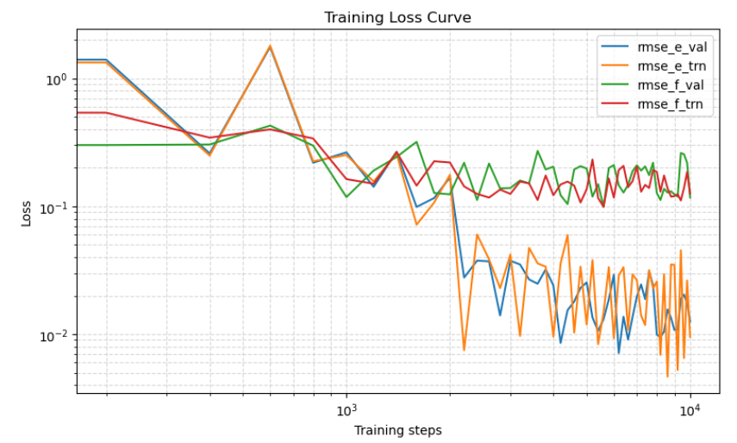

Figure5：Training Loss Curve

- Model Freezing and Compression
After confirming the usability of the trained model, we proceeded to freeze the model. This is necessary because the set of files and models generated after training in the terminal are still adjustable—similar to testing a recipe's seasoning ratio during cooking: once the optimal combination is found, it needs to be fixed for future reuse. This step is referred to as "freezing the model." Following the tutorial instructions, we performed the model freezing and saved the output to the path Desktop/Cu-DeePMD/01.train.finished/frozen_model.pb. According to the tutorial, the next step is model compression. The compression process involves optimizing the architecture and reducing the parameters of the trained neural network to generate a smaller, more efficient model file, compress.pb. This operation does not alter the model’s original learning accuracy or its physical fidelity but rather removes auxiliary data no longer needed during inference (e.g., gradients and optimizer states), and fuses certain static operations to enhance runtime efficiency. This leads to significantly faster performance in deployment scenarios, such as when the model is used in LAMMPS or ASE simulations. Compared to frozen_model.pb, the compressed model is designed specifically for deployment and is better suited for real-time molecular dynamics simulations, making it a critical step in translating the DeePMD model into practical applications.

However, it's important to note that compression may lead to a slight loss in model precision during simulations. In our current trial, since the simulated system is relatively simple and the dataset is not particularly large, we opted to compress the model for better usability. Nevertheless, for subsequent testing and evaluation of the model, we chose to continue using the uncompressed frozen model to ensure the highest possible simulation accuracy.

- MD Simulation and Model Visualization Analysis
在After completing the major stages of the DeePMD workflow, the final step is to evaluate the stability and predictive performance of the trained model in an actual MD simulation. This test directly determines the overall effectiveness of the model, and its results must be carefully analyzed—if the model performs well, we should identify where its strengths lie; if it performs poorly, we must trace which part of the workflow may have introduced issues. While the tutorial uses LAMMPS for MD simulation, due to compatibility issues with software formats on our local system, it was not possible to link LAMMPS with dpdata. As a result, we used ASE as the MD simulation “tool” in our workflow.

To assess the fitting performance of the constructed Deep Potential model on the training set, we developed an analysis script based on dpdata and matplotlib, focusing on three main parts: data loading, model prediction, and error visualization. First, the Cu training dataset—already converted into .npy format—was loaded using the dpdata.LabeledSystem interface. This dataset includes energy and atomic force values obtained from DFT calculations. Then, the trained frozen model (frozen_model.pb) was loaded using the .predict() method to perform energy and force predictions on the same structures. By constructing scatter plots and histograms of prediction errors, we were able to further analyze the model’s stability and accuracy in representing the training data.
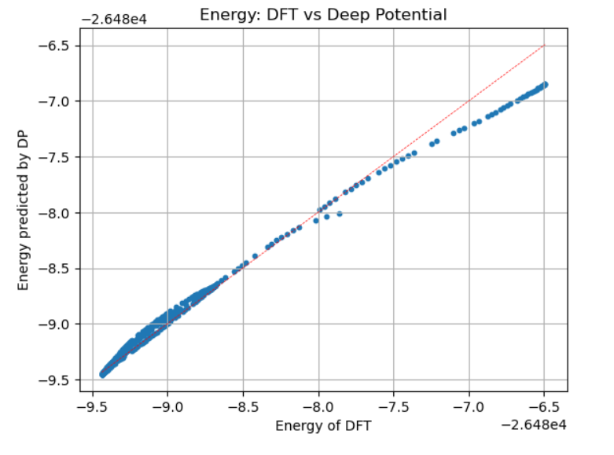
Figure5：energy DFT vs Deep Potential

Figure 5 shows the comparison between the energies predicted by the Deep Potential model and those calculated by DFT. Most data points are densely clustered around the ideal fitting line (red dashed line), forming an overall linear distribution, which indicates that the model has successfully captured the dominant structural features of the potential energy surface. Only a few slight deviations are observed in the high- and low-energy regions, which may be attributed to sparse sampling in those energy ranges or to more complex atomic configurations corresponding to those energy levels.
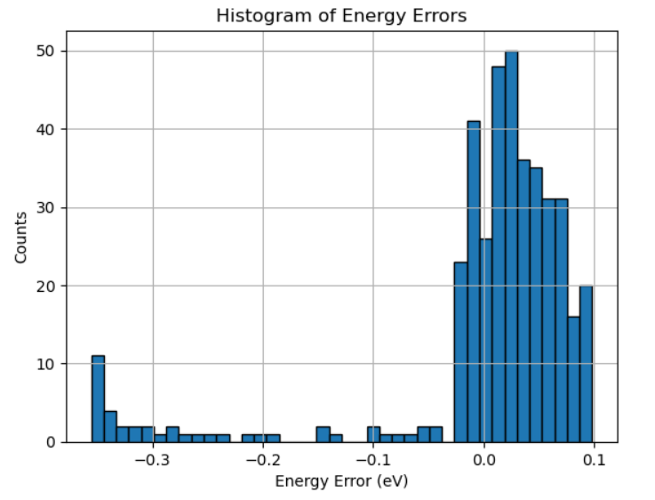
Figure6：Histogram of Energy Errors
Figure 6 presents the histogram of energy prediction errors, showing that most errors are concentrated within the range of -0.05 eV to 0.05 eV. The peak is close to zero and slightly right-skewed, indicating that the model achieves high accuracy in energy prediction with minimal systematic bias. Only a very small number of samples exhibit large errors exceeding ±0.3 eV, suggesting that such outliers should be considered in future data cleaning and resampling efforts. Figure 7 illustrates the distribution of force prediction errors, which follows a near-Gaussian shape centered around 0 eV/Å. This indicates that the model shows no significant bias in fitting interatomic forces, and most errors fall within ±0.2 eV/Å, demonstrating good force-learning capability and physical consistency.
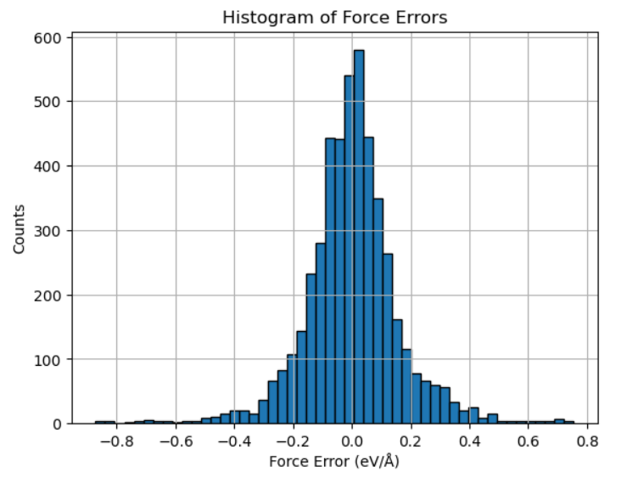
Figura7：Histogram of Force Errors

Overall, the predictions made by the Deep Potential model on the training set are highly consistent with the DFT data, and the energy regression errors are relatively small. This indicates that the model has effectively learned the potential energy surface of the system and possesses both usability and physical reliability for subsequent molecular dynamics simulations. However, the force prediction errors exhibit more fluctuation compared to energy, and although the overall distribution is reasonable, the model shows limited accuracy when fitting forces in complex configurations or under locally non-equilibrium conditions. This issue may stem from two main factors: on one hand, atomic forces are the gradients of energy with respect to atomic positions and are highly sensitive to small structural perturbations, making it more challenging for the model to capture directional variations and local stress responses; on the other hand, if the training set has an imbalanced distribution of configurations or an overrepresentation of low-force samples, the model may lack sufficient exposure to high-stress states during training. To improve the model's performance in force prediction, several approaches can be considered: increasing the loss weight of forces during training (e.g., by adjusting start_pref_f), enriching the dataset with more representative non-equilibrium and high-force configurations, applying an error-feedback-based resampling strategy to strengthen learning on high-error frames, and enhancing the model architecture with a deeper fitting_net or a more expressive descriptor type to better capture complex force fields. Additionally, modifying the ion_temperature setting in the .aimd.in file to use a nose-hoover thermostat may lead to more physically realistic temperature control. Through these optimizations, the model's generalization ability and physical robustness under extreme atomic configurations can be further improved.

- Conclusion
In summary, this study successfully constructed a DeePMD potential model for the copper (Cu) system, fully reproducing the entire workflow from DFT/AIMD data generation to model training, validation, and compressed deployment. The model demonstrated excellent fitting accuracy in energy prediction, with validation errors consistently below 0.1 eV. Although force predictions still exhibited some fluctuations, the overall error distribution remained physically acceptable. Through model freezing and compression, its deployability and computational efficiency were significantly improved, laying a solid foundation for subsequent molecular dynamics simulations. Nevertheless, there is still room for improvement in the accuracy of force predictions and the model's generalization to complex atomic configurations. Future efforts will focus on incorporating more diverse training samples, utilizing higher-dimensional feature representations, and applying multi-temperature sampling strategies to further enhance the model’s stability and applicability in real-world materials simulations. This work offers a practical pathway and methodological reference for developing machine learning interatomic potentials for metallic systems and provides a foundation for future high-throughput simulations and data-driven materials design.

