Monitoring Apache Airflow Using Prometheus & Grafana

Airflow monitoring diagram:

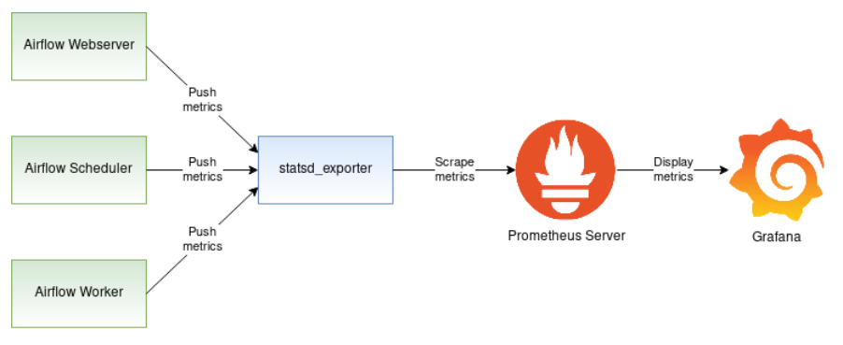

How it works:
- The diagram depicts three Airflow components: Webserver, Scheduler, and the Worker.
- The solid line starting at the Webserver, Scheduler, and Worker shows the metrics flowing from these three components to the statsd_exporter.
- The statsd_exporter aggregates the metrics, converts them to the Prometheus format and exposes them as a Prometheus endpoint.
- Prometheus endpoint is periodically scraped by the Prometheus server, which persists the metrics in its database.

How to setup:
- Configure Airflow to publish the statsd metrics.
- Convert the statsd metrics to Prometheus metrics using statsd_exporter.
- Deploy the Prometheus server to collect the metrics and make them available to Grafana.

Results:
- Airflow webserver UI: http://localhost:8080

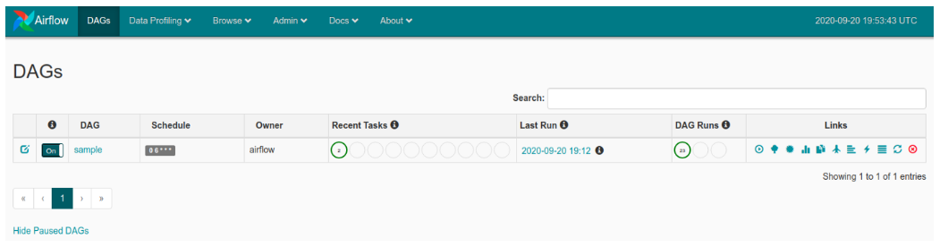

- StatsD metrics list: http://localhost:9123/metrics

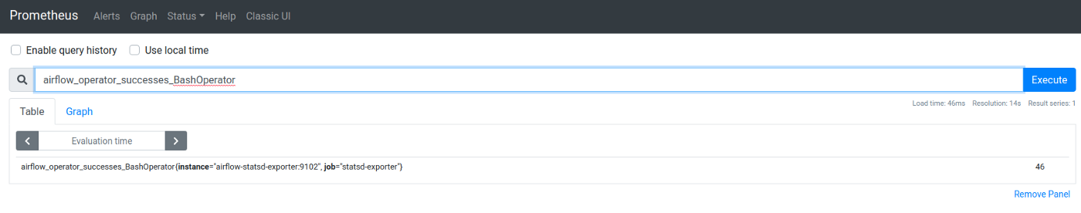
- Prometheus: http://localhost:9090


- Grafana: http://localhost:3000 (login: username=admin, password=password)

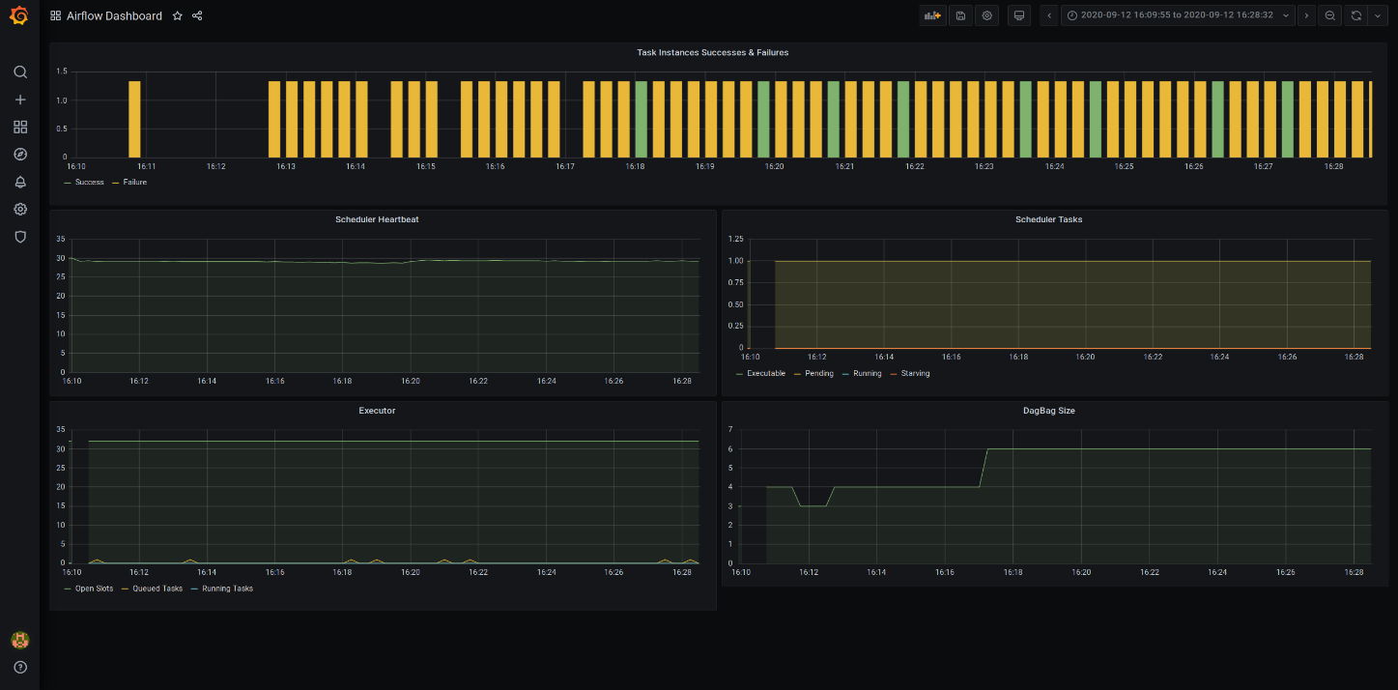

References:
- Monitoring Apache Airflow using Prometheus (redhat.com)
- Airflow in Docker Metrics Reporting | by Sarah Krasnik | Towards Data Science

Monitoring Apache Airflow Using InfluxDB & Grafana

Airflow monitoring diagram:

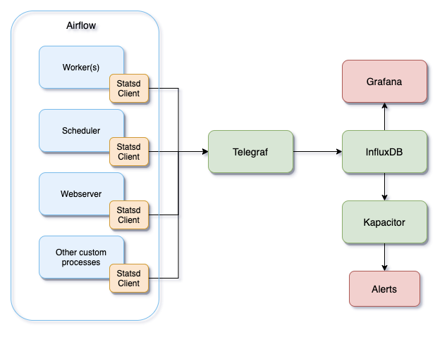

How it works:
- Multiple Airflow processes running in our different Kubernetes Pods, and each of them has a statsd client enabled using airflow.cfg.
- The statsd client will send all the metrics to Telegraf over UDP.
- We’ve configured InfluxDB as an output for Telegraf configuration (telegraf.conf) which will send the data over HTTP.
- Add InfluxDB as a data source in Grafana as well as in Kapacitor.
- The alerts can now be configured in Kapacitor using TICK scripts.

Monitoring Azure monitor in Grafana

- Azure monitor VMs should be connected to an Azure Log analytics Workspace, where all the metric data is being captured under Perf Table.
- Grafana Uses Azure Monitor as a data source to fetch data in real time from Azure services like Azure Monitor, Azure log analytics, Application Insights. For this we need to create a Service Principal and assign below permissions to the SPN:
  - Reader permission at subscription level (if multiple Subscriptions are present, then Reader permission for multiple subscriptions needed). This is needed to read all the resources present in the subscription via Azure Monitor.
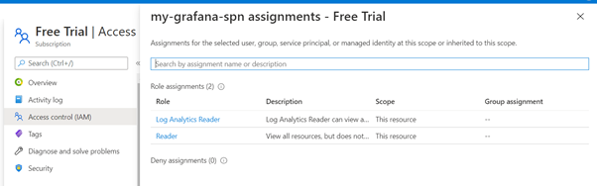
  - Log analytics Reader Permission for the subscription to read data from Azure log analytics.
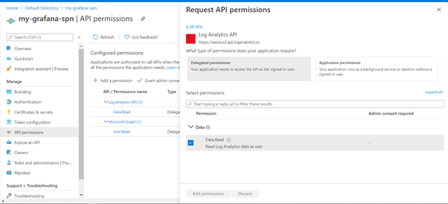

- Once the SPN with required permissions is created, configure the Azure Monitor Data Source
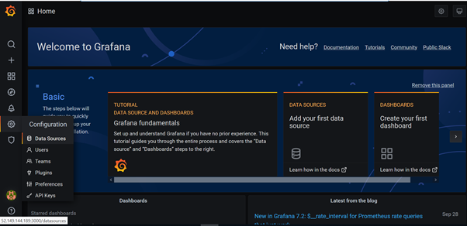
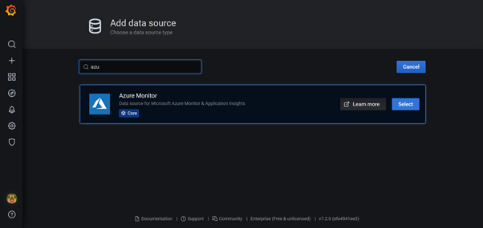

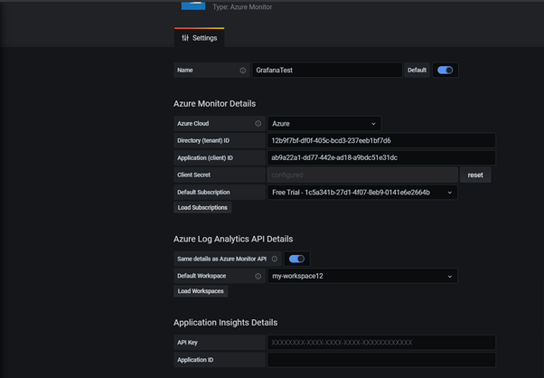

- Create variables ResourceGroup to list down all the RGs in the subscription
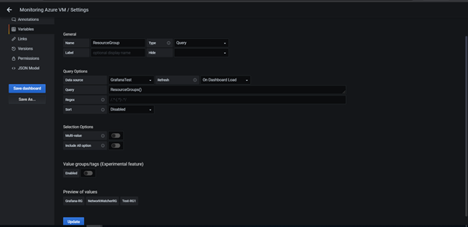

- Create variable VM to list down the VMs in RG
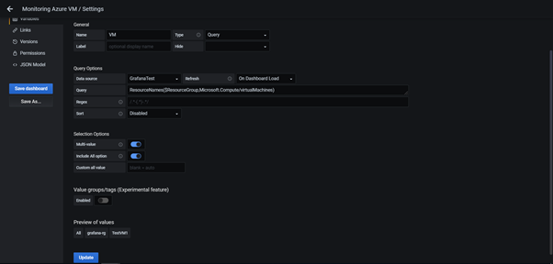

- Variable VM is used in the log analytics to display data for all the VMs in the selected RG

- Write query for different metrics to display data.
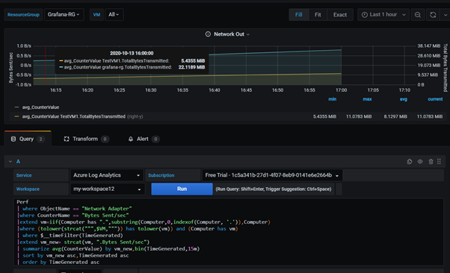

- Dashboard sharing: Grafana provides three ways of sharing by Link, Snapshot, Export
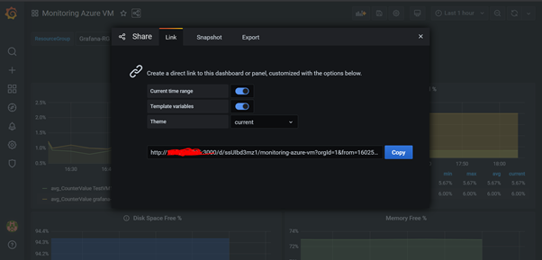
- Shared dashboard are in Json file, We can import dashboards as shown below.
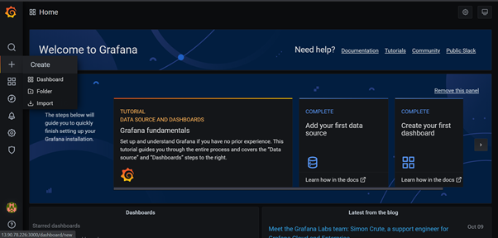

References:
- MONITORING AZURE VMs USING GRAFANA | by Shubham Jain | Globant | Medium
- Monitoring Azure by using Grafana dashboards - Azure DevOps Blog (microsoft.com)

Monitoring Kafka Using Prometheus and Grafana

Kafka monitoring diagram:
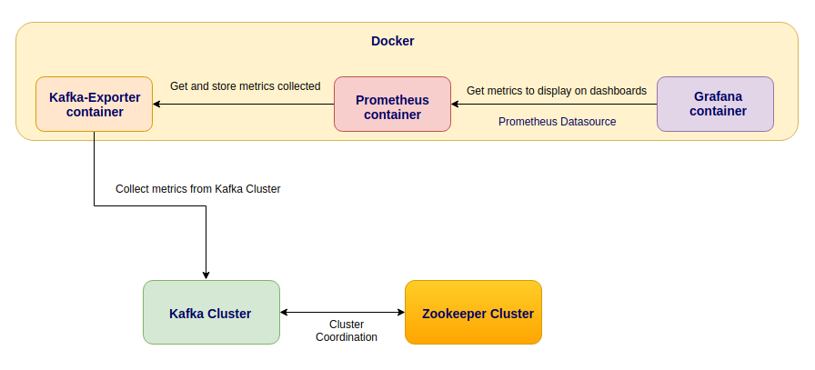

How it works:
- Kafka Exporter and JMX Exporter will collect some broker metrics from Kafka cluster.
- Prometheus will collect these metrics and store in it’s time series database.
- Grafana will connect on Prometheus to show some beautiful dashboards.

Steps:
- Install and configure all components like Kafka expoter, JMX expoter, Prometheus & Grafana.
- kafka_exporter that it collect kafka broker metrics. Prometheus will connect on this container through the port TCP 9308 to get metrics collected and store on it´s time series database.
- JMX exporter that runs on the kafka brokers as a javaagent. It runs on port TCP 7072 and Prometheus will connect on this port to get metrics and store on it´s time series database.
- Restart all kafka services
- After that we need to connect on Grafana on port 3000, configure the prometheus as a Data source and import the dashboard.

Results:

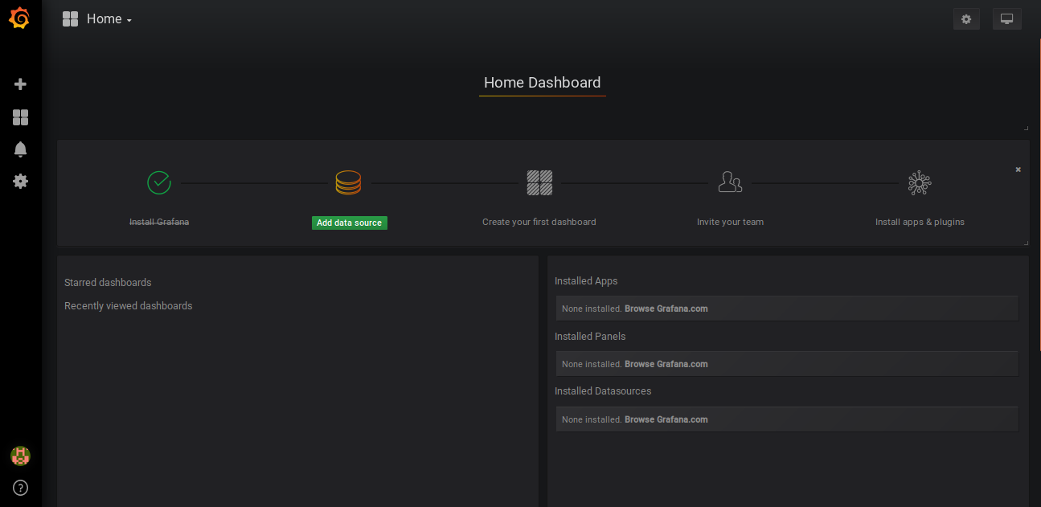

- Visualize Metrics are as below
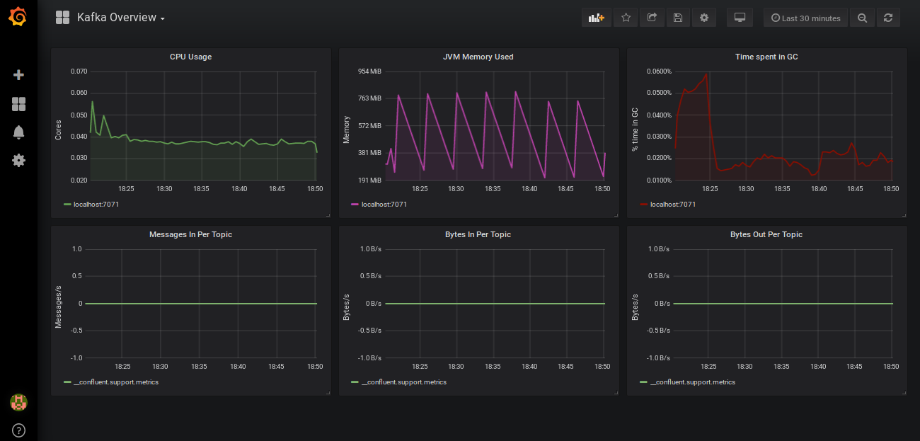

References:
- Monitoring Kafka. Monitoring Kafka with Kafka exporter +… | by Daniel Rosa | Medium
- Monitor Apache Kafka Using Grafana and Prometheus | by Seyed Morteza Mousavi | Medium

