Open Source DB Tools

InfluxDB
- InfluxDB is the time series platform for developer, Made for developers to build time-series-based applications quickly and at scale.
- InfluxDB provides a time series database designed to handle high write and query loads and offers highly scalable clusters on your infrastructure with a management UI.

Why use InfluxDB Open Source
InfluxDB contains everything that need in a time series platform in a single binary, Build on your laptop or run it on the edge.

Faster time to awesome
InfluxDB has everything that need from a time series platform in a single binary, A multi-tenanted time series database, UI and dashboarding tools, background processing and monitoring agent. All this makes deployment and setup a breeze and easier to secure.

Deep insights and analytics
Structure your queries and separate common logic into functions and libraries that are easily shared and help speed development. You can also enrich your time series data with other SQL data stores (Postgres, Microsoft SQL Server, SQLite, and SAP Hana) or with cloud-based data stores (Google Bigtable, Amazon Athena, and Snowflake).

Optimized for developer productivity
Everything in InfluxDB -Ingest, query, storage and visualization — is now accessible in a unified API. This enables faster time to awesome for developers because everything in the platform can now be programmatically accessed and controlled.

InfluxDB Features
API’s & toolset
- RESTful API and a set of client libraries(InfluxDB API,Arduuino,C#,Go,Java,Javascript,Kotlin,Node.js,PHP,Python,R,Ruby,Scala and Swift) to collect, transform and visualize data.
- Telegraf-an open source collector agent with over 300+ plugins
- Flux, a functional language for working w/time series data
A time series engine
- Run & grow large data workloads at high volumes globally
- Series cardinality & high throughput to continuously ingest and transform hundreds of millions of time series per second
- Batch & streaming to ingest & join data from from millions of sources in both batch & stream
- Flexible storage to manage retention for high fidelity & downsampled data
- A high available service that runs on 3 clouds,4 continents,20 regions.
Community & ecosystem
- Write data with AWS Lambda or InfluxDB CL
- Run Flux scripts natively and show results in VS Code
- Use the Flux REPL(read evaluation print loop) to execute flux scripts & interact with Influx DB & other data sources
- Connectors to Grafana,Google,Data Studio and PTC ThingWorx
- Use Postman to interact with the InfluxDB API
Easy to build, Easy to share
- InfluDB Templates-a set of tools that includes a packager and pre-made monitoring solutions allow you to share your monitoring expertise with co-workers & other community members around the world.
- The InfluxDB Templates gallery features available templates covering some of the most popular tools,applications, & protocols.
- These templates can also be checked in as code,fitting in with integrations & deployment pipelines to make deploying changes painless.
Start from the UI
- A best in class UI that includes a data explorer,dashboarding tools and a script editor.
- Use it to quickly browse through the metric and event data you collected & apply common transformations.
- The dashboarding tool comes with a handy list of visualizations that help you to see insights from your data faster.

Works in different environment
With a powerful set of ingestion agents, client libraries and APIs we can get data from everywhere.
- Telegraf
- Client libraries
- Edge & distributed environment

Cortex
- Cortex is an open source timeseries database and monitoring system for applications and microservices.
- Based on Prometheus, Cortex adds horizontal scaling and virtually indefinite data retention.

Features
- Horizontally scalable, Open source
- Built on Prometheus, Cortex is an open source project that adds horizontal scalability.
- Prometheus can scale up to 1 million samples/sec on a single machine, with Cortex horizontal scalability is practically limitless.

- Prometheus Compatible
- Cortex offers a Prometheus-compatible APIs and query language - PromQL.
- PromQL is a concise and expressive query language, allowing for powerful insight into your application's behavior.
- Due to Prometheus’ dimensional data model, you can slice, dice and drill down quickly into problems - enabling you to rapidly analyse resolve issues.

- Virtually Infinite Data Retention
  - Prometheus' local storage model limits the possible data retention and durability to that of a single machine.
  - Cortex' use of cloud-native storage such as Amazon DynamoDB and S3 allow for virtually infinite data retention.

- Designed for Microservices and Containers
- In a constantly changing environment, need alternative approaches to monitoring individual VMs or servers.
- Prometheus' service-discovery driven pull-based metrics system was designed for the dynamic nature of microservices. It lets you easily monitor your whole environment no matter how many moving parts.

5. Hundreds of Integrations
- Instrument your application to create custom metrics using standard Prometheus client libraries, or take advantage of the extensive collection of Prometheus Exporters that collect data from existing applications like MySQL, Redis, Java, ElasticSearch and many more.

Services
- Distributor, Ingester, Querier
- Compactor (required for blocks storage)
- Store gateway (required for blocks storage)
- Alertmanager (optional)
- Configs API (optional)
- Overrides exporter (optional)
- Query frontend (optional)
- Query scheduler (optional)
- Ruler (optional)

LOKI

- Loki is a horizontally scalable, highly available, multi-tenant log aggregation system inspired by Prometheus.
- It is designed to be very cost effective and easy to operate. It does not index the contents of the logs, but rather a set of labels for each log stream.
- Loki’s minimal indexing approach means that storing the same set of logs in Loki requires far less storage than with other solutions

Features
- Log any and all formats
- Fast writes
- Tiny indexes
- Cheaper to run
- Simpler to operate
- Fast queries
- Cut and slice your logs in dynamic ways (Flexible)
Loki takes a unique approach by only indexing the metadata rather than the full text of the log lines:
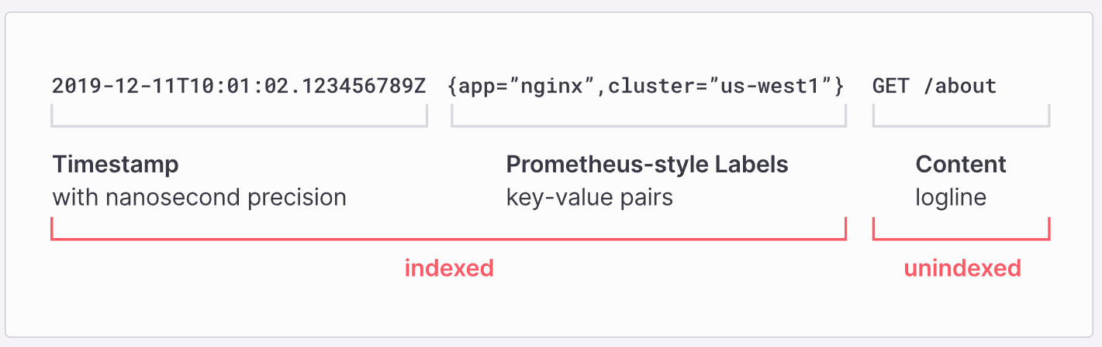

Loki Uses:
- It’s really easy to get started: because you can send logs in any format, from any source, using a wide array of clients
- 100% persistence to object storage: means you get petabyte scale, high throughput and cost-effective & durable storage
- Build metrics and generate alerts:from your log lines
- No ingestion log formatting requirements: gives you more flexibility and the option to format at query time
- Tail your logs in realtime: to see the logs as they come into the system, update the logs after every certain time, view logs for a particular date, etc.
- Natively integrates with Prometheus, Grafana and K8s: so you can seamlessly move between metrics, logs and traces within a single UI

How Grafana Loki works
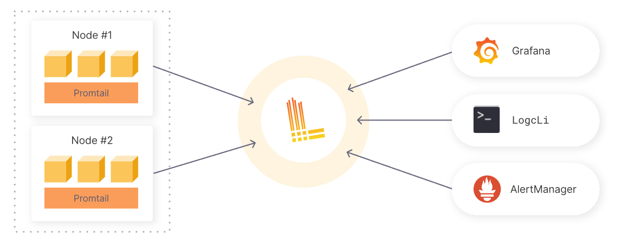
- Pull in any logs with Promtail
Promtail is a logs collector built specifically for Loki. It uses the same service discovery as Prometheus and includes analogous features for labeling, transforming, and filtering logs before ingestion into Loki.
- Store the logs in Loki
Loki does not index the text of logs. Instead, entries are grouped into streams and indexed with labels.Not only does this reduce costs, it also means log lines are available to query within milliseconds of being received by Loki
- Use LogQL to explore
Use Loki’s powerful query language, LogQL, to explore your logs. Run LogQL queries directly within Grafana to visualize your logs alongside other data sources, or with LogCLI, for those who prefer a command line experience.
- Alert on your logs
Set up alerting rules for Loki to evaluate on your incoming log data. Configure Loki to send the resulting alerts to a Prometheus Alertmanager so they can then get routed to the right team.

