Prometheus is a free software application used for event monitoring and alerting. It records real-time metrics in a time series database built using a HTTP pull model, with flexible queries and real-time alerting. Wikipedia

Introduction from docs

Supported exporters and integrations list : https://prometheus.io/docs/instrumenting/exporters/

Features
- a multi-dimensional data model with time series data identified by metric name and key/value pairs
- PromQL, a flexible query language to leverage this dimensionality
- no reliance on distributed storage; single server nodes are autonomous
- time series collection happens via a pull model over HTTP
- pushing time series is supported via an intermediary gateway
- targets are discovered via service discovery or static configuration
- multiple modes of graphing and dashboarding support
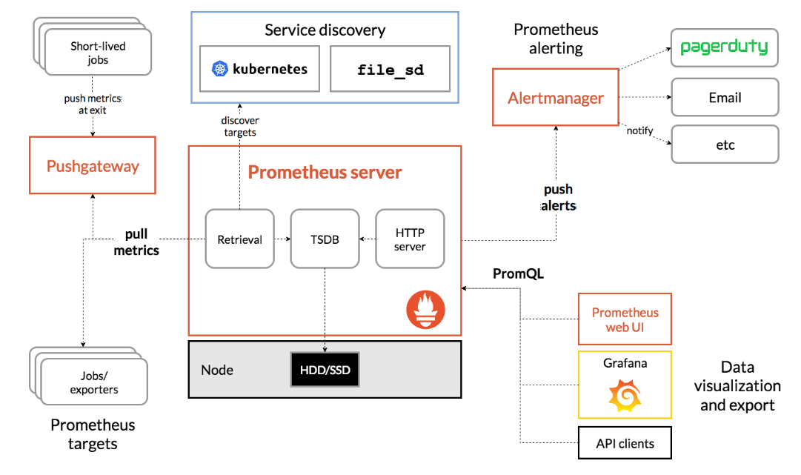
Architecture

When does it fit?
Prometheus works well for recording any purely numeric time series. It fits both machine-centric monitoring as well as monitoring of highly dynamic service-oriented architectures. In a world of microservices, its support for multi-dimensional data collection and querying is a particular strength.Prometheus is designed for reliability, to be the system you go to during an outage to allow you to quickly diagnose problems.
When does it not fit?
Prometheus values reliability. You can always view what statistics are available about your system, even under failure conditions. If you need 100% accuracy, such as for per-request billing, Prometheus is not a good choice as the collected data will likely not be detailed and complete enough.

References
- https://prometheus.io/

