Telegraf: Telegraf is a plugin-driven server agent for collecting and sending metrics and events from databases, systems, and IoT sensors.
- Input Plugins: collect metrics from the system, services, or 3rd party APIs
- Processor Plugins: transform, decorate, and/or filter metrics
- Aggregator Plugins: create aggregate metrics (e.g. mean, min, max, quantiles, etc.)
- Output Plugins: write metrics to various destinations

InfluxDB: InfluxDB is an open source time series platform. This includes APIs for storing and querying data, processing it in the background for ETL or monitoring and alerting purposes, user dashboards, and visualizing and exploring the data and more.
Kapacitor (background processing) – execute tasks, alert
Chronograf (the UI)

Grafana: Grafana allows you to query, visualize, alert on and understand your metrics no matter where they are stored.

TIG stack:
The TIG (Telegraf, Influx and Grafana) Stack is an acronym for a platform of open source tools built to make collection, storage, graphing, and alerting on time series data easy. In-short it complete monitoring stack just like Prometheus.

Architecture diagram:

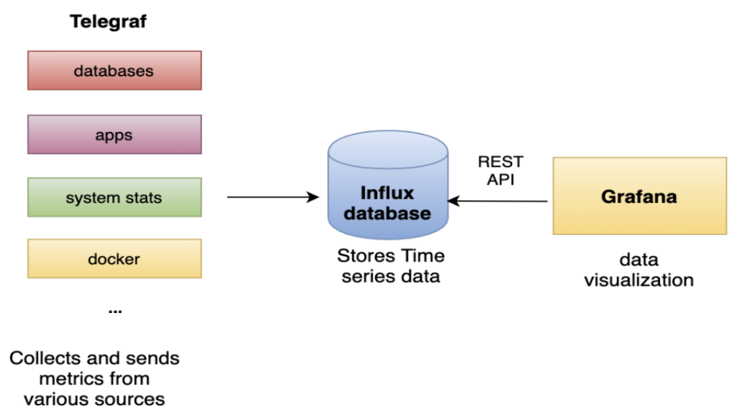
Image: taken from internet

