CHAPTER 1
INTRODUCTION
1.1 OVERVIEW OF THE INTERNSHIP
This internship played a crucial role in bridging my academic knowledge with real-world industry practices. While my academic curriculum provided a strong theoretical foundation in software systems and computing concepts, this internship enabled me to gain practical exposure to how these concepts are implemented in professional environments. I undertook this internship in a technical support role focused on a cloud-based subscription billing platform, which is widely used by modern businesses to automate recurring financial operations.
In recent years, the global business landscape has increasingly shifted towards subscription-based models. Organizations offering digital services, software products, and recurring solutions rely on subscription billing systems to manage customer payments efficiently. These systems handle complex processes such as recurring invoicing, subscription lifecycle management, payment tracking, and financial reporting. Performing these operations manually is inefficient and prone to errors, which makes automated platforms like Zoho Billing essential for modern businesses.
During my internship, I worked extensively with Zoho Billing, a cloud-based application designed to manage subscription-based services. The platform allows businesses to create subscription plans, define billing cycles, automate invoice generation, and track payments. It also supports integration with external systems through APIs, enabling organizations to automate their workflows and streamline operations.
My primary responsibility as a Support Engineer Trainee was to assist customers who were using Zoho Billing for their business operations. These customers ranged from small startups to established enterprises, each with unique billing requirements and workflows. I was responsible for understanding customer issues, analyzing system configurations, and providing solutions that aligned with the platform’s functionality.
I handled a variety of real-world issues, including incorrect invoice generation due to misconfigured billing cycles, subscription setup errors, payment failures, and API-related integration problems. Each issue required detailed analysis, as the root cause often depended on how the system was configured. By carefully examining the customer’s use case and system behavior, I was able to identify problems and guide customers toward appropriate solutions.
A significant portion of my work involved understanding and debugging API integrations. APIs (Application Programming Interfaces) are widely used by businesses to connect Zoho Billing with their applications, websites, or backend systems. Through APIs, operations such as customer creation, subscription updates, invoice generation, and data retrieval can be automated. I analyzed API request payloads, validated parameters, and interpreted API responses to identify errors such as missing fields, incorrect authentication tokens, and invalid endpoint usage.
In addition to API-related tasks, I gained hands-on experience in automation using Zoho’s Deluge scripting language. Deluge allows the creation of custom functions to automate workflows and implement business-specific logic. For example, I worked on automation scenarios such as applying late fees to overdue invoices and improving billing workflows. This provided valuable insight into how automation enhances efficiency and reduces manual effort in business operations.
Another important aspect of my internship was customer interaction. I communicated with customers through email and chat, where I explained technical solutions in a clear and structured manner. Since customers had varying levels of technical knowledge, I learned to simplify complex concepts such as APIs and configurations, ensuring that solutions were easily understood and implemented.
The internship also exposed me to real-world support workflows. Customer issues were managed through a ticketing system, where each case was analyzed, prioritized, and resolved systematically. This process involved understanding the issue, reproducing it in a test environment, identifying the root cause, and providing a validated solution. This structured approach significantly improved my analytical thinking and troubleshooting skills.
Overall, this internship provided comprehensive exposure to subscription billing systems, API integrations, automation techniques, and customer support operations. It helped me develop both technical expertise and professional skills, preparing me for future roles in software development, system integration, and technical support engineering.
1.2 OBJECTIVES OF THE TRAINING
The primary objective of this internship was to gain practical experience in working with a cloud-based subscription billing platform and to understand its real-world applications. While academic learning focuses on theoretical concepts, this internship aimed to provide hands-on exposure to how software systems function in a professional environment.
One of the key objectives was to understand subscription-based business models in depth. Unlike traditional one-time payment systems, subscription models involve recurring billing, which introduces additional complexity in managing billing cycles, renewals, and customer subscriptions. Through this internship, I was able to explore how these models are implemented and managed effectively using digital platforms.
Another important objective was to develop strong problem-solving and analytical skills. Customers frequently reported issues related to billing configurations, invoice generation, and API integrations. Resolving these issues required careful analysis, identification of root causes, and implementation of appropriate solutions. This process significantly improved my ability to approach problems in a structured and logical manner.
The internship also aimed to enhance my understanding of API integrations. APIs play a crucial role in modern software systems by enabling communication between different applications. I learned how to construct API requests, validate parameters, interpret responses, and debug errors. This knowledge is highly valuable for roles in backend development, system integration, and technical support.
Gaining experience in automation was another key objective. Automation is essential for improving efficiency and reducing manual workload in business operations. By working with Deluge scripting, I learned how to create custom functions that automate repetitive tasks and implement business logic. This helped me understand the importance of workflow automation in real-world systems.
Improving communication skills was also a major objective of the internship. Since my role involved interacting with customers, I needed to explain technical solutions clearly and effectively. I developed the ability to communicate complex technical concepts in a simple and understandable manner, which is an essential skill in any technical role.
Additionally, the internship aimed to provide exposure to real-world work environments. I learned how support teams operate, how issues are managed using ticketing systems, and how collaboration takes place within an organization. I also gained experience in managing multiple tasks, working under deadlines, and maintaining professionalism.
Finally, the internship contributed to building a strong foundation for my future career. By gaining practical experience in subscription billing systems, APIs, automation, and customer interaction, I developed skills that are directly applicable to roles in software development, technical support, and system integration.
1.3 SCOPE OF THE STUDY
The scope of this internship study covers various aspects of subscription billing systems, customer support operations, API integrations, and automation techniques. It provides a comprehensive understanding of how businesses use cloud-based platforms to manage financial operations efficiently.
One of the key areas within the scope is subscription management. This includes understanding how subscription plans are created, how billing cycles are configured, and how customer subscriptions are managed throughout their lifecycle. The study also covers automated invoice generation and payment tracking, which are essential components of subscription-based systems.
Another important area is customer support. During the internship, I handled real customer issues, which provided valuable insight into how support teams function in a SaaS environment. This includes understanding how issues are reported, analyzed, and resolved. It also highlights the importance of effective communication in delivering high-quality customer support.
The study also includes API integration, which is a critical component of modern software systems. Businesses use APIs to connect Zoho Billing with their applications, enabling automation of processes such as customer creation, subscription updates, and invoice generation. I explored how APIs work, how requests are structured, and how errors can be identified and resolved.

CHAPTER 2
COMPANY PROFILE
2.1 HISTORY OF THE ORGANIZATION
Zoho Corporation is a globally recognized technology company that specializes in providing cloud-based business software solutions. As part of my internship, I gained an understanding of the company’s evolution, which reflects its strong focus on innovation and long-term growth. The company was founded in 1996 by Sridhar Vembu and Tony Thomas under the name AdventNet. In its early stages, AdventNet primarily focused on developing network management and IT infrastructure software for enterprise clients, particularly in the telecommunications sector.
During the late 1990s and early 2000s, the rapid expansion of the internet created new opportunities for software companies. Recognizing this shift, the organization gradually transitioned from traditional enterprise software to web-based applications. This strategic shift marked the beginning of its journey into cloud computing and Software-as-a-Service (SaaS), which later became the foundation of its business model.
A significant milestone in the company’s growth occurred in 2005 with the launch of Zoho CRM. This product was designed to help businesses manage customer relationships more effectively. Zoho CRM gained rapid popularity due to its affordability, ease of use, and comprehensive features when compared to other solutions available in the market. This success encouraged the company to expand its product offerings across multiple business domains.
In 2009, AdventNet officially rebranded itself as Zoho Corporation. This rebranding represented a strategic shift towards becoming a full-scale provider of cloud-based business applications. Over time, Zoho significantly expanded its product portfolio to include solutions for finance, human resources, marketing, collaboration, and analytics.
One of the most distinctive aspects of Zoho’s growth is its independence. Unlike many technology companies that rely heavily on external funding, Zoho has remained privately owned. This has enabled the company to focus on long-term product development and customer-centric innovation rather than short-term financial pressures. It has also allowed Zoho to maintain full control over its product ecosystem and strategic direction.
Zoho has consistently invested in research and development to enhance its products and introduce innovative features. A significant portion of its engineering and development work is carried out in India, which highlights its strong technical foundation. This continuous focus on innovation has enabled Zoho to remain competitive in the global SaaS market.
Another unique aspect of Zoho’s operational strategy is its approach to workforce distribution. Instead of concentrating all operations in major metropolitan cities, the company has established offices in smaller towns and rural areas. This approach not only reduces operational costs but also creates employment opportunities in underrepresented regions, contributing to balanced economic development.
Today, Zoho Corporation serves millions of users across more than 180 countries. Its products are used by organizations ranging from small startups to large enterprises. The company’s ability to provide a fully integrated suite of applications has positioned it as a leading player in the SaaS industry.
The transformation of Zoho from a network software provider into a global cloud-based software company demonstrates its adaptability, innovation, and commitment to sustainable growth.
2.2 VISION AND MISSION
Zoho Corporation operates with a clear vision of empowering businesses through technology. During my internship, I observed how this vision is reflected in the design and functionality of its products. The company aims to create software solutions that simplify complex business processes and enable organizations to operate efficiently. Its vision is centered around providing a unified platform that integrates multiple business functions into a single ecosystem.
A key aspect of Zoho’s vision is reducing the dependency on multiple disconnected tools. By offering an integrated suite of applications, Zoho enables businesses to manage operations such as sales, finance, customer support, and collaboration within a single platform. This integration improves efficiency, minimizes errors, and enhances overall productivity.
The mission of Zoho focuses on delivering high-quality, user-friendly, and affordable software solutions. The company strongly believes that advanced technology should be accessible to businesses of all sizes, including small and medium enterprises. By providing cost-effective solutions, Zoho allows organizations to adopt digital tools without significant financial barriers.
Innovation plays a central role in Zoho’s mission. The company continuously enhances its products to meet evolving business requirements. It invests heavily in research and development to ensure that its applications remain relevant and competitive in a rapidly changing technological environment.
Another important element of Zoho’s mission is its commitment to data privacy and security. In an era where data protection is critical, Zoho prioritizes safeguarding customer information. The company follows strict security protocols and avoids business models that rely on exploiting user data, thereby maintaining customer trust.
Zoho also emphasizes ethical business practices and long-term sustainability. Instead of pursuing aggressive expansion through external investments, the company adopts a steady and sustainable growth strategy. This approach ensures stability and enables the company to deliver consistent value to its customers.
In addition to its business objectives, Zoho is actively involved in social responsibility initiatives. The company invests in education, skill development, and rural employment programs. By creating opportunities in smaller towns, Zoho contributes to inclusive economic development.
Overall, the vision and mission of Zoho reflect its commitment to innovation, customer satisfaction, ethical practices, and sustainable growth. These principles have played a significant role in shaping the company’s success and continue to guide its future direction.
2.3 PRODUCT / SERVICE RANGE
Zoho Corporation offers a comprehensive range of cloud-based applications that support various aspects of business operations. During my internship, I gained exposure to several of these products, particularly Zoho Billing, which is part of the company’s finance suite. All Zoho applications are designed to function as an integrated ecosystem, enabling organizations to manage their workflows efficiently across different departments.
One of the most widely used categories of Zoho products is Customer Relationship Management (CRM). Zoho CRM helps businesses manage customer interactions, track sales activities, and improve customer engagement. It includes features such as lead management, sales automation, analytics, and reporting, making it an essential tool for sales and marketing teams.
Zoho also provides a strong suite of financial management applications. These include Zoho Books for accounting, Zoho Invoice for invoicing, Zoho Expense for expense management, and Zoho Billing for subscription management. These tools enable businesses to manage financial operations accurately and efficiently.
Zoho Billing, which was the primary platform used during my internship, is specifically designed for subscription-based businesses. It allows organizations to create subscription plans, define billing cycles, automate invoice generation, and track recurring payments. The platform also supports integration with multiple payment gateways, ensuring seamless payment processing.
Another important category includes collaboration and productivity tools. Zoho Mail provides secure email communication, while Zoho Cliq enables team messaging and collaboration. Zoho Meeting supports virtual meetings and video conferencing, and Zoho WorkDrive offers cloud storage and file-sharing capabilities. These tools are particularly useful in remote and hybrid work environments.
Zoho Projects is a project management tool that allows teams to plan tasks, assign responsibilities, track progress, and manage deadlines. It enhances team coordination and ensures efficient project execution.
Zoho Creator is a low-code application development platform that enables users to build custom business applications. This reduces the need for complex programming and allows organizations to develop tailored solutions quickly.
For customer support operations, Zoho Desk provides a robust ticketing system that helps businesses manage customer queries and track support requests efficiently. It improves response time and enhances overall customer satisfaction.
Zoho Analytics is another key product that enables organizations to analyze data and generate meaningful insights. It supports data-driven decision-making by providing advanced reporting and visualization capabilities.
In addition, Zoho offers marketing tools such as Zoho Campaigns and Zoho Marketing Automation, which help businesses manage email campaigns, customer engagement, and lead nurturing processes.
One of the major strengths of Zoho’s product range is its seamless integration. All applications are designed to work together, allowing data to flow across systems without manual intervention. This reduces operational complexity and improves overall efficiency.
Zoho continues to expand its product ecosystem by introducing new features and applications to meet evolving business needs. Its solutions are scalable, flexible, and suitable for organizations of all sizes.
Overall, Zoho’s product and service range demonstrates its commitment to providing a comprehensive and integrated business software ecosystem, making it a preferred choice for businesses worldwide.

CHAPTER 3
INTERNSHIP WORK / PROJECT DETAILS
3.1 OVERVIEW
During my internship, I worked in a professional technical support environment where my primary responsibility was to assist customers using Zoho Billing for managing their subscription-based business operations. As a Support Engineer Trainee, I developed a strong understanding of both the functional and technical aspects of the platform while analyzing real-world business use cases.
Zoho Billing is widely used by organizations operating on recurring revenue models such as SaaS platforms, membership-based services, and digital subscriptions. These businesses rely heavily on accurate billing systems, as any error in subscription handling or invoice generation can directly impact revenue and customer trust. Through my internship, I gained practical exposure to how such systems operate in real business environments.
In my role, I handled a wide range of customer issues that varied in complexity. These included configuration-related problems, subscription setup errors, invoice generation issues, payment failures, and API integration challenges. For instance, I worked on cases where invoices were not generated due to incorrect billing cycle configurations and scenarios where subscriptions failed to renew because of improper renewal settings.
A key responsibility involved understanding each customer’s business workflow before diagnosing the issue. Different organizations follow different billing models, including fixed recurring billing, usage-based billing, and hybrid pricing structures. By analyzing these workflows, I ensured that system configurations aligned with the customer’s requirements and business logic.
Another important aspect of my role was identifying whether an issue was caused by incorrect configuration, API integration errors, or system limitations. In many cases, the issue was not due to a system defect but rather due to improper setup or misunderstanding of platform features. This required careful analysis and strong problem-solving skills.
The internship also exposed me to real-time support workflows where customer issues were managed through a structured ticketing system. Each request was categorized, prioritized, and resolved systematically. This helped me understand how large-scale support operations function efficiently.
In addition, I regularly interacted with customers through email and chat. I explained technical solutions in a structured and easily understandable manner, especially when dealing with non-technical users. This significantly improved my communication skills and ability to simplify complex technical concepts.
A major portion of my work involved API integrations. Many customers used Zoho Billing APIs to connect the platform with their applications. I debugged API issues by analyzing request payloads, validating parameters, checking authentication tokens, and interpreting error responses.
Furthermore, I gained hands-on experience in automation using Deluge scripting. I worked on custom functions that automated workflows such as applying late fees and processing invoice data. This demonstrated how automation can improve efficiency and reduce manual effort in business operations.
Overall, the internship provided me with in-depth exposure to subscription billing systems, customer support processes, API integrations, and automation techniques in a real-world environment.

3.2 TOOLS AND TECHNOLOGIES USED
During my internship, I worked with several tools and technologies that were essential for analyzing issues, debugging errors, and implementing solutions. The primary platform used was Zoho Billing, which is designed to manage subscription-based services and automate recurring billing operations.
I used Zoho Billing to analyze various customer configurations, including subscription plans, billing cycles, invoice generation workflows, and customer records. The platform supports different pricing models such as flat-rate, tiered, and usage-based billing. I worked on resolving issues related to incorrect configuration of these models, which often led to problems in invoice generation and subscription management.
Another important feature of Zoho Billing is automated invoice generation. I handled cases where invoices were not generated due to misconfigured billing cycles or incorrect subscription settings. By analyzing the configuration and correcting errors, I ensured proper functioning of billing workflows.
I also worked with payment tracking features, where I helped customers identify failed transactions and understand payment gateway responses. This required understanding how Zoho Billing integrates with external payment systems and how transaction statuses are managed.
REST APIs played a critical role in my internship. Many customers used APIs to automate operations such as creating customers, generating invoices, updating subscriptions, and retrieving billing data. I worked with API requests involving endpoint URLs, HTTP methods, headers, authentication tokens, and request parameters.
Debugging API issues was a key part of my role. I analyzed API responses, including status codes and error messages, to identify issues such as missing parameters, invalid authentication tokens, and incorrect endpoint usage. This helped me develop a strong understanding of system integration and API-based workflows.
Postman was extensively used for testing API requests. When customers reported API issues, I recreated their requests in Postman to isolate the problem. By modifying request parameters and analyzing responses, I was able to determine whether the issue was caused by the API or the customer’s implementation.
JSON was used as the standard data format for API communication. I worked with JSON data to construct request payloads and analyze responses. Many issues occurred due to incorrect JSON structure or missing fields, and I resolved these by carefully validating the data format.
In addition to APIs, I gained practical experience with Deluge scripting, which is Zoho’s scripting language used for automation. I created custom functions to automate workflows such as applying late fees to overdue invoices. This involved retrieving data, performing calculations, and updating records through API calls.
Working with Deluge required understanding programming concepts such as loops, conditional statements, and data handling. It also helped me understand how automation can enhance system efficiency and reduce manual intervention.
3.3 METHODOLOGY DESCRIPTION
To resolve customer issues effectively, I followed a structured and systematic approach throughout the internship. The process began with understanding the customer’s problem in detail. Customers often described issues based on their observations, which required further clarification to identify the actual root cause. I gathered relevant information, including configuration details, API requests, and screenshots, to gain a clear understanding of the issue.
Once the problem was understood, I attempted to reproduce it in a controlled environment. Reproducing the issue helped confirm its existence and allowed me to observe its behavior under specific conditions. This step was crucial in identifying patterns and understanding whether the issue was consistent or intermittent.
After reproducing the issue, I performed root cause analysis by examining system configurations, API requests, and response data. Many issues were related to incorrect configuration settings, missing parameters in API requests, or authentication errors. By carefully analyzing these elements, I was able to identify the exact cause of the problem.
Once the root cause was identified, I designed an appropriate solution. This involved correcting configuration settings, modifying API requests, or implementing automation where required. Before providing the solution to the customer, I tested it to ensure that it resolved the issue effectively without causing additional problems.
The solution was then communicated to the customer in a clear and structured manner. I provided step-by-step instructions to ensure that the customer could implement the solution correctly. In cases involving APIs, I shared corrected request examples to help customers understand the changes.
Finally, I verified the solution by confirming with the customer that the issue was resolved successfully. Follow-up communication ensured that the system was functioning as expected and that no additional issues were present. This structured methodology helped maintain consistency and accuracy in problem resolution.
3.4 WORK SAMPLES / DATA ANALYSIS
During the internship, I worked on several real-world cases that involved customer interaction, API debugging, and automation. One of the common issues I handled involved incorrect invoice generation due to misconfigured subscription settings. In one case, a customer reported that invoices were not being generated. Upon analyzing the configuration, I found that the billing cycle was not properly aligned with the subscription start date. After correcting the configuration and guiding the customer, the issue was resolved successfully.
Another case involved API debugging, where a customer encountered an error while creating invoices through the API. I recreated the request using Postman and analyzed the response. It was found that a required parameter was missing in the request payload. After correcting the request structure and adding the missing parameter, the API functioned correctly. I then shared the corrected request with the customer.
I also worked on developing a custom function using Deluge scripting to automate the application of late fees for overdue invoices. The function retrieved overdue invoices, calculated the number of overdue days, applied a late fee based on predefined conditions, and updated the invoice records using API calls. This automation improved efficiency and ensured consistency in billing operations.

CHAPTER 4
LEARNING OUTCOMES
4.1 TECHNICAL SKILLS GAINED
During my internship, I gained significant technical exposure to real-world software systems and their practical implementation in business environments. One of the most important skills I developed was understanding how cloud-based Software-as-a-Service (SaaS) platforms operate. By working with Zoho Billing, I learned how businesses manage subscription lifecycles, recurring billing, customer data, and financial workflows without relying on on-premise infrastructure. This provided me with a clear understanding of how modern cloud systems ensure scalability, accessibility, and operational efficiency.
A major area of learning was API integration and debugging. APIs play a critical role in enabling communication between different software systems, allowing businesses to automate operations such as customer creation, subscription updates, and invoice generation. During the internship, I worked extensively on analyzing API requests and responses, which helped me understand how data flows between systems in real time. I developed a strong understanding of HTTP methods such as GET, POST, PUT, and DELETE, and how each method is used to perform specific operations within an application.
Working with APIs also helped me understand authentication mechanisms in depth. Zoho APIs use authentication tokens to validate requests, and I encountered multiple scenarios where API failures were caused due to invalid, expired, or missing tokens. By resolving these issues, I gained practical knowledge of how secure communication is established between systems and how authentication plays a critical role in protecting sensitive data.
Another important technical skill I developed was working with JSON data structures. Since API communication is primarily based on JSON, I learned how to construct request payloads accurately and interpret response data effectively. Many real-world issues were related to incorrect JSON formatting, missing parameters, or invalid data types. Debugging such issues improved my attention to detail and strengthened my ability to validate and structure data correctly.
The internship also provided hands-on experience in automation using Deluge scripting. I learned how to write custom functions to automate workflows and implement business-specific logic. This involved applying programming concepts such as loops, conditional statements, and data manipulation techniques. By developing automation scripts, I understood how repetitive manual tasks can be minimized and how system efficiency can be improved significantly.
In addition to scripting, I gained a deeper understanding of system workflows and configurations. Subscription billing systems involve multiple interconnected components such as subscription plans, customer records, invoices, and payment transactions. I learned how these components interact and how incorrect configuration in one area can affect the entire workflow. This understanding was essential in diagnosing issues and ensuring proper system functionality.
Another key technical skill I developed was debugging and troubleshooting. Many customer issues required identifying the root cause by analyzing system behavior, API responses, and configuration settings. This process involved logical reasoning and step-by-step analysis, which helped me strengthen my analytical thinking and problem-solving abilities.
The use of tools such as Postman further enhanced my technical capabilities. By testing API requests in Postman, I was able to recreate issues, validate request parameters, and analyze responses in a controlled environment. This provided me with practical experience in API testing and debugging, which are essential skills in modern software development and integration roles.
I also gained a better understanding of data flow within systems. For example, when a customer subscribes to a plan, multiple backend processes are triggered, including invoice generation, payment processing, and database updates. Understanding this flow helped me identify where issues occurred and how they could be resolved efficiently.
Additionally, I was introduced to concepts related to scalability and performance. While working with large datasets such as multiple invoices or customer records, I understood the importance of efficient processing techniques, pagination, and optimization. This highlighted how systems must be designed to handle increasing workloads without performance degradation.
Furthermore, the internship exposed me to real-world system constraints and limitations. Not all requirements could be implemented directly due to platform limitations, which required identifying alternative approaches or workarounds. This improved my ability to think practically and design solutions within system boundaries.
Overall, the technical skills I gained during the internship provided a strong foundation in cloud computing, API integration, automation, debugging, and system analysis. These skills are highly relevant for roles in software development, backend engineering, and technical support.

4.2 PROFESSIONAL / SOFT SKILLS
In addition to technical knowledge, the internship played a crucial role in developing my professional and soft skills, which are essential for working effectively in a real-world environment. One of the most important skills I developed was effective communication. As part of my role, I regularly interacted with customers and was responsible for explaining solutions clearly and accurately. Since customers had varying levels of technical expertise, I learned how to simplify complex concepts and present them in a way that was easy to understand.
Another key skill I developed was problem-solving. Each customer issue required a unique approach, as no two problems were exactly the same. I learned to analyze situations carefully, identify possible causes, and apply logical reasoning to determine the most appropriate solution. This significantly improved my analytical thinking and decision-making abilities.
Time management was another important skill I gained during the internship. I often handled multiple support cases simultaneously, which required prioritizing tasks based on urgency and impact. I learned how to manage my workload efficiently while ensuring that all issues were addressed within expected timelines.
The internship also helped me develop adaptability. Working in a dynamic environment required me to quickly understand new features, system updates, and different types of customer issues. I learned how to adapt to changing requirements and continuously update my knowledge, which is essential in the rapidly evolving technology industry.
Teamwork and collaboration were also important aspects of my experience. I worked alongside other support engineers and occasionally collaborated to resolve complex issues. This helped me understand the importance of knowledge sharing, collective problem-solving, and effective coordination within a team.
Another important skill I developed was attention to detail. Even small errors in configuration or API parameters could lead to significant issues in the system. Therefore, I learned to carefully analyze every aspect of a problem and ensure that solutions were accurate and reliable.
The internship also improved my professional behavior and work ethics. I learned to maintain a professional tone in all communications, meet deadlines consistently, and take responsibility for assigned tasks. These qualities are essential for building trust and credibility in a professional environment.
Handling customer expectations was another valuable learning experience. Customers often expect quick resolutions, but it is equally important to ensure that the solution provided is accurate and sustainable. I learned how to balance speed and quality while maintaining customer satisfaction.
Additionally, I developed strong documentation skills by writing clear and structured responses to customer queries. This required organizing information logically and presenting it in a way that was easy to follow. These skills are useful for creating technical documentation and knowledge base articles.
The internship also improved my ability to handle pressure and work in a fast-paced environment. Managing multiple issues, meeting deadlines, and ensuring quality responses required focus and consistency. This experience helped me build resilience and maintain performance under pressure.
Finally, the internship significantly boosted my confidence in handling real-world challenges. By working on actual customer issues and successfully resolving them, I developed confidence in my technical abilities, communication skills, and decision-making capabilities. This confidence will be valuable in my future professional career.

CHAPTER 5
CHALLENGES AND SOLUTIONS
5.1 CHALLENGES FACED
During my internship, I encountered several challenges while working in a real-world technical support environment. These challenges were not limited to technical aspects but also involved communication, time management, adaptability, and decision-making. Facing and overcoming these challenges played a crucial role in strengthening both my technical and professional skills.
One of the primary challenges I faced was understanding the diverse business models used by different customers. Zoho Billing is utilized by a wide range of organizations, each with unique subscription requirements. Some businesses follow fixed recurring billing models such as monthly or yearly subscriptions, while others use usage-based billing where charges depend on customer activity. Accurately interpreting these business requirements was essential before providing a solution. Any misunderstanding of the customer’s workflow could lead to incorrect configurations and ineffective solutions.
Another major challenge involved identifying issues related to system configuration. Many customers faced problems due to incorrect setup of subscription plans, billing cycles, or invoice settings. These issues were often complex, as even a small misconfiguration could result in unexpected system behavior. Diagnosing such problems required a detailed understanding of how different system components interact and influence each other.
API-related issues were also a significant challenge during the internship. Many customers integrated Zoho Billing with their applications using APIs, and failures in these integrations were often difficult to analyze. Common issues included missing parameters, invalid authentication tokens, incorrect request formats, and improper endpoint usage. Understanding these errors required careful analysis of API responses and familiarity with documentation.
Debugging API issues was further complicated by the fact that customers used different programming languages and development environments. In several cases, the issue was not within Zoho Billing itself but in how the API was implemented in the customer’s system. Identifying the exact source of such problems required a structured and analytical approach.
Working with automation using Deluge scripting also presented challenges. Writing custom functions required logical thinking and a clear understanding of scripting concepts. Even minor errors in logic or conditions could result in incorrect data updates or unintended system behavior. Debugging such scripts required careful testing and validation.
Communication with customers was another important challenge. Customers often described issues in non-technical terms, which made it difficult to understand the exact problem initially. Additionally, some customers were not familiar with technical concepts such as APIs, JSON, or system configurations. Explaining solutions in a clear and simplified manner while maintaining technical accuracy required strong communication skills.
Time management was also a significant challenge. I was often required to handle multiple support cases simultaneously, each with different levels of complexity and urgency. Prioritizing tasks effectively while ensuring timely and accurate resolution was essential in maintaining efficiency.
Handling customer expectations added another layer of complexity. Customers often expected immediate solutions, especially when their business operations were affected. However, certain issues required detailed analysis and could not be resolved instantly. Balancing the need for quick responses with the requirement for accurate solutions was a critical challenge.
Adapting to continuous updates in the platform was another challenge I faced. Zoho Billing frequently introduces new features and enhancements, and it was necessary to stay updated with these changes. Understanding how new features impacted existing workflows required continuous learning and adaptability.
Ensuring data accuracy was also crucial while working with financial systems. Since billing systems deal with sensitive financial data, even a minor error could lead to significant consequences. This required careful validation of configurations, API operations, and automation processes before implementing any solution.
Overall, these challenges provided valuable learning experiences and helped me develop a deeper understanding of both technical systems and professional responsibilities.

5.2 SOLUTIONS AND STRATEGIES
To overcome the challenges encountered during the internship, I adopted several structured strategies and problem-solving approaches. These strategies not only helped in resolving issues effectively but also improved my efficiency and confidence in handling real-world scenarios.
One of the most important strategies I followed was adopting a systematic problem-solving approach. Instead of attempting to fix issues immediately, I focused on understanding the problem thoroughly. This involved analyzing the customer’s requirement, identifying the context, and gathering all relevant information. A clear understanding of the problem significantly increased the accuracy of the solution.
For resolving configuration-related issues, I followed a step-by-step analysis of system settings. Rather than making random changes, I carefully examined each component of the system, such as subscription plans, billing cycles, and invoice configurations. This structured approach helped in identifying the root cause efficiently and prevented unnecessary modifications.
API-related challenges were addressed by breaking down the problem into smaller components. I analyzed API requests by verifying the endpoint, request parameters, headers, and authentication tokens. I used Postman to recreate requests and test different scenarios, which helped in isolating errors and identifying issues such as missing parameters or incorrect data formats.
Referring to official API documentation played a crucial role in resolving integration issues. By validating request structures and required parameters against documentation, I ensured that API calls were constructed correctly and functioned as expected.
To handle challenges related to Deluge scripting, I adopted a modular approach to development. Instead of writing complex scripts in a single step, I divided the logic into smaller sections and tested each part individually. This made debugging easier and reduced the chances of errors in the final implementation.
Improving communication was another key strategy. I ensured that all solutions were explained in a clear and structured manner. I provided step-by-step instructions and used simple language to help customers understand the solution. This approach improved customer satisfaction and reduced the chances of miscommunication.
Time management was improved by prioritizing tasks based on urgency and business impact. Issues affecting critical operations, such as invoice generation or payment processing, were given higher priority. This ensured that high-impact problems were resolved quickly while maintaining overall efficiency.
Continuous learning was essential in overcoming challenges. I regularly referred to product documentation, API references, and knowledge base articles to enhance my understanding of the platform. This helped me stay updated with new features and provide accurate solutions.
Collaboration with team members also played an important role. Discussing complex issues with colleagues helped in gaining different perspectives and identifying solutions more effectively. This improved both problem-solving efficiency and knowledge sharing.
To ensure data accuracy, I followed a validation-first approach before implementing any changes. This included testing configurations, verifying API responses, and reviewing automation scripts. This practice minimized errors and ensured reliability in solutions.
Handling customer expectations was managed through transparent communication. I kept customers informed about the progress of their issues and provided realistic timelines for resolution. This helped build trust and maintain a positive customer experience.
Finally, I worked on improving automation processes to enhance efficiency. By adding validation checks, logging mechanisms, and optimization techniques such as pagination, I improved the reliability and scalability of custom functions.
Overall, the strategies I adopted enabled me to effectively overcome challenges while improving my technical knowledge, problem-solving ability, and professional skills. These experiences have prepared me to handle complex scenarios in real-world software environments with confidence.
CHAPTER 6
CONCLUSION AND FUTURE ENHANCEMENT
6.1 CONCLUSION
The internship provided me with valuable exposure to real-world software systems and hands-on experience in a professional technical environment. It played a crucial role in bridging the gap between the theoretical knowledge I acquired during my academic studies and its practical application in the industry. By working with a cloud-based subscription billing platform, I developed a clear understanding of how modern businesses manage recurring financial operations efficiently.
One of the most significant outcomes of this internship was gaining in-depth knowledge of subscription-based business models. Unlike traditional one-time payment systems, subscription models require continuous management of customer plans, billing cycles, renewals, and payment tracking. Through my hands-on experience with Zoho Billing, I understood how such systems automate complex workflows and ensure accuracy and consistency in financial operations.
The internship also provided me with practical exposure to customer support processes in a real-time environment. By handling actual customer issues, I learned how support systems operate in a structured manner. Each issue required a systematic approach, starting from understanding the customer’s requirement to identifying the root cause and implementing an appropriate solution. This significantly enhanced my analytical thinking and problem-solving skills.
Another important area of learning was API integration. APIs are a fundamental component of modern software systems, enabling seamless communication between applications. Through my work with APIs, I developed a strong understanding of request structures, authentication mechanisms, and error handling. Debugging API-related issues gave me valuable insight into how integration challenges are identified and resolved in real-world scenarios.
Automation using Deluge scripting was another key aspect of my learning. By creating custom functions, I was able to automate repetitive tasks and improve workflow efficiency. This experience demonstrated how automation can be leveraged to enhance productivity and reduce manual effort in business operations.
In addition to technical knowledge, the internship contributed significantly to my professional development. I improved my communication skills by interacting with customers and explaining technical solutions in a clear and structured manner. I also developed time management skills by handling multiple tasks simultaneously and prioritizing them based on urgency and impact.
The internship emphasized the importance of continuous learning in the technology field. Since software platforms are constantly evolving, I learned to regularly refer to documentation, explore new features, and update my knowledge. This habit will be essential for my long-term professional growth.
Another important takeaway was the need for accuracy and reliability in financial systems. Since billing platforms handle sensitive financial data, even minor errors can have serious consequences. This reinforced the importance of careful analysis, validation, and testing before implementing any solution.
Overall, the internship provided me with a comprehensive understanding of subscription billing systems, API integrations, automation techniques, and customer support workflows. It helped me build a strong foundation in both technical and professional skills. The knowledge and experience gained during this internship have prepared me to take on future roles in software development, system integration, and technical support with confidence.

6.2 FUTURE ENHANCEMENT
Although the internship provided a strong foundation in subscription billing systems and technical support processes, there are several areas where further enhancements can be implemented to improve system performance, efficiency, and user experience.
One of the key areas for future enhancement is automation. While basic automation was implemented using Deluge scripting, there is significant potential to develop more advanced workflows. For instance, automation can be extended to include intelligent billing adjustments, automated reminders based on customer behavior, and real-time reporting. Such enhancements can reduce manual effort and improve operational efficiency.
Another important area for improvement is API integration. While APIs offer powerful capabilities, improving validation mechanisms and error handling can enhance reliability. Providing more descriptive error messages and improving API documentation can help developers identify and resolve issues more efficiently. Additionally, implementing retry mechanisms and fallback strategies can make integrations more robust.
Scalability is another critical factor that can be enhanced. As businesses grow, they handle increasing volumes of data, including customers, subscriptions, and invoices. Optimizing API performance, implementing pagination, and improving data processing techniques can ensure that the system performs efficiently even under high workloads.
User experience can also be improved by simplifying system configuration processes. Some features may be complex for new users, particularly those without technical expertise. Providing guided workflows, better documentation, and intuitive interfaces can make the platform more user-friendly and reduce dependency on support teams.
Another potential enhancement involves integrating intelligent features such as predictive analytics and AI-based recommendations. For example, the system could analyze usage patterns and suggest optimal subscription plans or notify users about potential billing issues in advance. Such features can significantly enhance the value of the platform.
Security and data protection should continue to be a priority. Since billing systems handle sensitive financial information, implementing advanced security measures and ensuring compliance with industry standards is essential. Regular updates, monitoring, and audits can help maintain system integrity and user trust.
From a support perspective, improving knowledge base resources can reduce the number of support requests. Providing detailed documentation, tutorials, and troubleshooting guides can empower users to resolve issues independently, thereby improving overall efficiency.
Enhancing monitoring and logging mechanisms is another important area. Improved logging can help in faster issue detection and better understanding of system behavior, especially in complex scenarios involving multiple integrations.
Additionally, further exploration of advanced automation frameworks and integration techniques can help in developing more efficient and scalable solutions. By continuously improving technical expertise in these areas, it is possible to design systems that are both reliable and adaptable to future requirements.
Overall, future enhancements should focus on improving automation, integration, scalability, user experience, and security. These improvements will not only enhance system performance but also provide a more efficient and seamless experience for users.

APPENDICES
APPENDIX A
orgId = "898831333";
result = Map();
successList = List();
failureList = List();
initial_count = 0;
processed_count = 0;
// Fetch overdue invoices
response = invokeurl
[
url :"https://www.zohoapis.com/billing/v1/invoices?organization_id=" + orgId + "&status=overdue"
type :GET
connection:"mgneek"
];
invoices = response.get("invoices");
today = zoho.currentdate;
for each invoice in invoices
{
try
{
status = invoice.get("status");
dueDateStr = invoice.get("due_date");
if(status == "overdue")
{
initial_count = initial_count + 1;
}
if(dueDateStr != null && status == "overdue")
{
dueDate = dueDateStr.toDate("yyyy-MM-dd");
if(dueDate < today)
{
overdueDays = dueDate.daysBetween(today);
if(overdueDays > 7)
{
invoiceId = invoice.get("invoice_id");
invoiceNumber = invoice.get("invoice_number");
customerId = invoice.get("customer_id");
balance = invoice.get("balance");
if(balance == null)
{
balance = 0;
}
// Calculate 1% late fee
lateFee = (balance * 0.01).round(2);
if(lateFee > 0)
{
description = "Late fee of " + lateFee +
" applied on balance " + balance +
" for overdue invoice " + invoiceNumber +
" (" + overdueDays + " days overdue)";
data = Map();
data.put("customer_id", customerId);
data.put("reason", "Adding late fees");
data.put("adjustment_description", description);
data.put("adjustment", lateFee);
updateResp = invokeurl
[
url :"https://www.zohoapis.com/billing/v1/invoices/" + invoiceId + "?organization_id=" + orgId
type :PUT
parameters:data.toString()
headers:{"Content-Type":"application/json"}
connection:"mgneek"
];
if(updateResp.get("code") == 0)
{
successMap = Map();
successMap.put("invoice_id", invoiceId);
successMap.put("invoice_number", invoiceNumber);
successMap.put("late_fee", lateFee);
successMap.put("message", "SUCCESS");
successList.add(successMap);
info "SUCCESS: Late fee added to Invoice " + invoiceNumber;
}
else
{
failureMap = Map();
failureMap.put("invoice_id", invoiceId);
failureMap.put("invoice_number", invoiceNumber);
failureMap.put("error", updateResp);
failureList.add(failureMap);
info "FAILED: Invoice " + invoiceNumber +
" Reason: " + updateResp.toString();
}
processed_count = processed_count + 1;
}
}
}
}
}
catch (e)
{
errorMap = Map();
errorMap.put("invoice_id", invoice.get("invoice_id"));
errorMap.put("invoice_number", invoice.get("invoice_number"));
errorMap.put("error", e.toString());
failureList.add(errorMap);
info "EXCEPTION: Invoice " + invoice.get("invoice_number") +
" Error: " + e.toString();
}
}
// Final result
result.put("status", "completed");
result.put("total_overdue", initial_count);
result.put("processed", processed_count);
result.put("success_count", successList.size());
result.put("failure_count", failureList.size());
result.put("success", successList);
result.put("failures", failureList);
info result;
return result;

APPENDIX B
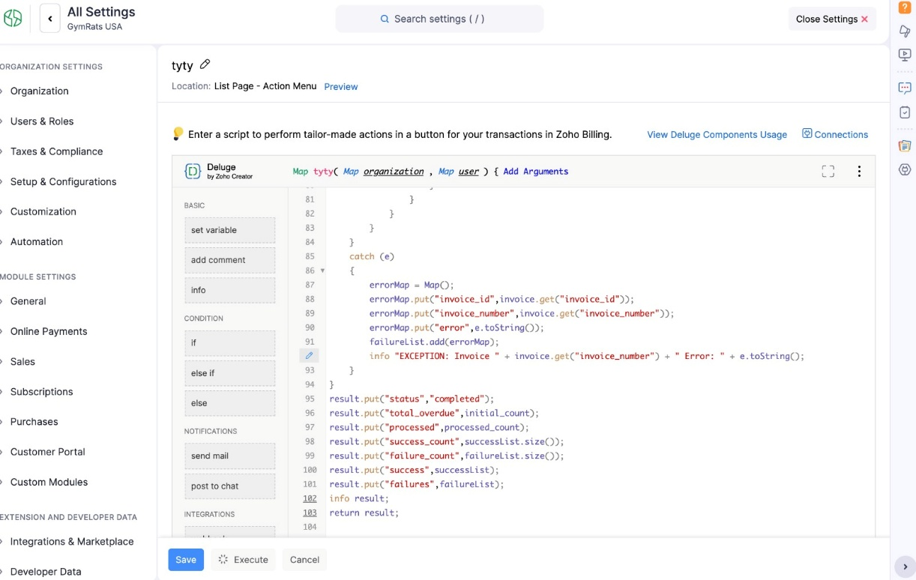
Figure B.1 Custom Function Execution
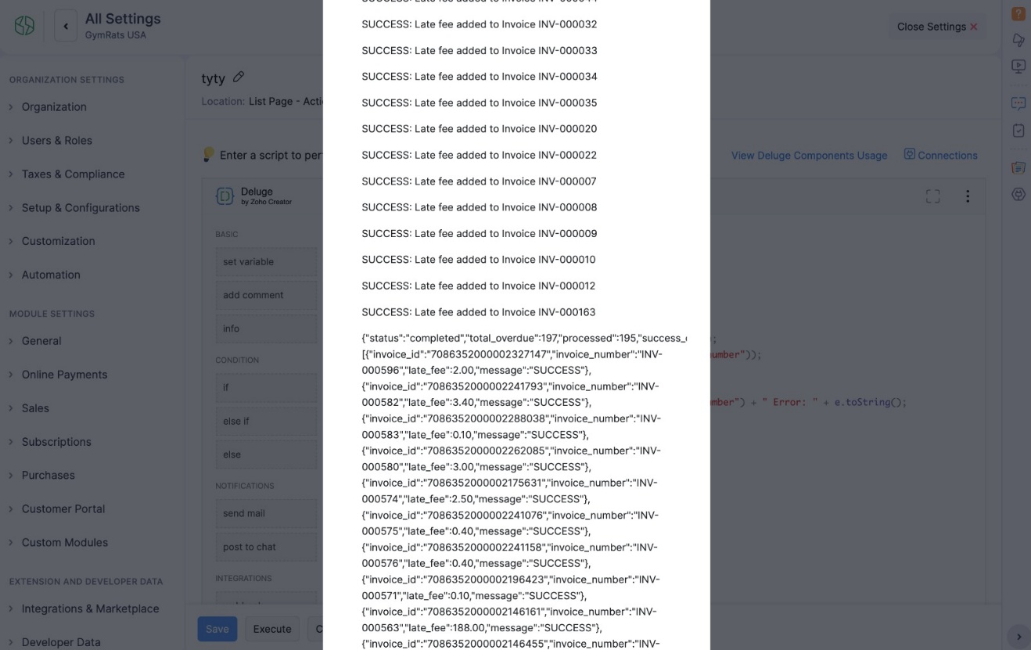
Figure B.2 Execution Logs
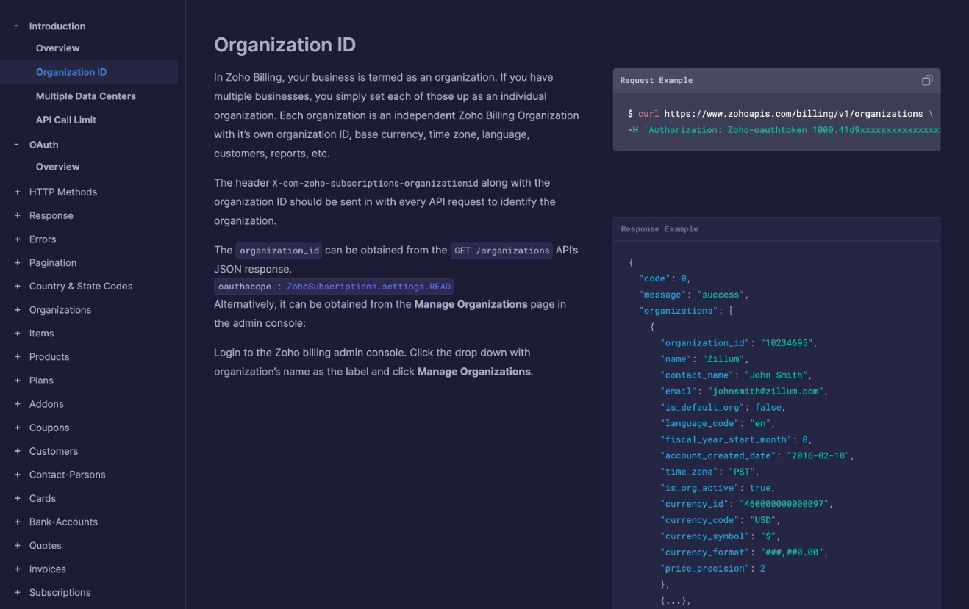
Figure B.3 API Help Doc

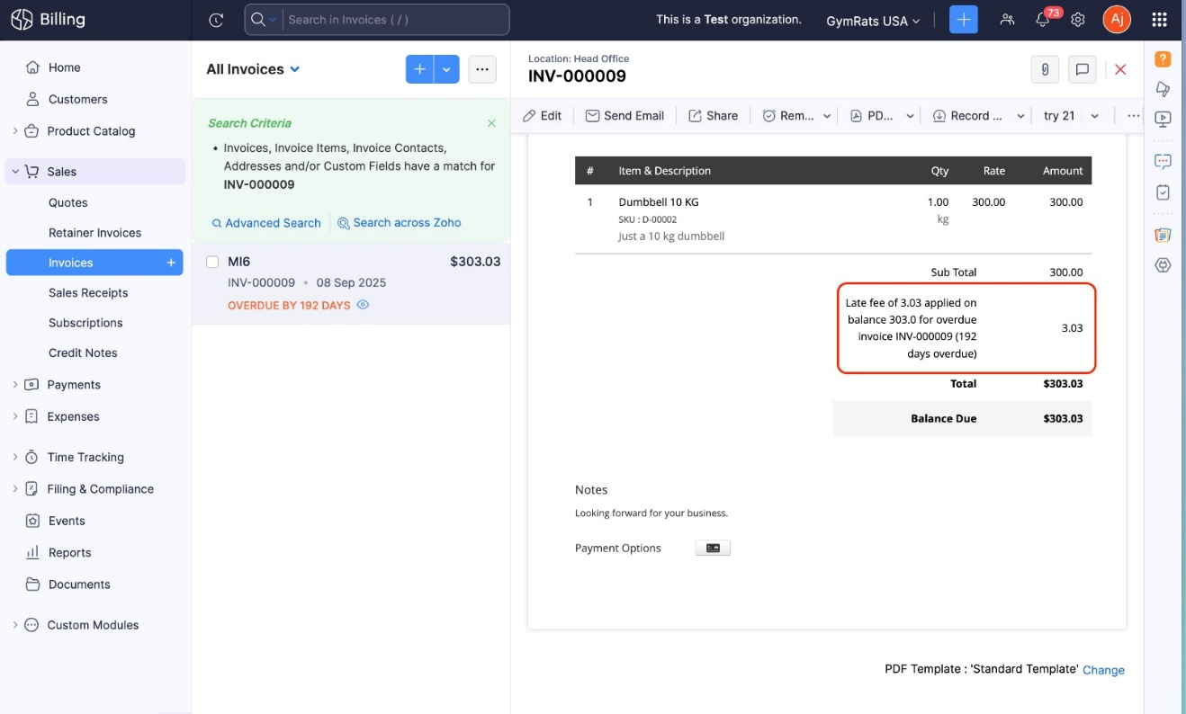
Figure B.4 Custom Function Result
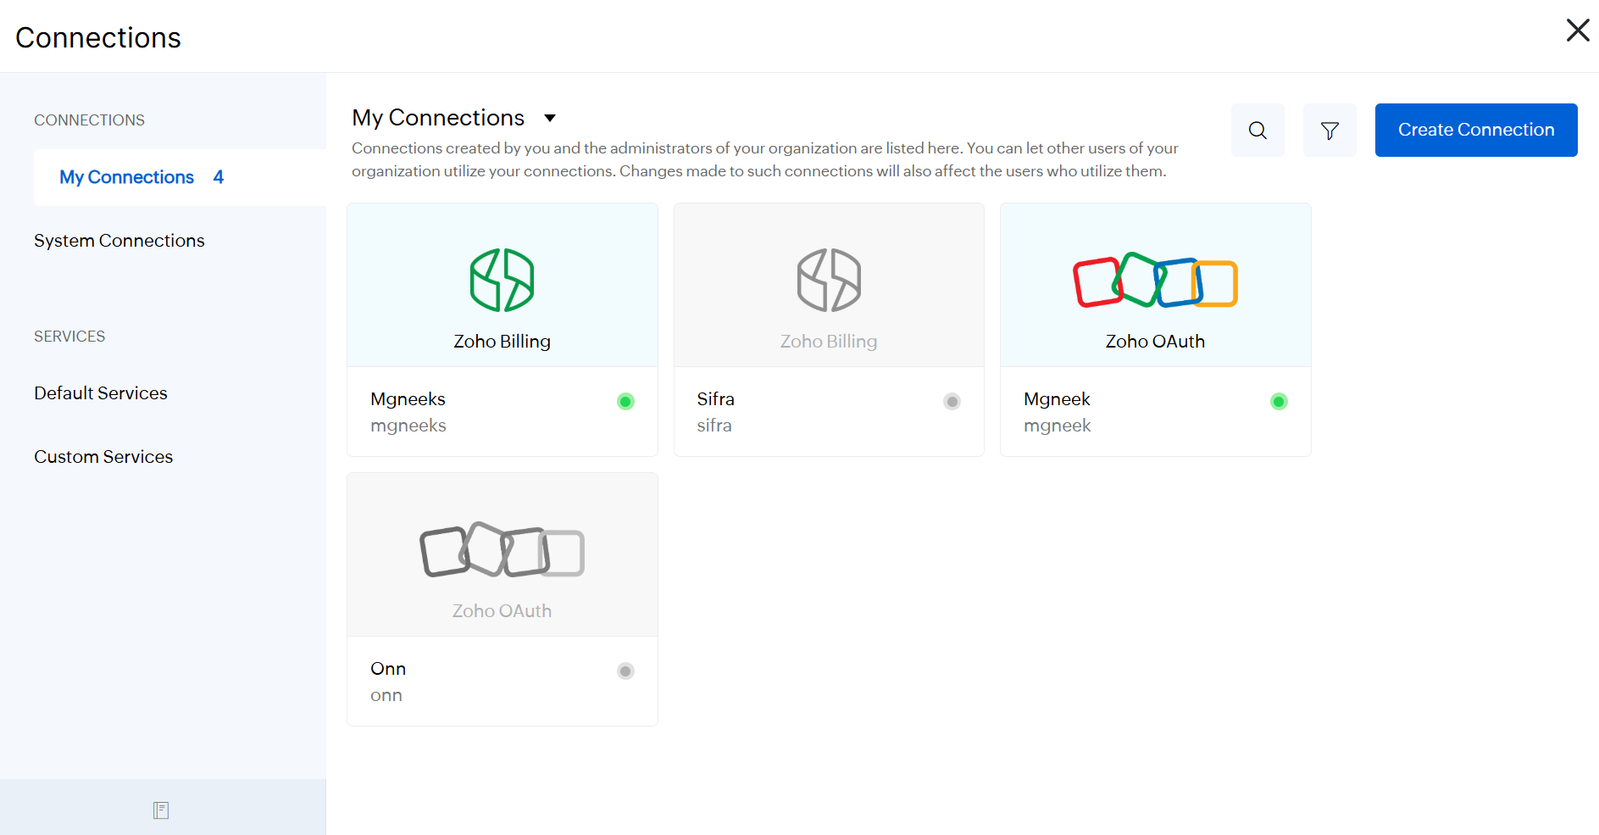
Figure B.5 Connection for Zoho Billing

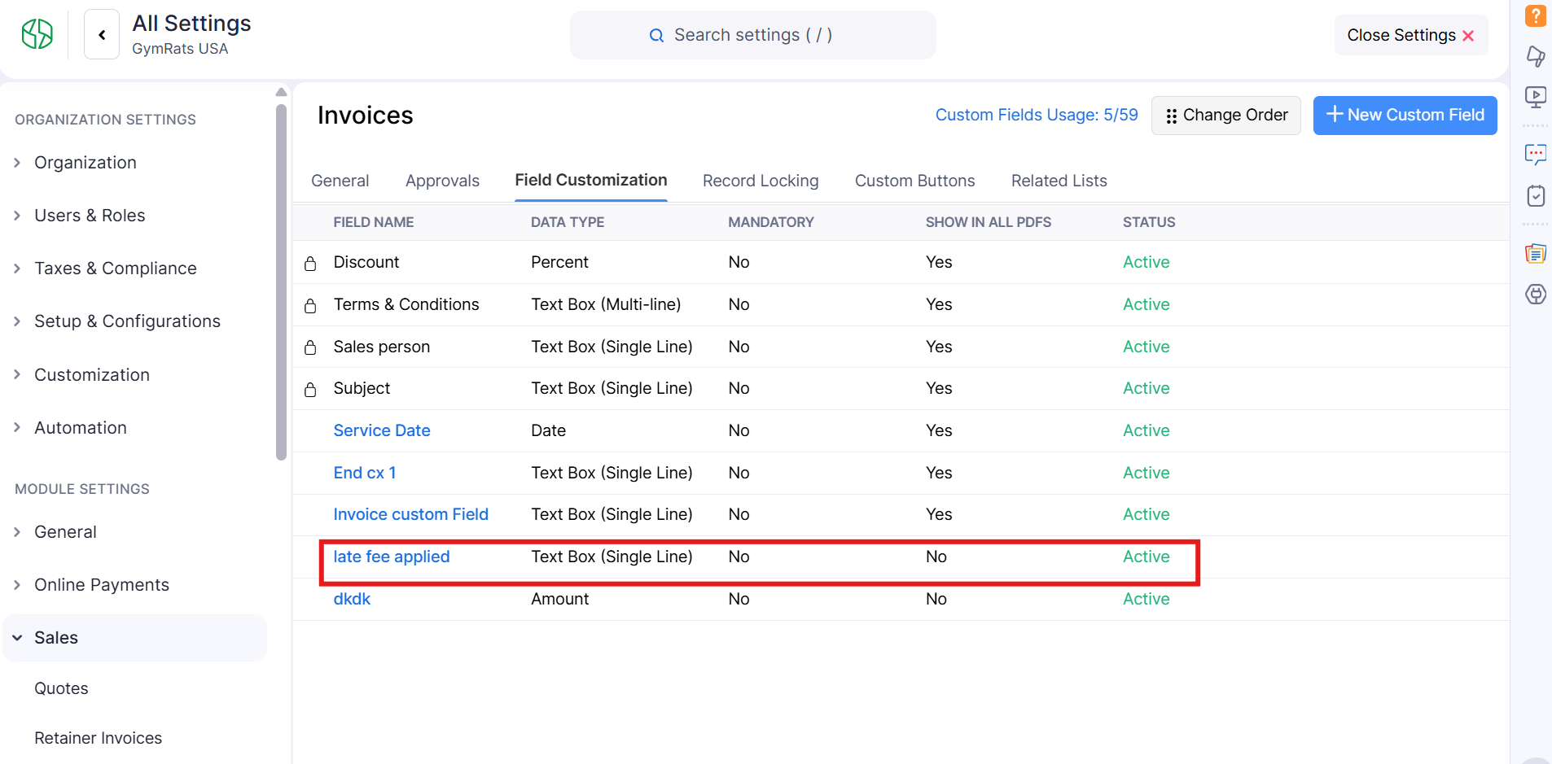
Figure B.6 Custom Field for Late Fee
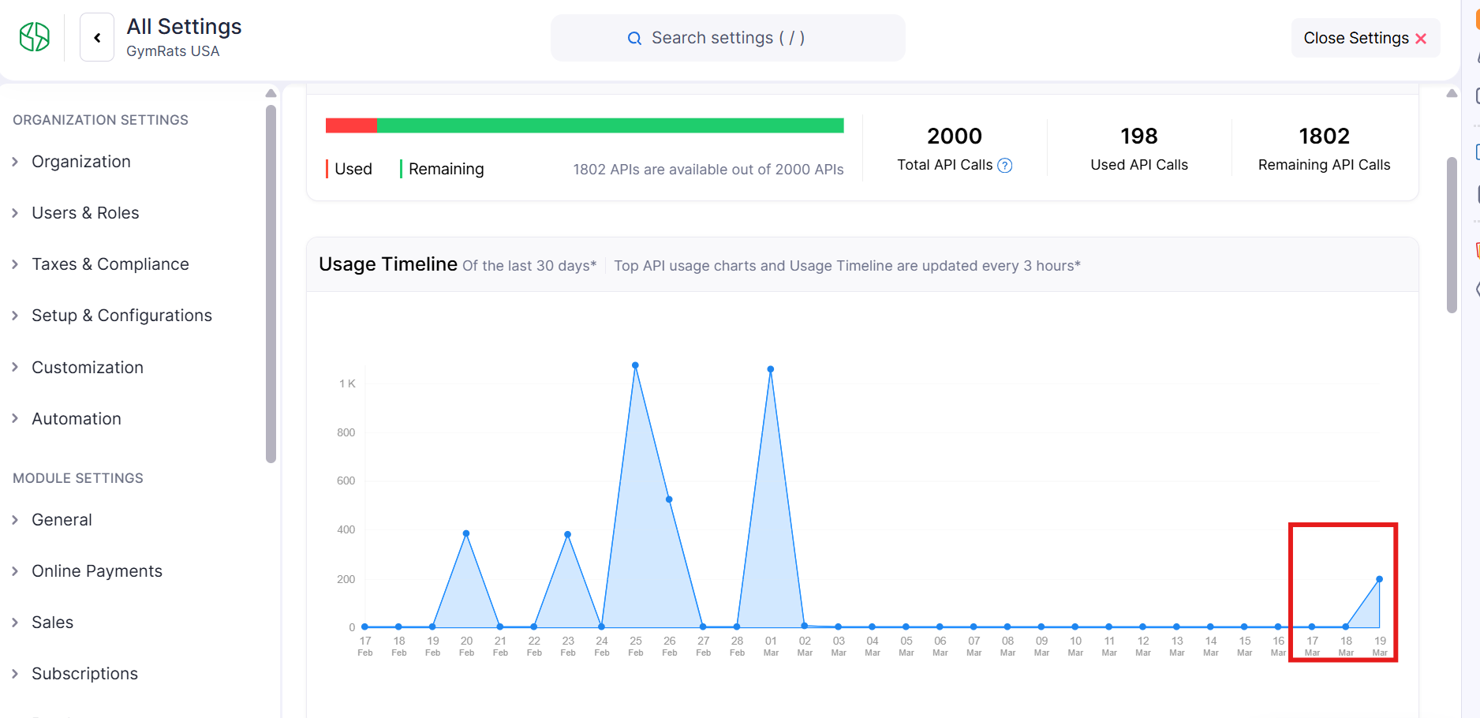
Figure B.7 API Usage for Custom Function
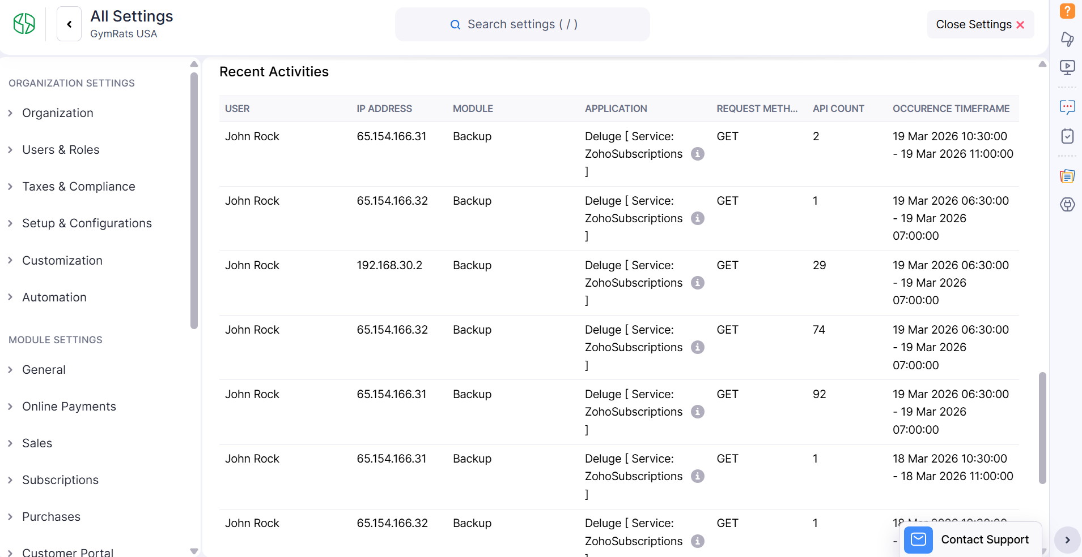
Figure B.8 Deluge Execution Logs
REFERENCES
- Zoho Corporation. (n.d.). Zoho Billing Documentation.
Available at: https://www.zoho.com/in/billing/help/
- Zoho Corporation. (n.d.). Zoho API Documentation.
Available at: https://www.zoho.com/billing/api/v1/
- Zoho Corporation. (n.d.). Deluge Scripting Guide.
Available at: https://www.zoho.com/deluge/help/
- Zoho Corporation. (n.d.). Zoho Billing Community Forum.
Available at: https://help.zoho.com/portal/en/community/zoho-billing
- Zoho Corporation. (n.d.). Zoho Knowledge Base.
Available at: https://help.zoho.com/portal/en/kb
- Zoho Corporation. (n.d.). Zoho Billing Academy.
Available at: https://www.zoho.com/billing/academy/

