AWS Task-2

Set up the Network (VPC, Subnets, IGW)

Step 1: Create the VPC
- Log in to the AWS Console and navigate to the VPC Dashboard.
- Click Create VPC.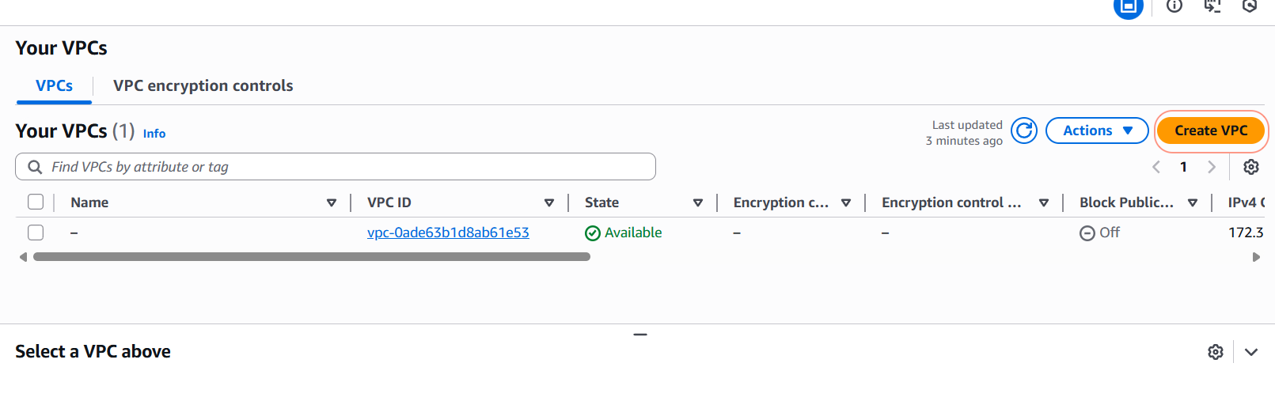
- Select VPC only.
- Name tag: My-Lab-VPC
- IPv4 CIDR block: 10.0.0.0/16
- Click Create VPC.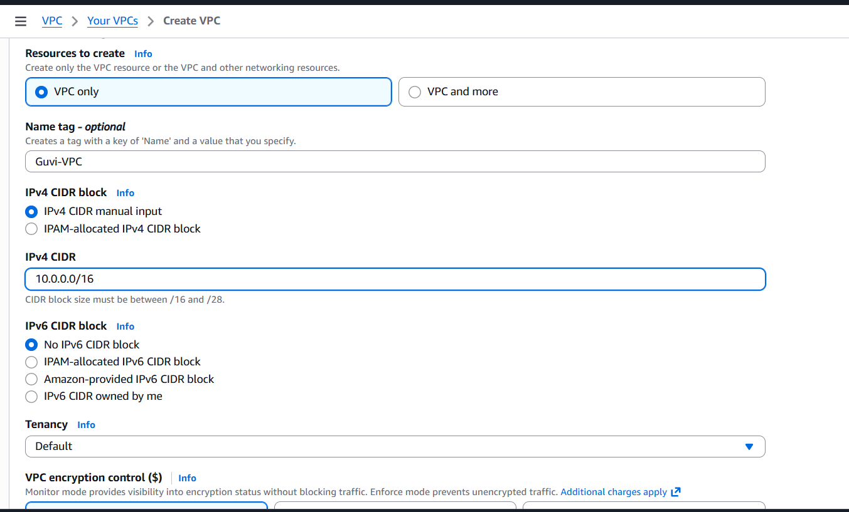

Step 2: Create the Subnets
- On the left menu, click Subnets > Create subnet.
- VPC ID: Select My-Lab-VPC.
- Subnet 1 (Public):
  - Subnet name: Public-Subnet
  - Availability Zone: Select one (e.g., us-east-1a)
  - IPv4 CIDR block: 10.0.1.0/24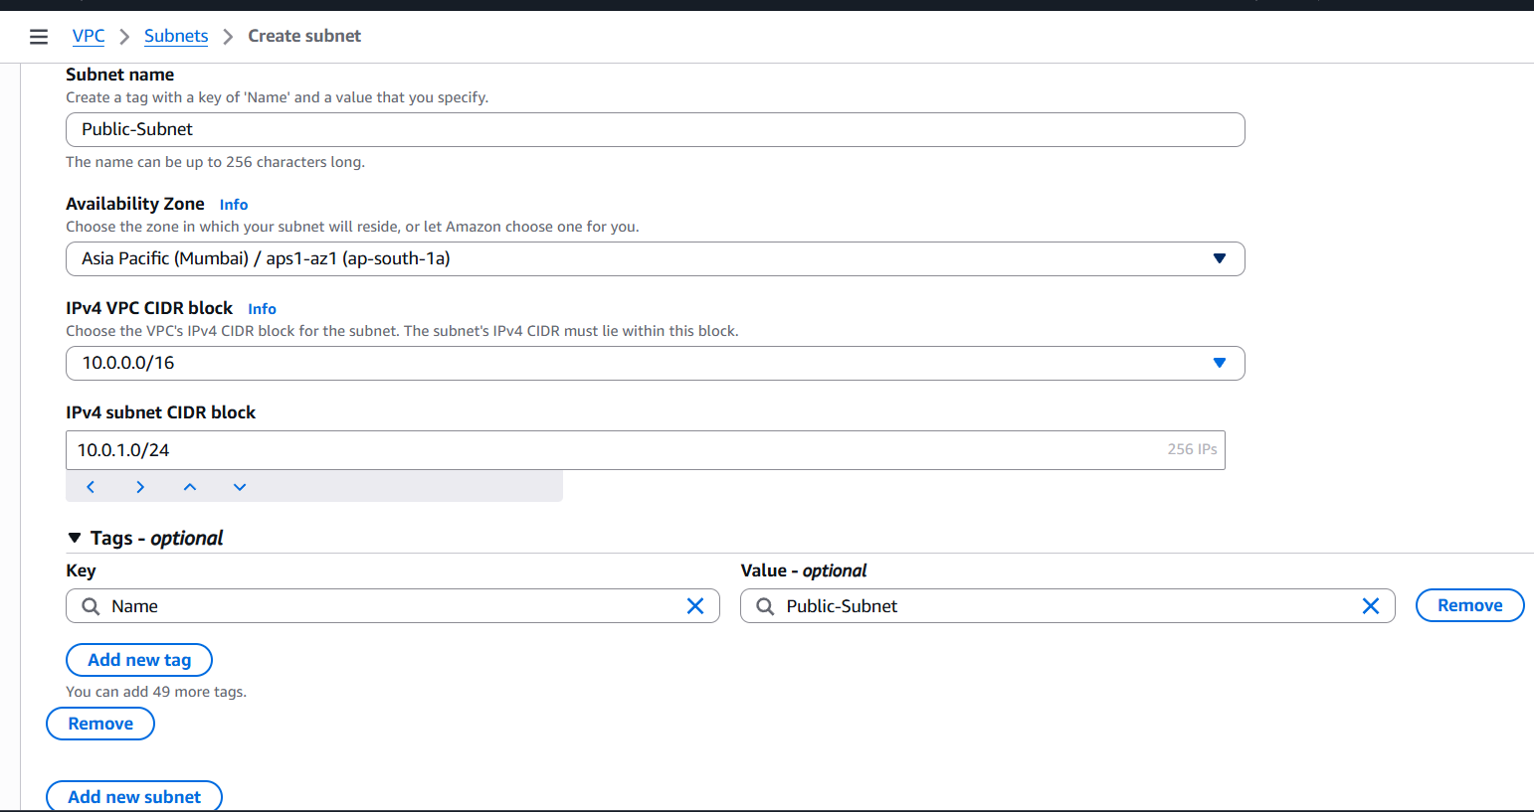
- Click Add new subnet to add the second one immediately.
- Subnet 2 (Private):
  - Subnet name: Private-Subnet
  - Availability Zone: Select a different one for high availability (e.g., us-east-1b)
  - IPv4 CIDR block: 10.0.2.0/24
- Click Create subnet.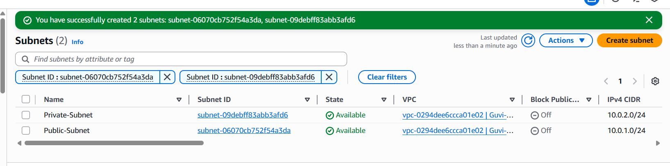

Step 3: Create and Attach Internet Gateway
- On the left menu, click Internet gateways > Create internet gateway.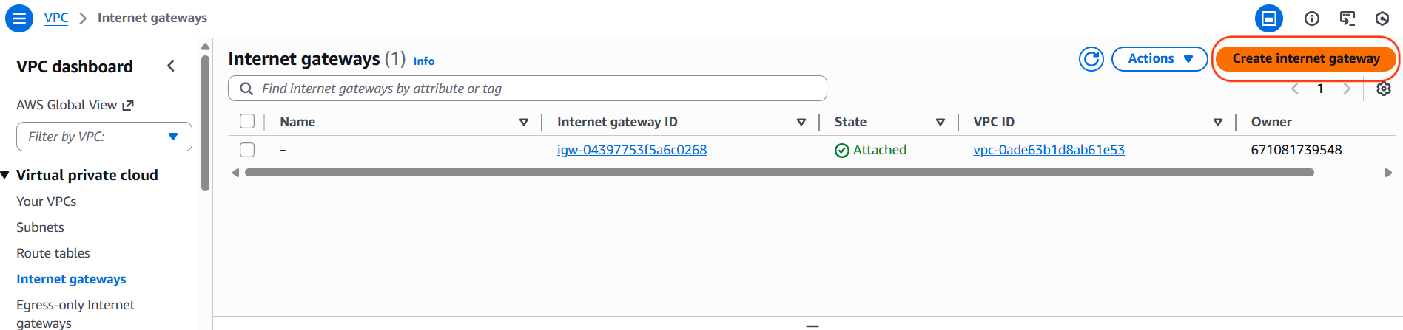
- Name tag: My-Lab-IGW.
- Click Create internet gateway.
- Once created, click Actions (top right) > Attach to VPC.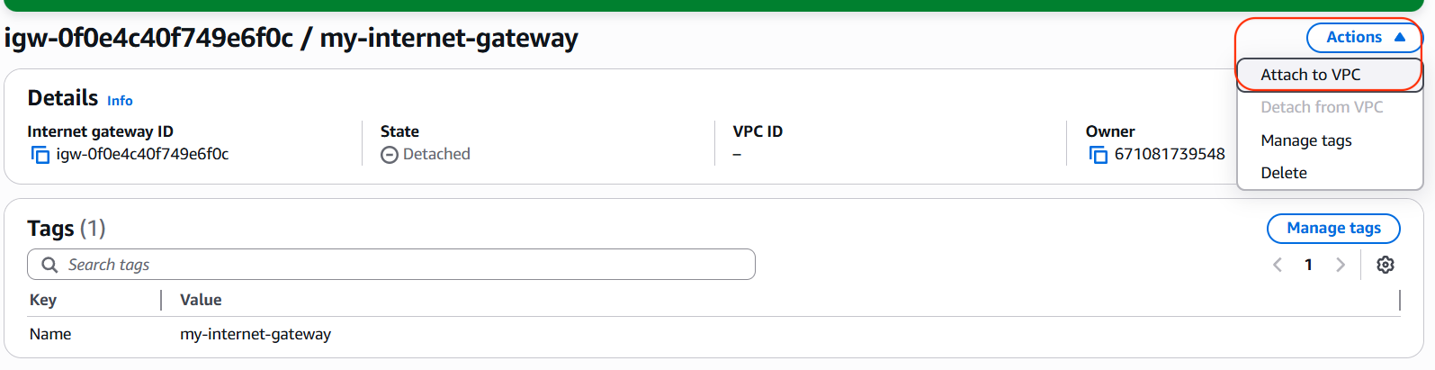
- Select My-Lab-VPC and click Attach internet gateway
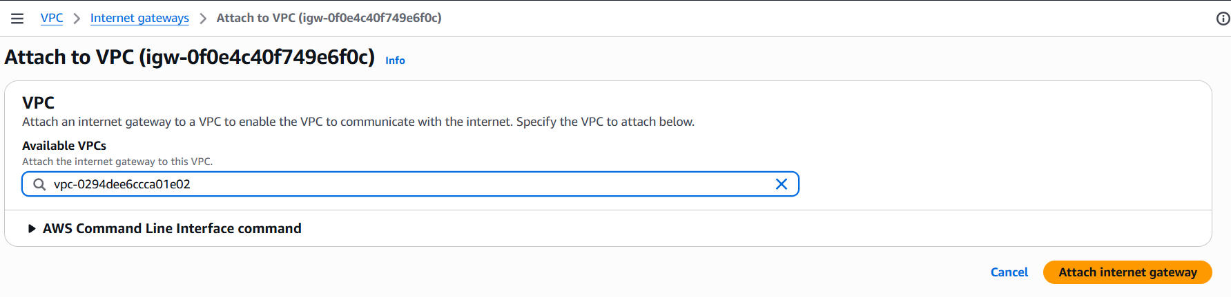

Step 4: Configure Route Tables
To make a subnet "Public," it must have a route table that directs traffic to the Internet Gateway.
- On the left menu, click Route tables > Create route table.
- Name: Public-Route-Table.
- VPC: Select My-Lab-VPC.
- Click Create route table.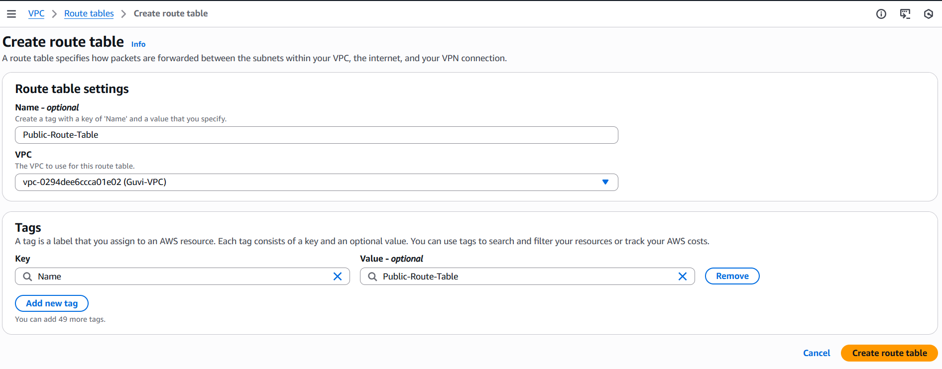
- Add the Route:
  - Scroll down to the Routes tab and click Edit routes.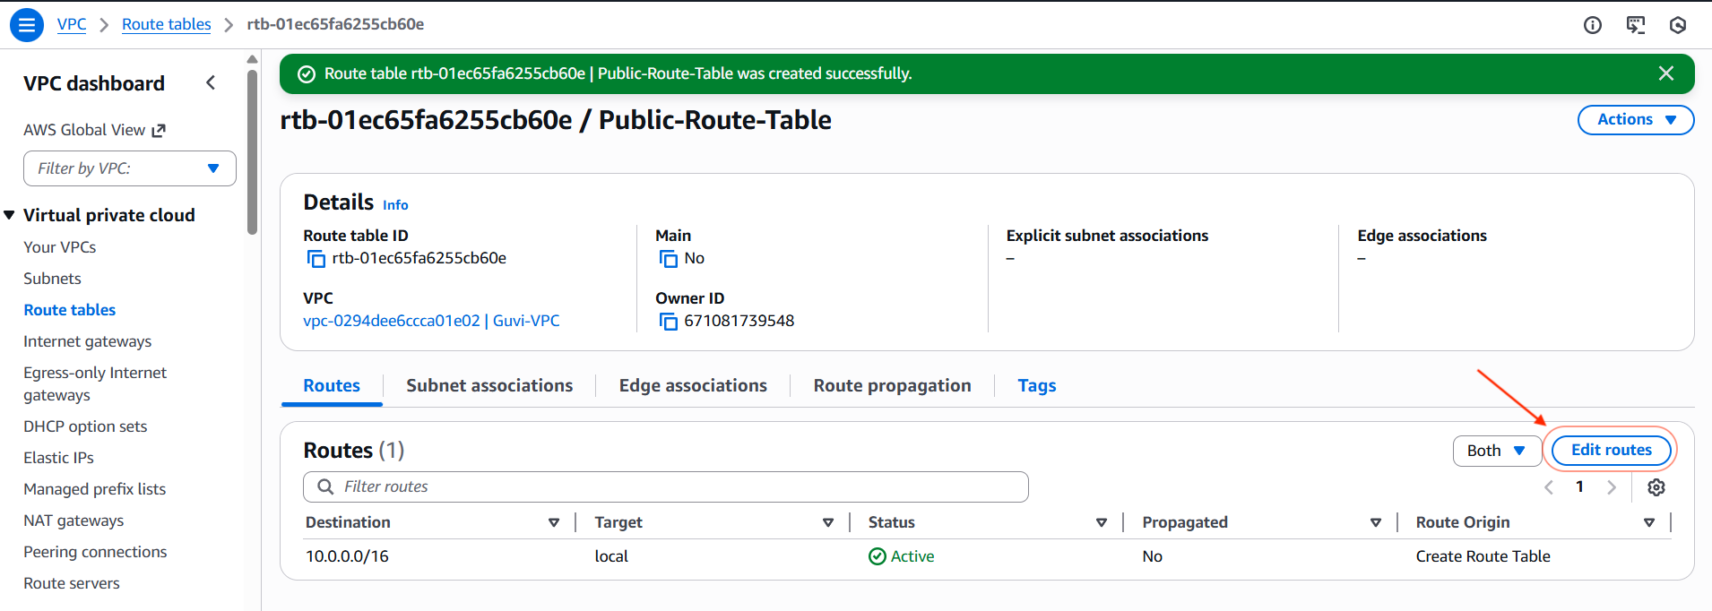
  - Click Add route.
  - Destination: 0.0.0.0/0 (This represents the internet).
  - Target: Select Internet Gateway, then choose My-Lab-IGW.
  - Click Save changes.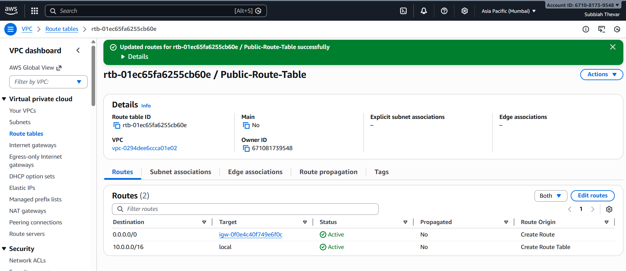
- Associate the Subnet:
  - Click the Subnet associations tab > Edit subnet associations.
  - Select only the Public-Subnet. (Leave the Private Subnet unchecked; this keeps it private).
  - Click Save associations.

Launch the EC2 Instance
Now we will launch a server inside the Public-Subnet we just created.
- Navigate to the EC2 Dashboard.
- Click Launch instance.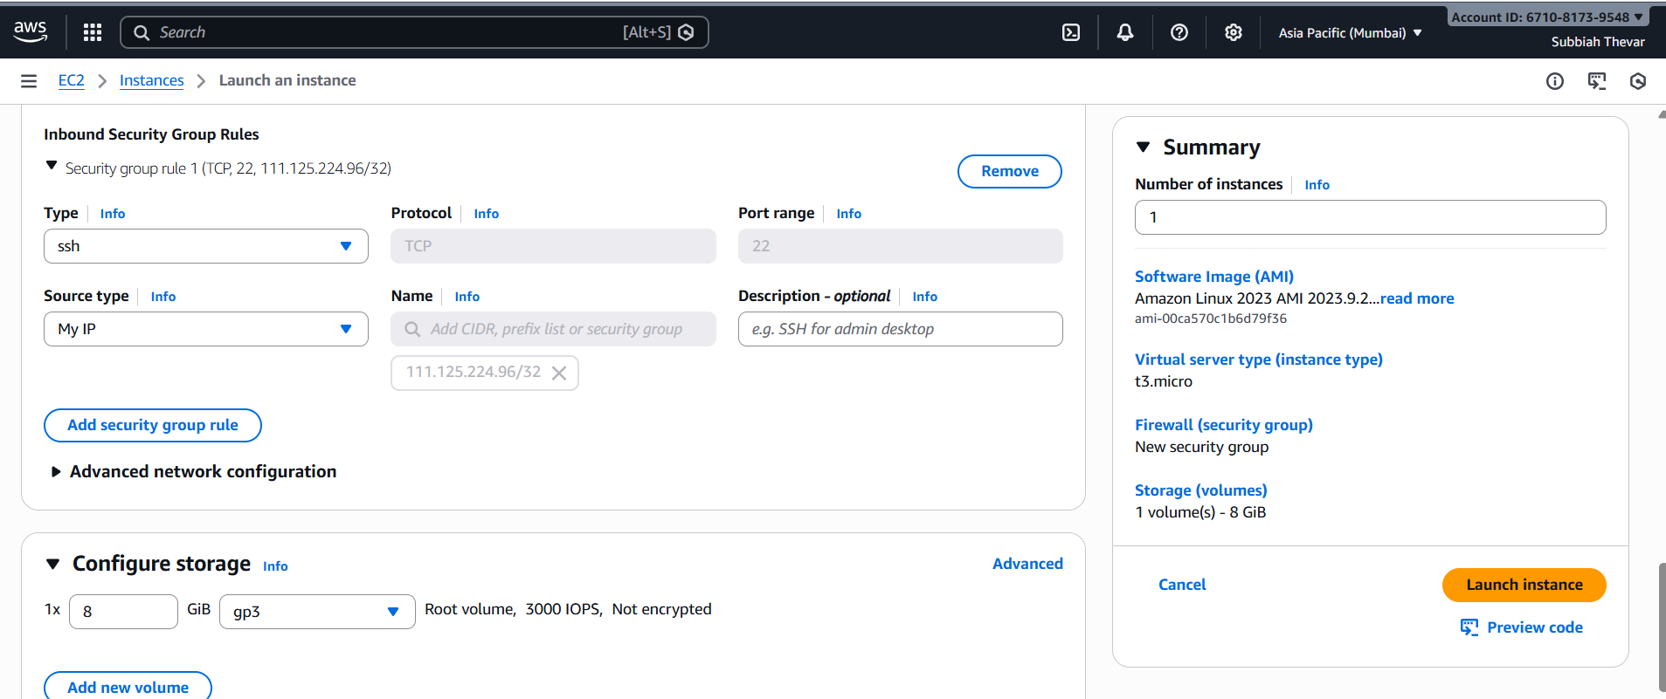
- Name: My-Public-Server.
- OS Image: Select Amazon Linux.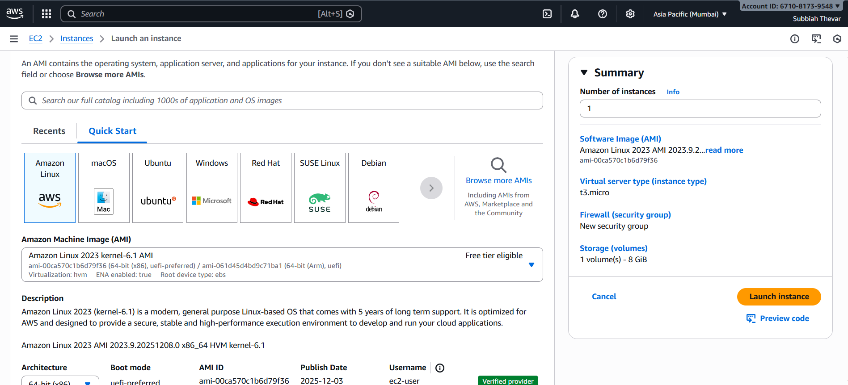
- Instance Type: t2.micro (Free tier eligible).
- Key Pair: Select an existing key pair or create a new one (save the .pem file).
- Network settings (Crucial Step):
  - Click Edit (top right of the Network box).
  - VPC: Select My-Lab-VPC.
  - Subnet: Select Public-Subnet.
  - Auto-assign public IP: Select Enable. (Required to access the instance from the internet).
  - Security Group: Create a new group allowing SSH traffic (Port 22) from your IP.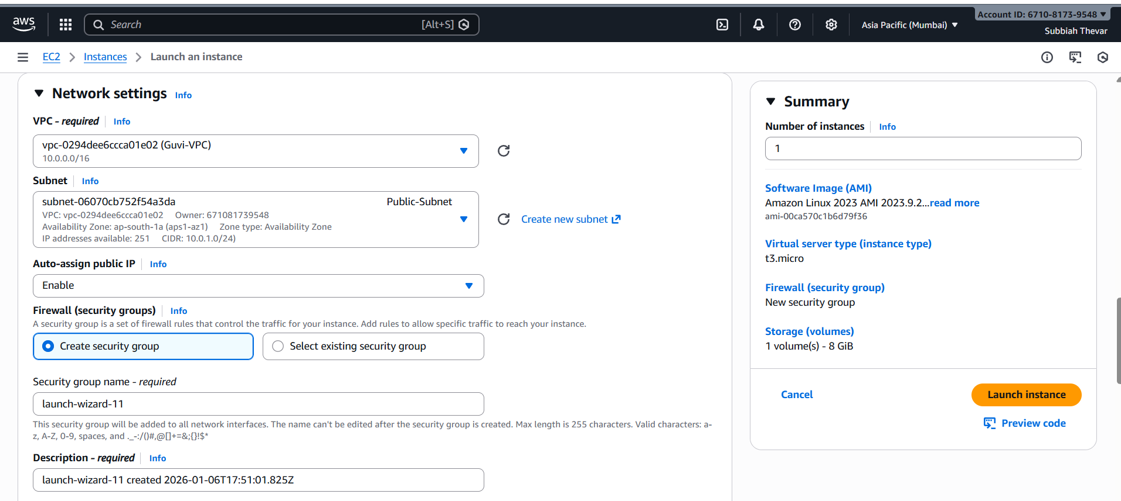
- Click Launch instance.

Verification
Once the instance state is Running:
- Select the instance in the console.
- Copy the Public IPv4 address.
- Open your terminal/command prompt and try to connect: ssh -i "your-key.pem" ec2-user@<Public-IP-Address>
My command: ssh -i demo-key-pair-guvi-19-dec.pem ec2-user@13.201.91.175
