DOCUMENTATION- BUS RESERVATION SYSTEM

Login For Customer:

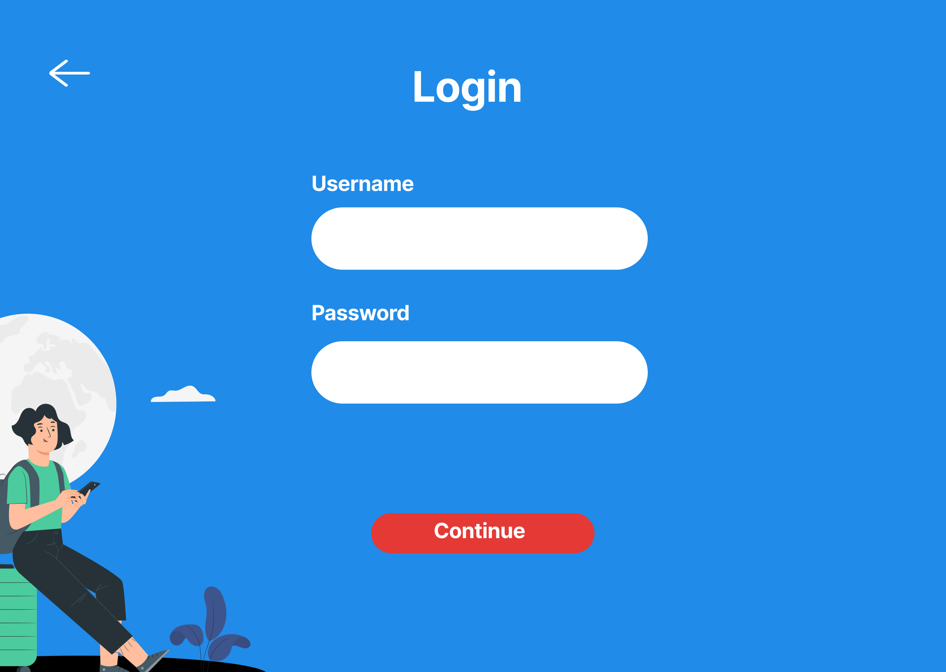

@GetMapping("/user/login")

Login For BusOperator:

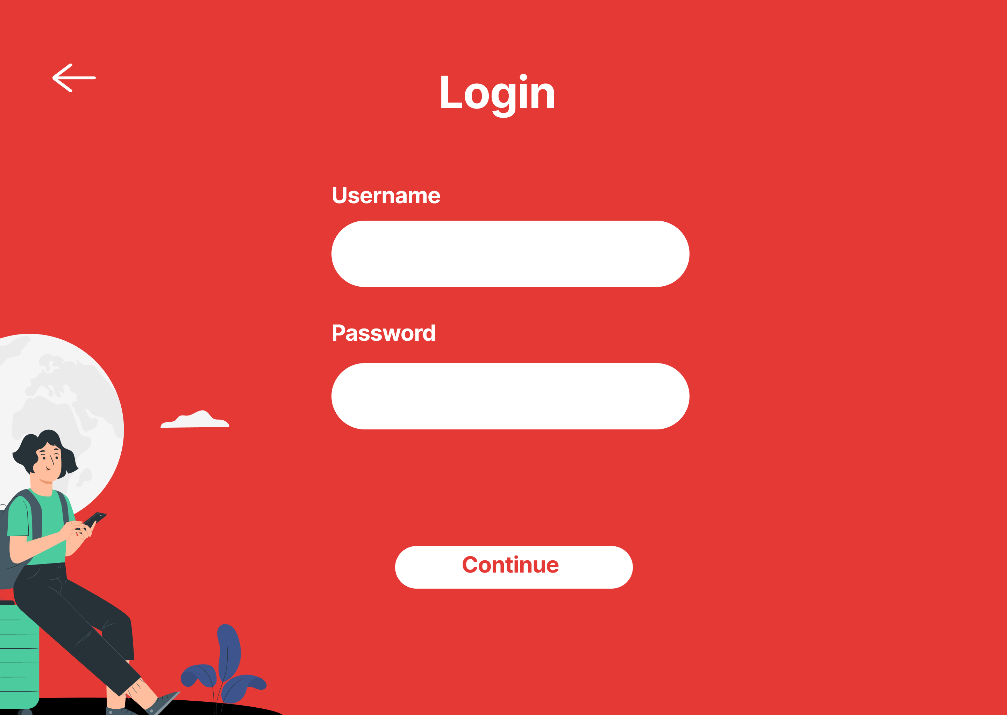

@GetMapping("/user/login")

Login For Executive:

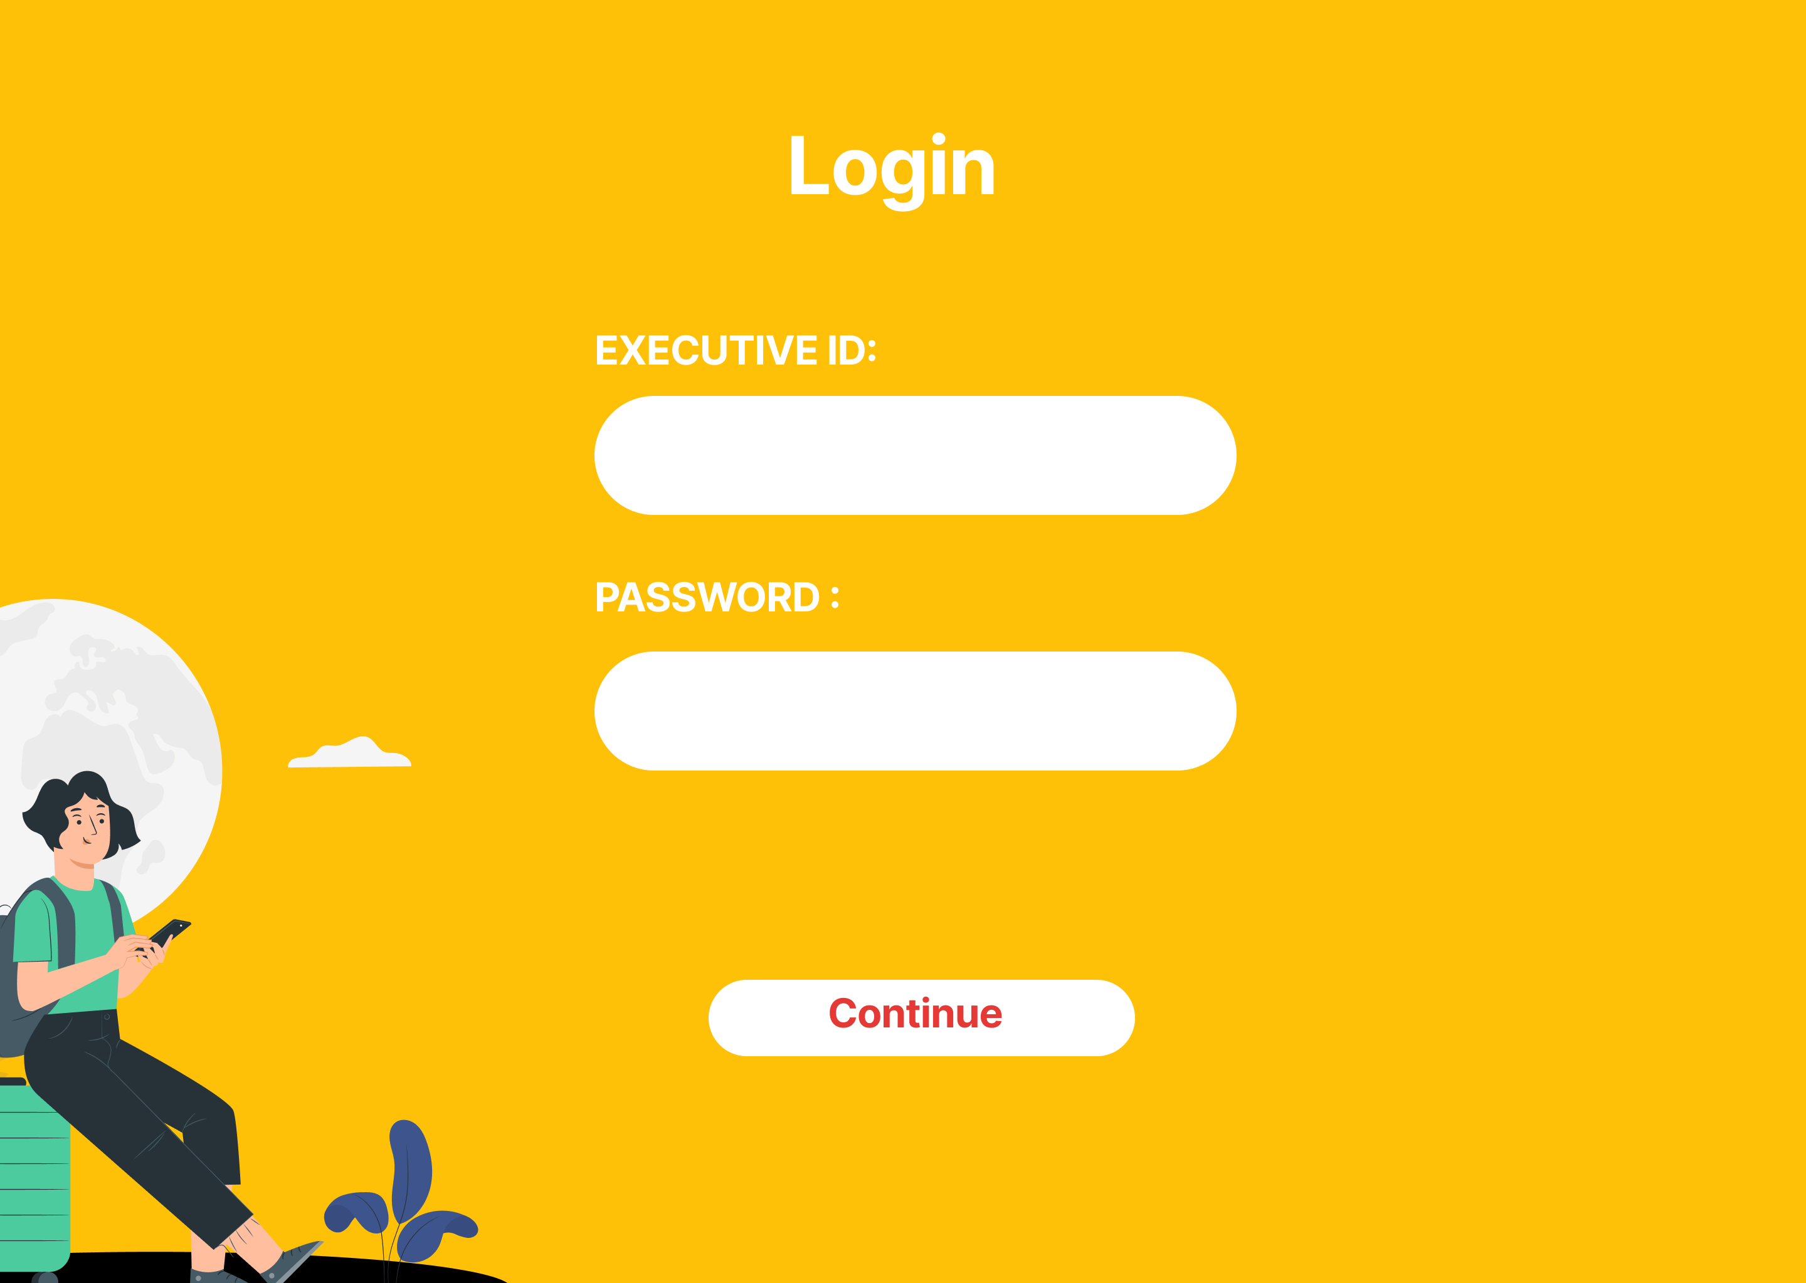

@GetMapping("/user/login")

Search Bus:

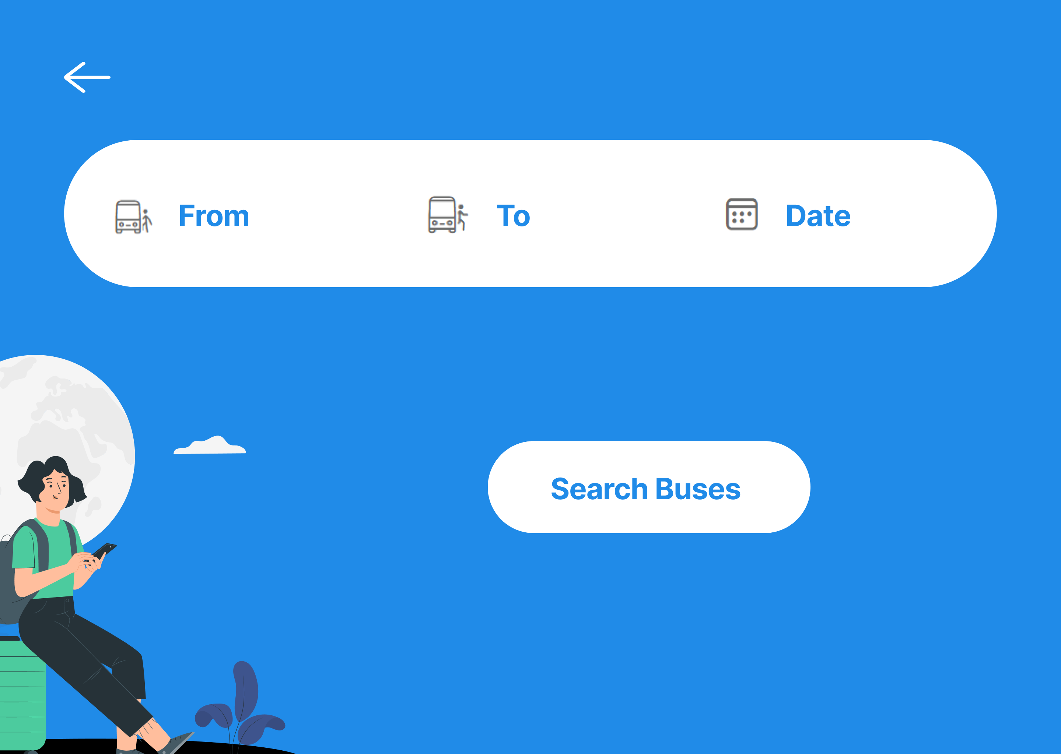

@GetMapping("/get/{source}/{destination}/{date}")

5. Select Bus:

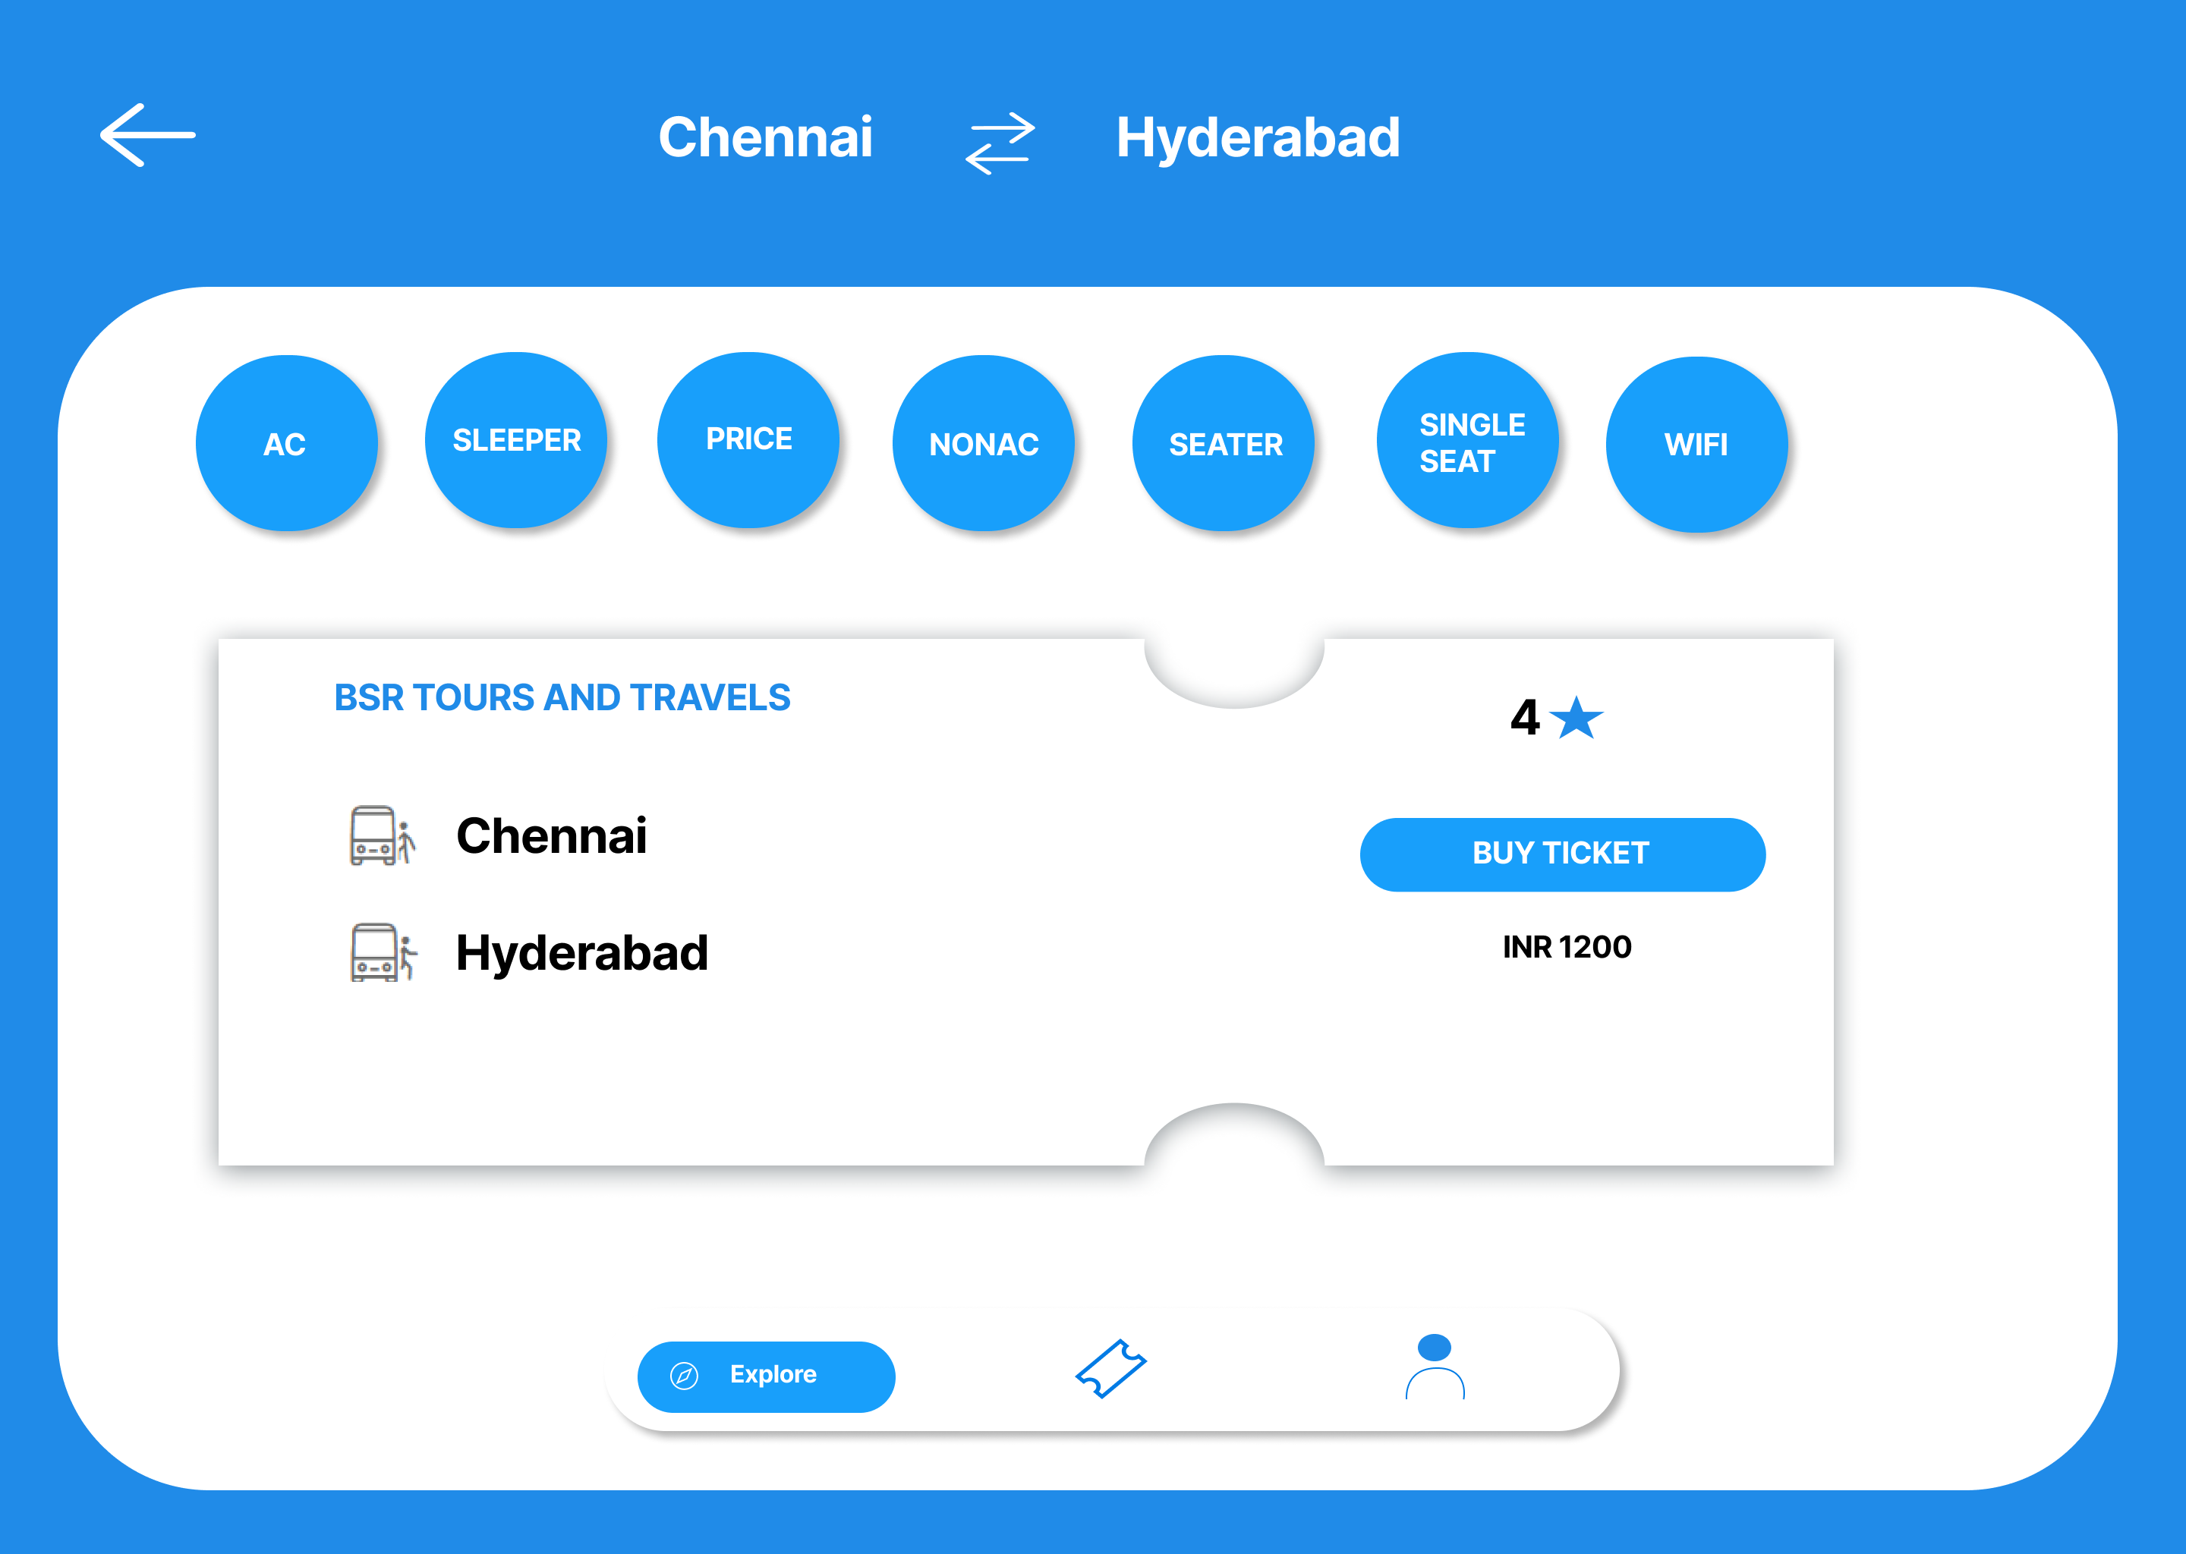

@GetMapping("/get/{bid}")

Select Seats:

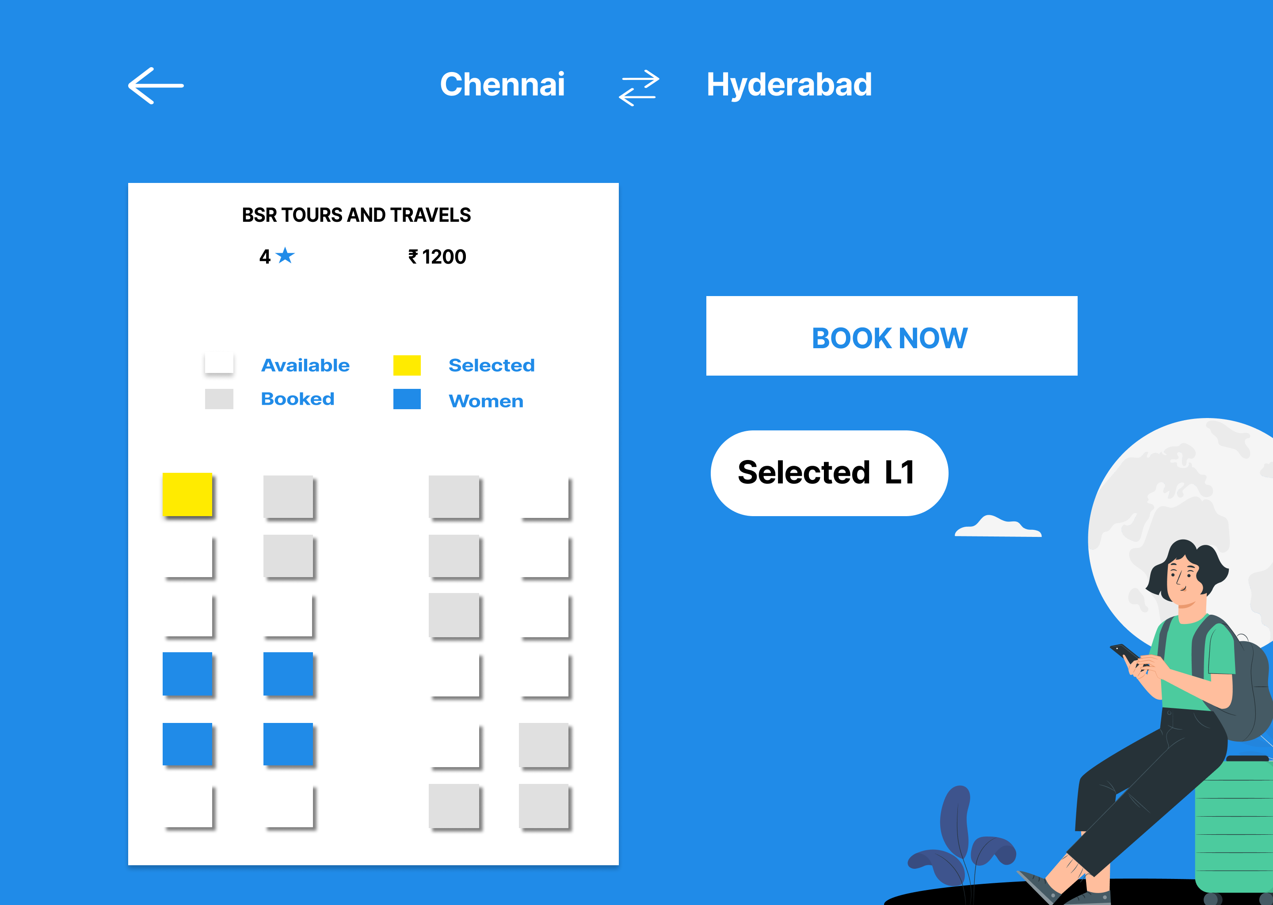

@PostMapping("/booking/multiple/{cid}/{bid}")

Booked Status:

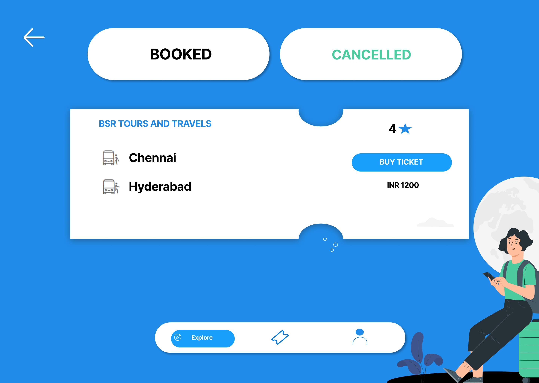

@GetMapping("/bookings/{cid}")

BusOperator Bus Add:

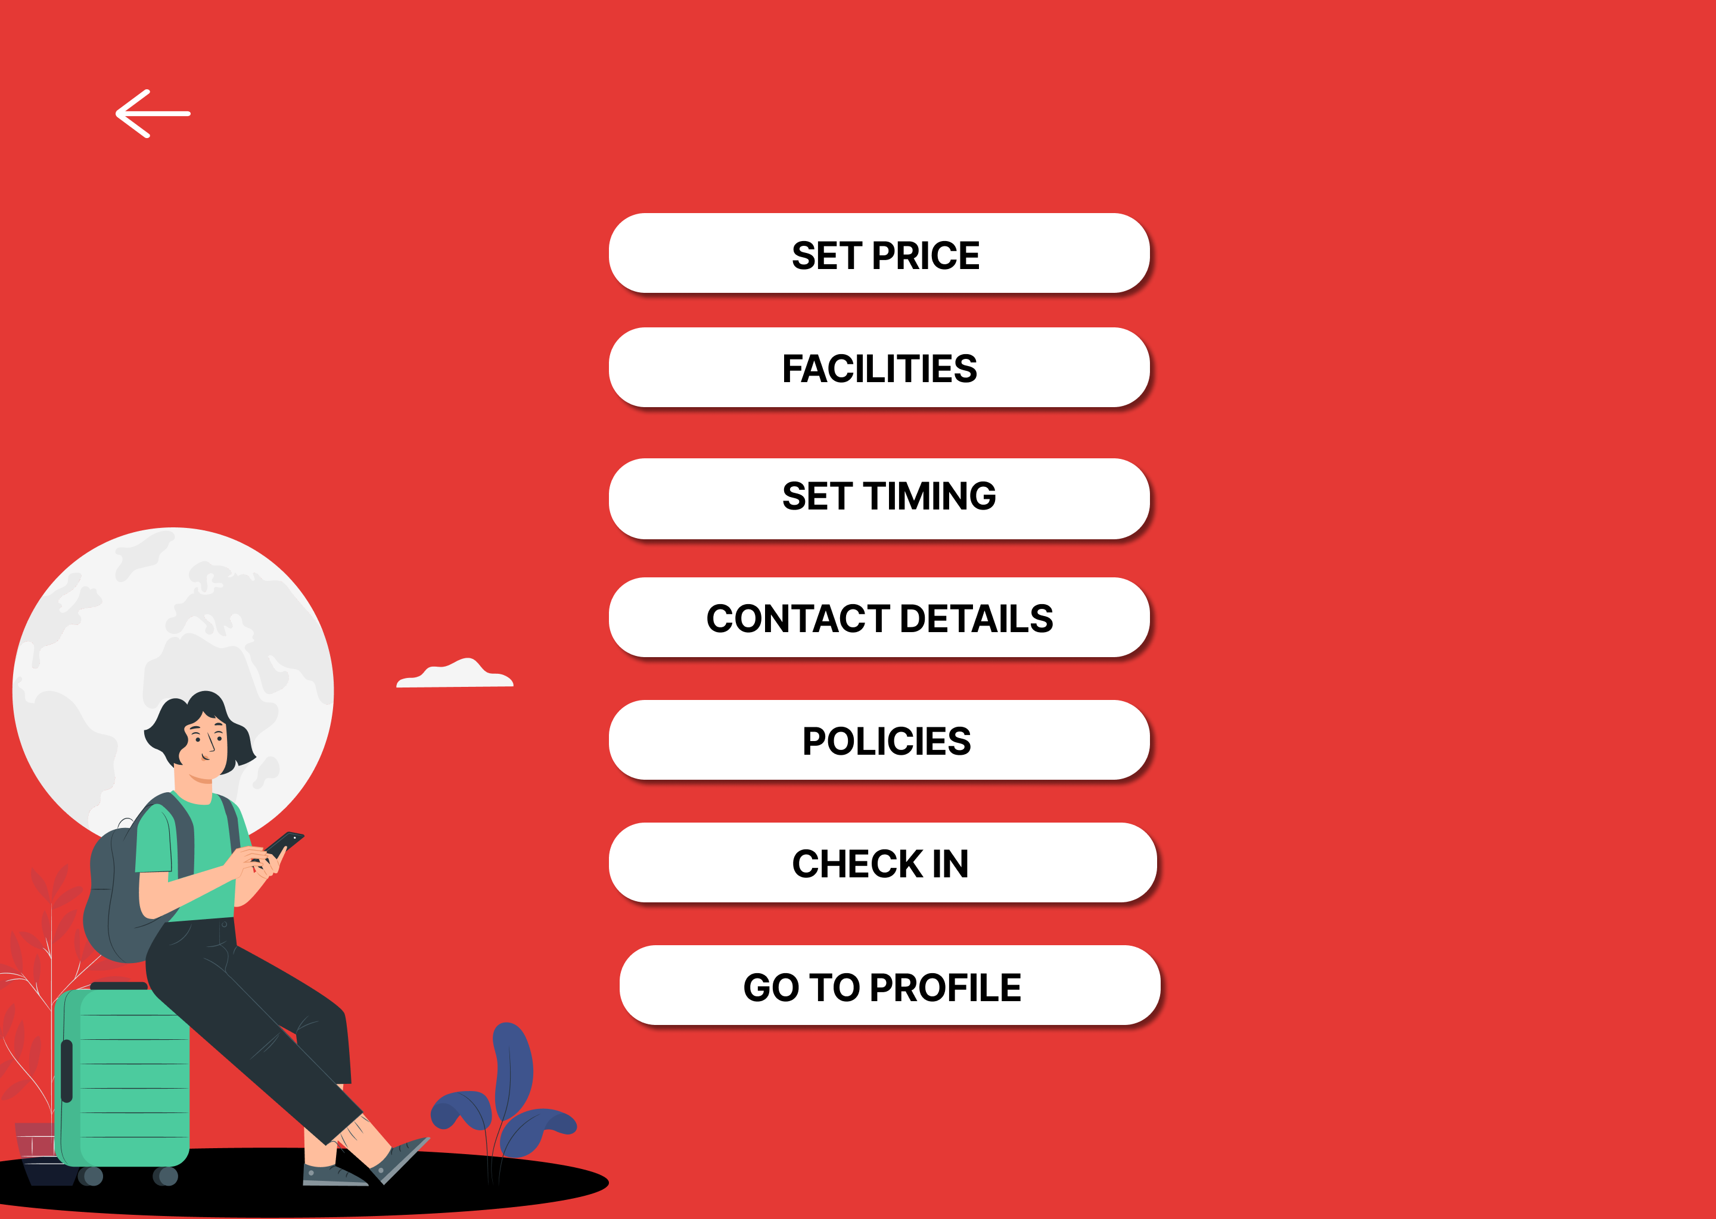

@PostMapping("/add/{bid}/{boid}")

@PutMapping("/update/{boid}")

@DeleteMapping("/bus/delete/{bid}")

@GetMapping("/get/bus/{boid}")

@GetMapping("/get/{boid}")

@GetMapping("/get/busSchedule/{boid}")

Executive Update/delete/Get:

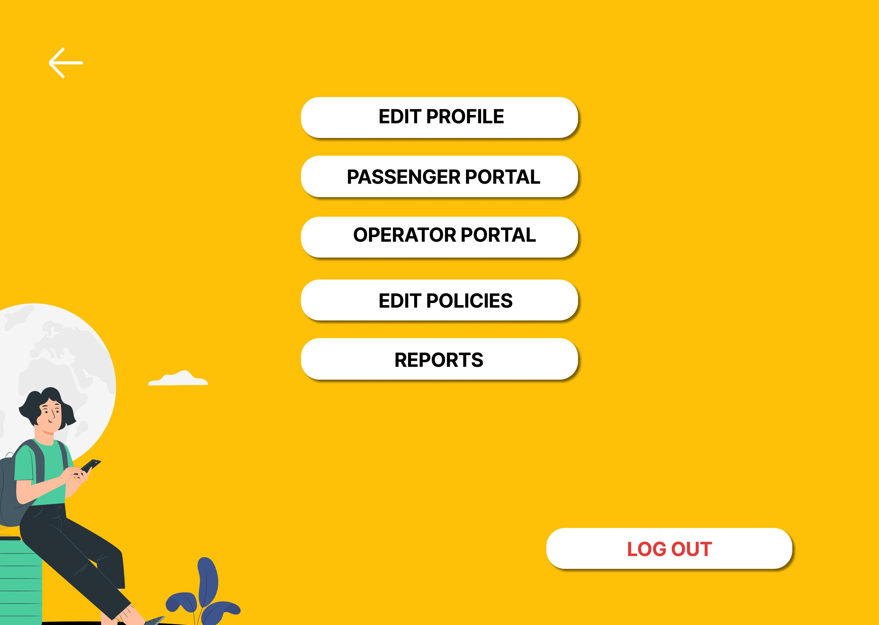

@GetMapping("/get/bus/{eid}")

@GetMapping("/get/busOperator/{eid}")

@GetMapping("/get/customer")

@DeleteMapping("/delete/busOperator/{boid}")



