

EEM 343 ROBOTICS

TASK 4

NAME: SUBRAMANIAN A/L SIVANESAN (139495)

LECTURER: ASSOCIATE PROFESSOR DR. MUHAMMAD NASIRUDDIN MAHYUDDIN

DATE OF SUBMISSION: 15h July 2020

**ENVIRONMENTAL & SUSTAINABILITY FEATURE**

The progressive interaction between robotics and plants, which is increasing rapidly through the development of sensors, actuators, and mechatronics, must also be evaluated in terms of social and environmental sustainability issues. My robot also follows 4 aspects of environmental and sustainability consideration.

This fruit plucking robot aid in the energy-saving process because they do not require as much energy to operate as humans do. For example, humans need a factory with sufficient lighting and heat, whereas robots can work in a cold and dark factory. This drastically reduces the amount of energy used in the production process. It is estimated that for every 1C reduced in factory heat levels, there is a potential saving of up to 8%.

Next, this robot is improving the sustainable practices of manufacturers is by reducing waste because they can be extremely accurate and minimize the error. This helps the plant become more efficient in that everything that they produce is being used, and there is no waste that is discarded that would impact the environment.

Regardless of whether it's reducing waste or decreasing the amount of energy expected to harvest the fruit, this robot is without a doubt helping manufactures become greener.

The robot is planned to be made using recycled items in the future if it developed into hardware. Through reusing materials, we can reduce the interest for new materials. This process can decrease the level of pollution which are radiated as we make new materials. Recycling makes financial as well as an environmental sense for businesses.  The cost of using recycled material is much less than the cost of creating brand new material with which to work.  therefore, through using recycled materials, businesses can lower their costs.

**This fruit plucking robot mainly runs in battery and electricity. Therefore, it will not cause air pollution.**

Development Process

As seen in the figure 1 below, this was my robot until task 3. I stared off this task by adding the gripper into it. I had some problems when adding it initially.

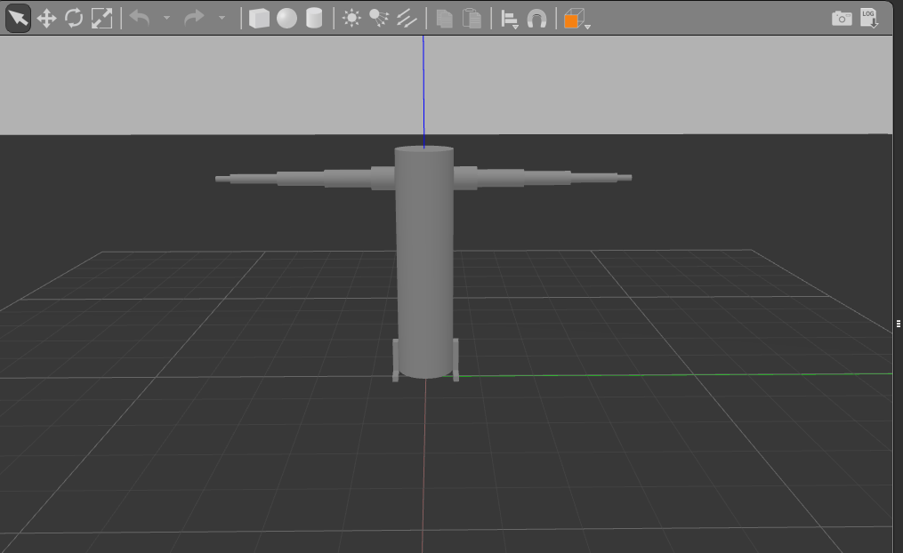

Figure 1

This figure 2 shows the gripper which is the end effector has been added to for plucking the fruit.

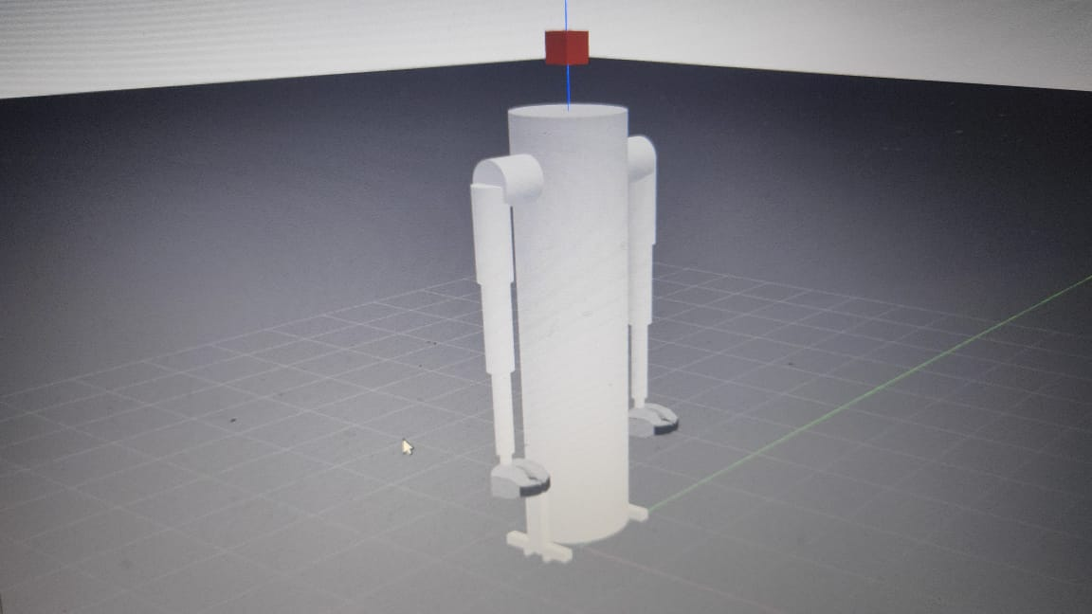

Figure 2

Then the kinect camera was added to the robot. It can see a 4 meter distance only.

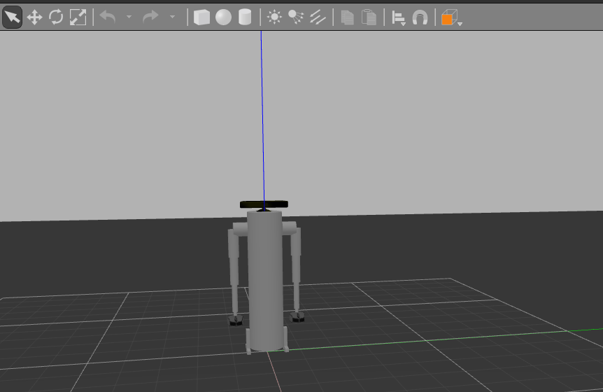

Figure 3

This figure 4 shows the robot in rviz. As we can see the object is not present in the camera place.

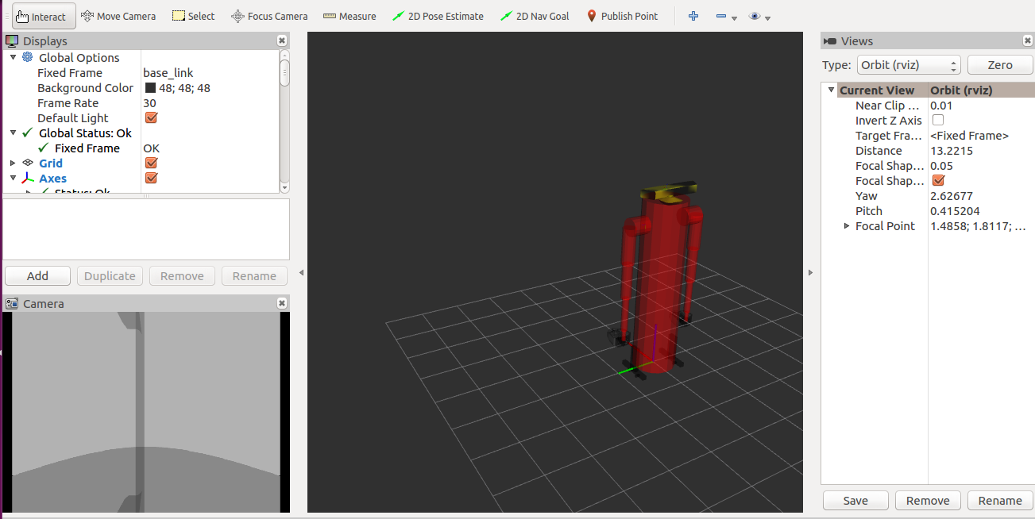

Figure 4

This figure 5 shows an image is placed in the gazebo and the object can be seen by the camera as seen in the right-hand side.

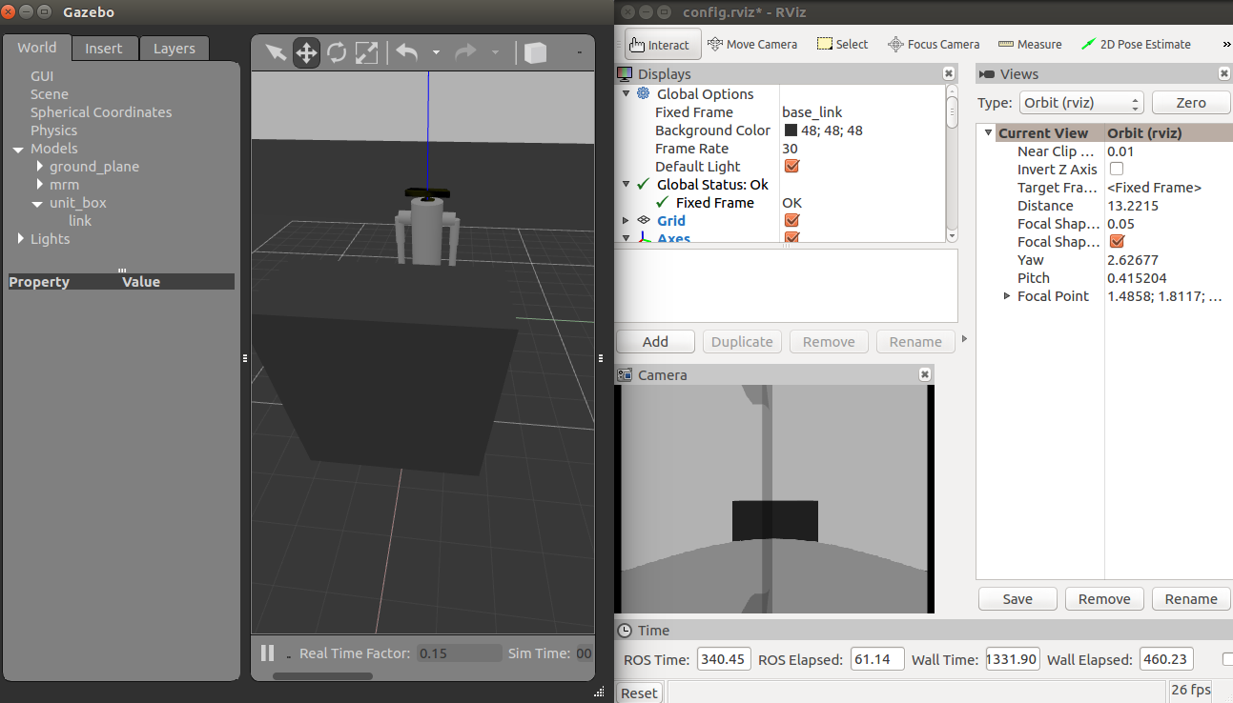

Figure 5

Next my robot can move also. I have installed the teleop_twist_keyboard. So as see in the figure 6 by pressing ‘I’ the robot moves front and by pressing ‘,’ the robot moves back. This are some important things to take note.

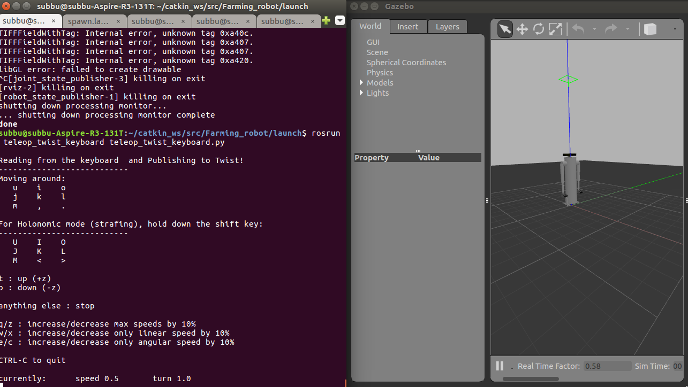

Figure 6

Then the basket was added into one of the robot hands. The idea is to place the sphere object(fruit) into the basket. The basket was downloaded from an open source website.

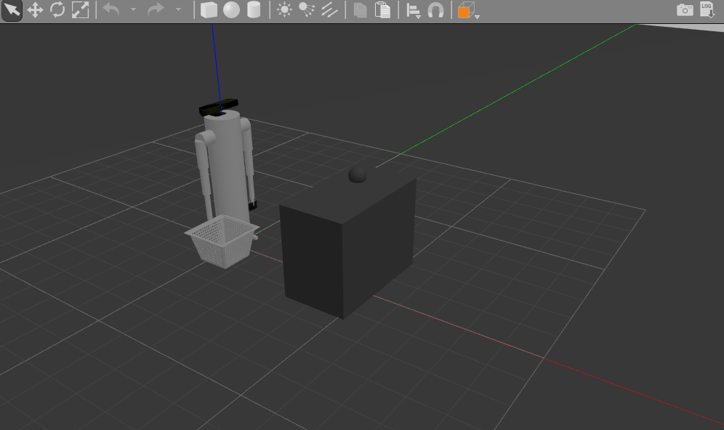

Figure 7

Figure 8 shows the fruit is being plucked.

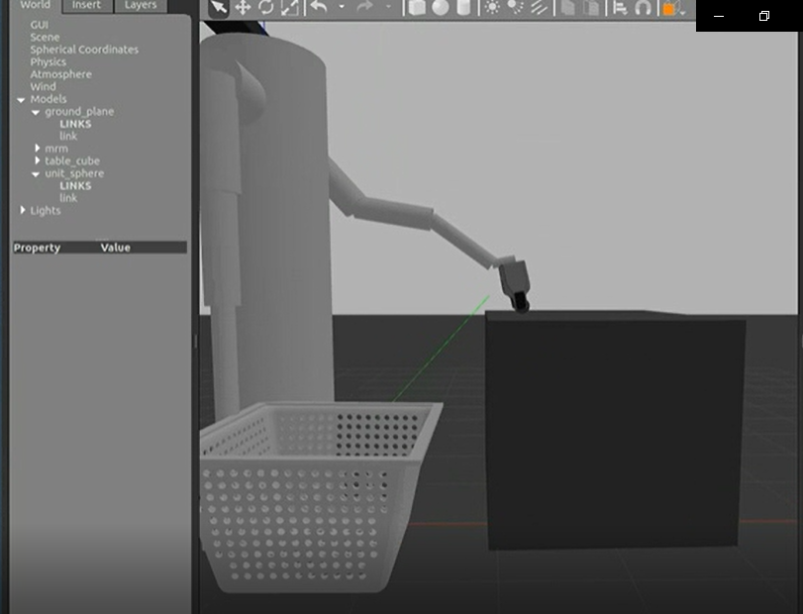

Figure 8

This final figure 9 shows the object has been picked and dropped into the basket.

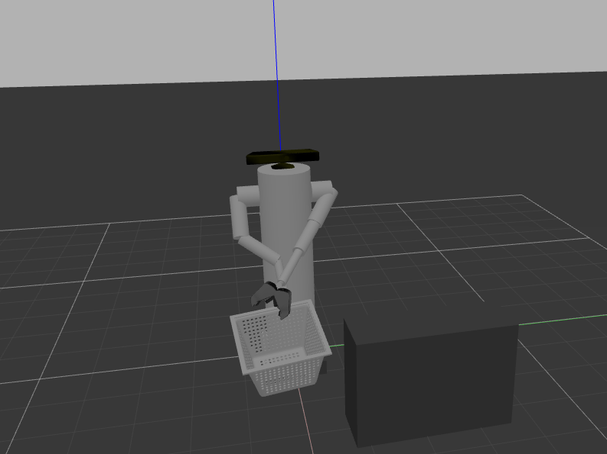

Figure 9

Future works

The simulation tests provided valuable insights in the performance of the system and how its modules functioned together. The following bottlenecks and possible improvements have been identified:

Ways to increase performance of the submodules for detection, reaching, picking, and catching should be further investigated. Compared with the overall size of the platform, the robotic arm (and its workspace) is rather small. However, an arm with longer joints will most likely also have more difficulties to plan and execute a collision free motion in this dense environment. An arm with more DOF will increase the computational efforts to plan the trajectory

A smaller end effector would increase reachability and would decrease the risk of collisions with the crop (future development). The current end effector is slightly big. Increasing the efficiency of the end effector in the future. The efficiency of the camera should be increased.

The robot designed will be more towards human interaction in the future. It must have human interaction to compensate for programming complexity issues.