Program Structures and Algorithms

Spring 2023(SEC 3)

NAME: Subbu Manickam

NUID: 002768764

**Task:** Assignment 1 - Random Walk – To find the relationship between d and m

**Relationship Conclusion:** The total mean distance (d) is directly proportional to the square root of number of steps (m).

**d = k (m)^0.**5, where k is any constant

**Evidence to support that conclusion:** As the number of steps (m) increases the mean distance (d) increases as a product of the square root of the value.

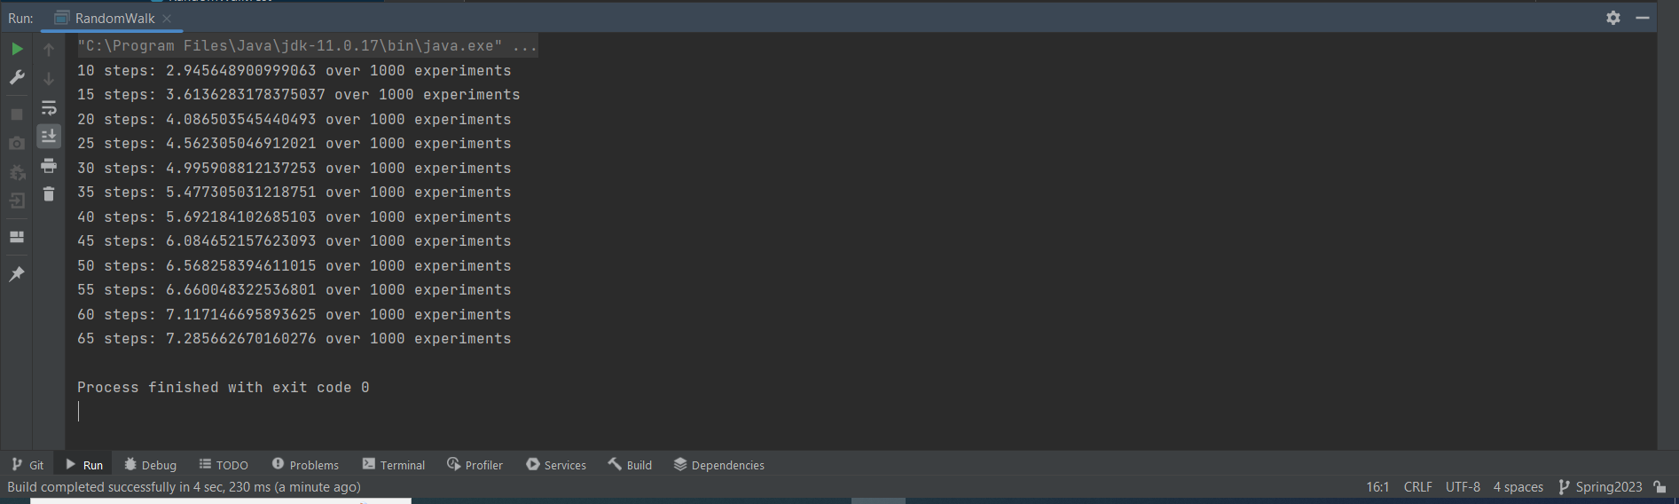

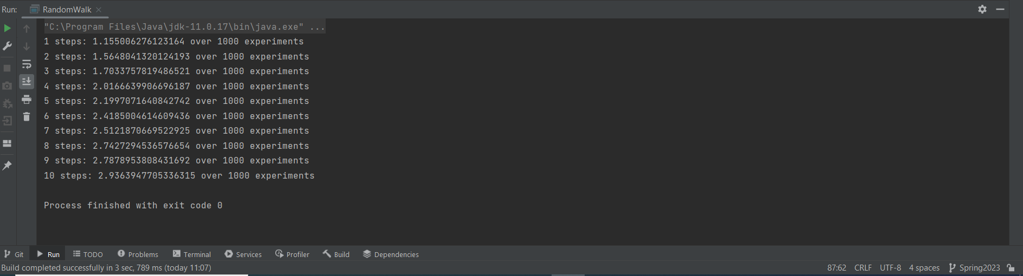

**Graphical Representation:** Thebelow image shows the comparison of the two parameters d and m in a graphical format.

* The correlation coefficient (~1), confirms that m and d have a direct proportionality
* The graph resembles a logarithmic plot
* By converting the graph to (log m) vs (log d), we get a linear curve
* The calculated slope of the plot is 0.485 which is approximately 0.5
* Logarithmic slope relation equation is x = k (y)^m, where k is a constant and m is the slope of the graph
* Thus d = k (m)^0.5, where k is any constant

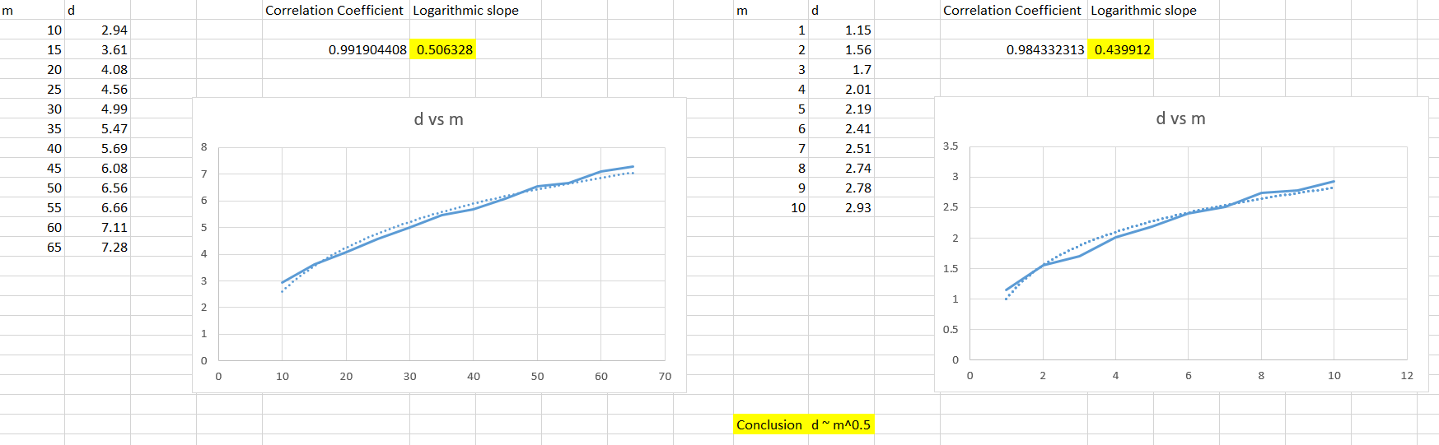

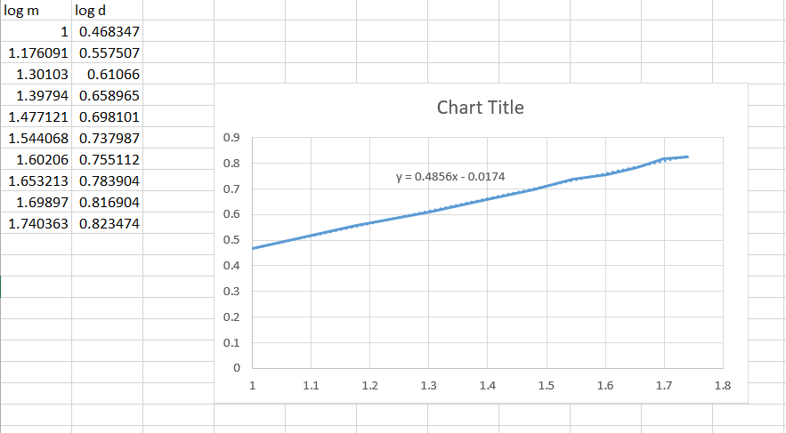

**Unit Tests Screenshot:**



**Code Snippet:**

