Program Structures and Algorithms

Spring 2023(SEC 3)

NAME: Subbu Manickam

NUID: 002768764

**Task:** Benchmark various solutions of Three Sum algorithm

**Relationship Conclusion:** The benchmarking timings are in the following order

Quadratic ~ Quadratic With Calipers < Quadrithmic < Cubic

**Evidence to support that conclusion:** From thegraphs of log(N) vs log(Three Sum method), we can conclude that Cubic takes more time to execute than Quadratic and Quadrithmic.

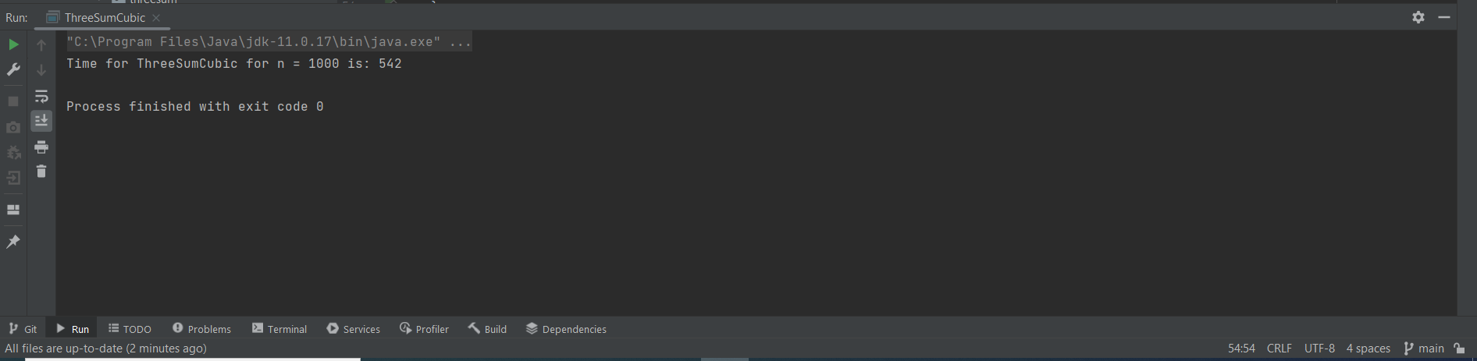

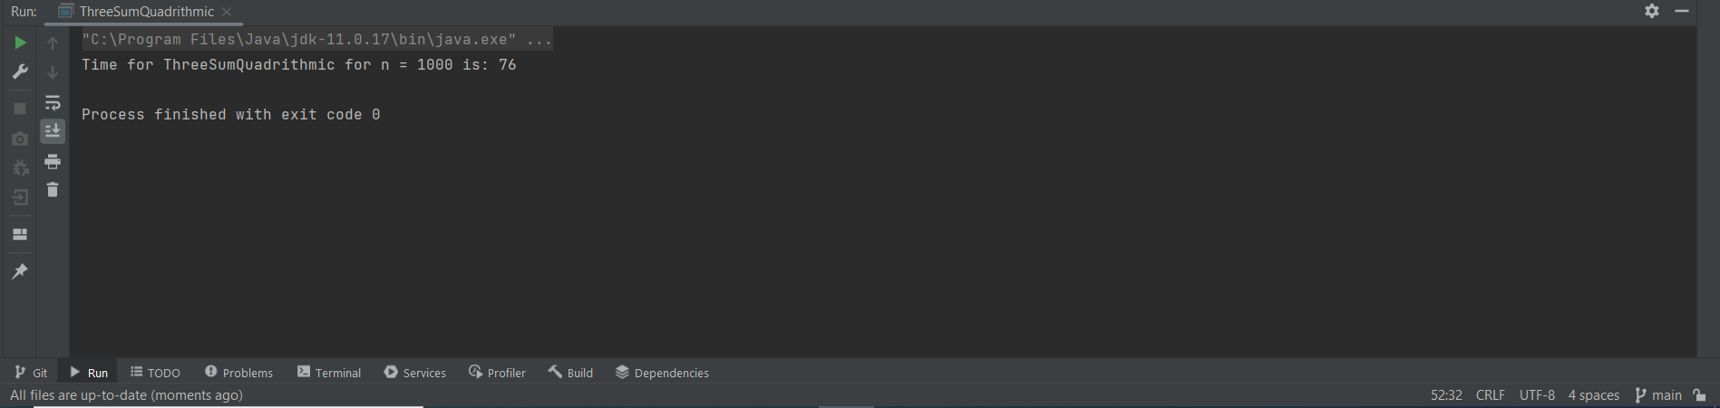

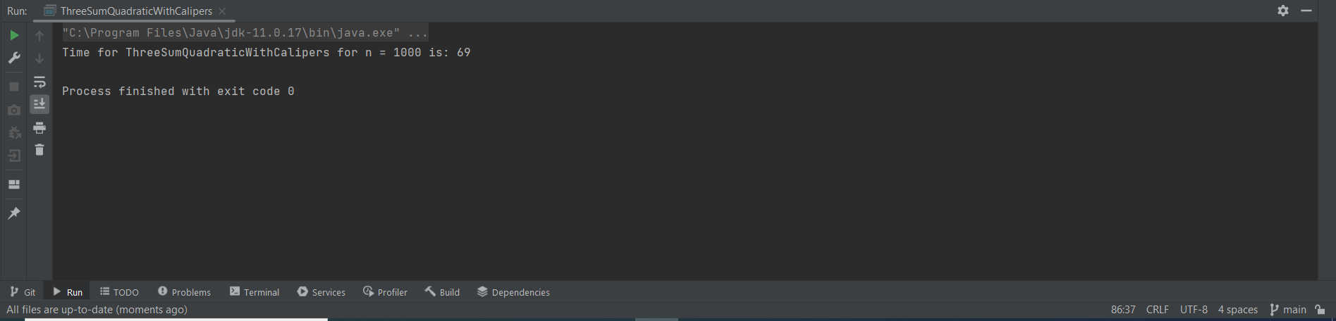

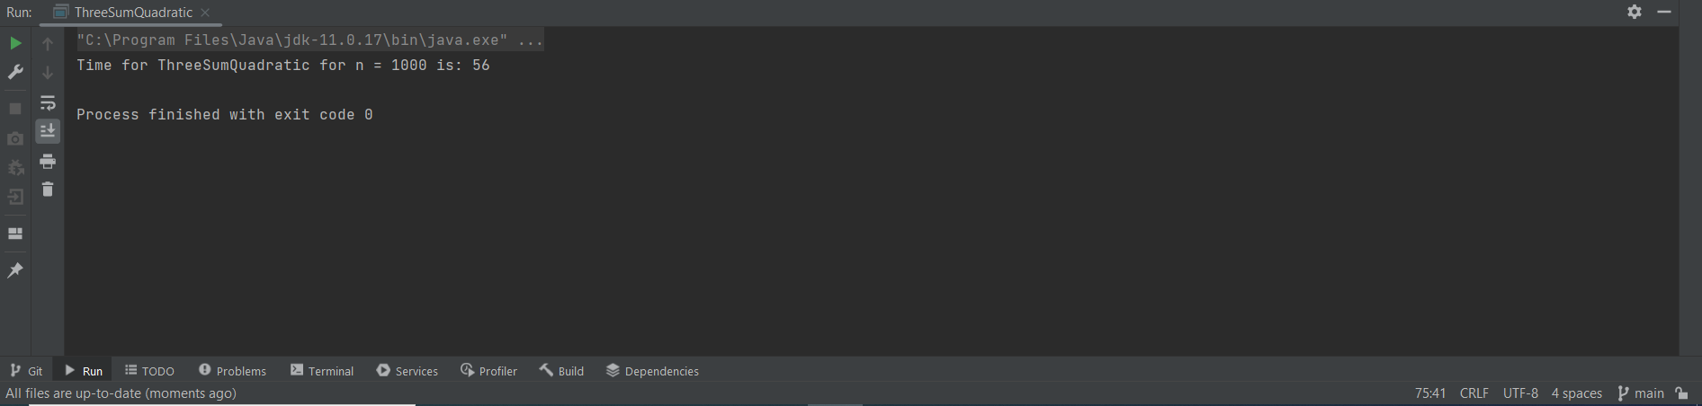

**Graphical Representation:** Using the doubling method, we have benchmarked the timings for N = {1000, 2000, 4000, 8000, 16000} and plotted the graph of log(N) vs log(time for each method).

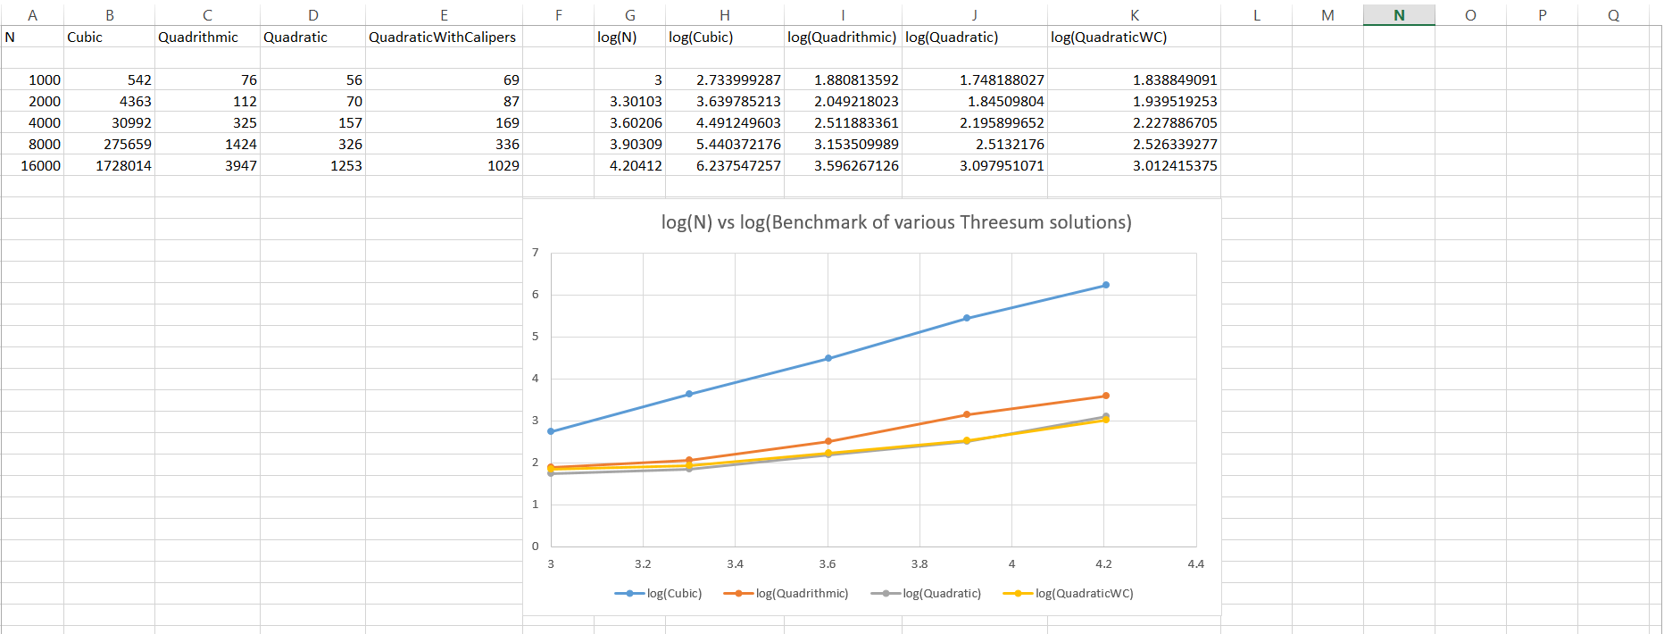

**Unit Test Screenshots:**

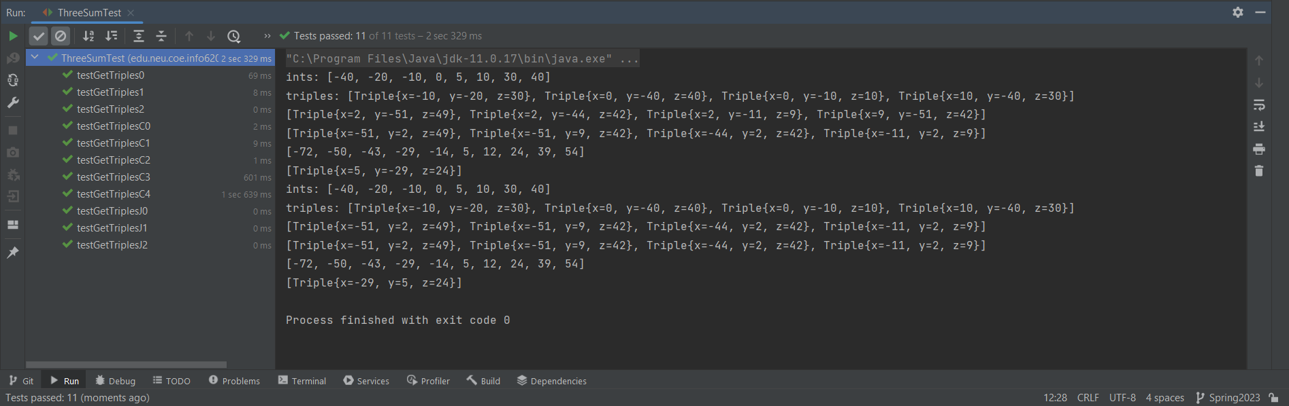

**Working of Quadratic method:** The Quadratic solution uses the two pointer method for finding the three values in a sorted array which sum up to 0. By fixing the middle element of the array in position i, we can create two pointers for the previous element (i-1) and next element (i+1). We can then compare the three elements, and check if the sum adds up to 0. If the sum is 0, then the three elements make a Three Sum triplet. We add the elements to an array and move both pointers accordingly. If the sum is less than 0, then we need to move the right pointer to the next element (i+2) and check for the condition again. If the sum is greater than 0, then we need to move the left pointer to the previous element (i-2) and check for the condition again. Finally, we stop checking for elements when the pointers reach the start and end of the array respectively.