Program Structures and Algorithms

Spring 2023(SEC 3)

NAME: Subbu Manickam

NUID: 002768764

**Task:** To benchmark sorting algorithm using insertion sort for different orders of an array

**Relationship Conclusion:** Insertion sort is fastest for an already ordered array whereas it is slowest for an array in reverse order. The benchmarking order is as follows

Ordered < Partially Ordered < Random < Reverse Ordered

**Evidence to support that conclusion:** From thegraphical representation of the benchmark timings, we can clearly conclude that reverse ordered array takes the maximum time and an ordered array takes the minimum time.

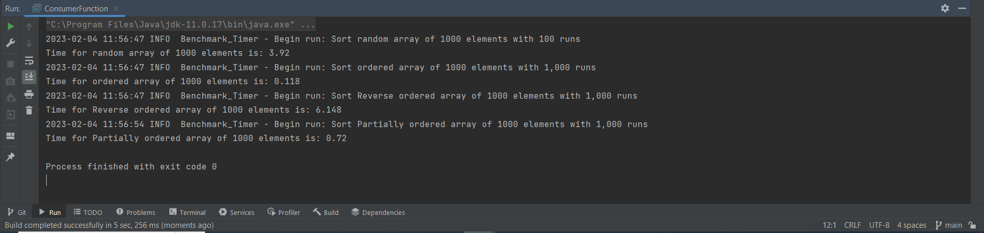

**Graphical Representation:**

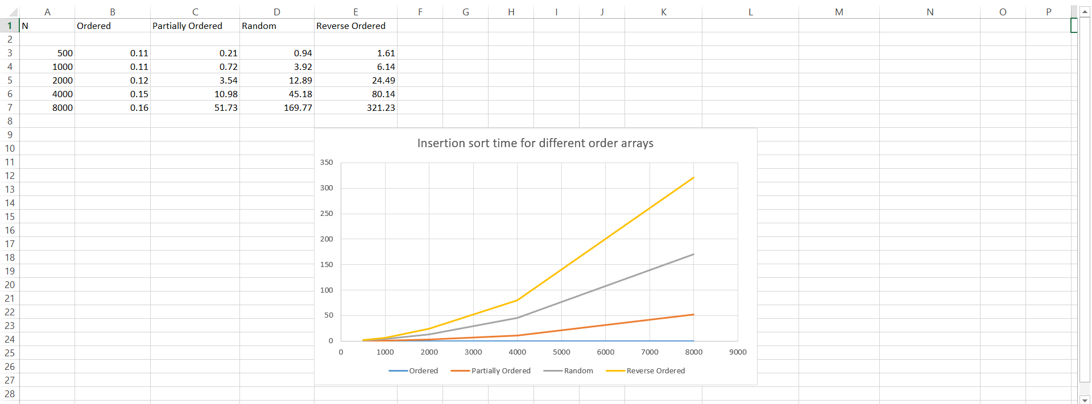

**Unit Test Screenshots:**

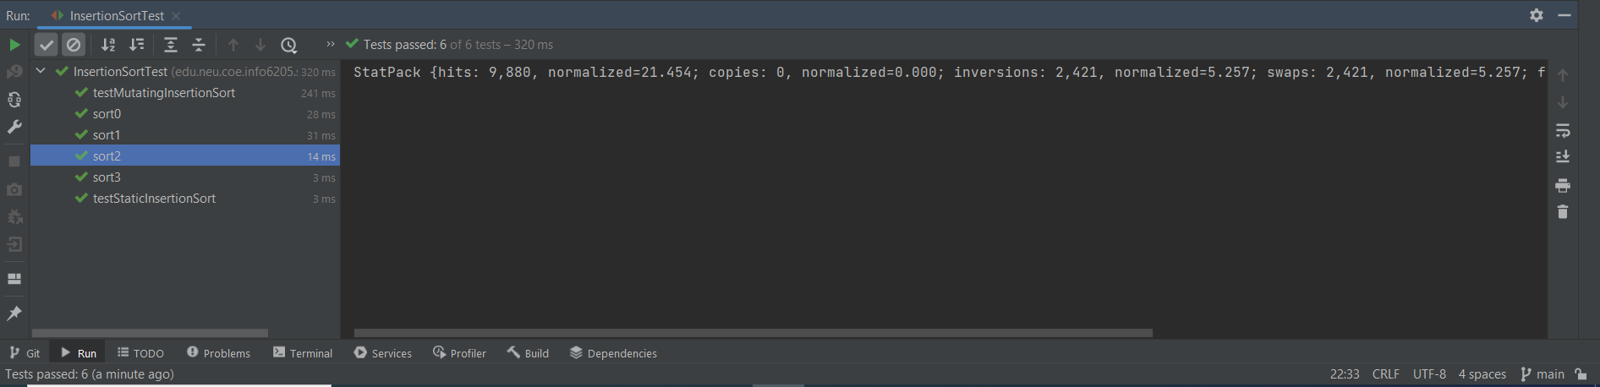

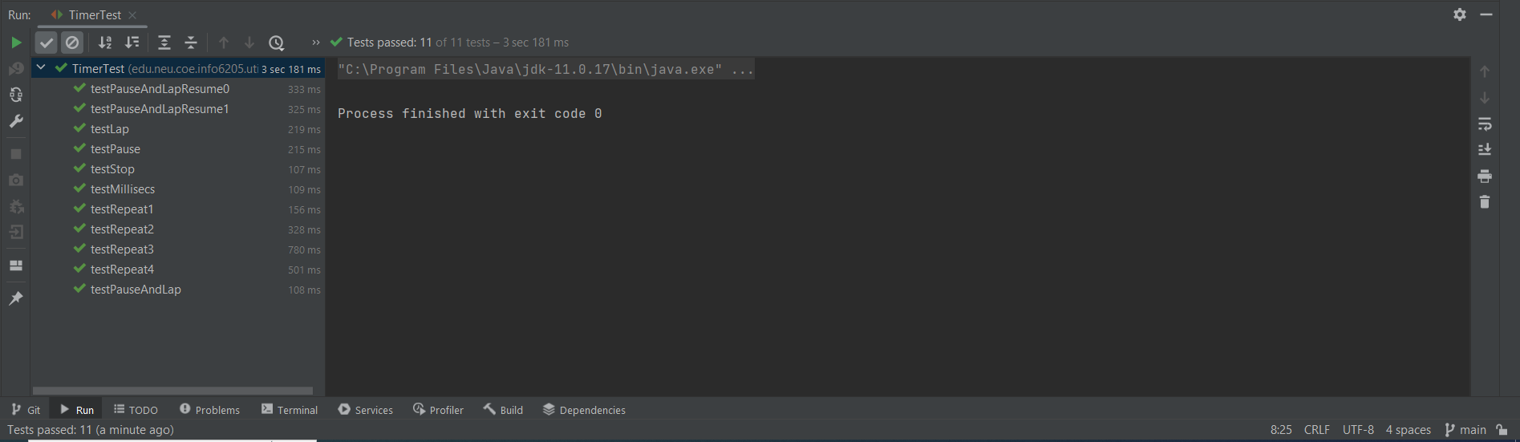

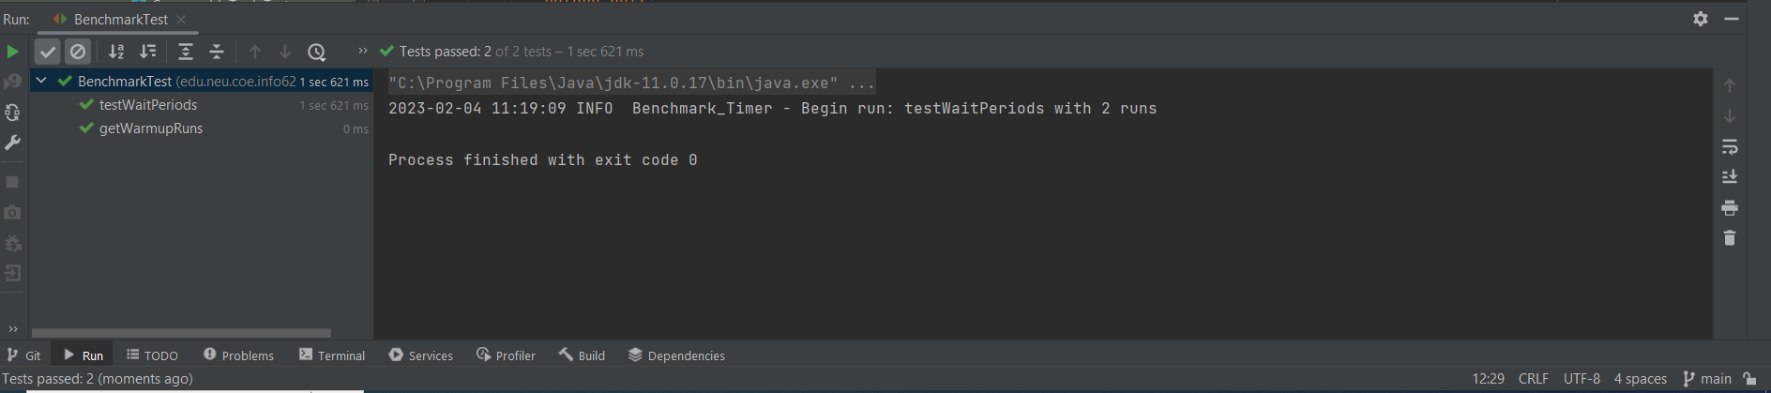

**Working of Insertion Sort:** Insertion sort checks every element with the previous elements and swaps them according to their order while shifting the other elements by one position. So in a reverse ordered array, it needs to parse through the entire array for every element which sums up to iterating the entire array twice thereby amounting to O(n^2) time complexity. In an ordered array, each element is only compared to its previous element and thus the time complexity will be O(n).