Program Structures and Algorithms

Spring 2023(SEC 3)

NAME: Subbu Manickam

NUID: 002768764

**Task:** To find the relationship between the number of objects (n) and the number of pairs (m) generated in a Union Find Algorithm.

**Relationship Conclusion:** For (n) objects in a Union Find Algorithm, the number of pairs generated is always equal to (n-1).

m = n - 1

**Evidence to support that conclusion:**

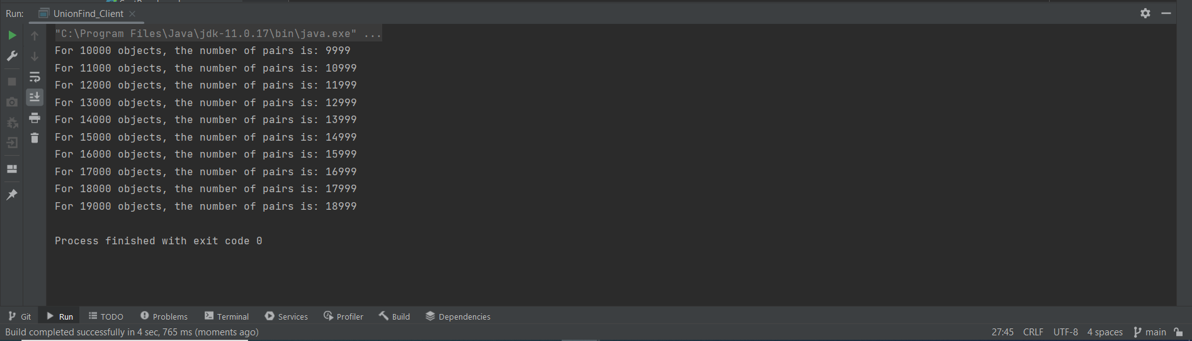

**Graphical Representation:** In the graph, we have plotted n and m values simultaneously for each run in a 3D format to visualize the parallel relationship between them.

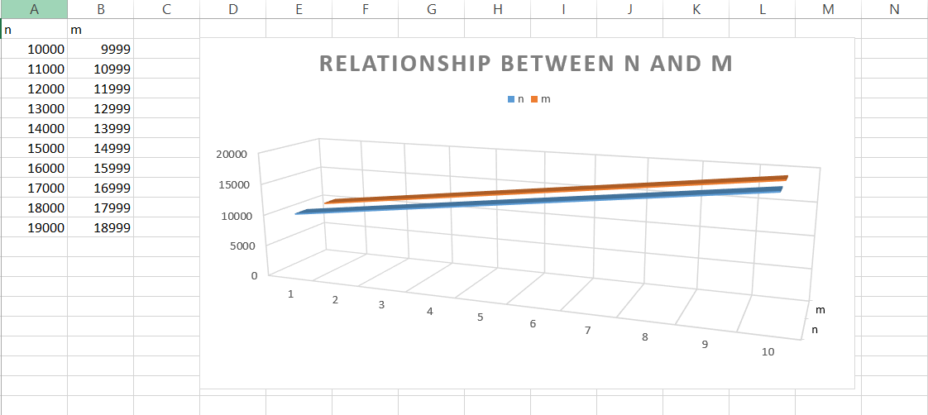

**Unit Test Screenshots:**

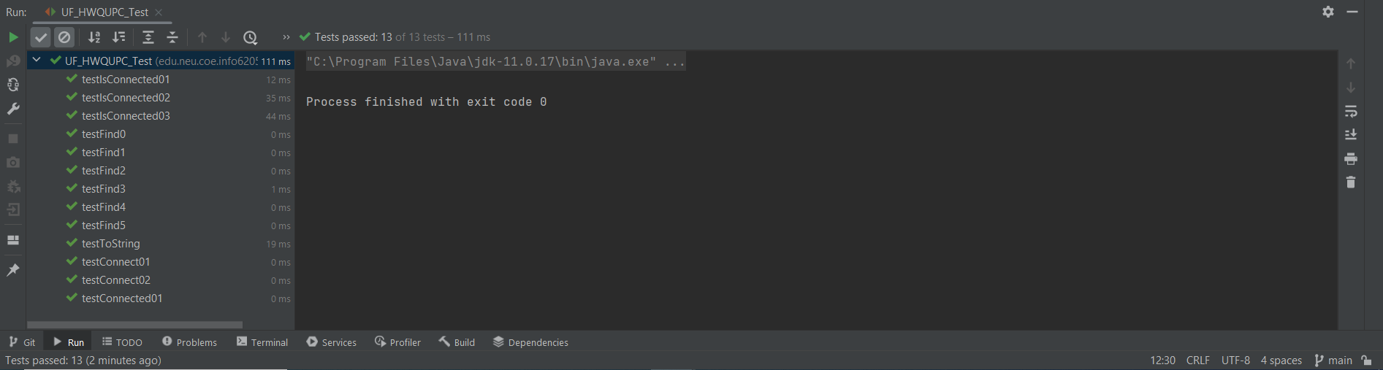

**Working of Union Find:** The Union Find Algorithm aims to connect multiple disjointed nodes into a single component graph. For n separate components to be combined into one single component, there needs to be n-1 connections made. At the beginning of the Algorithm, each node is separate and each time we connect two sets of nodes randomly, the total number of nodes reduces by 1 and the connection count increases by 1. Ultimately as the number of nodes become 1, the connection count would have summed up to n-1. Thus for n objects, the number of connections are always n-1.