Program Structures and Algorithms

Spring 2023(SEC 3)

NAME: Subbu Manickam

NUID: 002768764

**Task:** To find the best predictor of total execution time for different sorting algorithms.

**Relationship Conclusion:** Fromthe graphs and values we can conclude that hits and compares are both important predictors of the total execution time for a sorting algorithm.

**Evidence to support that conclusion:** Swaps cannot be a predictor of the execution time as for merge sort the number of swaps is always 0.

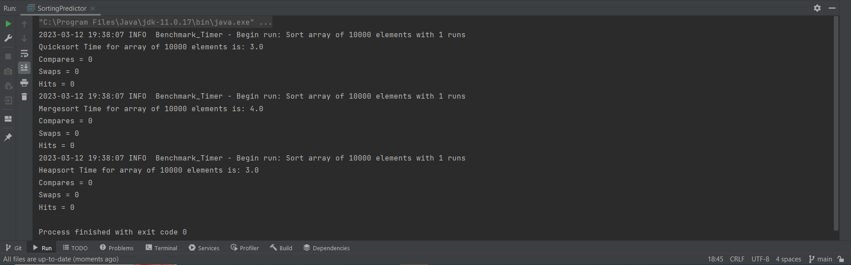

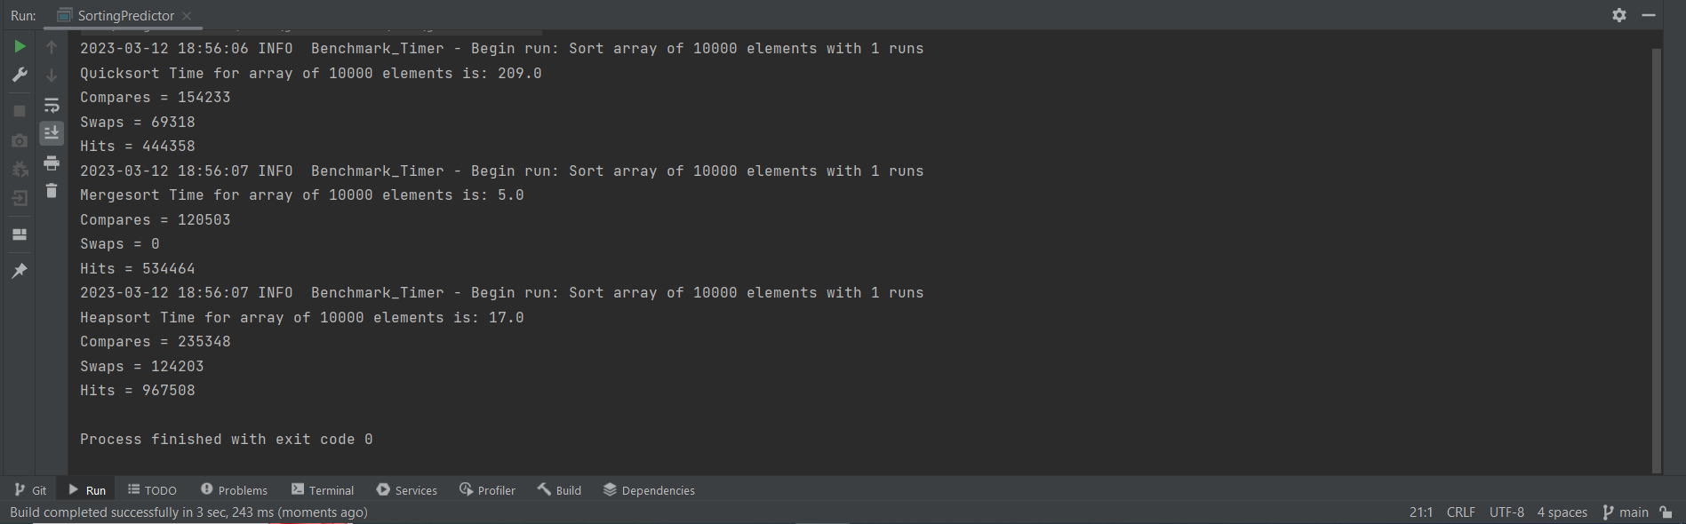

**Graphical Representation:**

