**CA1**

QUESTION :1

package com.CA.CA1;

import org.openqa.selenium.By;

import org.openqa.selenium.WebDriver;

import org.openqa.selenium.chrome.ChromeDriver;

import org.openqa.selenium.chrome.ChromeOptions;

import io.github.bonigarcia.wdm.WebDriverManager;

public class Q1 {

public static void main( String[] args ) throws InterruptedException{

ChromeOptions co=new ChromeOptions();

co.addArguments("--remote-allow-origins=*");

WebDriverManager.*chromedriver*().setup();

WebDriver driver=new ChromeDriver(co);

driver.get("https://www.amazon.in/2022-Apple-MacBook-Laptop-chip/dp/B0B3BQ11LP/ref=sr_1_1?pf_rd_i=1375424031&pf_rd_m=A1K21FY43GMZF8&pf_rd_p=34d0241f-2443-4c3b-b9aa-68c67855509c&pf_rd_r=M6K80EMA2F1ZF69VHMN2&pf_rd_s=merchandised-search-9&pf_rd_t=101&qid=1681288015&sr=8-1");

driver.manage().window().maximize();

String currentUrl=driver.getCurrentUrl();

String expectedUrl="https://www.amazon.in/2022-Apple-MacBook-Laptop-chip/dp/B0B3BQ11LP/ref=sr_1_1?pf_rd_i=1375424031&pf_rd_m=A1K21FY43GMZF8&pf_rd_p=34d0241f-2443-4c3b-b9aa-68c67855509c&pf_rd_r=M6K80EMA2F1ZF69VHMN2&pf_rd_s=merchandised-search-9&pf_rd_t=101&qid=1681288015&sr=8-1";

if(currentUrl.equals(expectedUrl)) {

System.***out***.println("URL MATCHED");

}

else {

System.***out***.println("URL NOT MATCHED");

}

Thread.*sleep*(5000);

driver.findElement(By.*xpath*("//*[@id=\"add-to-cart-button\"]")).click();

Thread.*sleep*(5000);

driver.findElement(By.*xpath*("//*[@id=\"attach-close_sideSheet-link\"]")).click();

Thread.*sleep*(5000);

driver.findElement(By.*xpath*("//*[@id=\"nav-cart-count-container\"]/span[2]")).click();

Thread.*sleep*(5000);

driver.findElement(By.*xpath*("//*[@id=\"a-autoid-0-announce\"]")).click();

Thread.*sleep*(5000);

driver.findElement(By.*xpath*("//*[@id=\"quantity_0\"]")).click();

Thread.*sleep*(5000);

driver.findElement(By.*xpath*("//*[@id=\"anonCarousel1\"]/ol/li[1]/div/a[1]/div/img")).click();

Thread.*sleep*(5000);

driver.findElement(By.*xpath*("//*[@id=\"add-to-cart-button\"]")).click();

Thread.*sleep*(5000);

driver.findElement(By.*xpath*("//*[@id=\"attach-close_sideSheet-link\"]")).click();

Thread.*sleep*(5000);

driver.findElement(By.*xpath*("//*[@id=\"nav-cart\"]")).click();

Thread.*sleep*(5000);

driver.findElement(By.*xpath*("//*[@id=\"a-autoid-0-announce\"]")).click();

Thread.*sleep*(5000);

driver.findElement(By.*xpath*("//*[@id=\"quantity_2\"]")).click();

Thread.*sleep*(5000);

driver.findElement(By.*xpath*("//*[@id=\"sc-buy-box-ptc-button\"]/span/input")).click();

Thread.*sleep*(5000);

}

}

OUTPUT:

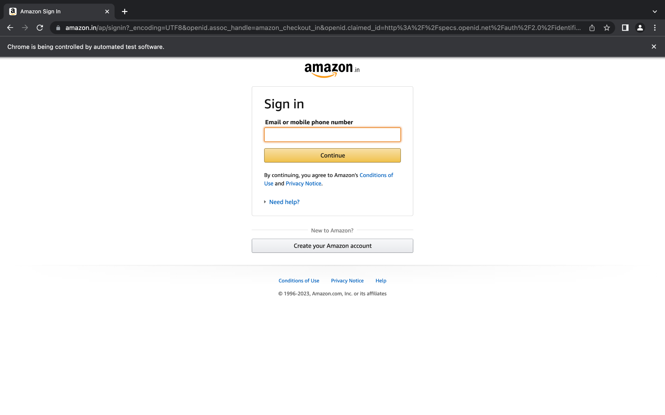

QUESTION :2

package com.CA.CA1;

import org.openqa.selenium.By;

import org.openqa.selenium.WebDriver;

import org.openqa.selenium.WebElement;

import org.openqa.selenium.chrome.ChromeDriver;

import org.openqa.selenium.chrome.ChromeOptions;

import io.github.bonigarcia.wdm.WebDriverManager;

public class Q2 {

public static void main(String[] args) {

ChromeOptions co=new ChromeOptions();

co.addArguments ("--remote-allow-origins=*");

WebDriverManager.*chromedriver*().setup ();

WebDriver driver=new ChromeDriver(co);

driver.get ("https://www.amazon.in/");

driver.manage().window().maximize() ;

String currentTitle=driver.getTitle();

System.***out***.println(currentTitle);

String expectedTitle="Online Shopping site in India: Shop Online for Mobiles, Books, Watches, Shoes and More - Amazon.in";

if(currentTitle.equals(expectedTitle)) {

System.***out***.println("URL Matched");

}

else {

System.***out***.println("URL Not Matched");

}

WebElement txtBoxl=driver.findElement(By.*xpath*("//*[@id=\"twotabsearchtextbox\"]"));

txtBoxl.sendKeys("macbook");

driver.findElement(By.*xpath*("//*[@id=\"nav-search-submit-button\"]")).click();

String txt1=driver.findElement(By.*xpath*("//*[@id=\"search\"]/div[1]/div[1]/div/span[1]/div[1]/div[3]/div/div/div/div/div/div/div/div[2]/div/div/div[1]/h2/a/span")).getText();

System.***out***.println(txt1);

String txt2=driver.findElement(By.*xpath*("//*[@id=\"search\"]/div[1]/div[1]/div/span[1]/div[1]/div[4]/div/div/div/div/div/div/div/div[2]/div/div/div[1]/h2/a/span")).getText();

System.***out***.println(txt2);

String txt3=driver.findElement(By.*xpath*("//*[@id=\"search\"]/div[1]/div[1]/div/span[1]/div[1]/div[5]/div/div/div/div/div/div[2]/div/div/div[1]/h2/a/span")).getText();

System.***out***.println(txt3);

String txt4=driver.findElement(By.*xpath*("//*[@id=\"search\"]/div[1]/div[1]/div/span[1]/div[1]/div[6]/div/div/div/div/div/div[2]/div/div/div[1]/h2/a/span")).getText();

System.***out***.println(txt4);

String txt5=driver.findElement(By.*xpath*("//*[@id=\"search\"]/div[1]/div[1]/div/span[1]/div[1]/div[7]/div/div/div/div/div/div[2]/div/div/div[1]/h2/a/span")).getText();

System.***out***.println(txt5);

//filter

driver.findElement(By.*xpath*("//*[@id=\"a-autoid-0-announce\"]")).click();

driver.findElement(By.*xpath*("//*[@id=\"s-result-sort-select_4\"]")).click();

}

}

OUTPUT:

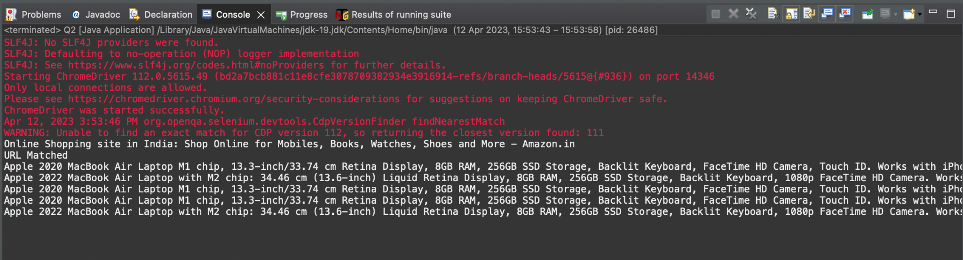

QUESTION :3

package com.CA.CA1;

import org.openqa.selenium.By;

import org.openqa.selenium.WebDriver;

import org.openqa.selenium.chrome.ChromeDriver;

import org.openqa.selenium.chrome.ChromeOptions;

import io.github.bonigarcia.wdm.WebDriverManager;

public class Q3 {

public static void main(String[] args) throws InterruptedException {

ChromeOptions co=new ChromeOptions();

co.addArguments ("--remote-allow-origins=*");

WebDriverManager.*chromedriver*().setup ();

WebDriver driver=new ChromeDriver(co);

driver.get ("https://www.amazon.in/");

driver.manage().window().maximize();

String currentTitle=driver.getTitle();

System.***out***.println(currentTitle);

String expectedTitle="Online Shopping site in India: Shop Online for Mobiles, Books, Watches, Shoes and More - Amazon.in";

if(currentTitle.equals(expectedTitle)) {

System.***out***.println("Title Matched");

}

else {

System.***out***.println("Title not Matched");

}

driver.findElement(By.*xpath*("//*[@id=\"nav-link-accountList\"]")).click();

driver.findElement(By.*xpath*("//*[@id=\"ap_email\"]")).sendKeys("8098884765");

driver.findElement(By.*xpath*("//*[@id=\"continue\"]")).click();

driver.findElement(By.*xpath*("//*[@id=\"ap_password\"]")).sendKeys("sUbbU@2003");

driver.findElement(By.*xpath*("//*[@id=\"signInSubmit\"]")).click();

Thread.*sleep*(1000);

driver.findElement(By.*xpath*("//*[@id=\"nav-orders\"]")).click();

String order = driver.findElement(By.*xpath*("//*[@id=\"a-page\"]/section/div[1]/div[4]/form/label")).getText();

System.***out***.println("Your last Order:"+order);

}

}

