AUTOMATION SELENIUM IDE

LAB EXERCISE

CLASS EXERCISE - 01:

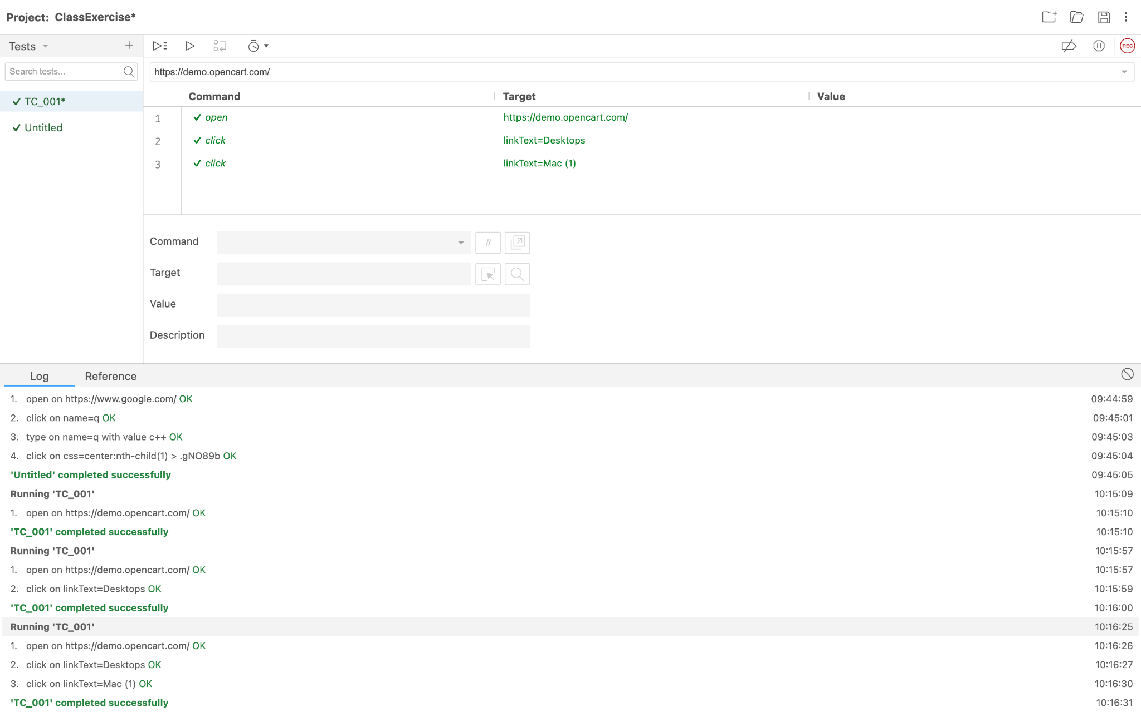

CLASS EXERCISE - 02:

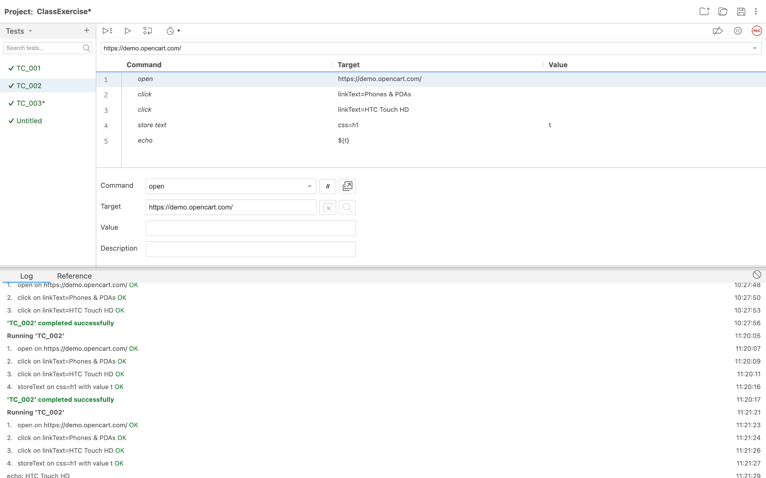

CLASS EXERCISE - 03:

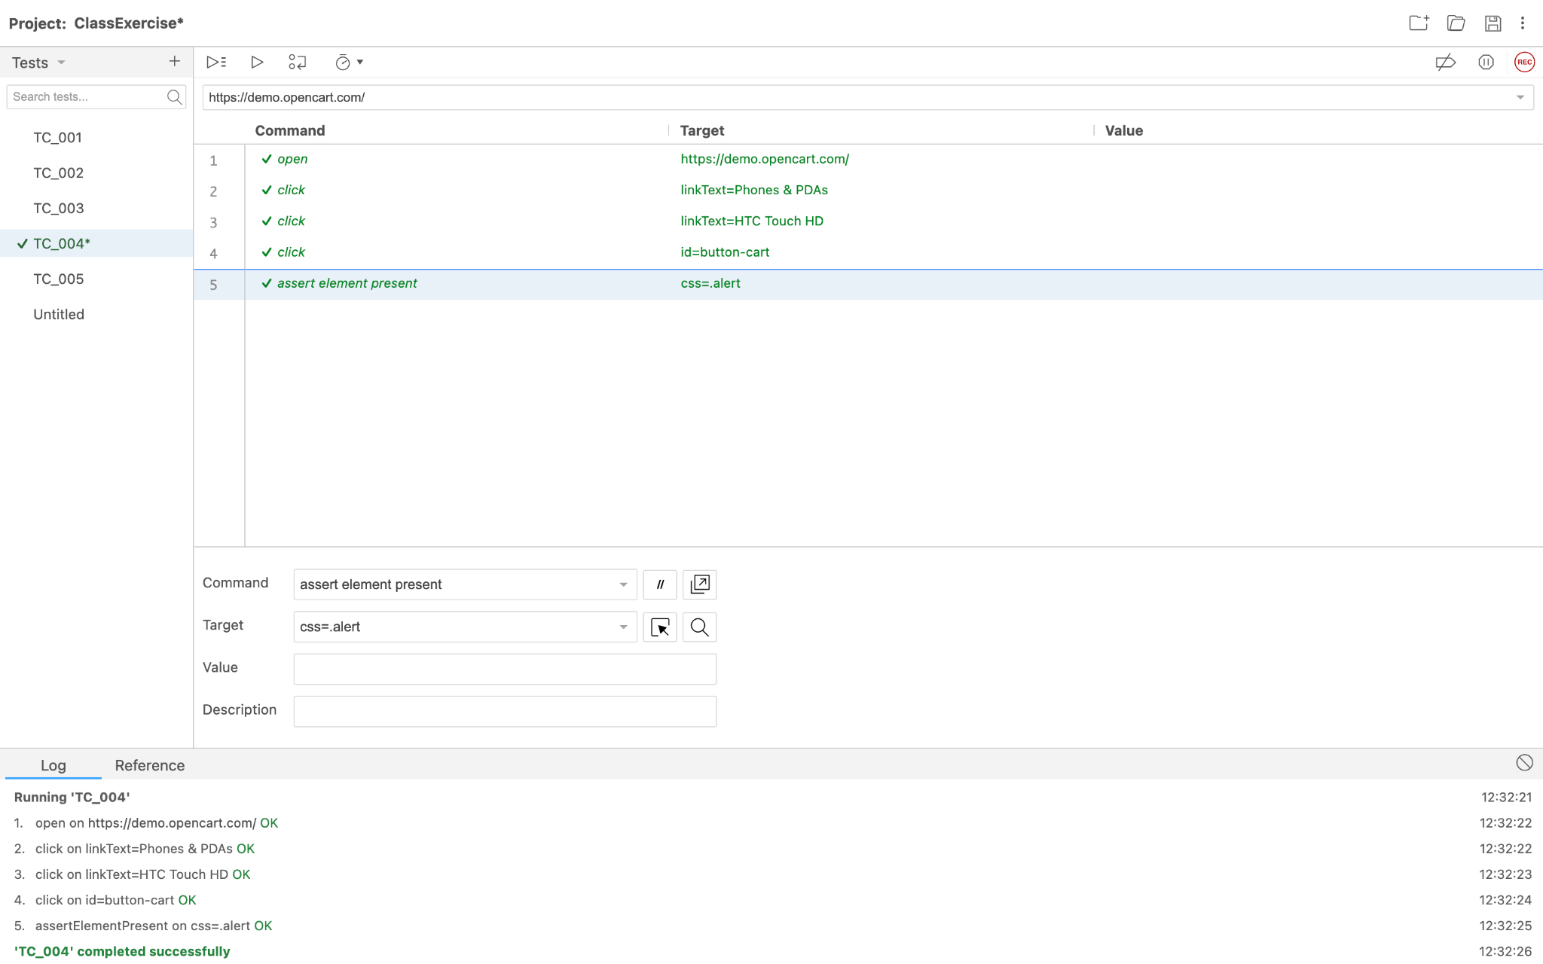

CLASS EXERCISE - 04:

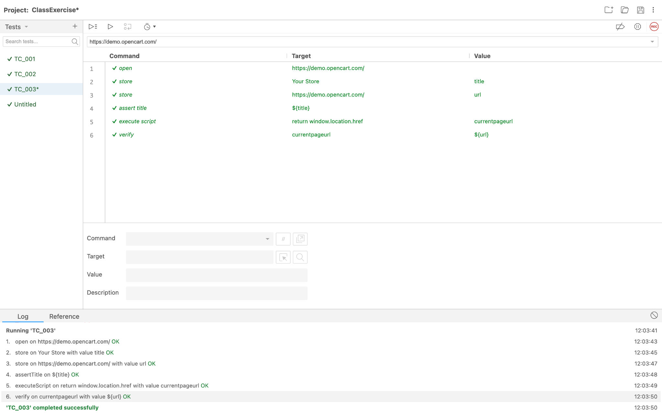

CLASS EXERCISE - 05:

