CLASS EXERCISE DAY 9: TESTNG

QUESTION NO:1

TASK:1

| package com.Test.Test; import org.testng.annotations.DataProvider; import org.testng.annotations.Test; public class D9_T1 {  @Test(dataProvider = "calculate")  public void add(Integer n1, Integer n2) {  System.out.println(n1+n2);  }  @Test(dataProvider = "calculate")  public void sub(Integer n1, Integer n2) {  System.out.println(n1-n2);  }  @Test(dataProvider = "calculate")  public void mul(Integer n1, Integer n2) {  System.out.println(n1*n2);  }  @Test(dataProvider = "calculate")  public void div(Integer n1, Integer n2) {  System.out.println(n1/n2);  }  @DataProvider  public Object[][] calculate() {  return new Object[][] {  new Object[] { 60, 5 },  new Object[] { 45, 3 },  };  } } |
| --- |

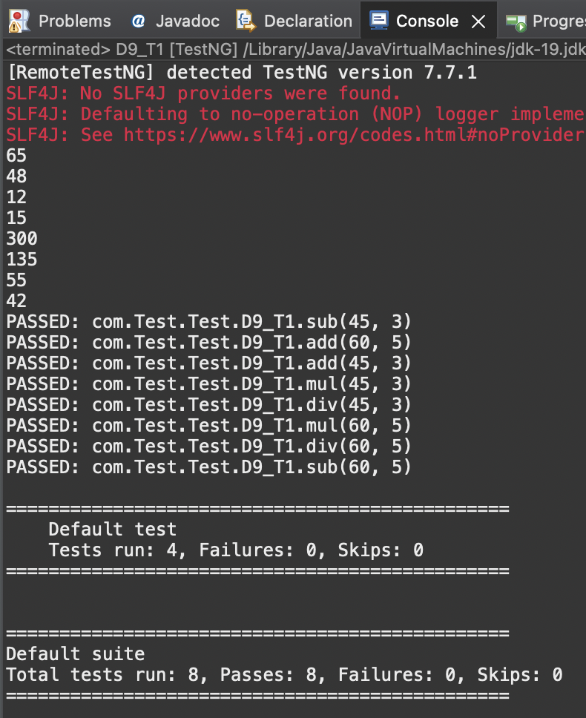

QUESTION NO:2

TASK:2

| package com.Test.Test; import java.util.concurrent.TimeUnit; import org.openqa.selenium.By; import org.openqa.selenium.WebDriver; import org.openqa.selenium.chrome.ChromeDriver; import org.openqa.selenium.chrome.ChromeOptions; import org.testng.Assert; import org.testng.annotations.Test; import io.github.bonigarcia.wdm.WebDriverManager; public class D9_T2 {  @Test  public void f() {  WebDriverManager.chromedriver().setup();  WebDriver driver;  ChromeOptions co = new ChromeOptions();  co.addArguments("--remote-allow-origins=*");  driver=new ChromeDriver(co);  driver.get("https://www.godaddy.com/en-in");  driver.manage().window().maximize();  String actualTitle="Domain Names, Websites, Hosting & Online Marketing Tools - GoDaddy IN";  String extractedTitle=driver.getTitle();  Assert.assertEquals(actualTitle, extractedTitle);  String actualURL="https://www.godaddy.com/en-in";  String extractedURL=driver.getCurrentUrl();  Assert.assertEquals(actualURL, extractedURL);  System.out.println("Hello");  driver.quit();  //driver.manage().timeouts().implicitlyWait(10, TimeUnit.SECONDS);   }  @Test  public void f2() {  WebDriverManager.chromedriver().setup();  WebDriver driver;  ChromeOptions co = new ChromeOptions();  co.addArguments("--remote-allow-origins=*");  driver=new ChromeDriver(co);  driver.get("https://www.godaddy.com/en-in");  driver.manage().window().maximize();  driver.manage().timeouts().implicitlyWait(5, TimeUnit.SECONDS);  driver.findElement(By.xpath("//*[@id=\"id-631b049a-e9c0-4d24-8710-c504745206dd\"]/div[2]/div[1]/ul/li[1]/button")).click();  driver.findElement(By.linkText("Domain Name Search")).click();    } } |
| --- |

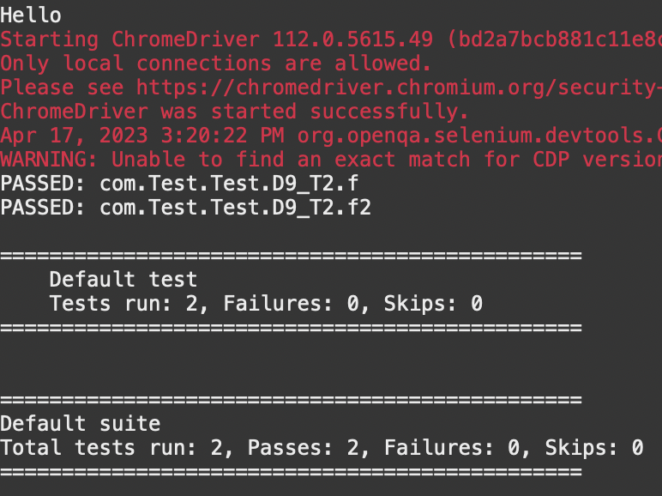

QUESTION NO:3

TASK:3

| ​​package com.Test.Test; import org.testng.annotations.Test; import io.github.bonigarcia.wdm.WebDriverManager; import org.testng.annotations.BeforeMethod; import java.util.concurrent.TimeUnit; import org.openqa.selenium.By; import org.openqa.selenium.WebDriver; import org.openqa.selenium.chrome.ChromeDriver; import org.openqa.selenium.chrome.ChromeOptions; import org.testng.Assert; import org.testng.annotations.AfterMethod; public class D9_T2_2 {  WebDriver driver;  @Test  public void check() throws InterruptedException {  Thread.sleep(5000);  String url = driver.getCurrentUrl();  String title = driver.getTitle();  String expectedUrl = "https://www.godaddy.com/en-in";  String expectedTitle = "Domain Names, Websites, Hosting & Online Marketing Tools - GoDaddy IN";    Assert.assertEquals(url,expectedUrl);  Assert.assertEquals(title,expectedTitle);  }  @BeforeMethod  public void BeforeMethod() {  ChromeOptions co = new ChromeOptions();  co.addArguments("--remote-allow-origins=*");  WebDriverManager.chromedriver().setup();  driver = new ChromeDriver(co);  driver.get("https://godaddy.com/en-in");  driver.manage().window().maximize();  }  @AfterMethod  public void AfterMethod() {  driver.close();  }    @Test  public void f2() throws InterruptedException{  ChromeOptions co=new ChromeOptions();  co.addArguments("--remote-allow-origins=*");  WebDriverManager.chromedriver().setup();  driver=new ChromeDriver(co);  driver.get("https://www.godaddy.com/");  driver.manage().window().maximize();  driver.manage().timeouts().implicitlyWait(10,TimeUnit.SECONDS);  driver.findElement(By.xpath("//*[@id=\"id-631b049a-e9c0-4d24-8710-c504745206dd\"]/div[2]/div[1]/ul/li[1]/button")).click();  driver.findElement(By.xpath("//*[@id=\"id-631b049a-e9c0-4d24-8710-c504745206dd\"]/div[2]/div[1]/ul/li[1]/div/div[2]/div[1]/ul/li[2]/a")).click();  }    @Test  public void f3() throws InterruptedException{  ChromeOptions co=new ChromeOptions();  co.addArguments("--remote-allow-origins=*");  WebDriverManager.chromedriver().setup();  driver=new ChromeDriver(co);  driver.get("https://www.godaddy.com/");  driver.manage().window().maximize();    Thread.sleep(5000);  String url = driver.getCurrentUrl();  String expectedUrl = "https://www.godaddy.com/en-in";  Assert.assertEquals(url,expectedUrl);  }  } |
| --- |

