1. Write a Python program to reverse the content of the string.
Do not use built in
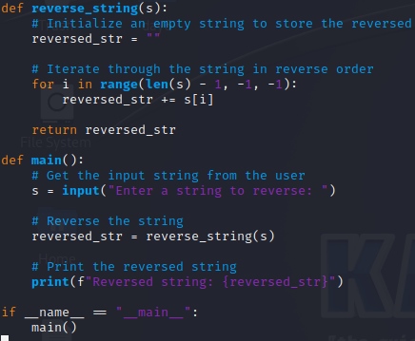
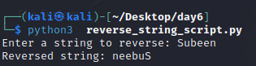

2. Create a program that performs basic string compression using the counts of repeated characters. For example, the string “aabcccccaaa” would become “a2b1c5a3”.
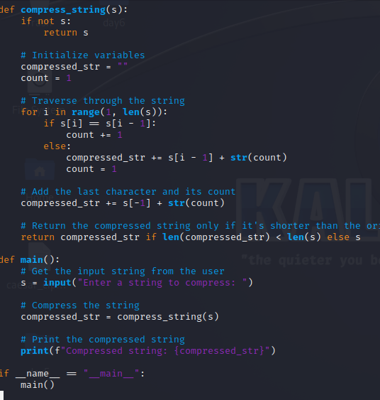
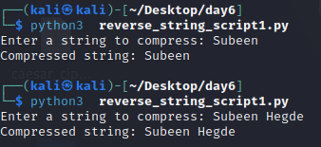

3. Get the Caesar cipher from the user Decrypt the cipher
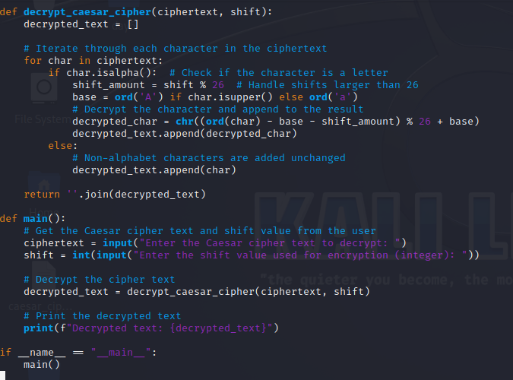
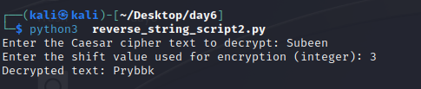

4. Get the cipher encrypted using shift cipher. Identify the key used to encrypt using brute force
ie all the values in the key space
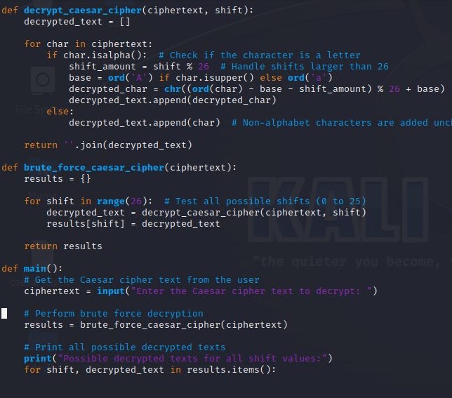
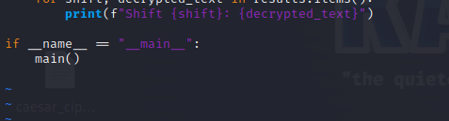
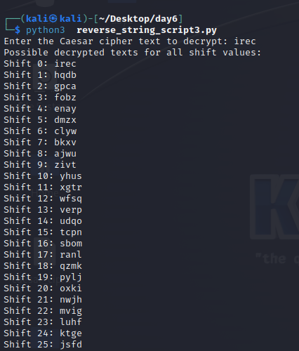

5. Find the k value , Provided cipher text and plain text
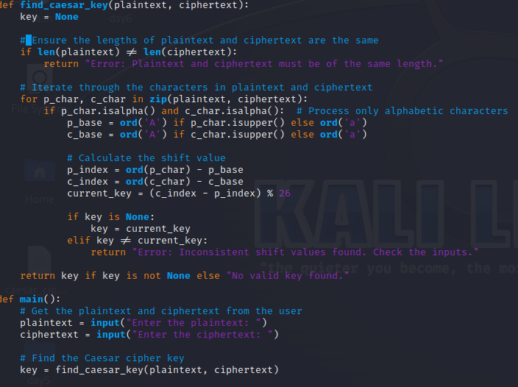
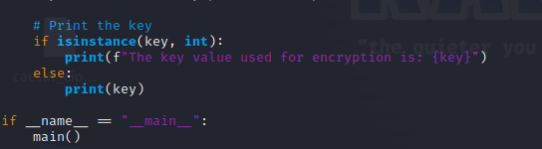
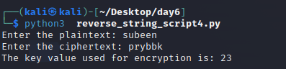

6. Encrypt and decrypt the string using Atbash cipher
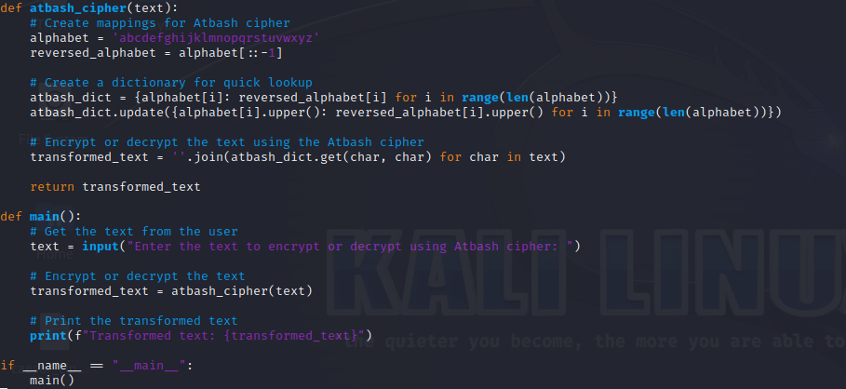
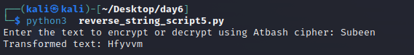

7. Encrypt and decrypt using Affine cipher
add validation
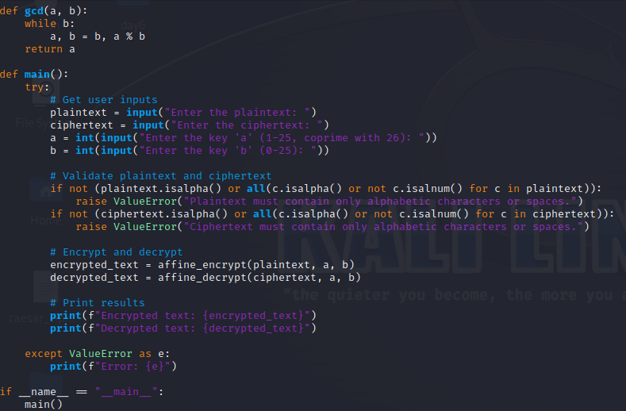
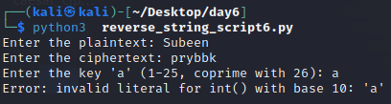

The harder you work for something, the greater you will feel when you achieve it.
Do not limit your challenges challenge your limit

