1. Write a Python Program to perform brute force attack on the cipher text “dvvkzecfssprkkve"

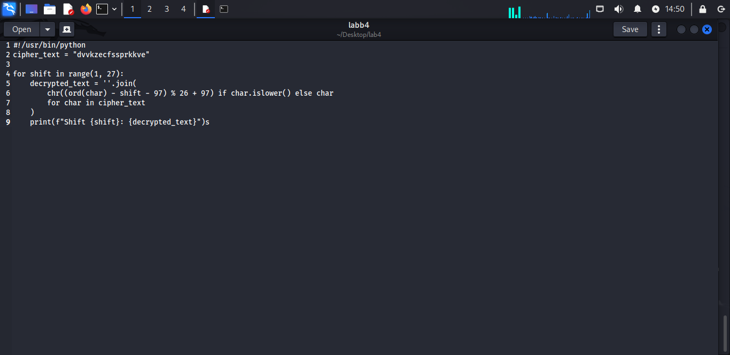

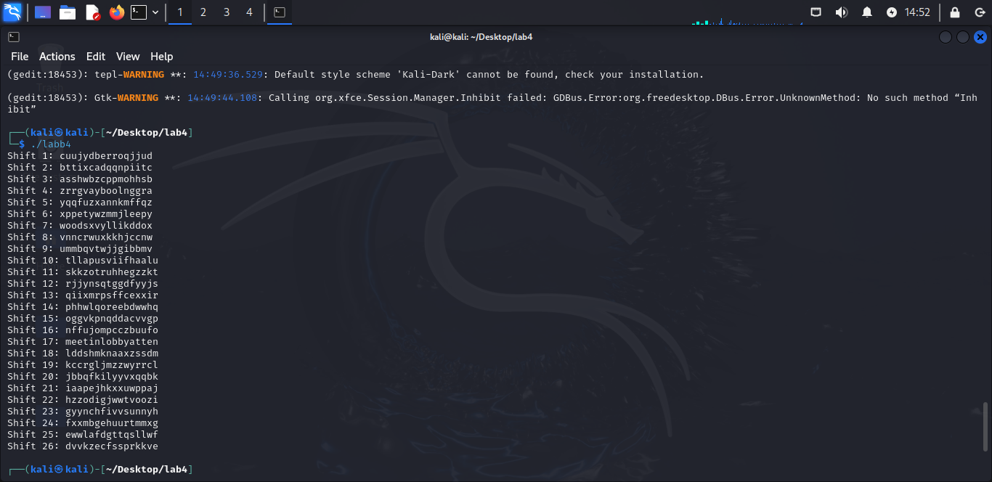

2. Write a Python program to use brute force attack to decipher the message.

Assume Affine cipher was used and "ab" is encrypted as "GL". Find the value of keys.

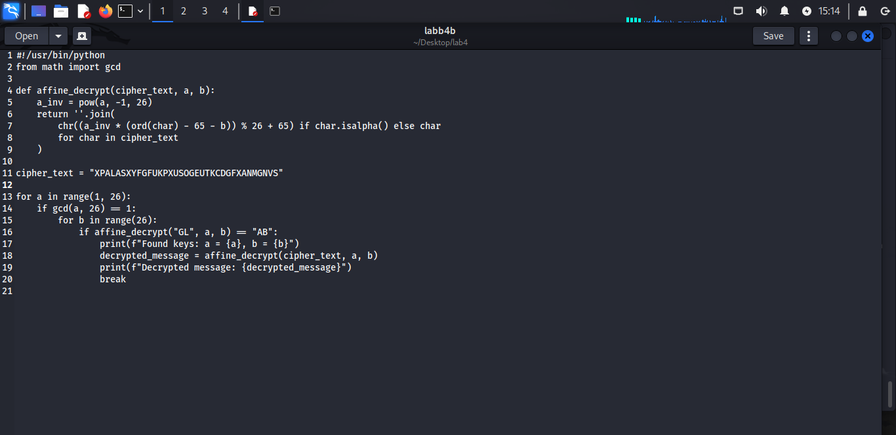

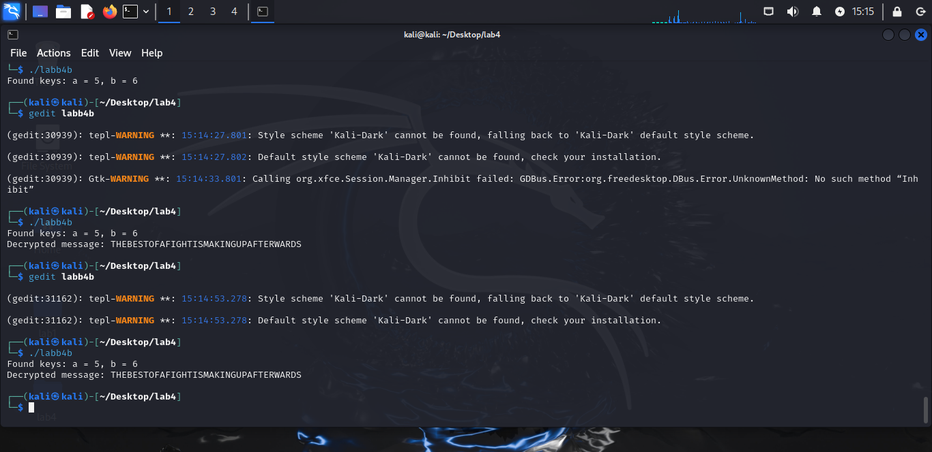

3. Encrypt the plain text using Rail Fence cipher

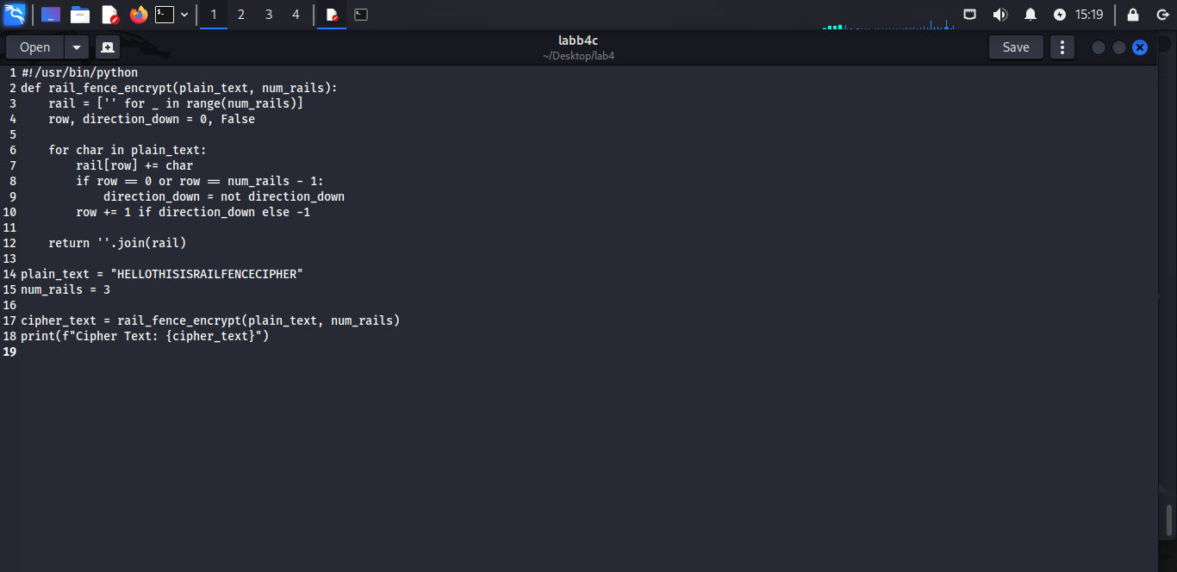

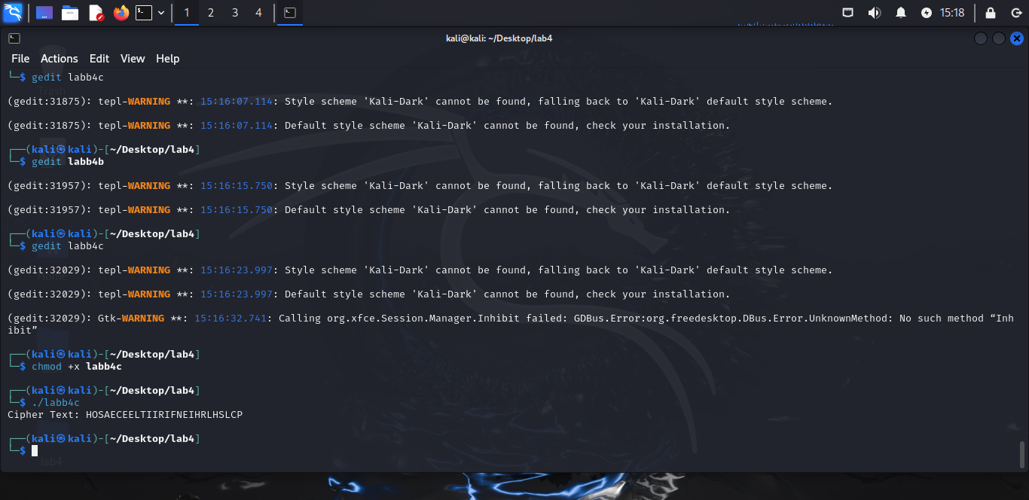

4. Decrypt the cipher using Rail Fence

AAIUJ SIHBE KTEAO TEADE SNUTF EAEMR TAHSA

RHROA YHNFO AITTE EHCBO FVCAT RNMNS NUTFE

RASHL WFHLN HIUJS IHTKS OEHNI FISAE FNTIG

RMRSO LSTIS OKIEH PEOE

