1. Assume you intercepted the following ciphertext. Using a statistical attack, find the plaintext

"XLILSYWIMWRSAJSVWEPIJSVJSYVQMPPMSRHSPPEVWMXMWASVX-LQSVILYVVCFIJSVIXLIWIPPIVVIGIMZIWQSVISJJIVW"\

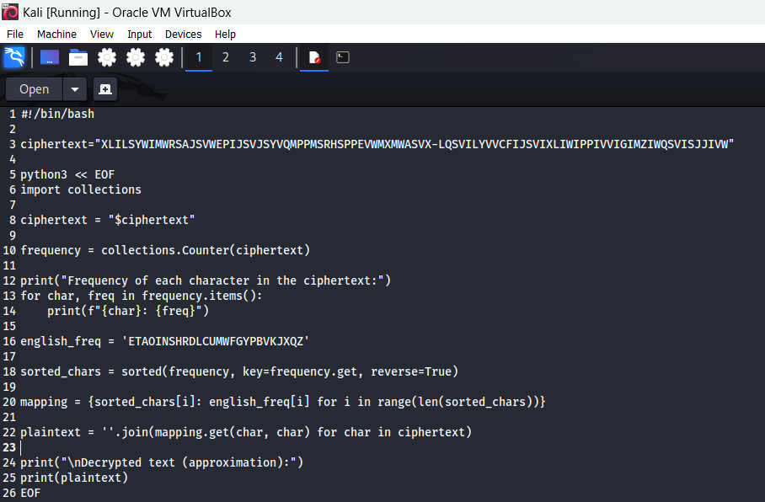

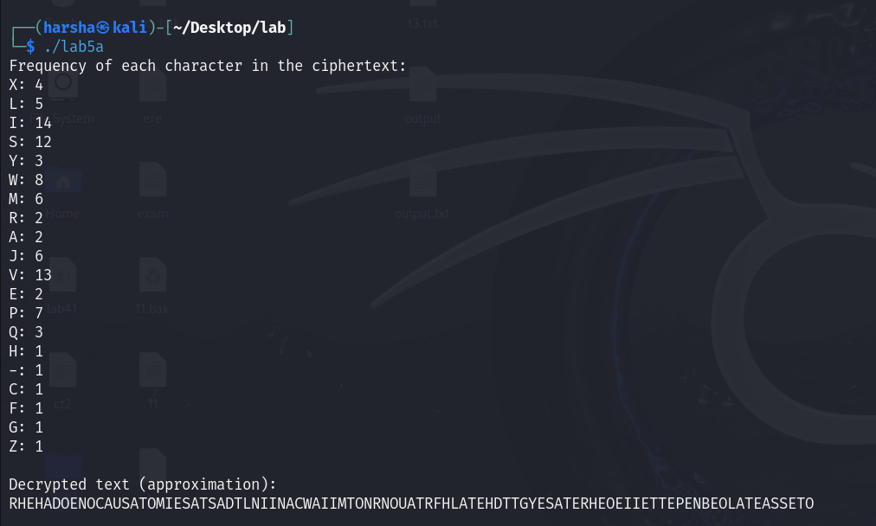

2. Write a Python script to encrypt using Rail Fence (Zig zag ) with three rows and with key (ONE).

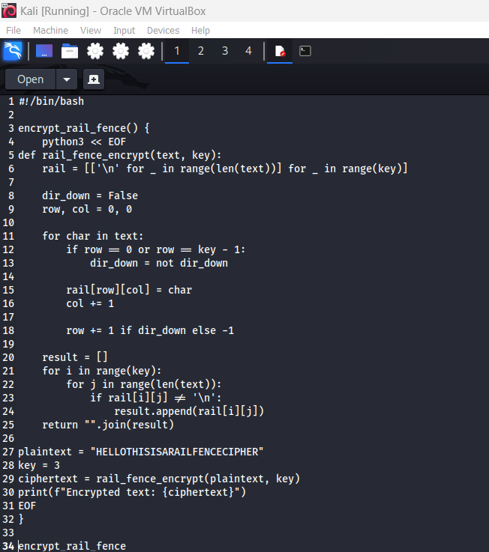

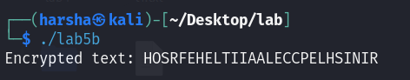

3. Write a python script to encrypt columnar transposition

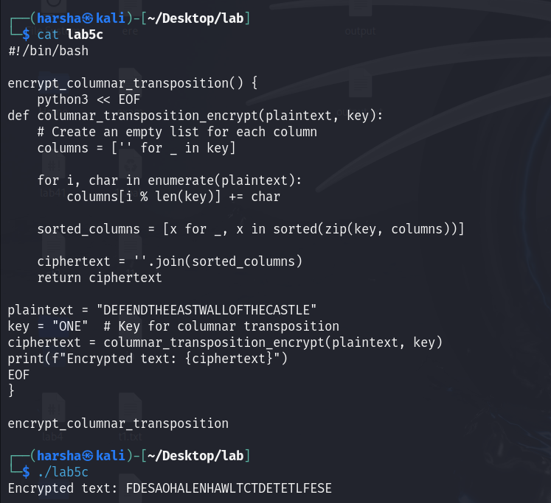

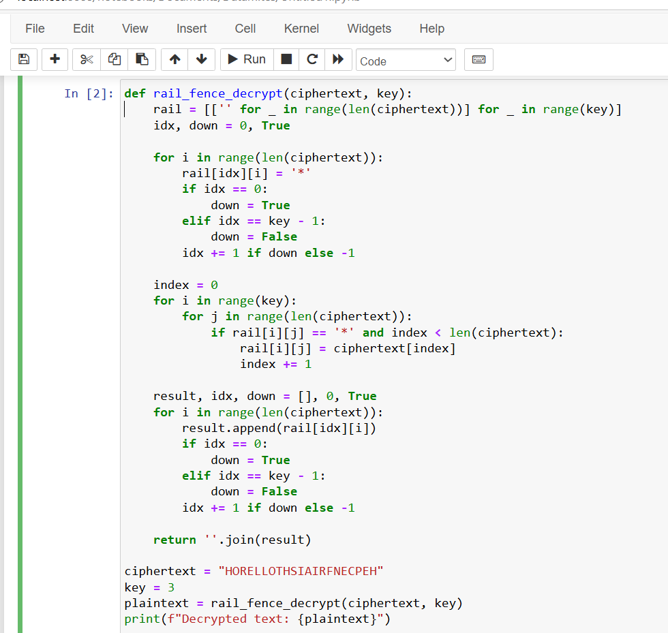4. Write a Python script to decrypt Rail Fence Cipher