Detecting Fraudulent Job Postings
with Multimodal Machine Learning
Experiment 1: Classical Baselines and Custom Multi-Kernel ResNet • Experiment 2: Pretrained ResNet-50 Transfer Learning
Project report • Source of truth: executed notebooks noteX.ipynb and Experiment_2_Multimodal_ResNet50.ipynb • September 2026
Headline result — Exp1 deep model: FAKE F1 0.747, recall 0.786 (55 FP / 37 FN) • Exp2: FAKE F1 0.786, precision 0.951 (6 FP / 57 FN). Transfer learning cut false alarms 9× but missed 20 more frauds.

Contents

Right-click the table of contents in Word and choose “Update Field” to populate page numbers.

1. Introduction and Problem Statement
Online job portals receive thousands of postings, a small fraction of which are fraudulent: phishing lures, advance-fee scams, or fake recruiters harvesting personal data. Manual moderation does not scale, so automated classification of postings as genuine (0) versus fake (1) is a practical necessity.
This project treats fake-job detection as a supervised binary classification problem over two modalities: the posting text (title, description, requirements and related fields) and a screenshot of the posting web page. The machine-learning objective is to maximise fraud detection — catching fake postings (recall) without flooding moderators with false alarms (precision) — under severe class imbalance (≈95% genuine / 5% fake), where raw accuracy is misleading. Two controlled experiments were conducted on the same corpus: Experiment 1 establishes classical baselines and a from-scratch multimodal network; Experiment 2 fixes a validation bug from Experiment 1 and replaces the custom image backbone with a pretrained ResNet-50.

2. Dataset and Overall Methodology

2.1 Dataset
Both experiments use fake_job_postings.csv (17,880 postings, 18 original columns) plus per-posting screenshot PNGs mapped as images/<fraudulent>/<job_id>.png, with a grey placeholder substituted for missing or corrupt images. The target fraudulent is binary (0 = genuine, 1 = fake). Table 1 summarises the data; Figure 1 shows the imbalance.
Item | Detail
Source file | fake_job_postings.csv + screenshot PNGs
Samples | 17,880 postings
Target | fraudulent: 17,014 genuine (95.16%) vs 866 fake (4.84%)
Text fields (merged) | title, location, department, company_profile, description, requirements, benefits
Structured fields | telecommuting, has_company_logo, has_questions, employment_type, required_experience, required_education, industry, function, salary_range, job_id
Images | Web-page screenshots, 224×224 input, ImageNet normalisation

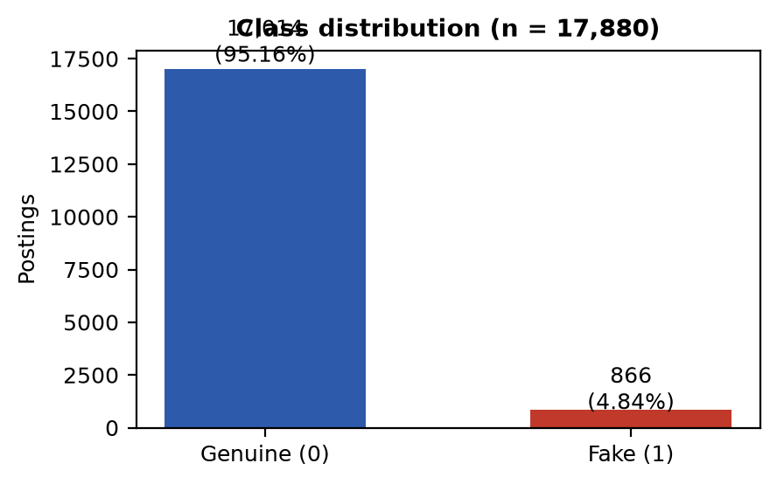
Figure 1 — Target class distribution: 95.16% genuine vs 4.84% fake.

2.2 Data characteristics
- Missingness is heavy in optional fields: salary_range (~15,000 missing), department (~11,500), required_education, benefits and experience are all incomplete; description is missing only once. Missing text is filled with empty strings before concatenation.
- Fraudulent postings are shorter (mean ≈286 vs ≈383 words) and disproportionately lack company logos, with unusual employment-type patterns — a signal the lexical branches exploit.
- No data leakage in feature fitting: TF-IDF and BoW vocabularies are fitted on training text only, then applied unchanged to validation/test.

2.3 Splits and training discipline
Experiment 1 uses a stratified 80/20 split (seed 42): 14,304 train / 3,576 test, both preserving the 4.84% fake ratio. Experiment 2 uses a three-way stratified split from the same seed: 11,443 train (64.0%) / 2,861 validation (16.0%) / 3,576 test (20.0%), each at ≈4.84–4.86% fake. The first-stage 80/20 operation is identical, so both experiments share the same held-out test set (3,403 genuine + 173 fake) and their test metrics are directly comparable. Class imbalance is handled by class-weighted loss (≈20:1 fake weight) rather than resampling in the deep models; the classical baselines additionally test SMOTE/ADASYN oversampling of the training set only. Evaluation always uses the original imbalanced test set, with FAKE recall and FAKE F1 as primary metrics and accuracy treated as secondary.

3. Experiment 1 — Baselines and Custom Multimodal Network

3.1 Objective
Establish (a) classical TF-IDF + logistic-regression baselines under three imbalance strategies, and (b) a from-scratch four-branch multimodal network, evaluated on the held-out test set.

3.2 Baselines: features, models, results
TF-IDF (max 1,000 features, 1–2-grams) fitted on training text feeds L2 logistic regression under three regimes: Normal (imbalanced), SMOTE (k=5, balanced to 13,611/13,611 in TF-IDF space), ADASYN (same balancing, denser near hard minority regions). Figure 2 previews the outcome; Table 2 gives exact test figures.
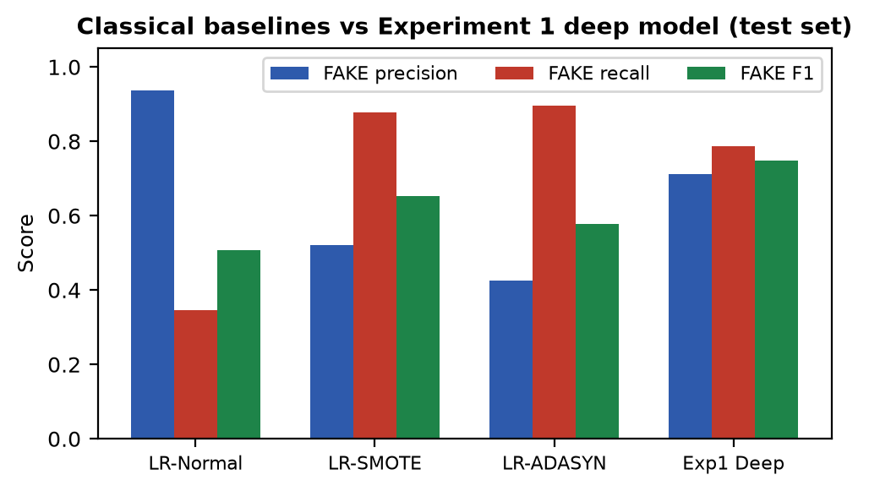
Figure 2 — FAKE-class precision/recall/F1: classical baselines vs the Experiment 1 deep model.
Method | Acc. | FAKE prec. | FAKE rec. | FAKE F1 | ROC-AUC | FP | FN
LR Normal | 0.9673 | 0.9375 | 0.3468 | 0.5063 | 0.9655 | 4 | 113
LR SMOTE | 0.9550 | 0.5205 | 0.8786 | 0.6538 | 0.9751 | 140 | 21
LR ADASYN | 0.9365 | 0.4258 | 0.8960 | 0.5773 | 0.9711 | 209 | 18

Verdict on baselines: Normal hides fraud (113 of 173 fakes missed despite 96.7% accuracy); SMOTE is the best classical trade-off (F1 0.654, AUC 0.975); ADASYN gains 2 recall points but nearly doubles false alarms (209 FP) — its hard-region synthesis adds noise.

3.3 Deep model: representation and training
- Branches (all frozen or from-scratch as noted): BERT-base-uncased frozen, [CLS] 768-d → 256; TF-IDF 1,000-d → 256; binary BoW 500-d → 128; custom MultiKernelResNet (stem 7×7 conv + maxpool, four stages of parallel 3×3/5×5/7×7 blocks with residual shortcuts, GAP → 512-d) trained from scratch → 256. Each projection uses ReLU + BatchNorm + dropout 0.4.
- Fusion: concatenated 896-d → MLP 896→512→256→2, with per-branch auxiliary classifiers (deep supervision) and learnable modality weights α, β, γ, δ.
- Loss/optimiser: class weights [0.525, 10.32] in an adaptive multi-task loss (fusion CE + learned-weighted branch CEs); AdamW with per-module rates (3e-4 fresh heads, 1e-4 BERT/image projections, 1e-5 CNN backbone, 2e-4 fusion, 1e-3 modality weights), weight decay 0.01, gradient clipping (norm 1.0), AMP, batch size 8, 5 epochs (≈19–22 min/epoch on an RTX 3050 6 GB laptop GPU). Checkpoint on validation loss; fixed 0.5 threshold; no early stopping, no threshold tuning.

3.4 Results
Metric | Value
Accuracy | 0.9743
FAKE precision | 0.7120
FAKE recall | 0.7861
FAKE F1 | 0.7473
ROC-AUC | 0.9656
Macro / weighted F1 | 0.87 / 0.97
Confusion matrix | [[3348, 55], [37, 136]] (55 FP, 37 FN)

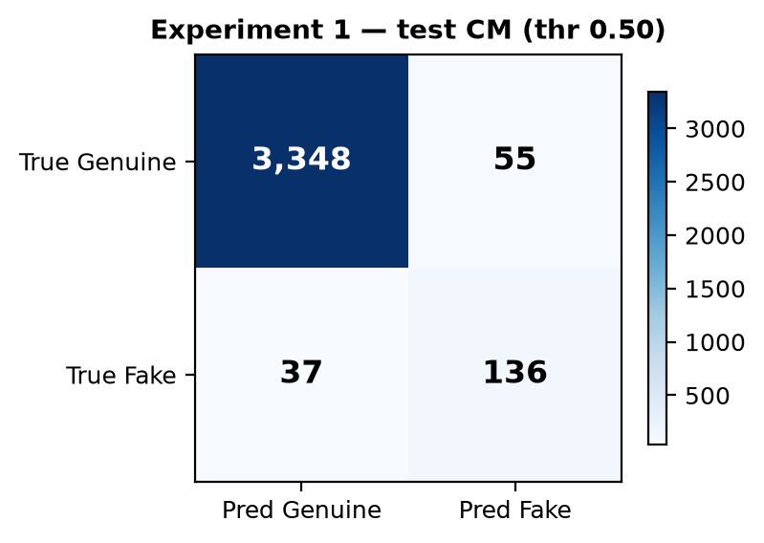
Figure 3 — Experiment 1 test confusion matrix at threshold 0.50.
Key findings: the multimodal net beats every baseline (F1 0.747 vs 0.654, AUC 0.966) and balances both error types (55 FP / 37 FN). Caveat: the validation loader was constructed from the training dataset (val_loader = DataLoader(train_dataset, …)), so validation loss/model selection were optimistic — the test metrics above remain valid because the test set was never touched, but checkpoint choice was made on leaked validation signal.

4. Experiment 2 — Pretrained ResNet-50 Transfer Learning

4.1 Objective and differences from Experiment 1
Test whether replacing the from-scratch MultiKernelResNet with an ImageNet-pretrained ResNet-50 (transfer learning) improves fraud detection, while fixing Experiment 1’s validation bug. Everything else is held comparable: identical BERT/TF-IDF/BoW branches and projections, identical 896→512→256→2 fusion, same 0.4 dropout and auxiliary heads — minus the learnable modality weights. The full decision log (15 items) is recorded in decision.md; the substantive changes are: (1) genuine train/val/test split; (2) frozen ResNet-50 backbone (2048-d → 256 projection; optional Phase-B unfreezing of layer3/4 documented but run under frozen Phase A); (3) plain weighted cross-entropy instead of the adaptive multi-task loss; (4) checkpointing and early stopping on validation FAKE F1; (5) systematic threshold search on validation; (6) FAKE-focused metrics (macro/weighted F1, FP/FN counts).

4.2 Training
Weighted cross-entropy (balanced weights, fake ≈10×); AdamW per-module (1e-5 frozen backbones, 1e-4/3e-4 projections, 2e-4 fusion), weight decay 0.01; ReduceLROnPlateau on validation FAKE F1 (factor 0.5, patience 3); gradient clipping, AMP, batch 8, max 20 epochs with early stopping (patience 5). Training stopped at epoch 11; the best checkpoint (epoch 6, validation FAKE F1 0.8065) was kept. Mild screenshot augmentation only (flip p=0.3, ±5° rotation, colour jitter); validation/test preprocessing deterministic. Figure 7 shows the history: train loss falls throughout while validation FAKE F1 peaks at epoch 6 and early stopping fires after five stagnant epochs.
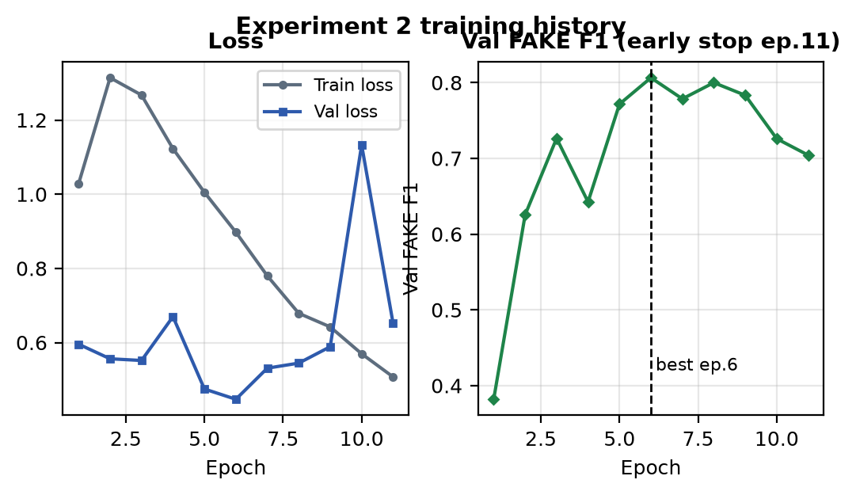
Figure 7 — Experiment 2 training history: loss (left) and validation FAKE F1 peaking at epoch 6 (right).

4.3 Threshold selection (validation only)
Thresholds 0.30–0.70 (step 0.05) were scored on the validation set (n=2,861) maximising FAKE F1; 0.40 was selected (validation FAKE F1 0.8080, 10 FP / 38 FN). Tuning never touched the test set.
Thr. | 0.30 | 0.35 | 0.40★ | 0.45 | 0.50 | 0.60 | 0.70
Val FAKE F1 | 0.8016 | 0.8048 | 0.8080 | 0.8080 | 0.8065 | 0.8016 | 0.7984
Val FAKE prec. | 0.8938 | 0.9018 | 0.9099 | 0.9099 | 0.9174 | 0.9167 | 0.9327
Val FAKE rec. | 0.7266 | 0.7266 | 0.7266 | 0.7266 | 0.7194 | 0.7122 | 0.6978

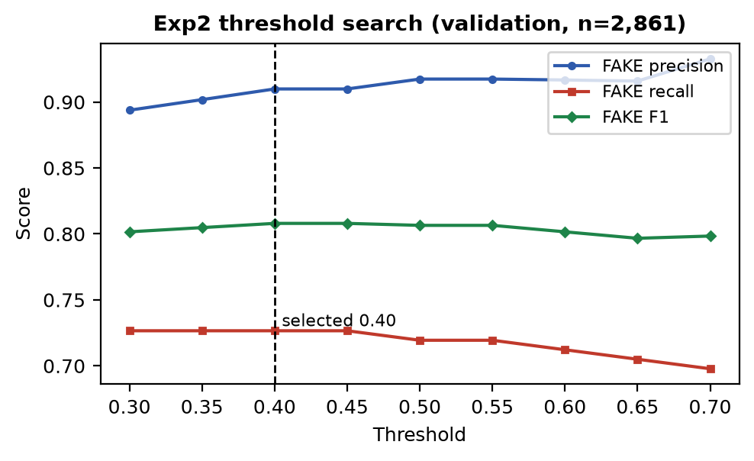
Figure 6 — Validation threshold sweep: flat F1 plateau 0.40–0.55; 0.40 selected (highest recall on the plateau).

4.4 Final test results (threshold 0.40, applied once)
Metric | Value
Accuracy | 0.9824
FAKE precision | 0.9508
FAKE recall | 0.6705
FAKE F1 | 0.7864
Macro / weighted F1 | 0.8886 / 0.9809
Confusion matrix | TN 3397, FP 6, FN 57, TP 116
ROC-AUC | Not computed in the notebook — not available

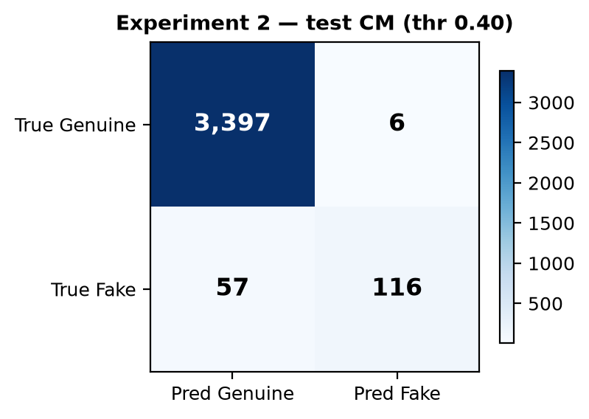
Figure 4 — Experiment 2 test confusion matrix at the selected threshold 0.40.
Key findings: near-perfect precision (95.1%; only 6 false alarms) with moderate recall (67.1%; 57 of 173 fakes missed). The validation→test FAKE F1 gap is small (0.808 → 0.786), indicating honest generalisation. The seven designed ablation configurations (BERT/TF-IDF/BoW/ResNet-only, text-only, text+ResNet, full) are defined in the notebook but were not executed — no ablation results exist, so modality contributions remain unmeasured.

5. Experiment 1 vs Experiment 2
Aspect | Experiment 1 | Experiment 2
Test set | 3,576 (3,403 G / 173 F) | Identical 3,576 (same seed/split)
Train / val | 14,304 train; val = train (bug) | 11,443 train / 2,861 genuine val
Image branch | Custom MultiKernelResNet, from scratch (512-d) | ResNet-50 ImageNet-pretrained, frozen (2048-d)
Loss / selection | Adaptive multi-task loss; ckpt on val loss | Weighted CE; ckpt + early stop on val FAKE F1
Threshold | Fixed 0.50 | Tuned on val → 0.40
Accuracy | 0.9743 | 0.9824 (+0.0081)
FAKE precision | 0.7120 | 0.9508 (+0.2388)
FAKE recall | 0.7861 | 0.6705 (−0.1156)
FAKE F1 | 0.7473 | 0.7864 (+0.0391)
Macro / weighted F1 | 0.87 / 0.97 | 0.8886 / 0.9809
ROC-AUC | 0.9656 | Not available
FP / FN | 55 / 37 | 6 / 57

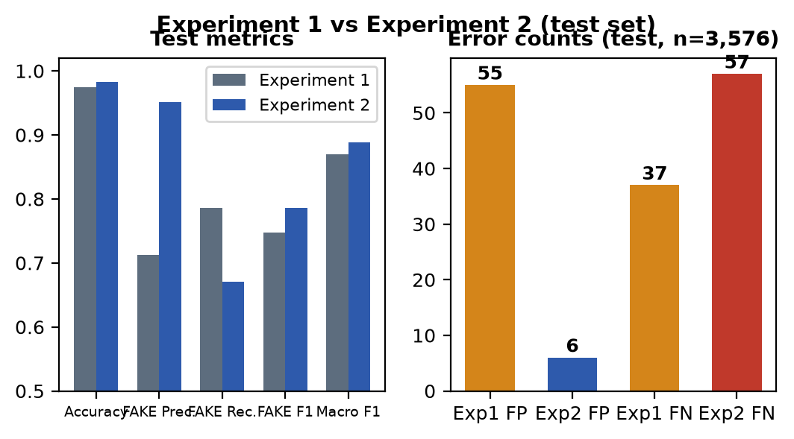
Figure 5 — Head-to-head test metrics (left) and error counts (right).
Technical analysis: Experiment 2 is not a Pareto improvement — it trades recall for precision. The pretrained backbone plus FAKE-F1-driven selection and a lower threshold operating point raised precision by 24 points and cut false alarms 55→6, lifting FAKE F1 by 3.9 points, macro F1 and accuracy with it. But FAKE recall fell 11.6 points (37→57 missed frauds). Because both share the same test set, the comparison is apples-to-apples; the caveat is attribution — the gain bundles four changes (backbone, honest validation/early stopping, FAKE-F1 checkpointing, threshold tuning), so the ResNet-50 alone cannot be credited. The improvement is meaningful where moderator workload dominates (9× fewer false alarms for +3.9 F1 points) but is a regression where missing fraud dominates: 20 extra missed fakes is a 54% increase in false negatives. Overall the better experiment depends on cost asymmetry; on the project’s headline metric (FAKE F1), Experiment 2 wins.

6. Overall Findings and Discussion
- Best approach by FAKE F1: Experiment 2 (0.786) ahead of Experiment 1 deep (0.747) and SMOTE-LR (0.654). Best fraud-catcher by recall: SMOTE-LR (0.879) and ADASYN-LR (0.896) — at 140–209 false alarms — then Exp1 deep (0.786); Exp2 trails at 0.671.
- Precision/recall operating points differ starkly: Exp1 deep 0.712/0.786 (balanced), Exp2 0.951/0.671 (conservative). Exp2 flags almost only sure fraud; Exp1 catches ~12 points more fraud at ~9× the false-alarm rate.
- False negatives are the critical error: a missed fake posting exposes job seekers to scams, while a false positive merely costs a manual review. Exp1 misses 37 fakes, Exp2 misses 57 — Exp2’s headline win comes entirely from eliminating false positives (55→6), not from catching more fraud.
- Class imbalance dominates design: accuracy (0.97–0.98) is uninformative — the Normal baseline “scores” 0.967 while missing two-thirds of fraud. Weighted loss, resampling, and FAKE-first metrics are what make the task learnable.
- Feature observations: short text, missing logos and lexical cues carry fraud signal (baselines reach 0.88 recall on TF-IDF alone); the image branch’s marginal value is unproven — ablations were never run, and Exp2’s gain cannot be isolated to ResNet-50.
- Unexpected result: transfer learning plus rigorous selection improved precision far more than recall — the opposite of the naive “better backbone catches more fraud” expectation; the conservative operating point suggests pretrained screenshot features are discriminative but the tuned threshold favours certainty.
Practical reading: deploy Exp2 where review capacity is scarce (6 false alarms per 3,576 postings); deploy Exp1 (or the SMOTE baseline) where missing fraud is costlier, accepting higher review load. A cost-weighted threshold, rather than either fixed point, is the natural next operating choice.

7. Limitations and Future Improvements

7.1 Limitations (grounded in the implementation)
- Small minority: only 866 fakes total (554 train in Exp2); deep multimodal training on a few hundred positives risks overfitting and noisy recall estimates (±1 fake ≈ 0.6 recall points on test).
- Exp1 validation leak: checkpoint selection on training-data-as-validation; mitigated in Exp2 but Exp1’s reported operating point carries selection bias.
- Attribution gap: Exp2 changes backbone, validation, checkpoint metric and threshold simultaneously — no isolation of the ResNet-50 effect; ablations A–G unexecuted.
- Missing metrics: no ROC-AUC or PR curve for Exp2, so ranking quality across thresholds cannot be compared with Exp1’s 0.9656.
- Limited tuning: single seed, single split, fixed 0.5 (Exp1) / coarse 0.05-grid (Exp2) thresholds, no cross-validation, Phase-B fine-tuning untried, frozen BERT throughout.
- Feature gaps: structured signals (logo presence, employment type, text length) enter only implicitly via text/screenshots; placeholder grey images for missing screenshots add noise.

7.2 Future improvements
- Execute the seven ablations plus PR/ROC curves to isolate the image branch’s value and compare ranking quality.
- Phase-B ResNet fine-tuning (layer3/4, lr 1e-5), BERT unfreezing/LoRA, and a cost-weighted threshold reflecting FN≫FP harm.
- K-fold or repeated-seed evaluation with confidence intervals; calibration of fake probabilities.
- Explicit structured features (logo, length, employment type) and modern text encoders; external or synthetic fraud augmentation beyond SMOTE.

8. Conclusion
Two experiments investigated multimodal fake-job detection on 17,880 postings at a 95/5 imbalance. Experiment 1 showed classical TF-IDF logistic regression tops out at F1 0.654 (SMOTE) while a from-scratch four-branch network (frozen BERT + custom MultiKernelResNet + TF-IDF + BoW) reached accuracy 0.9743, FAKE F1 0.7473 and recall 0.7861 with 55 FP / 37 FN — despite a validation-split bug. Experiment 2 fixed validation, adopted a frozen pretrained ResNet-50, FAKE-F1 checkpointing/early stopping and validation-tuned threshold 0.40, achieving accuracy 0.9824 and FAKE F1 0.7864 with only 6 false alarms but 57 missed frauds. On the headline FAKE-F1 metric Experiment 2 performs better (+3.9 points, 9× fewer false alarms); on fraud recall Experiment 1 is better (−11.6 points, 20 fewer misses). The most important finding is the trade-off itself: rigorous transfer learning made the model far more precise but more conservative. Recommended direction: run the pending ablations, fine-tune Phase B, and choose the operating threshold from explicit false-negative/false-positive costs rather than F1 alone.

