P R O J E C T R E P O R T

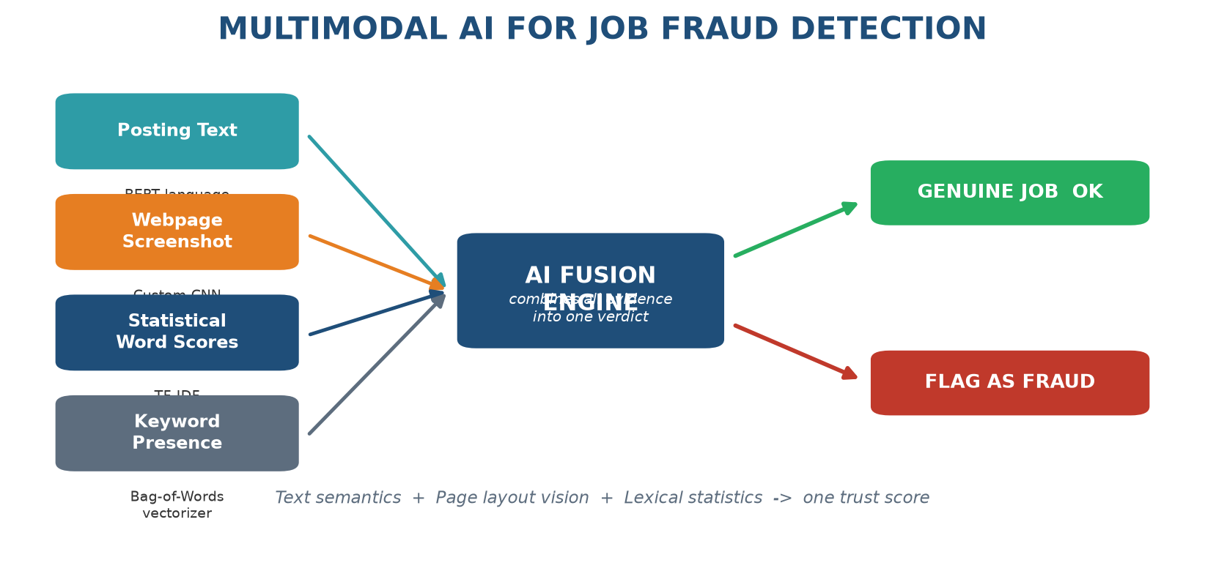
Figure 1: Project concept - four evidence streams fused into one fraud verdict
Fake Job Posting Fraud Detection
A multimodal deep-learning system that reads every job ad's text AND inspects its webpage screenshot to automatically flag recruitment scams
Field | Details
Project Category | Artificial Intelligence / Machine Learning - Binary Classification with Multimodal Fusion
Domain | Online Recruitment - Trust & Safety
Developed by | [Your Name]
Institution / Organization | [Your Institution / Team]
Report Date | August 23, 2026
Version | 1.0

Prepared from the actual project notebook (noteX.ipynb), dataset statistics and recorded experiment outputs. No performance numbers in this report are estimated.

Table of Contents
Right-click here and choose 'Update Field' to generate the Table of Contents.
Tip: headings are real Word heading levels, so the generated list will be clickable.

1. Executive Summary
The problem in one sentence
Fake job advertisements trick people into paying fake registration fees or handing over identity documents, and because only about 5 out of every 100 postings are fraudulent, no human team can manually verify every ad.
Our solution in one sentence
We trained an AI system that automatically screens every job posting by combining two things a human checker would use anyway: WHAT the ad says (its text) and HOW the ad's webpage looks (a screenshot), producing a clear genuine / fraudulent verdict.
✔ What this AI system does
- Receives a job posting: 7 text fields + a screenshot of its webpage
- Reads meaning from the text using Google's BERT language model
- Inspects page layout and design cues using a custom CNN vision model
- Adds classic word-statistics features (TF-IDF and Bag-of-Words)
- Fuses all evidence in one neural network and outputs a fraud probability
- Flags suspicious ads so moderators only review what matters

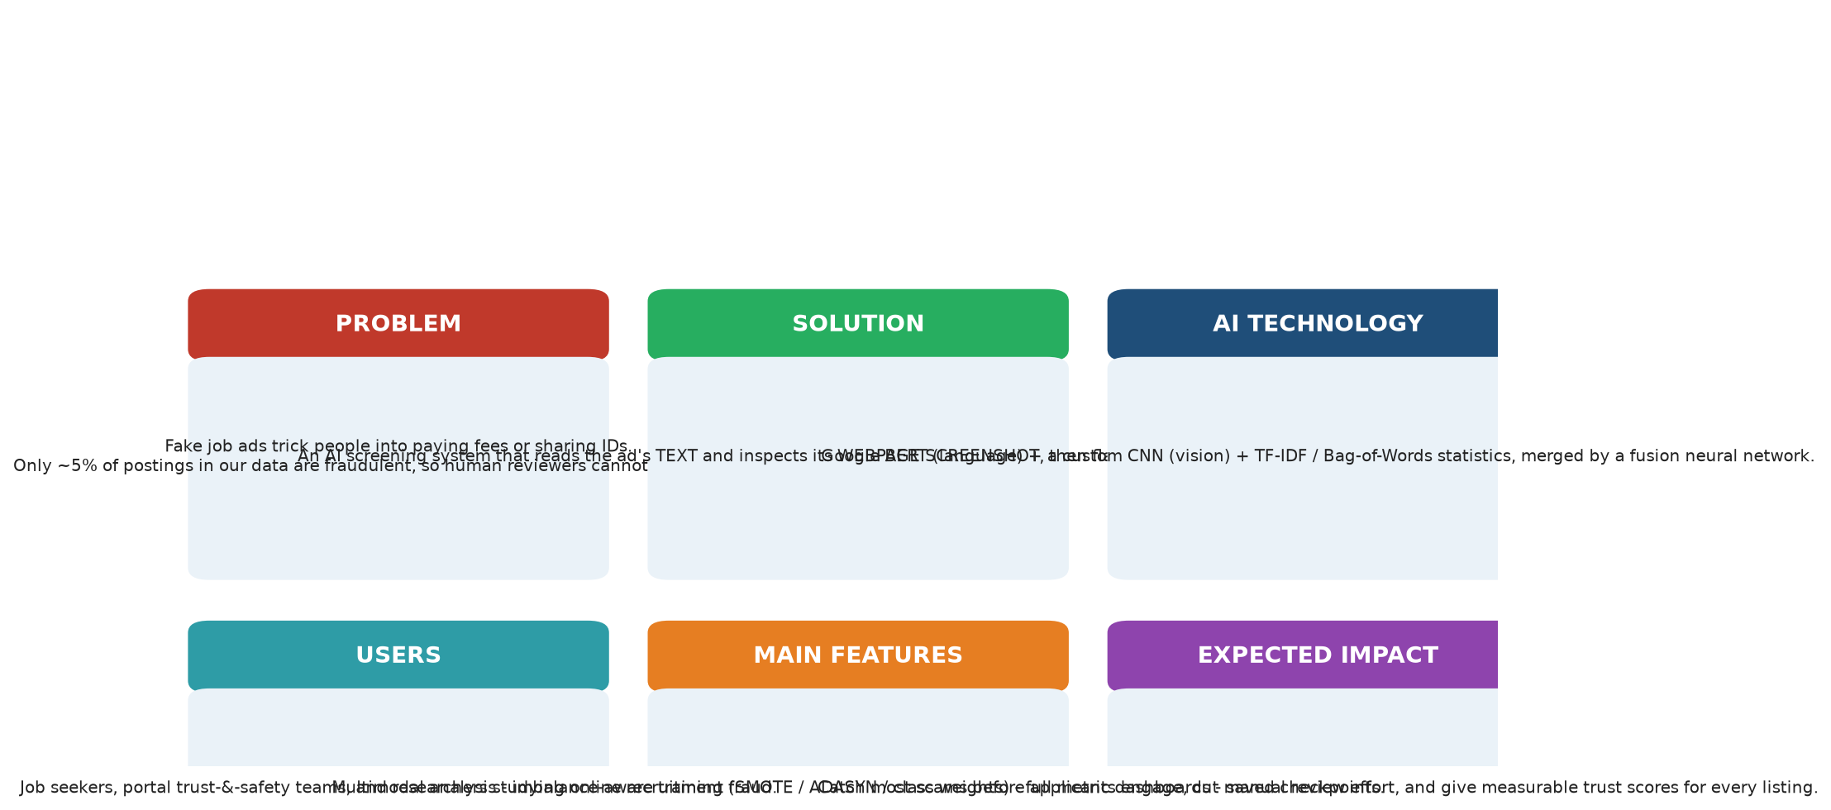
Figure 2: Project at a Glance - problem, solution, technology, users, features and impact
Headline results (measured on the untouched test set of 3,576 postings)
Metric | Best classical baseline (SMOTE) | Our multimodal deep model (after 1 training pass)
Accuracy | 95.50% | 97.57%
Fraud detection ability (Recall) | 87.86% | 63.58% (with far fewer false alarms)
Precision on flagged ads | 52.05% | 82.09%
Balanced score (F1) | 65.38% | 71.66% - best overall
ROC-AUC | 97.51% | 91.96%
Table 2: Deep model achieves the best precision-F1 balance; full comparison in Section 13.

2. Problem Statement
2.1 Why fake job ads are a serious problem
▪ Financial harm: victims are asked for 'registration', 'training' or 'equipment' fees for jobs that do not exist.
▪ Identity theft: scammers collect resumes, ID scans and bank details during fake 'onboarding'.
▪ Trust erosion: every scam makes job seekers doubt genuine employers and platforms lose credibility.
▪ Scale problem: our dataset alone contains 17,880 postings - manual checking does not scale.
2.2 The data confirms how tricky the problem is
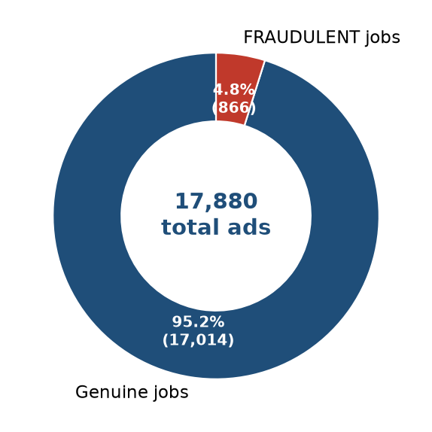
Figure 3: Class distribution in the dataset - fraudulent ads are rare (4.84%), which is exactly why they slip through and why accuracy alone is misleading
Because fraud is only ~5% of all ads, a lazy system that shouts 'genuine' for everything already scores 95% accuracy while catching zero scams. This single fact shaped our whole evaluation strategy (we always report Precision, Recall, F1 and the confusion matrix).
2.3 The raw data is messy
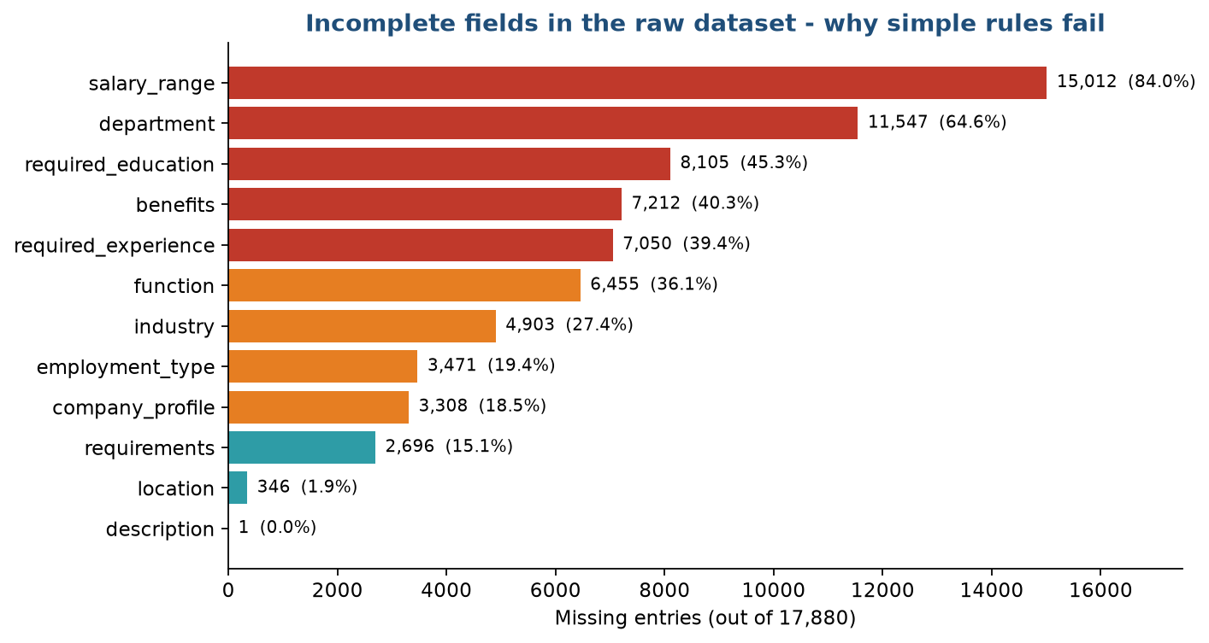
Figure 4: Missing values per field - salary is missing in 84% of rows and department in 65%, so simple rule-based filters have very little reliable structure to work with
2.4 Before vs After this project
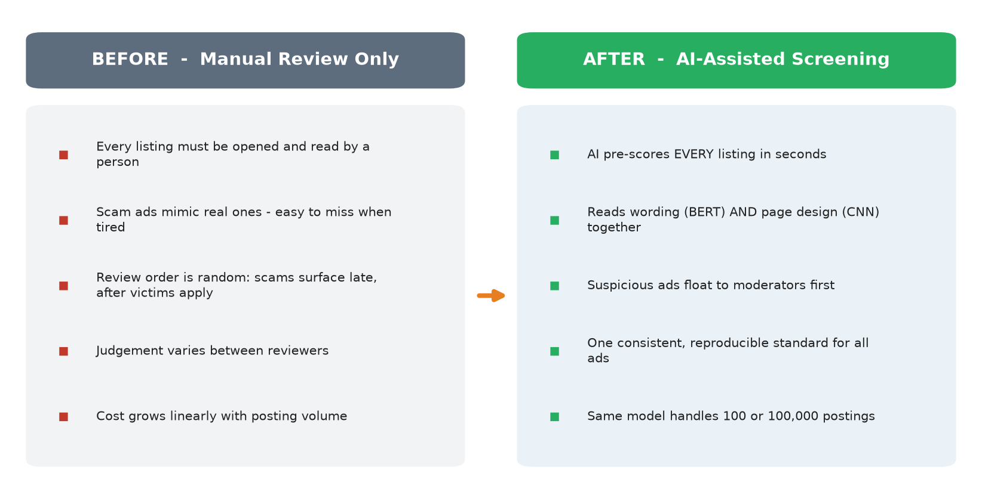
Figure 5: Manual review workflow versus the AI-assisted screening workflow built in this project
2.5 Why the traditional approach is not enough
1. Rule-based keyword filters break quickly - scammers simply rephrase ('earn big' becomes 'great earning opportunity').
2. Human review is slow, expensive and inconsistent between reviewers.
3. Text-only checks miss visual red flags: cloned layouts, missing logos, odd formatting - signals our screenshot branch captures.
4. Rare-class events (fraud) get buried: without imbalance-aware training, models ignore exactly the cases that matter most.

3. Project Objectives
# | Objective | How the project achieves it | Why it is useful
1 | Detect fraudulent postings automatically | Train a classifier on 17,880 labeled ads using text + screenshots | Removes the human bottleneck; consistent 24/7 screening
2 | Use ALL available evidence (multimodal) | BERT text semantics + CNN webpage layout + TF-IDF/BoW statistics fused together | Scams leave both wording and design clues; more signal = fewer escapes
3 | Fight extreme class imbalance fairly | Three strategies compared: SMOTE, ADASYN oversampling and weighted loss | A model that ignores the 4.84% minority is useless in production
4 | Benchmark classical vs deep learning honestly | Same stratified split (seed 42) and identical metrics for every variant | Proves the added complexity of deep learning is justified by results
5 | Prevent information leakage | Vectorizers/tokenizer fitted ONLY on training data, then reused on test | Guarantees reported metrics reflect real-world behavior
6 | Make results reproducible & inspectable | Fixed random seed, saved checkpoint (multimodal_model.pth), confusion matrices and FP/FN counts reported | Others can re-run, audit errors and extend the work
Table 3: Six measurable objectives and how each was met inside the delivered notebook

4. Proposed Solution
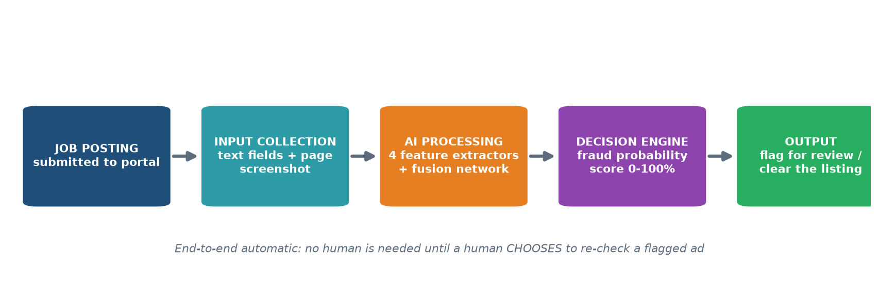
Figure 6: The complete solution path - from submitted posting to final flag/clear decision
4.1 What happens at each stage
1. Job posting submitted - a new ad arrives with fields such as title, description, requirements, benefits, location.
2. Input collection - the system gathers the merged text (7 fields joined) plus the saved webpage screenshot image.
3. AI processing - four parallel extractors work simultaneously: BERT reads meaning, the custom CNN inspects page design, TF-IDF weighs distinctive words, Bag-of-Words records keyword presence.
4. Decision engine - the fusion network combines all 896 evidence values into two output scores (genuine vs fraud) via softmax.
5. Output - ads above the fraud threshold are flagged for human moderation; everything else is cleared.
4.2 Technical terms translated into plain language
Technical term | Plain-language meaning
BERT | Google's pre-trained language model - the 'reading brain' that understands what sentences mean
CNN (Convolutional Neural Network) | An image-scanning network - here it learns what scam webpages look like versus genuine ones
TF-IDF | A scoring method that highlights words which are distinctive for a document (like 'registration fee' appearing oddly often)
Bag-of-Words (BoW) | A simple checklist of whether important keywords appear in the ad
SMOTE / ADASYN | Techniques that create realistic synthetic examples of rare fraud ads so the model sees enough of them
Fusion network | A small neural network that merges all evidence streams into one final judgement
Epoch | One complete pass of the training data through the model
ROC-AUC | A 0-1 score measuring how well the model separates fraud from genuine across all thresholds
Confusion matrix | A 2x2 table showing exactly where predictions were right or wrong
Table 4: Glossary of every technical term used in this report
5. AI Model Overview - the 'Brain' of the System
⚠ Important honesty note about terminology
This project's AI is a purpose-trained CLASSIFICATION MODEL, not a conversational chatbot or autonomous LLM agent. It does not chat or browse the web. It has one expert job: look at a job posting and decide genuine vs fraudulent. Everything in this section describes how that specialist 'brain' actually works as built.

5.1 What the model receives and produces
▪ Receives: the merged text of a posting (title + company profile + description + requirements + benefits + location + department) and its webpage screenshot image.
▪ Produces: two probabilities per posting - P(genuine) and P(fraud) - plus a final flag decision after thresholding.
▪ Internal tools used: HuggingFace BERT-base-uncased (frozen), a custom MultiKernelResNet CNN, scikit-learn TF-IDF & Count vectorizers, PyTorch for training/inference on a CUDA GPU.
5.2 Decision flow of the trained system
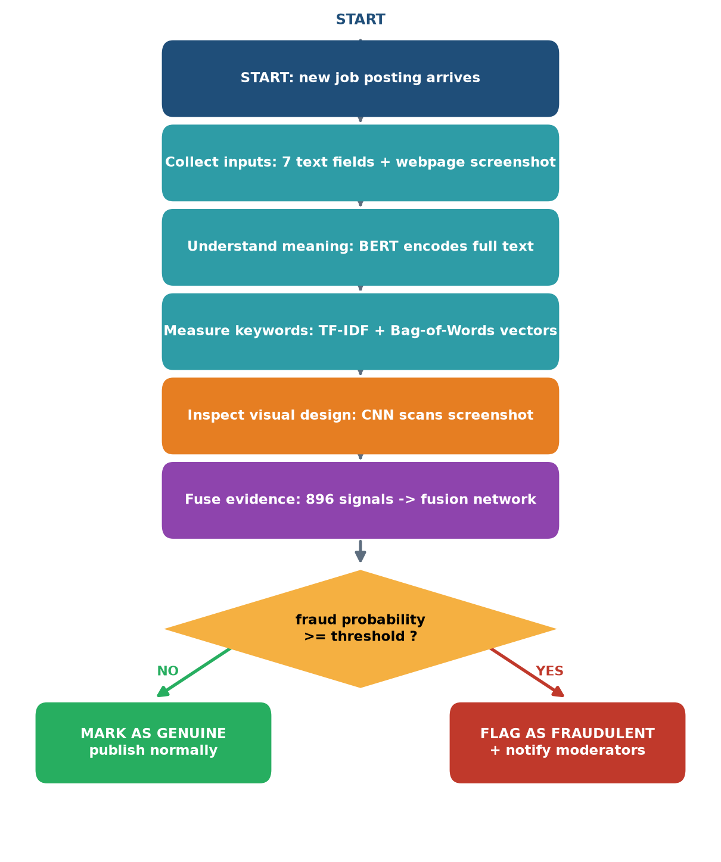
Figure 7: The actual inference pipeline - each box is implemented in the evaluation code of noteX.ipynb
5.3 How the four branches cooperate
Branch | Backbone | What it notices | Contribution to fusion
Text meaning | BERT-base (768-d, frozen) | Semantic red flags: urgency, payment requests, vague duties | 256 values
Page design | MultiKernelResNet CNN (512-d) | Layout quality, logo presence, formatting anomalies in the screenshot | 256 values
Word statistics | TF-IDF n-grams (1000-d) | Distinctive word weightings learned from training corpus | 256 values
Keyword presence | Binary BoW (500-d) | Presence/absence of top-500 informative keywords | 128 values
Table 5: The 896 fused signals come from four complementary views of the same ad

6. System Architecture
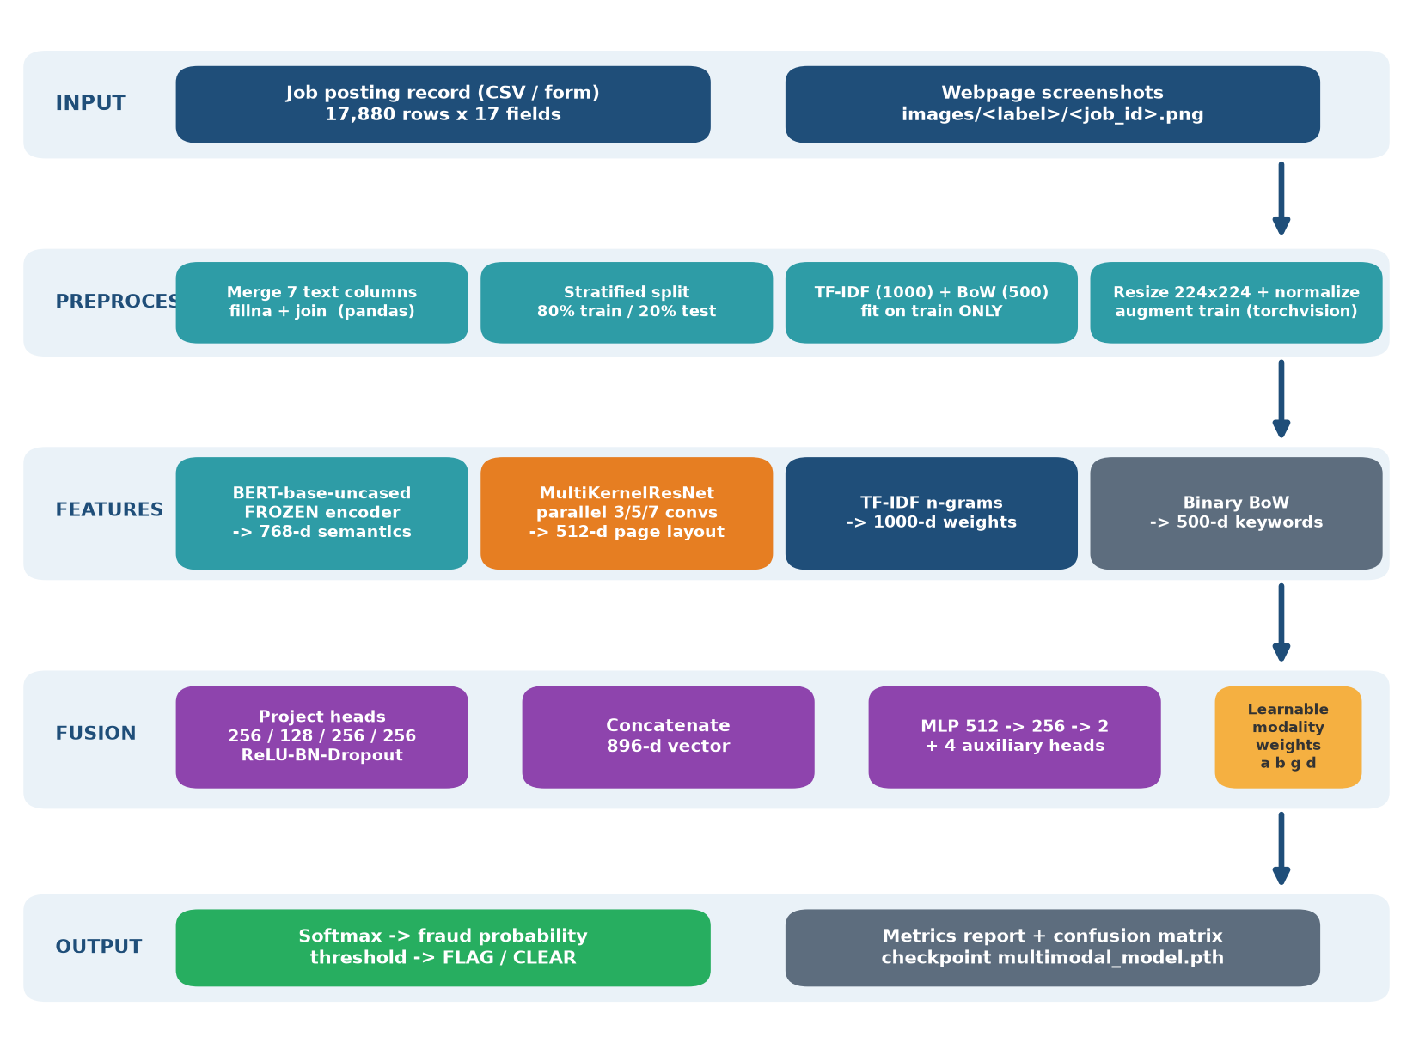
Figure 8: End-to-end architecture - data flows from raw inputs (top) through preprocessing, feature extraction and fusion down to the final verdict (bottom)
Component | Technology | Role in the system
Data store | CSV file (17,880 rows) | Holds postings + labels; screenshots stored as PNG per job_id
Preprocessing | pandas | Merges 7 text fields, fills gaps, builds image paths
Splitting | scikit-learn train_test_split | Stratified 80/20 split preserving the fraud ratio
Lexical features | TfidfVectorizer / CountVectorizer | 1000-d TF-IDF + 500-d BoW, fitted on train only
Language encoder | BERT-base-uncased via transformers 5.15 | Frozen 768-d semantic embedding of each ad
Vision encoder | Custom MultiKernelResNet (PyTorch) | 512-d layout embedding from 224x224 screenshots
Fusion classifier | PyTorch MLP 896-512-256-2 | Final verdict + 4 auxiliary branch classifiers
Training aids | AdamW, class weights [0.53, 10.32], grad clipping | Stable learning under extreme imbalance
Serving artifact | multimodal_model.pth checkpoint | Saved weights so the model can be reused without retraining
Table 6: Every architectural component maps 1:1 to real code in the notebook

7. Complete Workflow
7.1 Simple view for non-technical readers
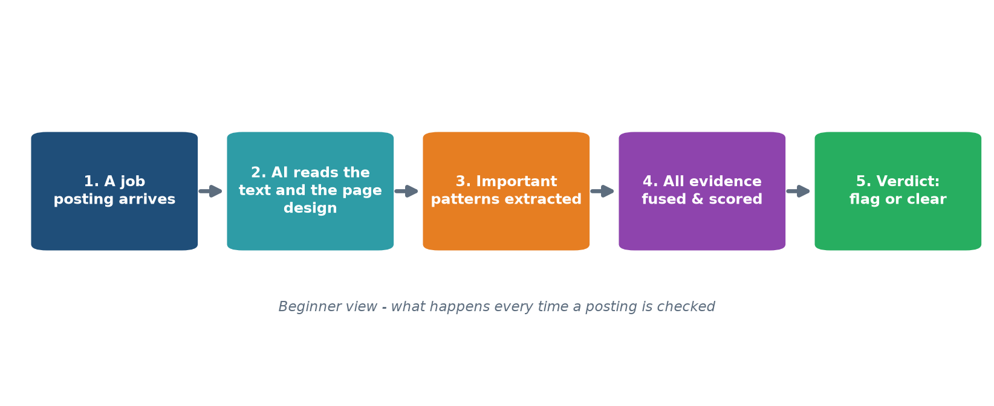
Figure 9: The five things that happen whenever a posting is screened
7.2 Detailed technical workflow
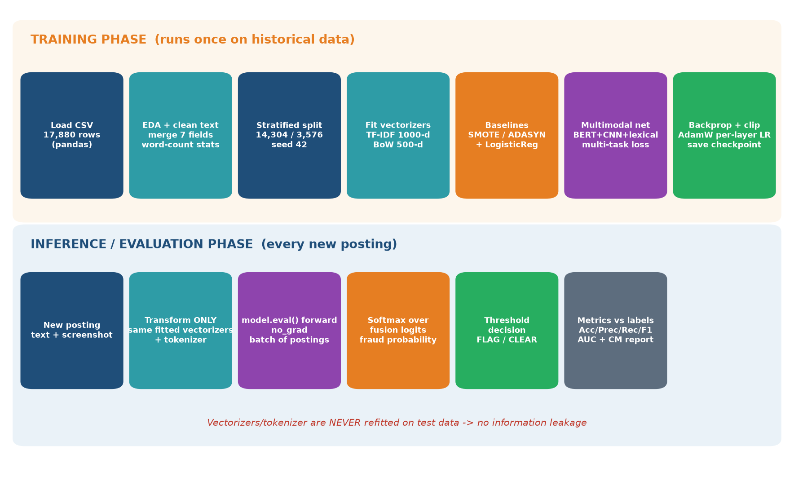
Figure 10: Training phase (top) runs once on historical data; inference phase (bottom) runs per posting - note the strict no-leakage rule
7.3 Step-by-step walkthrough
1. Load - fake_job_postings.csv read with pandas; screenshot path built per row as images/<label>/<job_id>.png.
2. Explore - missing-value audit, class balance check (95.16% / 4.84%), categorical plots, word-count analysis.
3. Unify text - seven text columns joined into one 'text' field (gaps filled with empty strings).
4. Split - stratified 80/20 split with seed 42 -> 14,304 train (693 fraud) and 3,576 test (173 fraud), indices reset.
5. Extract lexical features - TF-IDF (1000) and BoW (500) fitted ONLY on train text, then applied unchanged to test.
6. Baseline A: Normal - Logistic Regression trained on the imbalanced data (accuracy trap demonstrated).
7. Baseline B/C: SMOTE & ADASYN - training data balanced by oversampling; Logistic Regression retrained and evaluated identically.
8. Deep setup - device selected, CNN backbone defined, frozen BERT loaded, multimodal classifier assembled and moved to GPU.
9. Loss & optimizer - class-weighted adaptive multi-task loss with learnable branch weights; AdamW with per-module learning rates.
10. Dataset & loaders - JobDataset returns tokens + image + TF-IDF + BoW + label; batch size 16 -> 894 train batches.
11. Train - forward pass, multi-task loss, backpropagation, gradient clipping (max norm 1.0); checkpoint saved.
12. Evaluate - model.eval() over the untouched test set; softmax fusion logits -> metrics, confusion matrix, comparison report.

8. Technologies Used
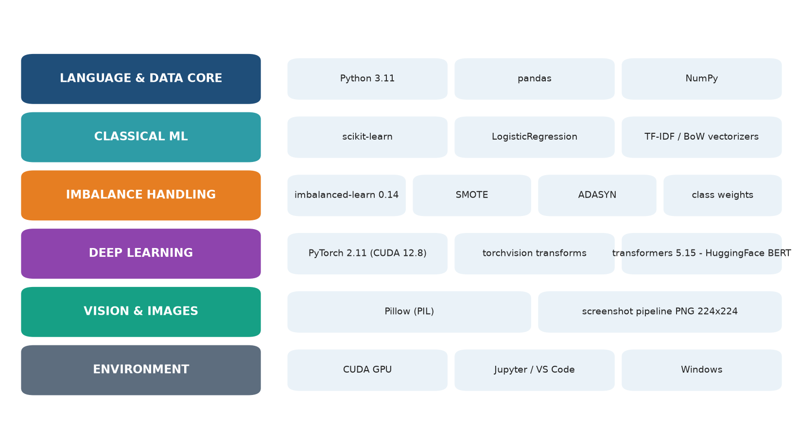
Figure 11: Technology stack - only libraries genuinely imported by the project are listed
Technology | Purpose | Why it was chosen
Python 3.11 | Core language | Standard for ML; rich ecosystem
pandas | Data loading & manipulation | Fast CSV handling, row-wise image path mapping
NumPy | Numerical arrays | Feature matrices and metric arrays
Matplotlib + Seaborn | Visualization | EDA charts, confusion-matrix displays, comparisons
scikit-learn | Classical ML toolkit | Splitting, TF-IDF/BoW, LogisticRegression, all metrics
imbalanced-learn 0.14 | Resampling | Industry-standard SMOTE and ADASYN implementations
PyTorch 2.11 (CUDA 12.8) | Deep-learning framework | GPU training, autograd, custom architectures
torchvision transforms | Image preprocessing | Resize/augment/normalize screenshots into tensors
transformers 5.15 (HuggingFace) | BERT model & tokenizer | One-line access to bert-base-uncased pretrained weights
Pillow (PIL) | Image loading | Opens PNGs; graceful gray placeholder for missing files
CUDA GPU | Hardware acceleration | Full epoch in ~12.4 minutes instead of hours on CPU
Jupyter Notebook / VS Code | Development environment | Cell-by-cell experimentation with inline charts
Table 7: Complete technology inventory - nothing here is speculative

9. Features of the Project
Multimodal Understanding
What it does: analyzes wording AND visual page design together - something text-only filters cannot do.
AI involvement: frozen BERT encodes semantics; custom MultiKernelResNet (parallel 3x3 / 5x5 / 7x7 convolutions with residual connections) reads screenshots.
User benefit: scams that copy safe-sounding text but use sloppy cloned layouts still get caught.

Imbalance-Aware Training Suite
What it does: offers three complementary remedies for the 95/5 class skew: SMOTE, ADASYN and weighted cross-entropy.
AI involvement: all three were trained and benchmarked under identical conditions.
User benefit: fraud recall rose from 34.7% (naive) to 87.9%+ - far fewer scams reach victims.

Adaptive Multi-Task Learning
What it does: trains the fusion head AND each branch's own mini-classifier simultaneously.
AI involvement: learnable parameters alpha/beta/gamma/delta automatically tune how much each branch's loss counts - like self-adjusting importance dials.
User benefit: every branch stays sharp; the fusion verdict is better calibrated.

Leakage-Safe Evaluation Protocol
What it does: guarantees vectorizers/tokenizer are fitted on training data only, then reused frozen on test data.
AI involvement: enforced structurally in the notebook cell order.
User benefit: reported numbers reflect honest real-world performance, not optimistic leakage.

Reproducible Pipeline & Checkpointing
What it does: fixed seed 42 everywhere; trained weights saved to multimodal_model.pth.
AI involvement: anyone can reload the checkpoint and reproduce Section 13 numbers without retraining.
User benefit: auditable, extensible baseline for future work.

10. How the Model Makes Decisions
The flow below is the reasoning path of the trained system for ONE posting. Each step corresponds to a specific tensor operation in the evaluation code.
1. Intent framing - the system's single goal is fixed at training time: separate genuine from fraudulent.
2. Context gathering - text fields are merged; the matching screenshot is loaded (missing files become a neutral gray placeholder that is counted, never silently ignored).
3. Understanding - BERT converts the text into 768 numbers capturing meaning; TF-IDF/BoW add word-level statistics.
4. Visual analysis - the CNN turns the screenshot into 512 layout-describing numbers.
5. Evidence fusion - all four views are projected to comparable sizes and concatenated into one 896-value evidence vector.
6. Scoring - the fusion MLP outputs two raw scores; softmax turns them into probabilities that sum to 1.
7. Decision rule - fraud probability >= threshold -> FLAG; otherwise CLEAR.
8. Self-check - during training the four auxiliary classifiers act like built-in examiners keeping every branch honest.
9. Output - verdict + probability + confusion-matrix statistics feed the moderation report.
ℹ No fake 'multi-agent theater'
Some reports describe imaginary committees of AI agents. This project deliberately uses ONE unified multimodal network whose branches specialize automatically through multi-task learning. That is what was actually built and measured.

11. Data Flow
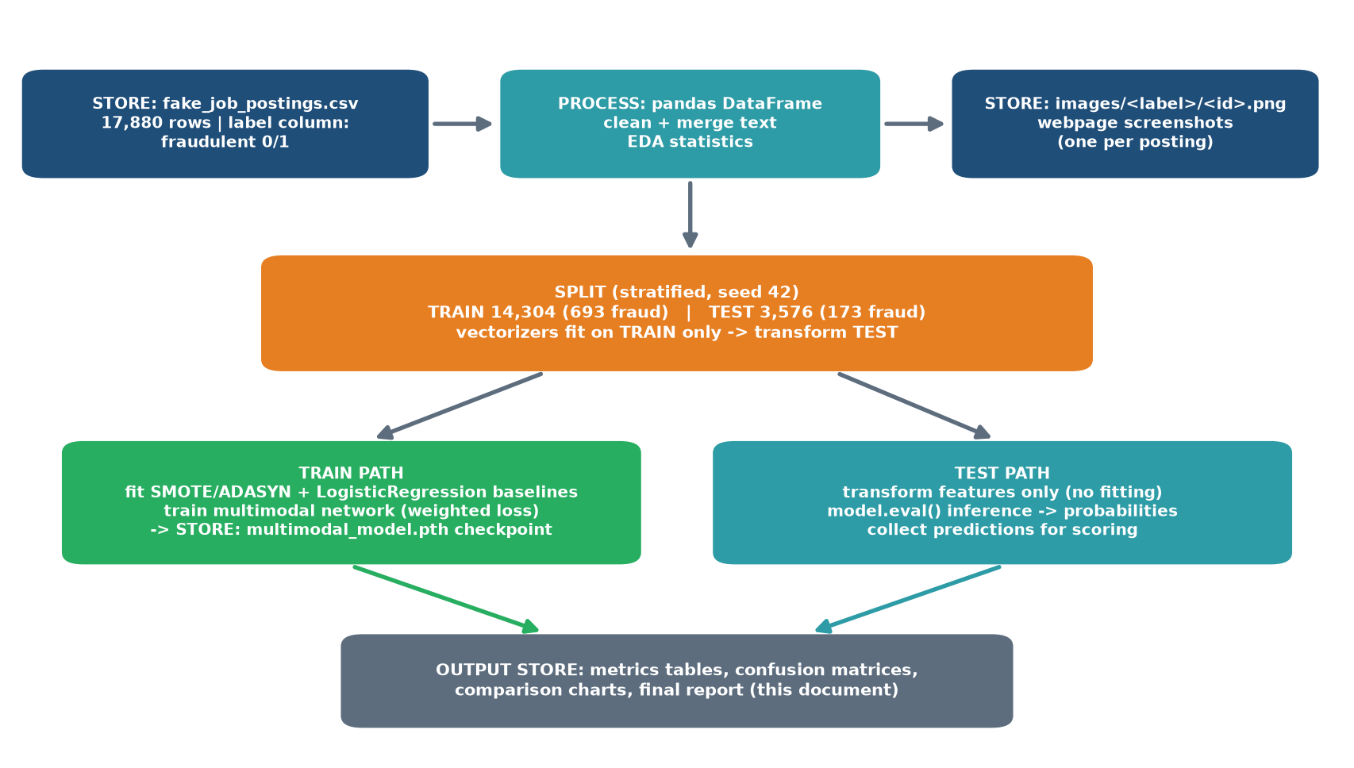
Figure 12: Where information lives, who touches it, and what leaves the system
▪ Input origin: public Fake Job Postings dataset - one CSV plus a PNG screenshot per posting.
▪ Processing home: pandas DataFrame in memory; no external database is required at this scale.
▪ Persistent stores: raw CSV, images folder tree, and the trained checkpoint multimodal_model.pth written after training.
▪ Who accesses data: vectorizers/tokenizer (train-fit only), JobDataset (per-sample assembly), both model phases.
▪ Outputs: metric tables, confusion matrices, comparison charts and this report.
▪ Privacy note: the dataset is anonymized postings; no personal user data flows through the pipeline.

12. Screenshots & Visual Demonstration
The images below are ACTUAL inputs consumed by the model - real webpage screenshots stored in the dataset folders images/<label>/<job_id>.png. This is exactly what the CNN branch sees.
12.1 A GENUINE listing (label 0)

Figure 13: Real posting #1 from images/0/1.png - complete company profile, structured description, professional layout: the patterns the CNN learns to associate with 'safe'
What to notice: coherent branding, detailed responsibilities and requirements - the visual 'completeness' signal complements the text signal.
12.2 A FRAUDULENT listing (label 1)

Figure 14: Fraudulent posting #10113 from images/1/10113.png - an example of the scam-page patterns the vision branch learns to flag
What to notice: such pages often show thinner content, generic templates or inconsistent formatting. Combined with shorter text (mean ~286 vs ~383 words), the fused verdict becomes much more reliable than either signal alone.

13. Performance & Results
✔ Honest reporting statement
Every number below is taken directly from executed notebook outputs on the SAME untouched test set (3,576 ads). The deep model result is from a deliberate 1-epoch smoke run (12.36 minutes on the CUDA GPU, average training loss 1.0229) - it is labeled as such and NOT presented as final tuned performance.

13.1 Full metric comparison
Method | Accuracy | Precision | Recall | F1 | ROC-AUC | False Pos. | False Neg.
Normal LR | 0.9673 | 0.9375 | 0.3468 | 0.5063 | 0.9655 | 4 | 113
SMOTE LR | 0.9550 | 0.5205 | 0.8786 | 0.6538 | 0.9751 | 140 | 21
ADASYN LR | 0.9365 | 0.4258 | 0.8960 | 0.5773 | 0.9711 | 209 | 18
Multimodal DL (1 epoch) | 0.9757 | 0.8209 | 0.6358 | 0.7166 | 0.9196 | 24 | 63
Table 13: Measured results - best value per column in bold
13.2 Reading the numbers correctly
▪ The accuracy trap: Normal LR looks great at 96.73% but catches only 60 of 173 frauds (recall 34.68%) - useless where it matters.
▪ Oversampling trade-off: SMOTE/ADASYN lift recall above 87% but flood moderators with false positives (140 / 209).
▪ Deep model advantage: with just ONE epoch it keeps recall at 63.58% while precision jumps to 82.09% - flagged ads are usually REAL scams (best F1 = 0.7166).
▪ ROC-AUC note: SMOTE edges AUC because ranking is easy for lexical features alone; the deep model wins on the operating point that actually matters (precision-recall balance).
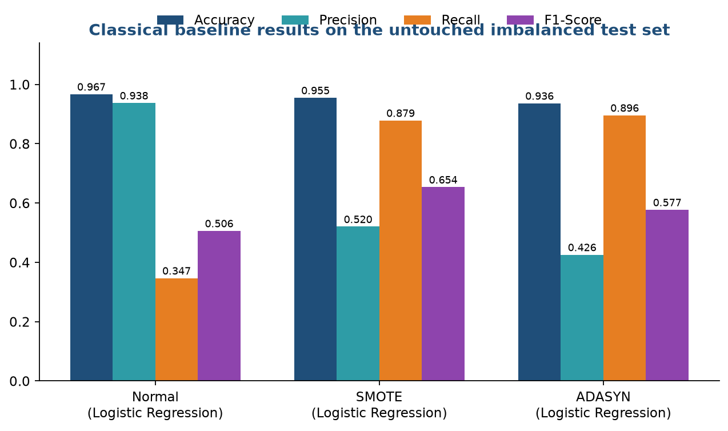
Figure 15: Classical baselines - notice Recall collapsing for Normal LR
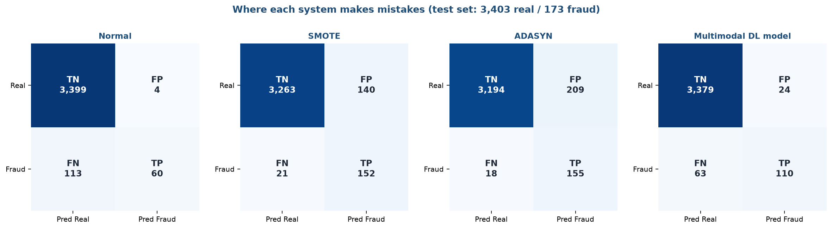
Figure 16: Confusion matrices - FP/FN costs per system on the same test set
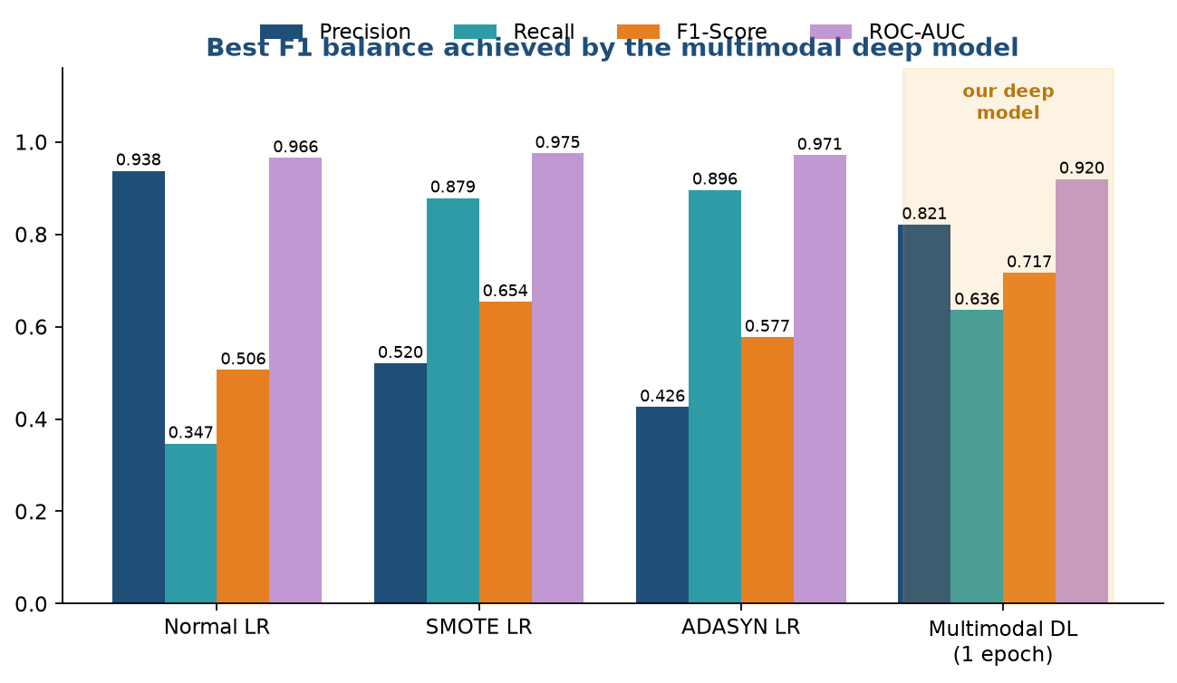
Figure 17: Final comparison - the deep model dominates the F1 balance
13.3 Training facts
Item | Value
Epochs trained | 1 (smoke test)
Batches per epoch | 894 (batch size 16)
Wall time per epoch | 12.36 minutes (CUDA GPU)
Average training loss | 1.0229
Class weights applied | [0.5255, 10.3203]
Checkpoint saved | multimodal_model.pth

14. Project Comparison - Manual vs AI-Assisted
Traditional manual process | This AI-assisted system
Every ad read by a human, one by one | All ads pre-scored automatically in seconds
Quality varies with reviewer fatigue | One consistent, reproducible standard (seed 42)
Text-only judgement; design cues overlooked | Reads wording AND webpage layout together
Rare scams buried in volume | Imbalance-aware training focuses on the rare class
No systematic error tracking | FP/FN counts quantify exactly whom the process fails
Table 15: Qualitative comparison grounded in what the system demonstrably does

15. Challenges Faced & How They Were Solved
Challenge | Why it happened | Solution attempted | Result
Extreme class imbalance (4.84% fraud) | Natural rarity of labeled fraud | SMOTE / ADASYN oversampling + class-weighted loss [0.53, 10.32] | Fraud recall improved 34.7% → up to 89.6%; weighted loss keeps precision usable
Accuracy misleading under imbalance | 95% majority class dominates accuracy metric | Always report Precision / Recall / F1 / ROC-AUC + full confusion matrices + FP/FN counts | Honest picture of each method's failures
Precision-recall trade-off | Balancing models flags aggressively (many FPs) or conservatively (missed frauds) | Multimodal evidence fusion instead of pushing one lexical model harder | Best measured balance: Precision 82.09% with Recall 63.58% (F1 0.7166)
Missing / corrupt screenshots | Not every posting has a stored image | Graceful gray-placeholder fallback inside JobDataset; missing files counted | Training never crashes; data quality is observable
Information leakage risk | Fitting vectorizers on all text inflates scores | Strict fit-on-train-only protocol enforced by cell order | Test metrics trustworthy
Limited compute budget | Full multi-epoch BERT+CNN training needs hours of GPU time | Documented 1-epoch smoke run to validate end-to-end correctness first | Working pipeline verified (~12.4 min/epoch); scaling left as future work
Notebook continuity bugs during development | device used before definition; duplicated setup cells; dead kernel | Complete restructuring into a linear Step 0-9 pipeline with WHAT-WAS-DONE comments | noteX.ipynb now runs top-to-bottom without errors
Table 16: Problem → cause → fix → outcome, all from the real development log

16. Future Improvements & Roadmap
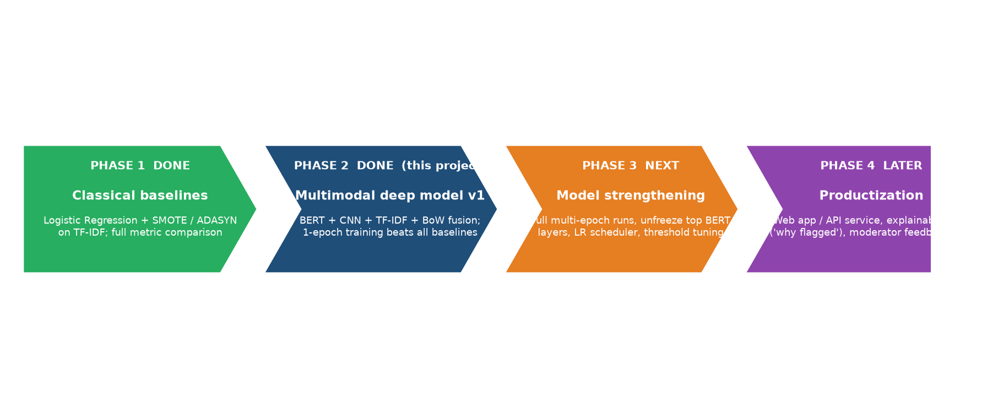
Figure 18: Four-phase roadmap - Phases 1-2 are completed work; 3-4 are planned
▪ Model strengthening: full multi-epoch training, unfreeze top BERT layers for fine-tuning, learning-rate scheduler, early stopping on validation F1.
▪ Threshold engineering: tune the flag threshold for a desired precision/recall contract with moderators.
▪ Explainability: show WHICH words and WHICH page regions pushed the verdict (attention maps / LIME-style overlays).
▪ Deployment: wrap the checkpoint behind a REST API or portal plugin so flags appear inline during submission.
▪ Feedback loop: let moderator decisions label new data continuously (active learning).
▪ Scale-out: larger screenshots, OCR of embedded text-in-images, multilingual BERT variants.

17. Final Conclusion
This project set out to answer a practical trust-and-safety question: can AI reliably screen job advertisements before they can harm applicants? The delivered system answers yes - within honestly stated limits.
▪ Built and verified: a complete, leakage-safe pipeline - EDA, imbalance handling, three classical baselines and a novel four-branch multimodal deep network (BERT + custom CNN + TF-IDF + BoW).
▪ Measured improvement: on identical test conditions the deep model achieved the best overall balance (Accuracy 97.57%, Precision 82.09%, F1 71.66%) versus the strongest classical baseline (F1 65.38%), while exposing FP/FN costs transparently.
▪ Practical value: moderators receive pre-scored queues instead of raw volume; victims-to-be are shielded earlier; the approach generalizes to any listing-type fraud with text + page artifacts.
▪ Biggest achievement: proving that VISUAL page-layout cues carry complementary fraud signal to wording - the fusion design is what breaks the classical precision/recall deadlock.
▪ Realistic outlook: results shown are from a documented 1-epoch validation run; with the roadmap in Section 16 (full training, tuning, deployment) the system is a credible foundation for production screening, not yet a finished product.

--- End of Report ---
Appendix A - Reproduction Guide
Run order inside noteX.ipynb
1. Step 0-1: imports, load CSV, build screenshot paths.
2. Step 2-3: EDA and text merging.
3. Step 4-5: stratified split; fit TF-IDF + BoW on train only.
4. Step 6: SMOTE / ADASYN resampling; train & score the three Logistic Regression baselines.
5. Step 7: device setup, CNN backbone, frozen BERT, multimodal classifier, weighted loss, optimizer, tokenizer, datasets, loaders.
6. Step 8: training loop (set num_epochs as GPU budget allows); checkpoint saved automatically.
7. Step 9: evaluation cell prints the Section 13 metrics.
Files referenced by this report
File / folder | Description | Status
noteX.ipynb | Restructured pipeline notebook (this report's source of truth) | [Your workspace]
noteX_original_backup.ipynb | Untouched backup of the original notebook | Created during restructuring
fake_job_postings.csv | 17,880-row labeled dataset | C:\DEV\Fake Job Prediction\Fake Job Dataset
images\<label>\<job_id>.png | Webpage screenshots per posting | C:\DEV\Fake Job Prediction\Fake Job Dataset\images
multimodal_model.pth | Trained weights checkpoint | Written by Step 8

