DB Design:

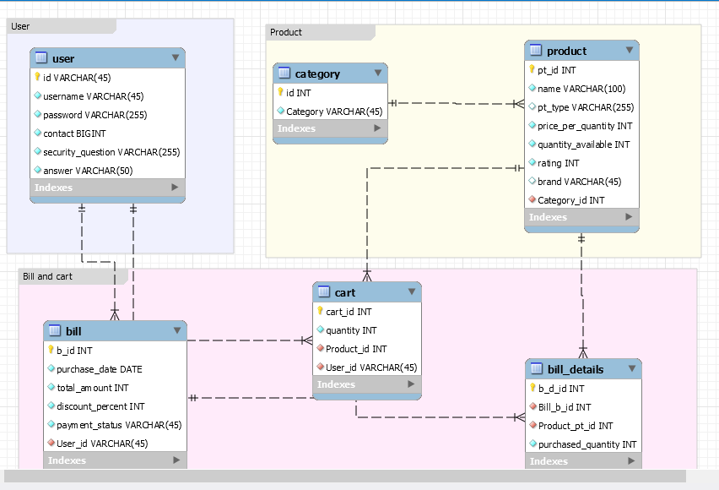

All the services are registered in eureka server and used zuul API gateway for all the services

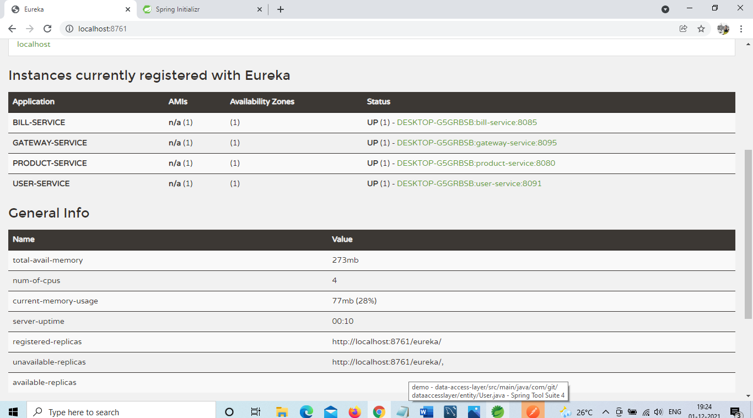

**Rest calls:**

**Eureka server port: 8761**

**Gateway server port: 8095 (use this port for accessing all endpoints)**

**Services: user-service (8091), product-service(8080), bill-service (8085).**

Signup: http://localhose:8095/user-service/user/signup

Use payload as :

{

"id": "H0002",

"username": "Subha",

"password": "password",

"contact": "9952601095",

"securityQuestion":"what is your favourite color",

"answer":"red"

}

(change userid everytime otherwise you will get useralreadyexist message)

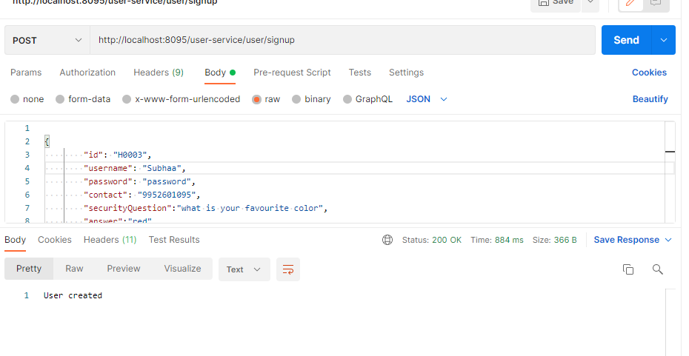

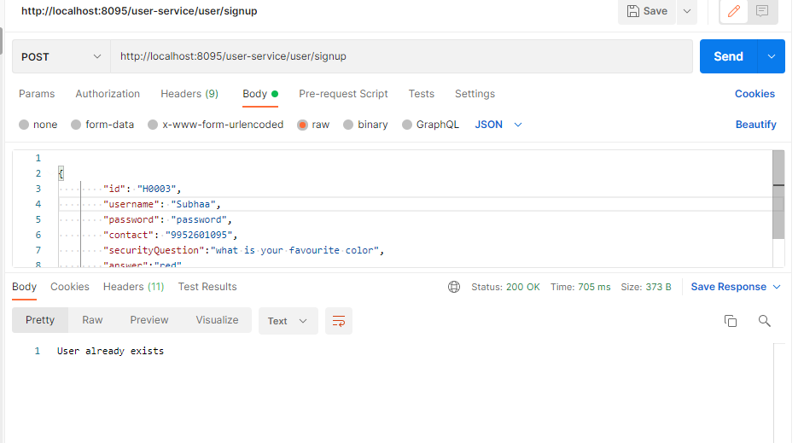

Auth: done in gateway server.

url: <http://localhost:8095/authenticate>

generates and sends JWT token.

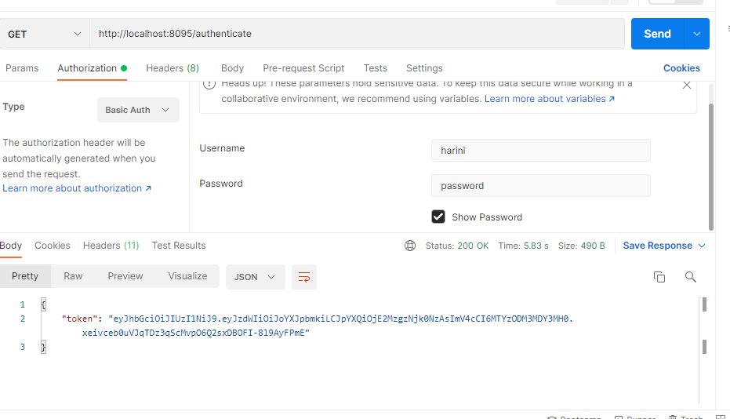

Product service endpoints:

getAllProducts: http://localhost:8095/product-service/hashkart/products

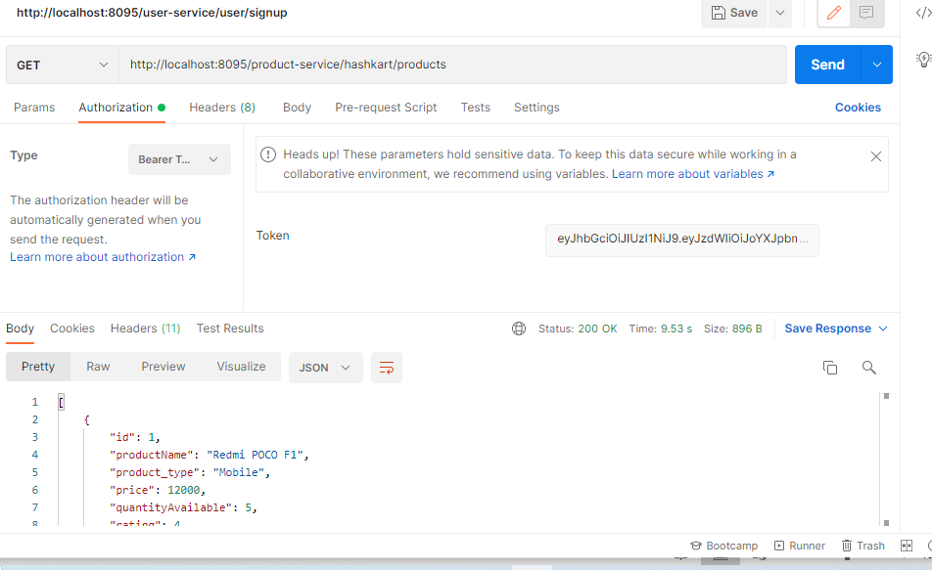

Get products by id; http://localhost:8095/product-service/hashkart/products/2

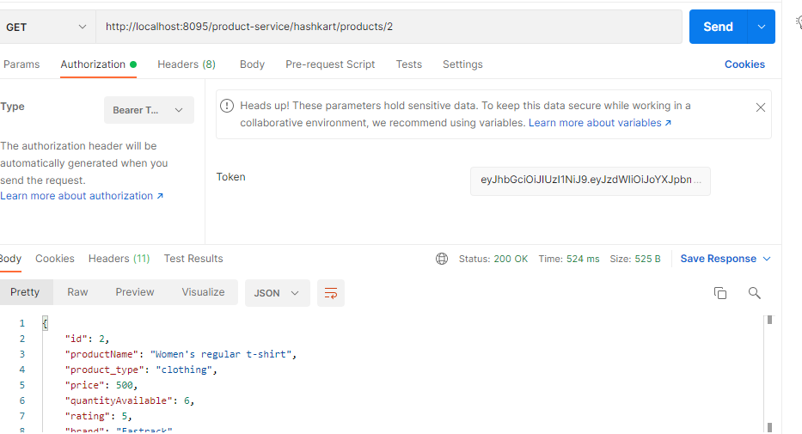

Addproduct:

Use payload as: http://localhost:8095/product-service/hashkart/products/

{

    "productName": "Men's regular t-shirt",

    "product_type": "clothing",

    "price": 400,

    "quantityAvailable": 15,

    "rating": 5,

    "brand": "Fastrack",

    "category": {

        "id": 2,

        "category": "Fashion"

    }

}

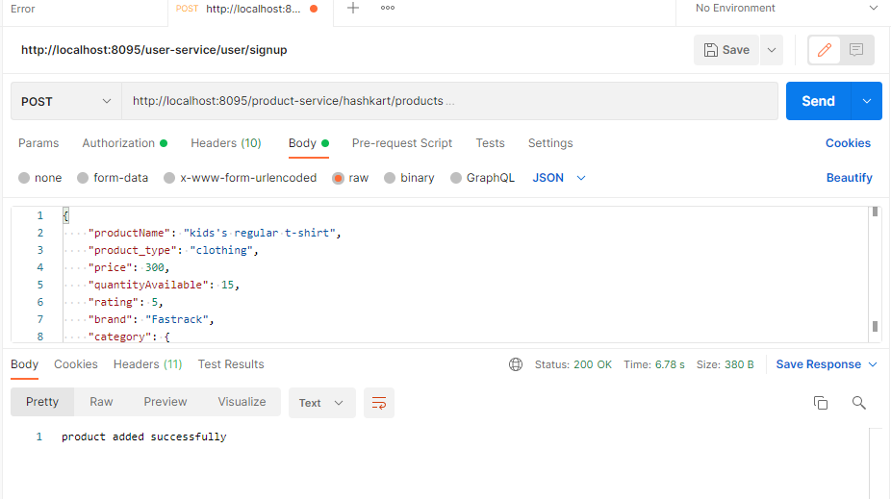

Sort product: http://localhost:8095/product-service/hashkart/products/sort-by-price

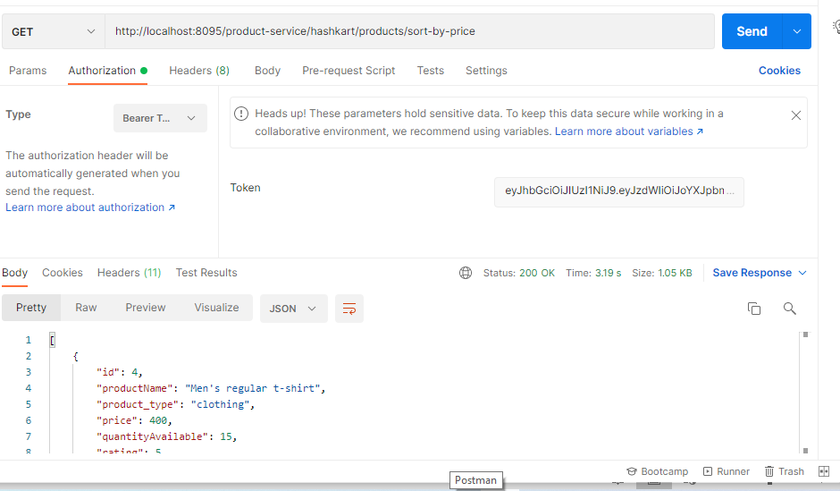

<http://localhost:8095/product-service/hashkart/products/sort-by-rating>

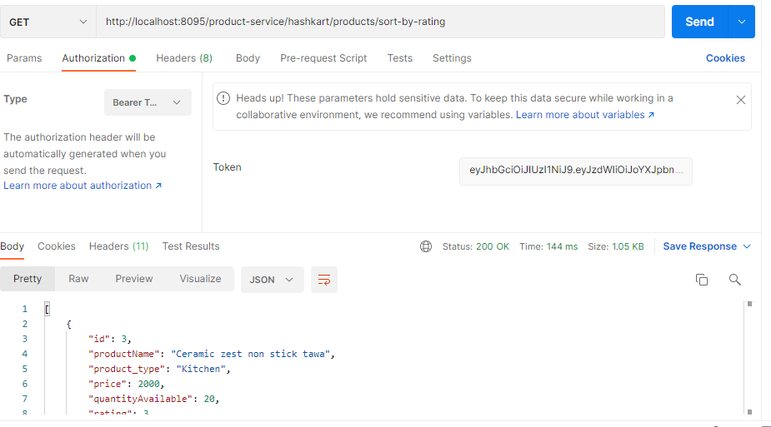

Add to cart: http://localhost:8095/bill-service/hashkart/cart

Payload:

{

    "userId" : "H0002",

    "productId" : "4",

    "quantity" : "2"

}

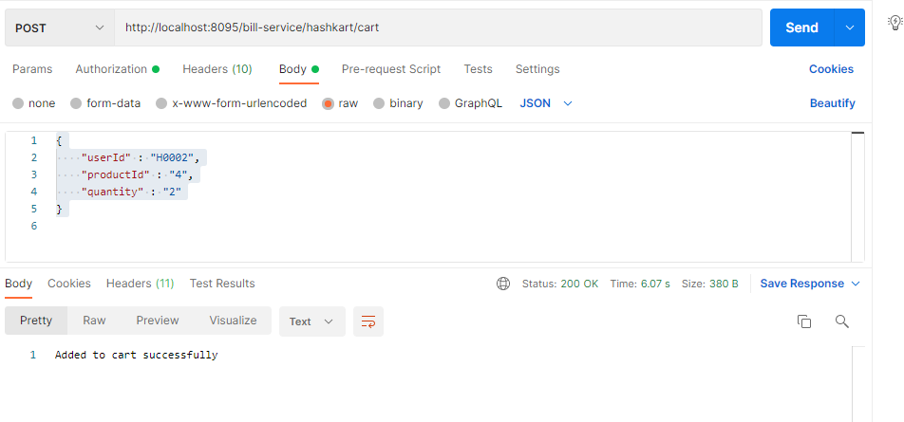

Add to bill:

Payload:

{

    "userId" : "H0003",

    "productList" : [

    {

        "productId" : "1",

        "quantity" : "2"

    },

    {

        "productId" : "2",

        "quantity" : "3"

    }

    ],

    "billId":"0"

}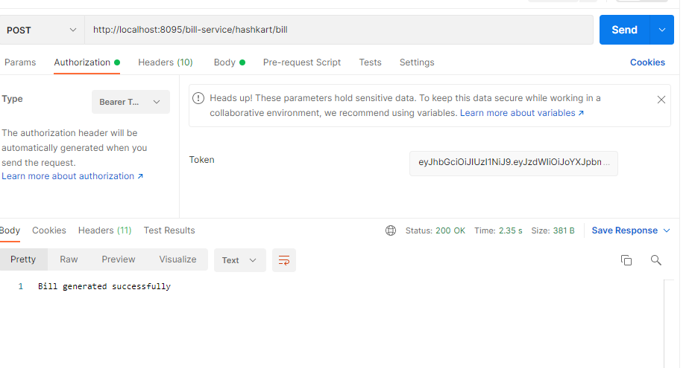

On successful bill generation product will be removed form user cart. If user add same product to cart which he is having already, it will update new quantity to existing product in the cart

If jwt token not provided, unauthorized error is got

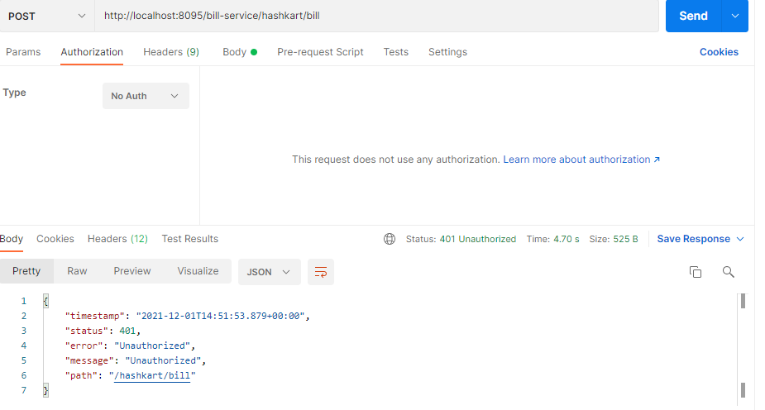

Junit:

