**Project Title**

**Team Id :** NM2025TMID19434

**Team Members :**

**Team Leader :** Subhashini R

**Team Member 1 :** Someshwar A

**Team Member 2 :** Sunil Kumar V

**Team Member 3 :** Thamizhselvan K

**Team Member 4 :** Tharun P

**Problem Statement :** Optimizing User, Group and Role Management with access control and workflow

**Objective :** To establish secure, role-based access and automate workflows in ServiceNow through proper configuration.

**Skills :** ServiceNow administration, ACL security, process automation, and workflow management.

**TASK INITIATION :**

**Milestone 1 : Users**

**Activity 1 : Create User**

**Steps to Create a User in ServiceNow**

1. Log in to **ServiceNow developer** .

2. Navigate to **All Applications** and search for **Users**.

3. Under **System Security**, select **Users**.

4. Click **New** to add a user record.

5. Enter the required user details in the form fields.

6. Click **Submit** to save the new user.

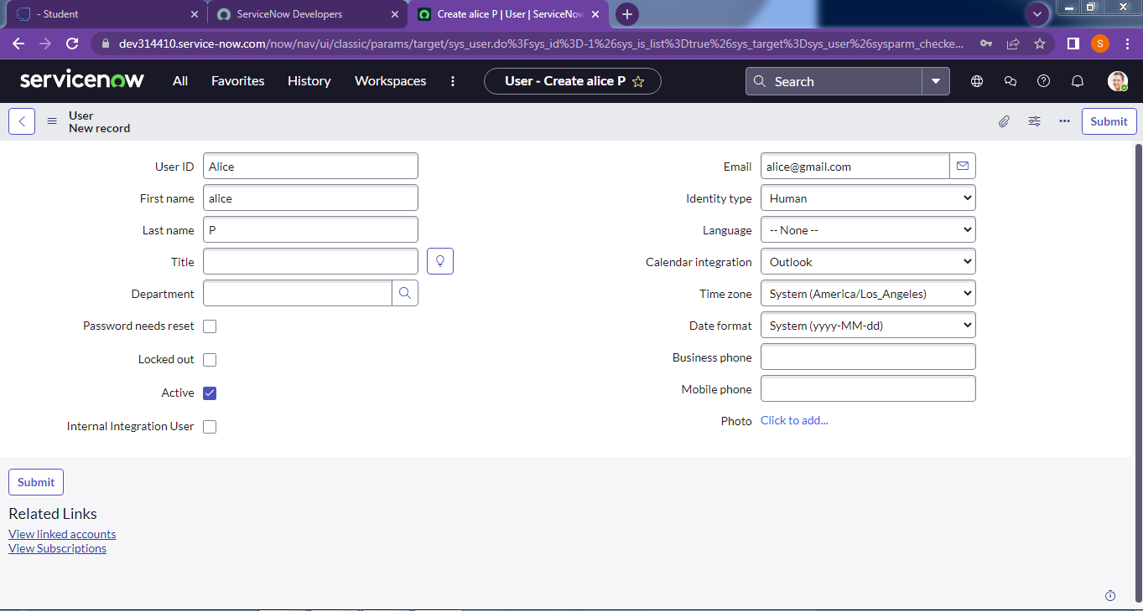

**Creating an Another User**

1. Repeat the same process by clicking **New** again.

2. Provide the details for the second user.

3. Click **Submit** to finalize the creation.

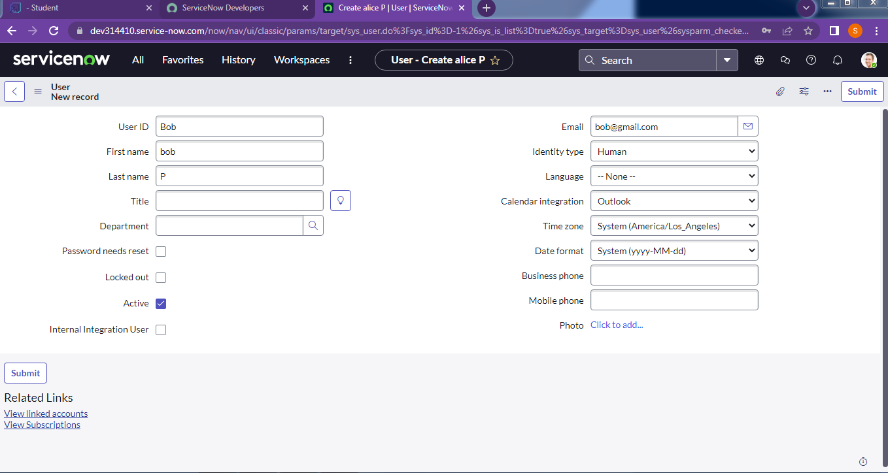

**Milestone 2 : Groups**

**Activity 1 : Create Group**

**Steps to Create a Group in ServiceNow**

1. Open the ServiceNow.

2. From the navigation panel, click **All** and search for **Groups**.

3. Under **System Security**, select **Groups**.

4. Click **New** to add a new group record.

5. Enter the required group details in the form.

6. Click **Submit** to save the group.

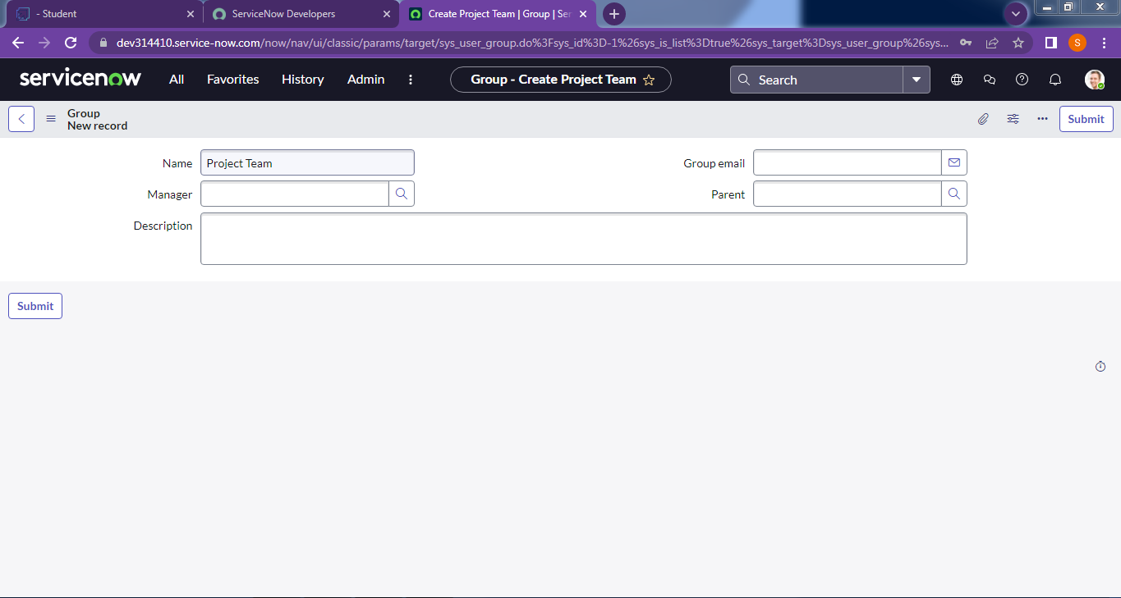

**Milestone 3 : Roles**

**Activity 1 : Create Roles**

**Steps to Create a Role in ServiceNow**

1. Log in to **ServiceNow**.

2. From the application navigator, click **All** and search for **Roles**.

3. Under **System Security**, select **Roles**.

4. Click **New** to add a new role record.

5. Enter the required role details in the form.

6. Click **Submit** to save the role.

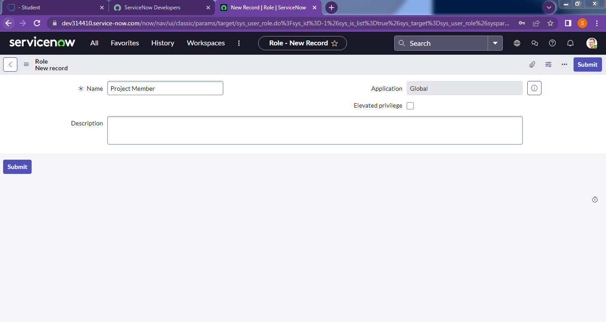

**Creating an Additional Role**

1. Click **New** again to create another role.

2. Enter the role name as **Team member** (along with other required details, if applicable).

3. Click **Submit** to finalize the role creation.



**Milestone 4 : Table**

**Activity 1 : Create Table**

**Steps to Create a Table in ServiceNow**

1. Log in to ServiceNow.

2. From the application navigator, click **All** and search for **Tables**.

3. Under **System Definition**, select **Tables**.

4. Click **New** to create a new table.

5. In the form, enter the following details:

* **Label:** Project Table.
* Select the checkboxes **Create module** and **Create mobile module**.
* Under **New menu name**, enter Project Table.

6. Define the required **Table Columns** by adding the necessary fields.

7. Click **Submit** to save the table.

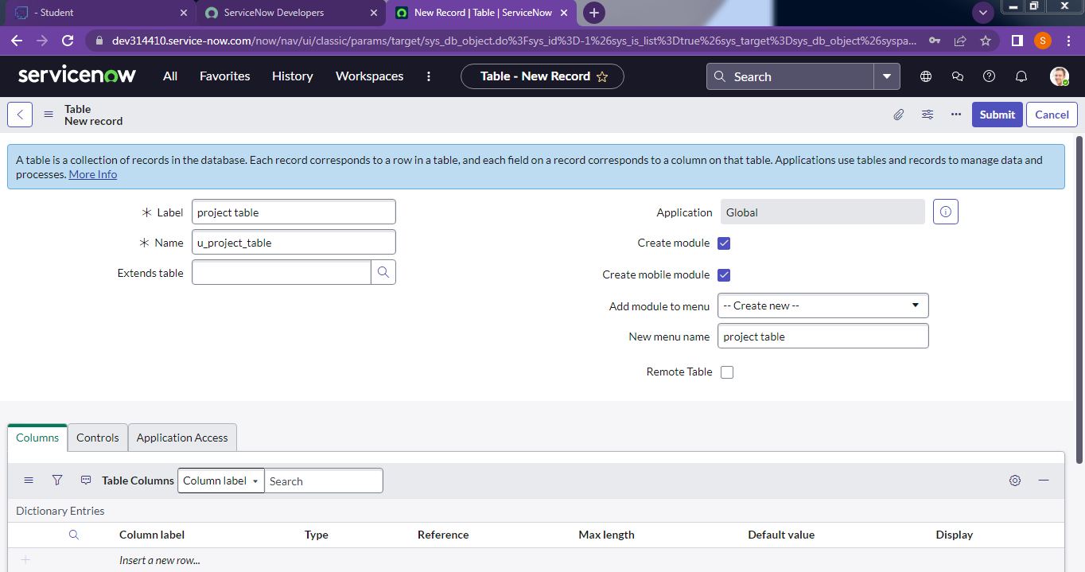

**Creating an Additional Table**

1. Click **New** again to create another table.

2. Enter the following details:

* **Label:** Task Table 2
* Add the required **Table Columns**.

3. Click **Submit** to finalize the table creation.

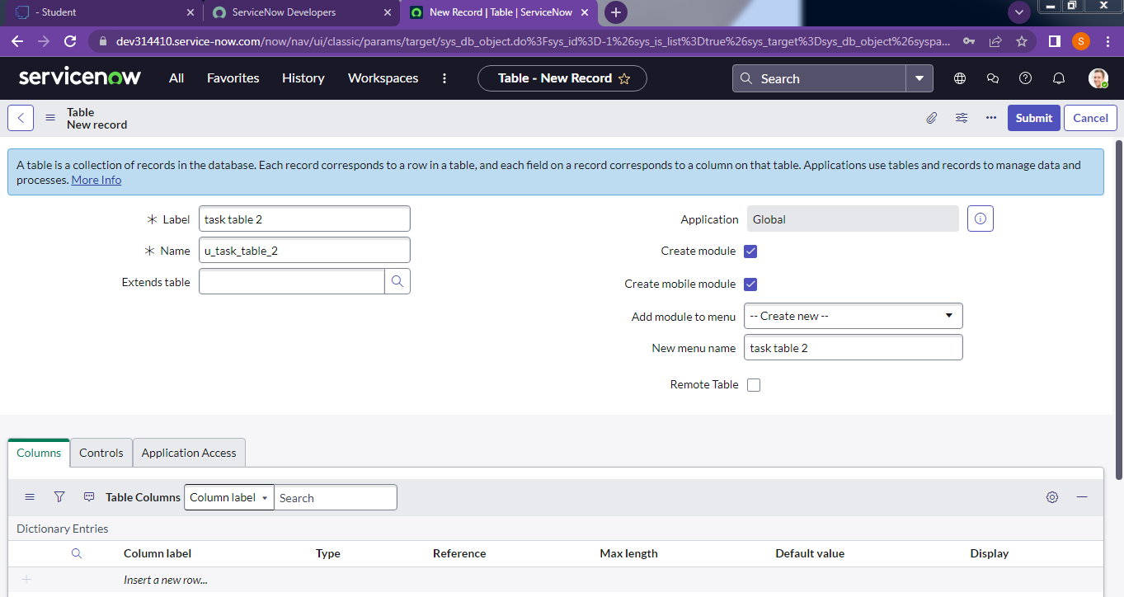

**Milestone 5 : Assign User to Groups**

**Activity 1 : Assign User to Project User Groups**

**Steps to Assign Users to the Project Team Group in ServiceNow**

1. Log in to ServiceNow.

2. From the application navigator, click **All** and search for **Groups**.

3. Under **System Security**, select **Groups**.

4. Locate and open the **Project Team Group**.

5. Scroll to the **Group Members** section.

6. Click **Edit** to manage group membership.

7. From the list of available users, select **Alice P** and **Bob P**.

8. Click **Save** to update the group membership.

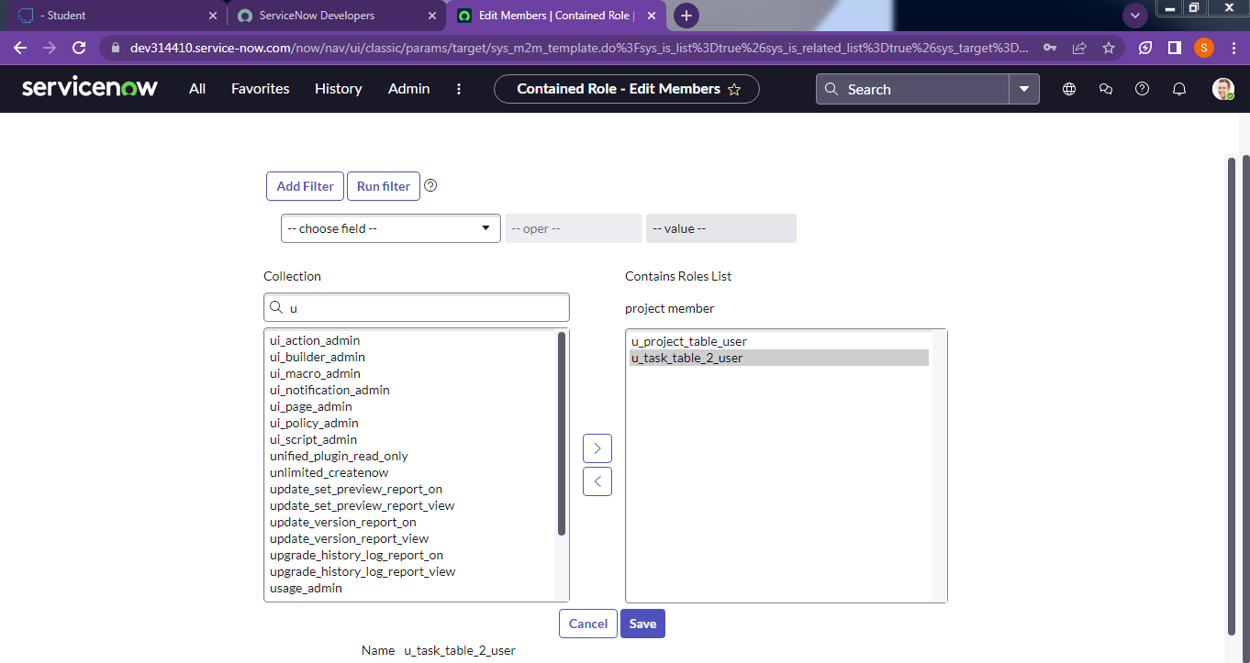

**Milestone 6 : Assign Roles to Users**

**Activity 1 : Assign Roles to Alice User**

**Steps to Assign Roles to the Alice User in ServiceNow**

1. Log in to ServiceNow.

2. From the application navigator, click **All** and search for **Users**.

3. Under **System Security**, select **Users**.

4. Locate and open the user record for **Alice (Project Manager user).**

5. In the **Roles** section of the user form, click **Edit**.

6. From the available roles list, select **Project Member** and click **Save**.

7. Again, click **Edit** in the **Roles** section.

8. Add the following roles:

* **u_project_table**
* **u_task_table**

9. Click **Save** to apply the changes.

10. Finally, click **Update** on the user form to confirm and save the record.

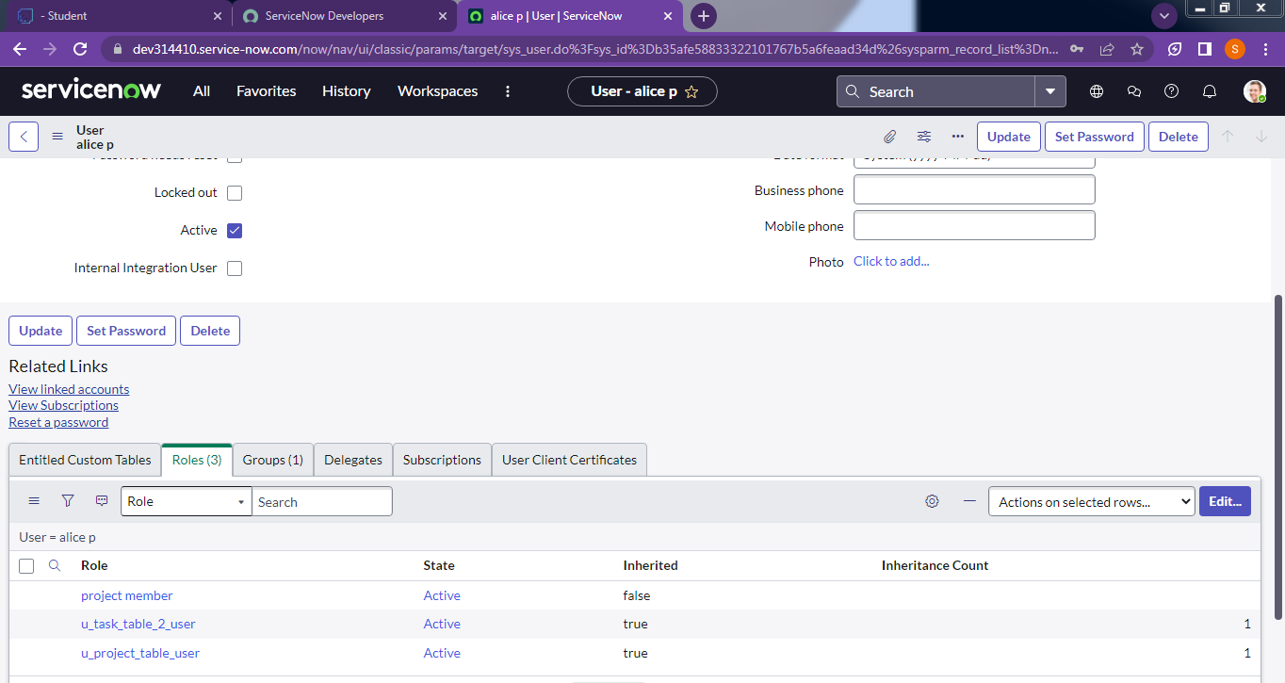

**Activity 2: Assign Roles to Bob User**

**Steps to Assign Roles to the Bob User in ServiceNow**

1. Log in to ServiceNow.

2. From the application navigator, click **All** and search for **Users**.

3. Under **System Security**, select **Users**.

4. Locate and open the user record for **Bob P**.

5. In the **Roles** section of the user form, click **Edit**.

6. Assign the following roles:

* Team Member.
* Relevant **Table Role** (e.g., access to Task Table 2).

7. Click **Save** to apply the role assignments.

8. To validate, click the **Profile Icon** and select **Impersonate User → Bob P.**

9. Confirm that **Task Table 2** is visible and accessible for Bob.



**Milestone 7 : Application Access**

**Activity 1 : Assign Table access to Application**

**Steps to Assign Table Access to an Application in ServiceNow**

1. When a new table is created, ServiceNow automatically generates an **Application** and a **Module** for that table.

2. In the application navigator, search for the **Project Table Application**.

3. Open the application and click **Edit Module**.

4. Assign the **Project Member** role to this application.

5. Next, search for **Task Table 2 Application** in the navigator.

6. Open the application and click **Edit Application**.

7. Assign the following roles to the application:

* Project Member
* Team Member

8. Save the changes to update the access permissions.

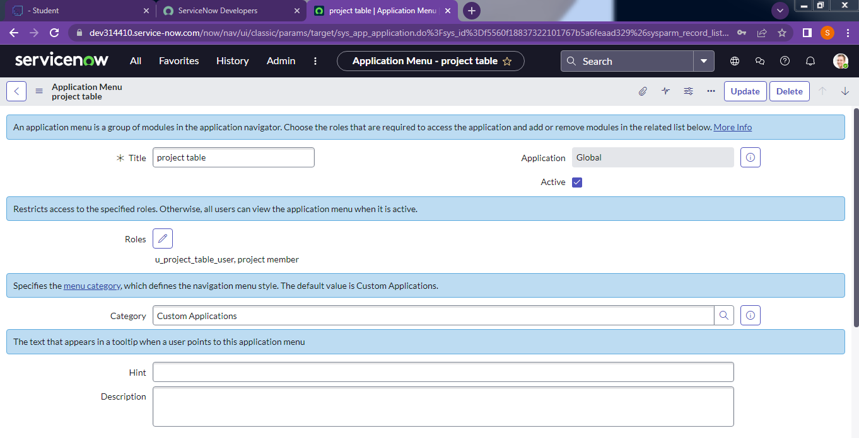

**Milestone 8 : Access Control List**

**Activity 1 : Create ACL**

**Steps to Create an Access Control List (ACL) in ServiceNow**

1. Log in to ServiceNow.

2. From the application navigator, click **All** and search for **ACL**.

3. Under **System Security**, select **Access Control (ACL).**

4. Click **Elevate Role** to gain administrative access.

5. Click **New** to create a new ACL.

6. In the ACL form, provide the required details for the rule.

7. Scroll down to the **Requires Role** section.

8. Double-click on **Insert a new row** and assign the following:

* Table: Task Table
* Role: Team Member

9. Click **Submit** to save the ACL.

**Creating Additional ACLs**

* Repeat the above steps to create **four ACLs** for the required fields (e.g., `Comment`, `Status`, etc.).

**Testing ACLs**

1. Click the **Profile Icon** in the top-right corner.

2. Select **Impersonate User**.

3. Choose the user **Bob P**.

4. From the application navigator, go to **All** and open **Task Table 2**.

5. Verify that the **Comment** and **Status** fields are editable, confirming the ACLs are applied correctly.

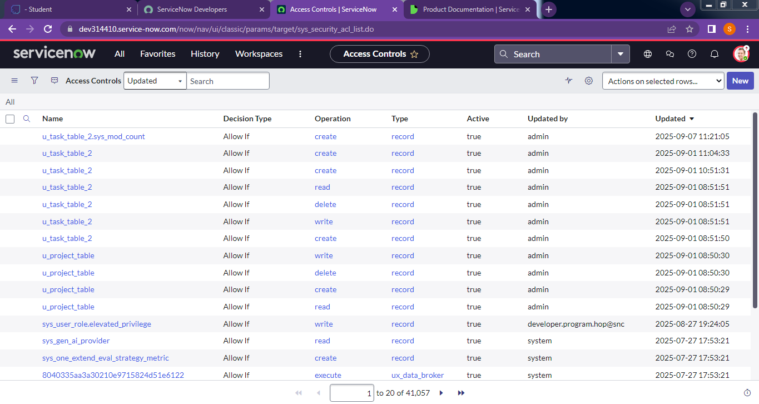

**Milestone 9 : Application Access**

**Activity 1 : Assign Table access to Application**

**Steps to Create a Flow to Assign Operations Ticket to a Group**

**1. Open Flow Designer**

1. Log in to ServiceNow.

2. From the application navigator, click **All** and search for **Flow Designer**.

3. Under **Process Automation**, select **Flow Designer**.

4. Click **New** and select **Flow**.

5. In **Flow Properties**, provide the following details:

* + Flow Name: Task Table
  + Application: Global

6. Click **Build Flow** to proceed.

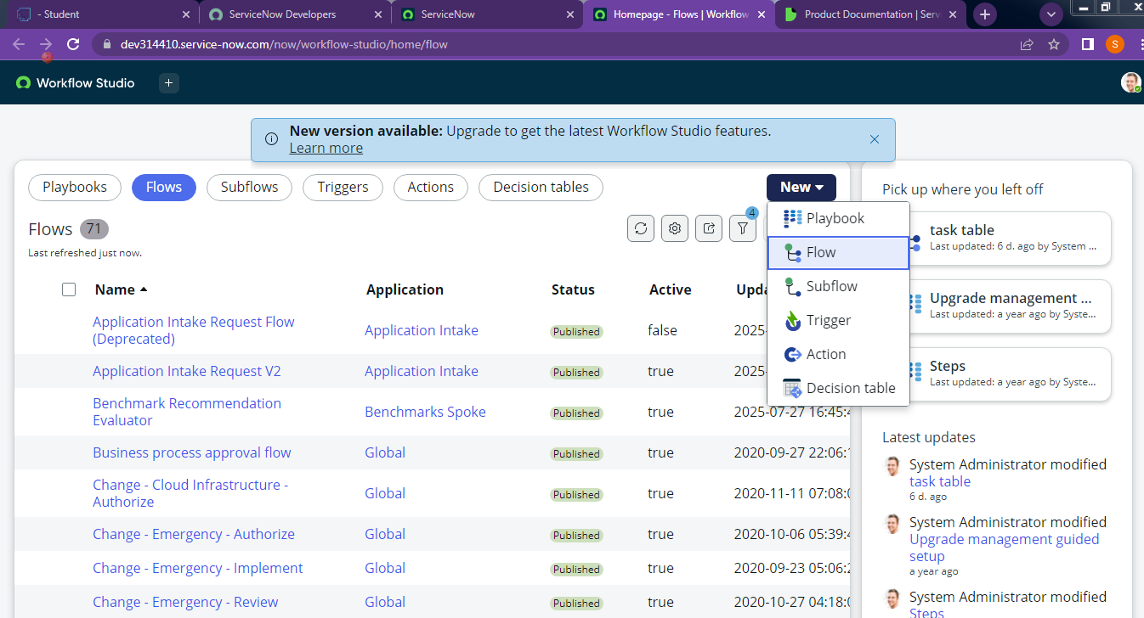

**2. Add a Trigger**

1. Click **Add a Trigger**.

2. In the search bar, search for **Create Record** and select it.

3. Provide the trigger details:

* + **Table**: Task Table
  + **Conditions:**
* Field: `Status` | Operator: `is` | Value: `In Progress`
* Field: `Comments` | Operator: `is` | Value: `Feedback`
* Field: `Assigned To` | Operator: `is` | Value: `Bob`

4. Click **Done.**

**3. Add First Action – Update Records**

1. Click **Add an Action**.

2. In the search bar, search for **Update Records** and select it.

3. In the **Record** field, drag and drop fields from the **Data Pill Navigation** (on the right side).

4. The **Table** will be auto-filled.

5. Update the following field:

* Field: `Status` | Value: `Completed`

6. Click **Done**.

**4. Add Second Action – Ask for Approval**

1. Under **Actions**, click **Add an Action**.

2. In the search bar, search for **Ask for Approval** and select it.

3. In the **Record** field, drag and drop the fields from **Data Pill Navigation**.

4. The **Table** will be auto-filled.

5. Provide the following details:

* Approval Field: `Status`
* Approver: `Alice P`

6. Click **Done**.

**5. Validate Flow Execution**

1. In the application navigator, search for **Task Table**.

2. Verify that the **Status** field updates to **Completed**.

**6. Test Approval Process**

1. In the application navigator, search for **My Approvals**.

2. Select **My Approvals** under **Service Desk**.

3. Verify that **Alice P** receives the approval request.

4. Right-click on the request and select **Approved**.

