DAY 15

ER –DIAGRAM FOR MOVIE RENTAL SYSTEM

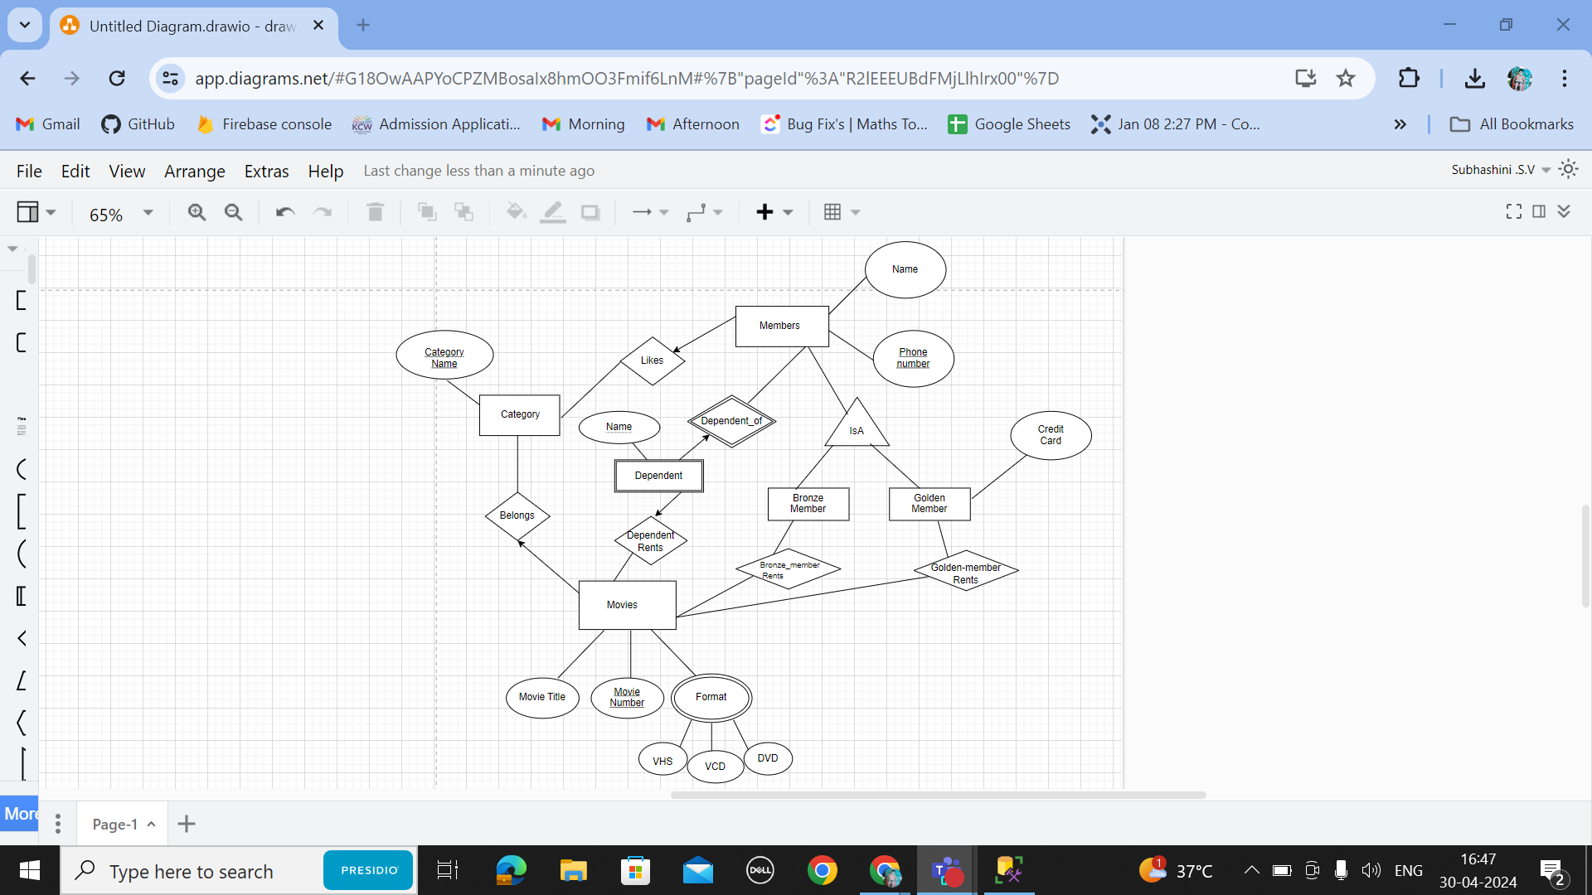

SHOP MANAGEMENT SYSTEM  
