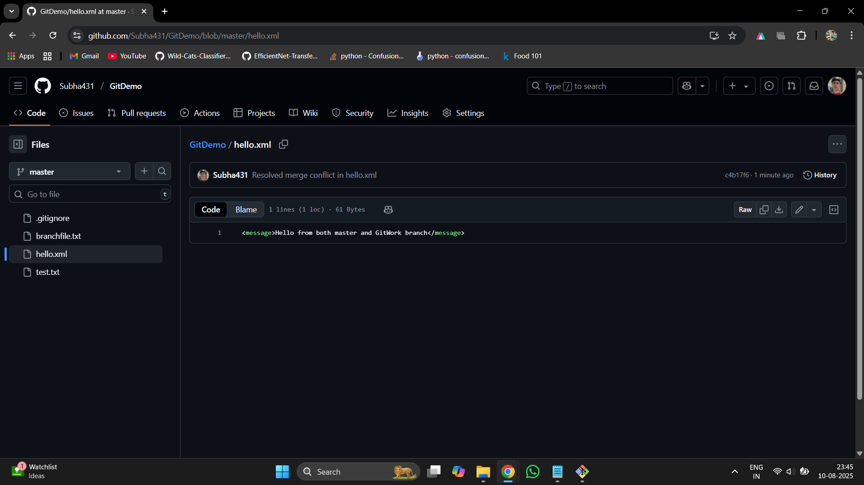
SUBHADEEP@LAPTOP-BAR8N63J MINGW64 ~
$ cd ~/downloads/GitDemo

SUBHADEEP@LAPTOP-BAR8N63J MINGW64 ~/downloads/GitDemo (master|MERGING)
$ git add hello.xml

SUBHADEEP@LAPTOP-BAR8N63J MINGW64 ~/downloads/GitDemo (master|MERGING)
$ git commit -m "Resolved merge conflict in hello.xml"
[master c4b17f6] Resolved merge conflict in hello.xml

SUBHADEEP@LAPTOP-BAR8N63J MINGW64 ~/downloads/GitDemo (master)
$ git push origin master
Enumerating objects: 10, done.
Counting objects: 100% (10/10), done.
Delta compression using up to 12 threads
Compressing objects: 100% (7/7), done.
Writing objects: 100% (9/9), 891 bytes | 445.00 KiB/s, done.
Total 9 (delta 4), reused 0 (delta 0), pack-reused 0
remote: Resolving deltas: 100% (4/4), completed with 1 local object.
To https://github.com/Subha431/GitDemo.git
f0cd0ac..c4b17f6 master -> master

SUBHADEEP@LAPTOP-BAR8N63J MINGW64 ~/downloads/GitDemo (master)
$

