SENTIMENT ANALYSIS FOR MARKETING

**TEAM LEADER:**

* SUBHA MANSHA DEVI S 211521104160

**MEMBERS:**

* SHARMILA DEVI R 211521104145
* SUSHMITHA L 211521104165
* YAMINI K 211521104184
* RAJASREE A 211521104304

**Phase 4: DEVELOPMENT PART 2**

**DATASET: Link:**[**https://www.kaggle.com/datasets/crowdflower/twitter-airline-sentiment**](https://www.kaggle.com/datasets/crowdflower/twitter-airline-sentiment)

In this phase, we can begin building our project by loading and preprocessing the dataset. Perform different analysis as needed. After performing the relevant activities create a document around it.

**INTRODUCTION:**

Sentiment analysis, also known as opinion mining, is a crucial task in natural language processing (NLP) that involves determining and extracting sentiment or emotion expressed in a piece of text. There are several reasons why sentiment analysis is important and widely used in various fields.

Continue building the sentiment analysis solution by:

• Employing NLP techniques

• Generating insights for us airline dataset Twitter review

Continue building the sentiment analysis solution by:

• Employing NLP techniques

• Generating insights for us airline dataset Twitter review

Certainly! Continuing with the sentiment analysis solution for the US Airline Twitter dataset, you can employ Natural Language Processing (NLP) techniques to further analyze the text data and generate meaningful insights. Here are some steps you can follow:

1. Text Preprocessing:

- Tokenization: Split the text into individual words or tokens.

- Removing Stopwords: Remove common words like 'the', 'is', 'and' as they don't contribute much to sentiment analysis.

- Lemmatization/Stemming: Reduce words to their base or root form to normalize the text.

2. Sentiment Analysis using VADER:

- Utilize VADER (Valence Aware Dictionary and sEntiment Reasoner), a lexicon and rule-based sentiment analysis tool, to analyze the sentiment of each twee…

**DATA LOADING:**

To load data into Python, you can use various libraries and methods based on the format of your data (e.g., CSV, Excel, JSON, SQL databases). Here, I'll provide examples using the pandas library, which is widely used for data manipulation and analysis. Before you proceed, make sure you have pandas installed. If you haven't installed it yet, you can do so using pip.

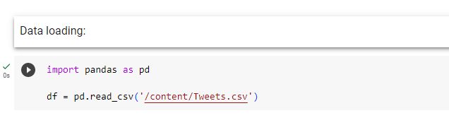

**EXPLORATORY DATA ANALYSIS (EDA):**

Exploratory Data Analysis (EDA) is an approach to analyzing data sets to summarize their main characteristics, often with visual methods. EDA helps understand the data, discover patterns, spot anomalies, and check assumptions. It uses a variety of techniques and visualizations to achieve these goals without making any assumptions about the underlying statistical distribution.

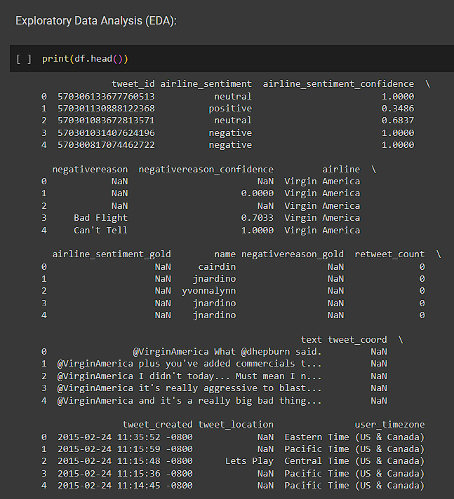

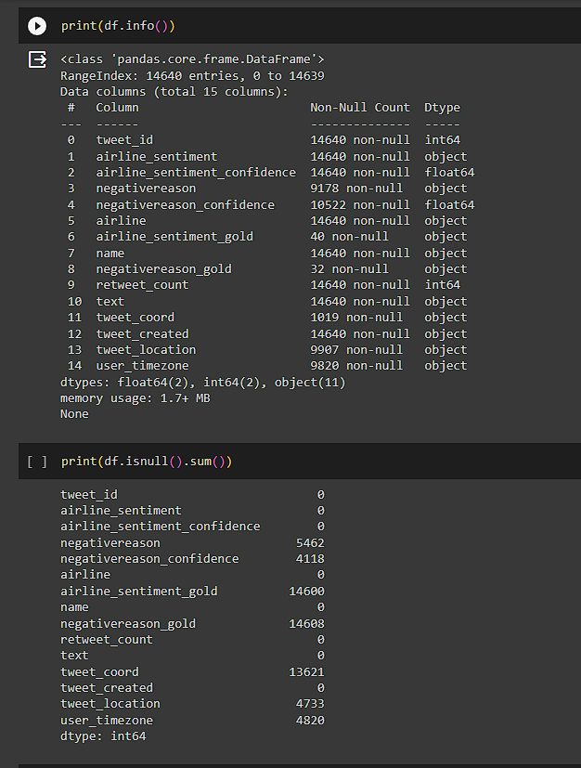

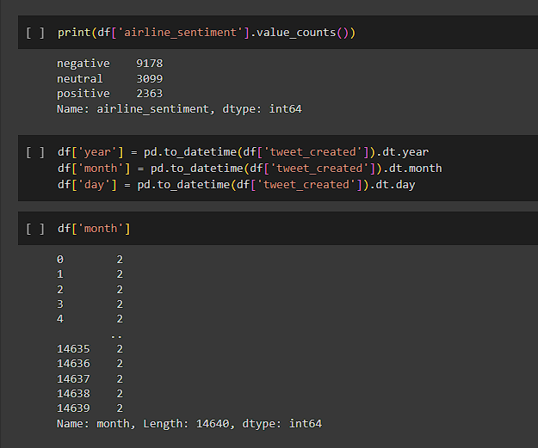

**DATA VIZUALIZATION:**

Data visualization is the representation of data through use of common graphics, such as charts, plots, infographics, and even animations. These visual displays of information communicate complex data relationships and data-driven insights in a way that is easy to understand.

* **Wordcloud** :A word cloud is a technique to show which words are the most frequent in the given text. We can use a Python library to help us with this

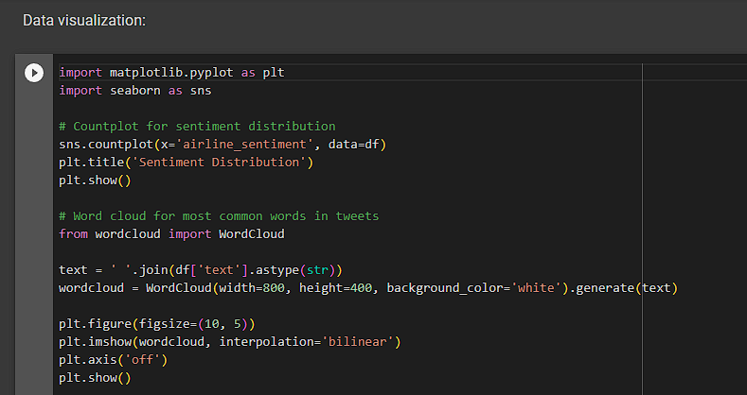

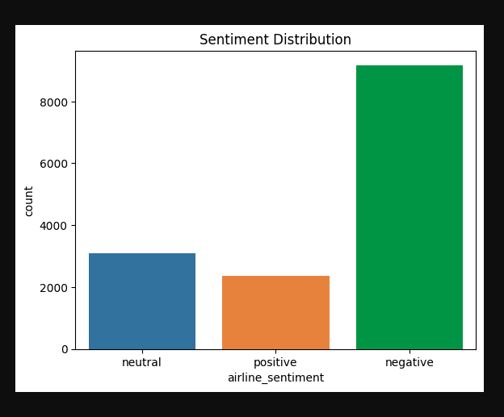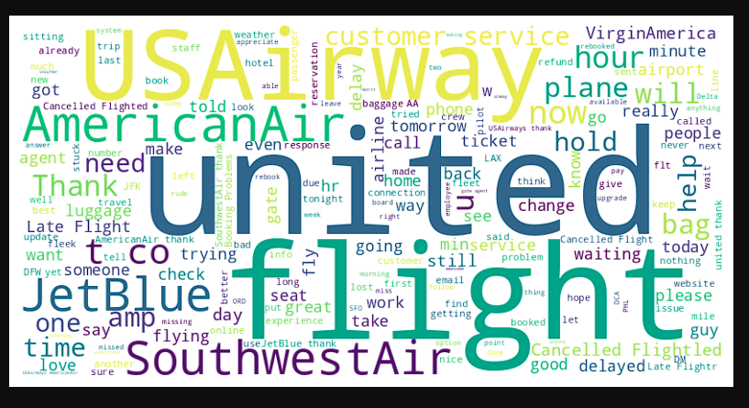

**DATA PREPROCESSING:**

Data Preprocessing is the process of preparing the raw data and making it suitable for the machine learning model. It is the first and the most crucial step in machine learning. The data that we have are not proper, clean and formatted. For the machine learning model to perform efficiently, the data must be cleaned and put in a formatted way before performing any other process.

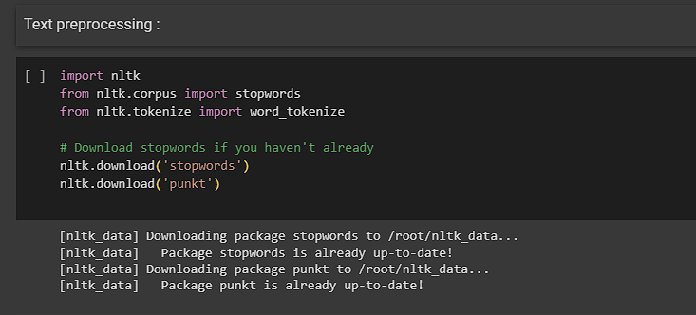

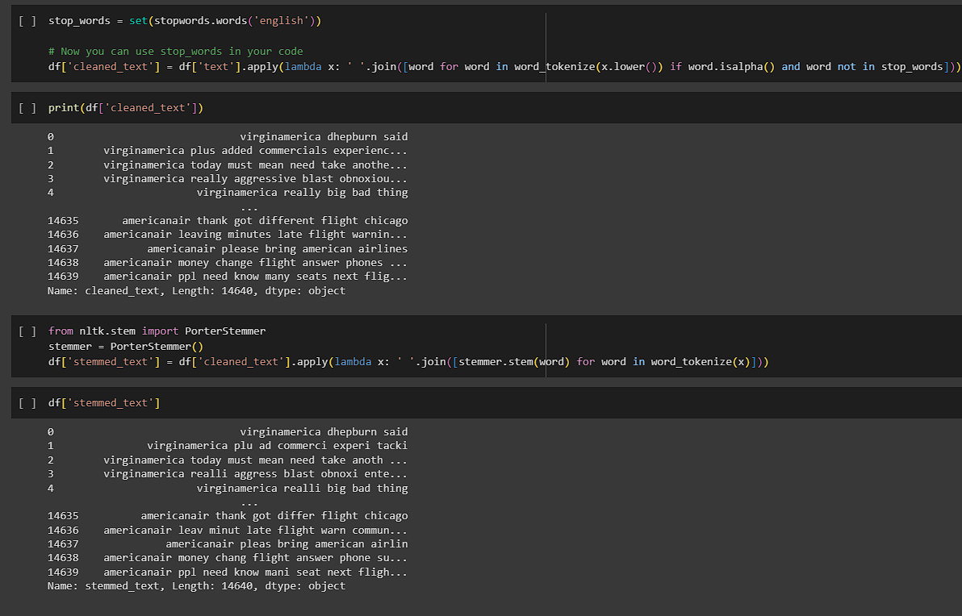

**DATA ANALYSIS:**

how to analyze the dataset using Python and popular data analysis libraries like Pandas and Matplotlib. you can do it step by step process.

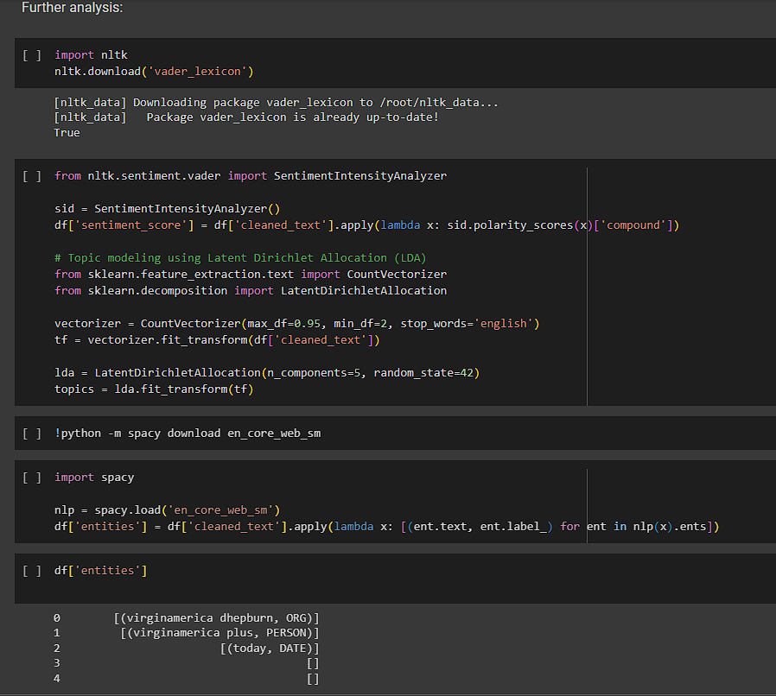

**CONCLUSION:**

These steps provide a solid foundation for preprocessing and understanding your dataset. After this preprocessing, you can proceed with the innovative techniques mentioned in the innovation phase of your document, such as ensemble methods, deep learning architectures, and fine-tuning pre-trained models, to perform sentiment analysis for marketing using the US Airline dataset.