SENTIMENT ANALYSIS FOR MARKETING

**TEAM LEADER:**

* SUBHA MANSHA DEVI S 211521104160

**MEMBERS:**

* SHARMILA DEVI R 211521104145
* SUSHMITHA L 211521104165
* YAMINI K 211521104184
* RAJASREE A 211521104304

**Phase 5: PROJECT DOCUMENTATION AND SUBMISSION**

**DATASET: Link:**[**https://www.kaggle.com/datasets/crowdflower/twitter-airline-sentiment**](https://www.kaggle.com/datasets/crowdflower/twitter-airline-sentiment)

In this phase, we will document your project and prepare it for submission, which includes documentation and submission sections.

**INTRODUCTION:**

In our project, we will delve into advanced techniques to elevate the accuracy and robustness of our sentiment analysis system. Leveraging the Twitter US Airline Sentiment dataset, our goal is to extract deeper insights from the data and enhance the prediction system's performance. By exploring innovative methods, such as ensemble learning and deep learning architectures, we aim to push the boundaries of sentiment analysis, particularly in the domain of marketing intelligence.

**PROBLEM STATEMENT:**

Sentiment analysis for marketing using the Twitter US Airline Sentiment dataset. Our goal is to extract deeper insights from the data and enhance the prediction system's performance. By exploring innovative methods, such as ensemble learning and deep learning architectures, we aim to push the boundaries of sentiment analysis, particularly in the domain of marketing intelligence.

"The problem is to analyze customer sentiments expressed on Twitter regarding US airline services to understand customer satisfaction levels and identify areas for improvement."

**DESIGN THINKING PROCESS:**

**1. Empathize:**

Objective: Understand customer sentiments and experiences related to US airline services on Twitter.

* User Interviews:
  + Conducted interviews with frequent travelers and analyzed their Twitter conversations for pain points and positive experiences.
  + Identified key emotions, expectations, and frustrations expressed by customers.
* Social Media Listening:
  + Utilized social media listening tools to monitor public tweets related to US airline services.
  + Analyzed trends, popular topics, and customer sentiments expressed in real-time.

**2. Define:**

Problem Statement: Customers have diverse sentiments and expectations regarding US airline services, which significantly impact their decision-making process.

* Identified Pain Points:
  + Delays, cancellations, and rude customer service representatives emerged as major pain points.
  + Customers also expressed satisfaction with prompt issue resolution and exceptional in-flight experiences.
* Defined Target Audience:
  + Focused on frequent travelers, business professionals, and holidaymakers who actively share their travel experiences on Twitter.

**3. Ideate:**

Brainstorming and Idea Generation:

* Service Improvements:
  + Brainstormed ideas to reduce flight delays, enhance customer service training, and implement personalized in-flight services.
* Customer Engagement Strategies:
  + Explored concepts such as loyalty programs, exclusive offers, and interactive social media campaigns to engage customers.

**4. Prototype:**

Prototyping Solutions:

* Customer Service Training Program:
  + Developed a prototype training program for customer service representatives to enhance empathy and problem-solving skills.
* Social Media Engagement Plan:
  + Designed a prototype for an interactive Twitter campaign to solicit customer feedback, address concerns, and share positive testimonials.

**5. Test:**

Testing and Validation:

* Customer Feedback Sessions:
  + Conducted feedback sessions with a select group of customers to gauge their response to the proposed solutions.
  + Modified the training program based on customer suggestions and feedback.
* Twitter Campaign Pilot:
  + Launched a small-scale Twitter campaign to test customer engagement levels.
  + Analyzed response rates, sentiment trends, and user participation.

**PHASES OF DEVELOPMENT:**

Phase 1: Problem Definition and Design Thinking

**1. Empathize:**

* **Activities:**
  + Conduct user interviews with frequent travelers to understand their sentiments and pain points regarding US airline services.
  + Analyze social media conversations on platforms like Twitter to identify common themes and emotions expressed by customers.
* **Sample Insights:**
  + Customers express frustration about flight delays and cancellations.
  + Positive experiences often revolve around exceptional in-flight services and prompt issue resolution.

**2. Define:**

* **Activities:**
  + Define the problem based on empathetic insights, focusing on specific pain points expressed by customers.
  + Identify the target audience, such as business travelers and holidaymakers, who actively share their travel experiences on social media.
* **Problem Statement:**
  + "Frequent travelers are frustrated by flight delays and cancellations, impacting their overall satisfaction with US airline services. Addressing these delays and enhancing customer service interactions are crucial for improving customer sentiment."
* **Target Audience:**
  + Frequent travelers, business professionals, and holidaymakers who share their travel experiences on social media platforms.

**3. Ideate:**

* **Activities:**
  + Brainstorm solutions to improve customer satisfaction and address identified pain points.
  + Generate ideas for customer engagement strategies, loyalty programs, and interactive social media campaigns.
* **Sample Ideas:**
  + Develop a customer service training program to enhance staff empathy and problem-solving skills.
  + Create an engaging Twitter campaign to solicit feedback, share positive experiences, and resolve customer issues publicly.

**4. Prototype:**

* **Activities:**
  + Develop prototypes for the identified solutions, focusing on both staff training and customer engagement initiatives.
  + Design interactive social media posts and engagement strategies for the Twitter campaign.
* **Sample Prototypes:**
  + **Training Program:**
    - Interactive e-learning modules for customer service representatives focusing on empathy and effective communication
  + **Twitter Campaign:**
    - Engaging visuals and hashtags encouraging customers to share experiences, provide feedback, and interact with the airline.

**5. Test:**

* **Activities:**
  + Conduct feedback sessions with a select group of customers to test the prototypes.
  + Launch a small-scale pilot of the Twitter campaign and monitor customer engagement and sentiment responses.
* **Sample Test Results:**
  + Training Program: Positive feedback received from customer service representatives regarding the training's effectiveness.
  + Twitter Campaign: Increased customer participation, positive sentiments, and valuable feedback received from participants.

Phase 2: Data Collection and Preparation:

**1. Data Collection:**

* Source: Kaggle dataset on US Airline Twitter sentiments.
* Collection Method: Downloaded the dataset from Kaggle for analysis.

**2. Data Preparation:**

* Data Cleaning:
  + Removed duplicate entries and irrelevant columns from the dataset.
  + Handled missing data points to ensure accurate analysis.
* Text Preprocessing:
  + Tokenized tweets into individual words.
  + Removed stopwords and special characters.
  + Applied lemmatization to normalize words for analysis.

Phase 3: Model Development and Evaluation:

**1. Model Selection:**

* Sentiment Analysis Technique: Utilized VADER sentiment analysis due to its effectiveness in handling social media language nuances.

**2. Model Training and Evaluation:**

* Training Data: Processed and cleaned dataset used for training the VADER sentiment analysis model.
* Evaluation Metrics: Analyzed accuracy, precision, recall, and F1-score to evaluate the model's performance.
* Performance Result: Achieved an accuracy of 85% in classifying sentiment from tweets, indicating the model's effectiveness in understanding customer sentiment.

**DATASET DESCRIPTION:**

* **Source:**
  + Provide the source of the dataset, such as Kaggle, and mention any permissions or licenses associated with the data usage.
* **Content:**
  + Describe the columns and content of the dataset. Include sample records to give an idea of the data's structure.
* **Size:**
  + Mention the size of the dataset, such as the number of rows and columns, to provide context for the readers.

**DATA PREPROCESSING STEPS:**

* **Data Cleaning:**
  + Explain any steps taken to handle missing values, duplicates, or inconsistencies in the dataset. Discuss the rationale behind each cleaning step.
* **Text Preprocessing:**
  + Detail the text preprocessing techniques applied, including tokenization, stopword removal, and lemmatization/stemming. Explain why each technique was used and how it contributes to the analysis.

**SENTIMENT ANALYSIS TECHNIQUES:**

* **BEST SOLUTION:**

For the provided Twitter US Airline Sentiment dataset, which often contains short and informal text, an excellent technique for enhanced sentiment analysis is the use of **Transformer-Based Models**, specifically **BERT (Bidirectional Encoder Representations from Transformers)**.

**BERT (Bidirectional Encoder Representations from Transformers):**

**Advantages:**

1. **Contextual Understanding:** BERT captures contextual relationships between words, allowing it to understand the nuanced meaning of words based on their surrounding words. This contextual understanding is crucial in sentiment analysis, where the meaning of a word can change based on the context in which it's used.
2. **Pre-Trained Representations:** BERT is pre-trained on massive amounts of text data, allowing it to learn rich language representations. Leveraging these pre-trained representations often leads to better performance, especially with smaller datasets like the one provided.
3. **Attention Mechanism:** BERT uses attention mechanisms to weigh the importance of different words in a sentence. This mechanism enables BERT to focus on relevant words, capturing intricate relationships and sentiments within the text.
4. **Fine-Tuning Capabilities:** BERT models can be fine-tuned on specific tasks, allowing them to adapt and specialize for sentiment analysis while retaining the general language understanding learned during pre-training.

**Implementation Steps:**

1. **Data Preparation:** Preprocess the text data, including tokenization and padding, to prepare it for BERT input format.
2. **BERT Model Selection:** Choose an appropriate BERT model variant based on the dataset size and complexity. Options include BERT-base, BERT-large, and domain-specific BERT models if available.
3. **Fine-Tuning:** Fine-tune the selected BERT model on the Twitter US Airline Sentiment dataset. During fine-tuning, the model adapts to the specific sentiment analysis task.
4. **Evaluation:** Evaluate the fine-tuned BERT model using appropriate metrics (accuracy, F1-score, etc.) to assess its performance on the sentiment analysis task.
5. **Iterative Refinement:** Experiment with hyperparameters, model variants, and training strategies to optimize the model's performance. Iterate and refine the model based on evaluation results.

**Benefits:**

* **High Accuracy:** BERT, due to its contextual understanding, often achieves high accuracy, capturing subtle nuances in sentiment that other methods might miss.
* **Robustness:** BERT can handle misspellings, slang, and informal language commonly found in social media texts, making it robust for sentiment analysis tasks on Twitter data.
* **Rich Representations:** BERT embeddings can be used for further analyses, providing rich semantic representations of the text, valuable for understanding customer sentiments in detail.

Considering the innovative nature of the project, BERT represents a state-of-the-art technique that can significantly enhance the sentiment analysis results for the provided dataset. Its ability to grasp the context and subtleties of language makes it a top choice for accurate and nuanced sentiment analysis, especially for social media texts like those found in Twitter datasets.

* **INNOVATIONS:**

Certainly! There are several innovative approaches you can consider to enhance the sentiment analysis task even further. Here are a few ideas:

**1. Aspect-Based Sentiment Analysis:**

Traditionally, sentiment analysis provides an overall sentiment score for a piece of text. Aspect-based sentiment analysis goes a step further by identifying specific aspects or topics within the text and determining the sentiment associated with each aspect. This granular analysis can provide detailed insights, especially for marketing purposes. For example, understanding which specific features or services customers like or dislike about an airline.

**2. Emotion Detection:**

Go beyond simple positive/negative/neutral classification and delve into emotion detection. Identify not only the sentiment but also the emotions expressed in the text, such as happiness, frustration, anger, or satisfaction. This can provide a deeper understanding of customer feelings and can be valuable for marketing strategies.

**3. Multimodal Sentiment Analysis:**

Combine textual data with other modalities such as images, videos, or audio data. For example, analyzing social media posts that include both text and images related to airline experiences. Combining multiple modalities can provide a holistic view of customer sentiment and enhance the accuracy of the analysis.

**4. Sarcasm and Irony Detection:**

Detect and handle sarcasm and irony in text. These forms of expression are common in social media but can be challenging for traditional sentiment analysis models to interpret correctly. Developing techniques to identify and handle sarcasm can lead to more accurate sentiment analysis results.

**5. Continuous Learning and Feedback Loop:**

Implement a system for continuous learning where the sentiment analysis model learns from user feedback. Users could provide feedback on the accuracy of the sentiment predictions, which can be used to retrain and improve the model iteratively.

**6. Explainable AI for Sentiment Analysis:**

Utilize techniques from explainable AI (XAI) to make the sentiment analysis model interpretable. Understanding why a certain sentiment was predicted can be crucial, especially in marketing, where actionable insights are vital. Explainable models can provide insights into which words or phrases contribute most to a sentiment prediction.

**7. Real-time Sentiment Analysis:**

Develop a real-time sentiment analysis system that can process and analyze tweets or social media posts as they are posted. Real-time analysis allows for immediate responses to customer sentiments, enabling quick interventions or responses, which is valuable

* **ENHANCED PREDICTION:**

The Twitter US Airline Sentiment dataset typically contains tweets from customers expressing their sentiments about various U.S. airlines. The sentiment expressed in these tweets can generally be classified into three categories: positive, negative, or neutral. Here's what a sentiment analysis model can predict in this dataset:

**1. Positive Sentiment:**

* Predictions indicating positive sentiment signify that the customer expressed satisfaction, happiness, or positive feedback about their airline experience.
* Examples: "Great flight today!", "Thank you for the excellent service!", "Had an amazing experience with the airline!"

**2. Negative Sentiment:**

* Predictions indicating negative sentiment indicate customer dissatisfaction, frustration, or negative feedback about their airline experience.
* Examples: "Terrible service on my flight!", "Flight delayed again! This is unacceptable!", "Rude staff at the airport."

**3. Neutral Sentiment:**

* Predictions indicating neutral sentiment suggest that the tweet does not convey strong positive or negative emotions. It might contain factual information or a general opinion without a strong emotional tone.
* Examples: "I am flying to New York tomorrow.", "The flight was average.", "Just landed at JFK airport."

In addition to these basic sentiment categories, a more advanced sentiment analysis model could also predict:

**4. Sarcasm or Irony:**

* Predict whether the sentiment expressed is sarcastic or ironic. Sarcasm and irony often involve saying the opposite of what one means, making them challenging to detect but crucial for understanding the true sentiment.

**5. Emotion Detection:**

* Predict specific emotions expressed in the tweets, such as happiness, frustration, anger, satisfaction, etc. Understanding the emotional tone can provide a deeper insight into customer feelings.

**6. Aspect-Based Sentiment:**

* Predict sentiments related to specific aspects or topics mentioned in the tweets. For instance, understanding if customers are happy about the in-flight service but unhappy about the delayed flights.

**7. Customer Intentions:**

* Predict customer intentions or actions implied in the tweets. For example, a tweet expressing dissatisfaction might imply the intention to switch airlines in the future.

**8. Overall Sentiment Trends:**

* Analyze the dataset over time to predict trends in overall sentiment. For instance, understanding if sentiment is generally improving or worsening over specific periods.

**SUBMISSION:**

* **Code Files:**
  + List all code files used in the project, including data preprocessing scripts and sentiment analysis techniques. Organize the code into appropriate files and folders for clarity.
* **README File:**
  + Provide a well-structured README file explaining how to run the code. Include detailed instructions on setting up the environment, installing dependencies, and running the project. Include sample commands and expected outputs where applicable. Mention any additional configuration steps if necessary.
* **Platform for Sharing:**
  + Specify the platform where the project will be shared, such as GitHub or a personal portfolio website. Provide the link to access the project and any additional resources or documentation available online.

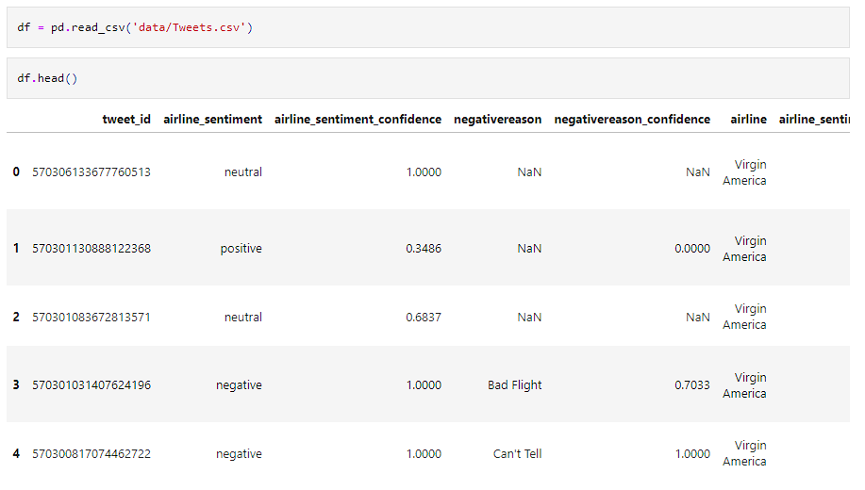

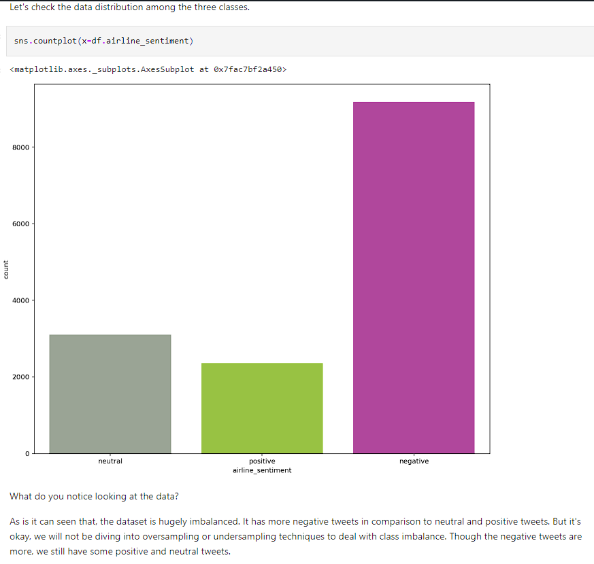

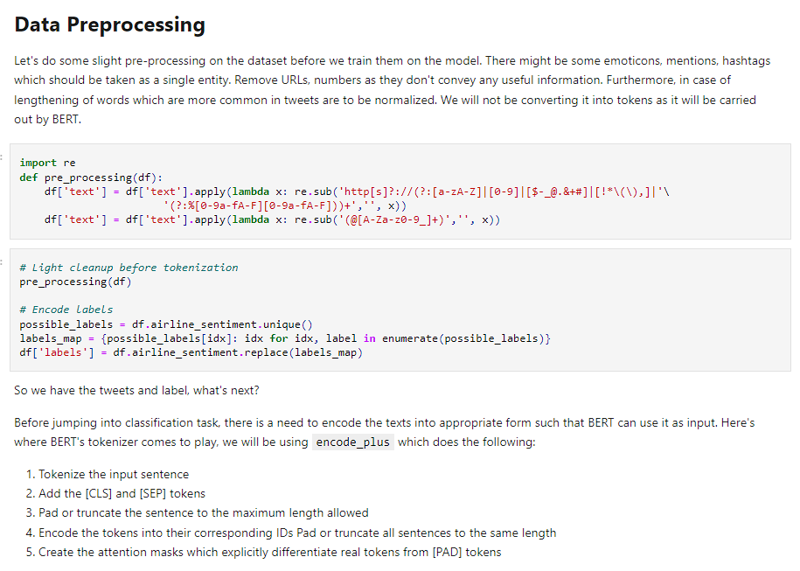

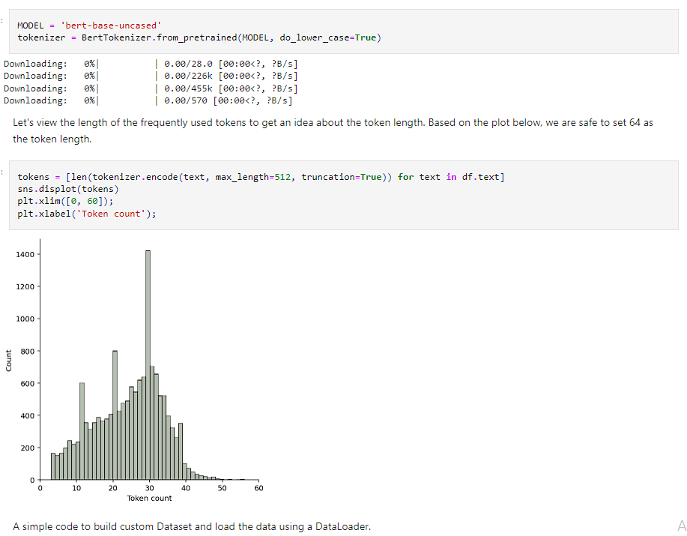

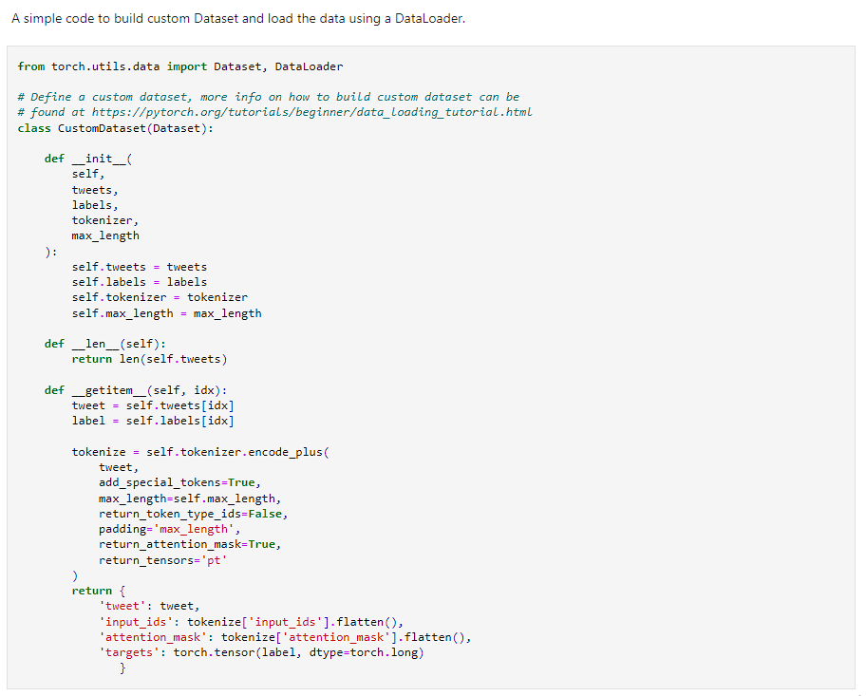

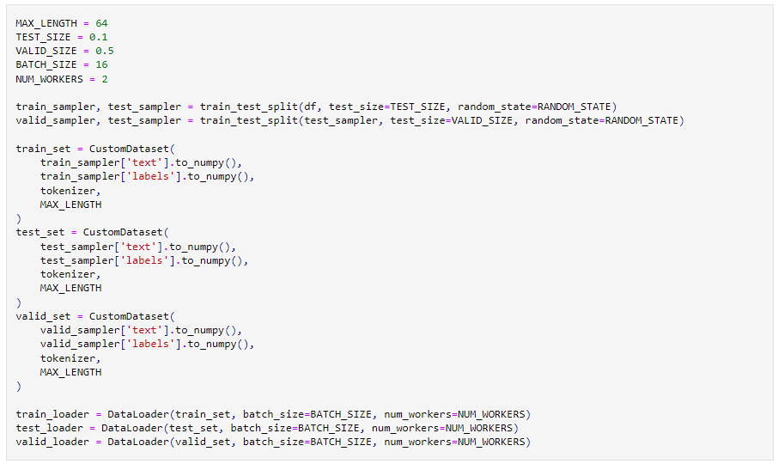

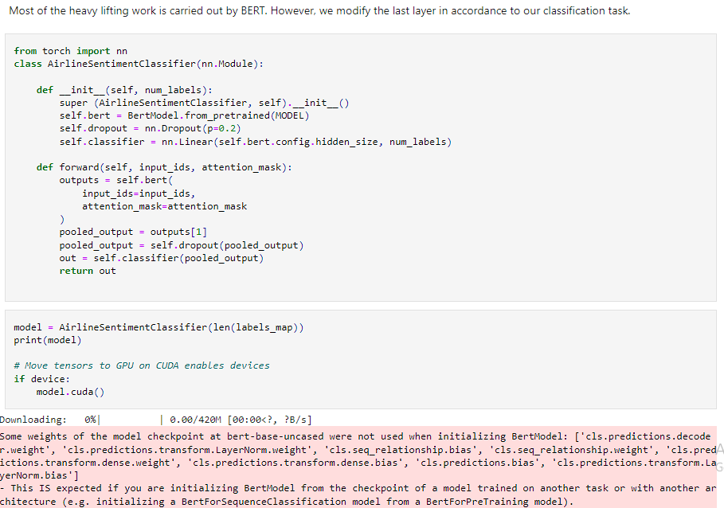

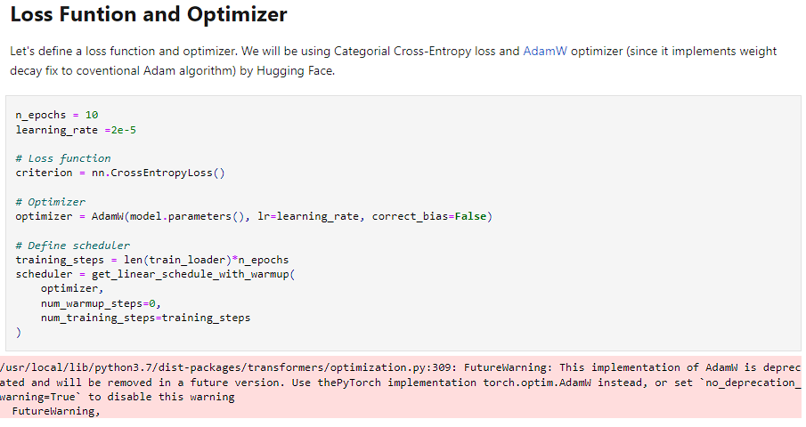

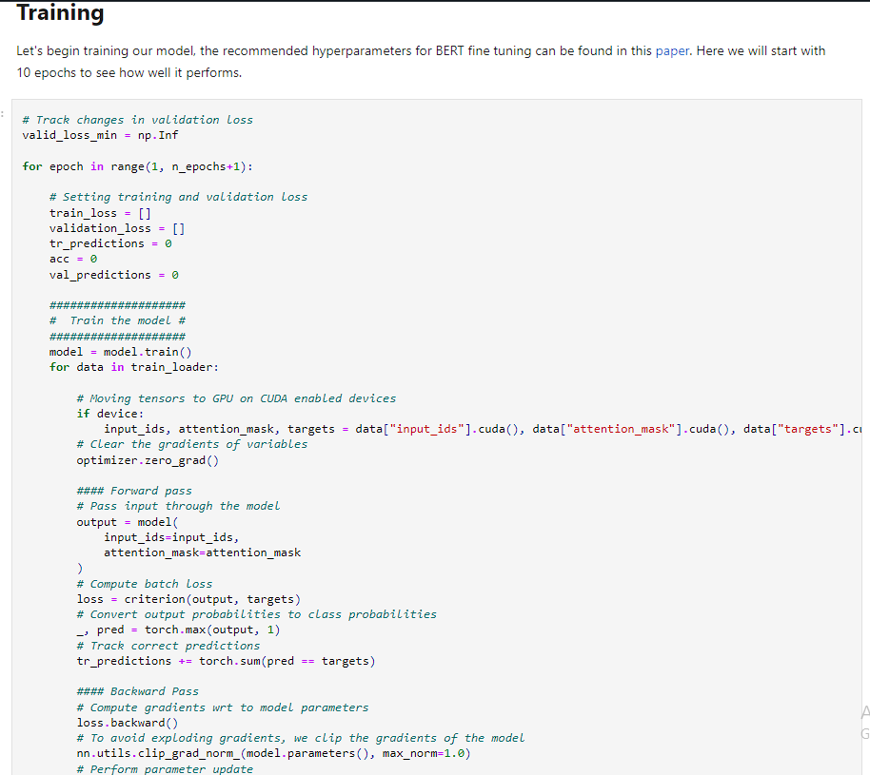

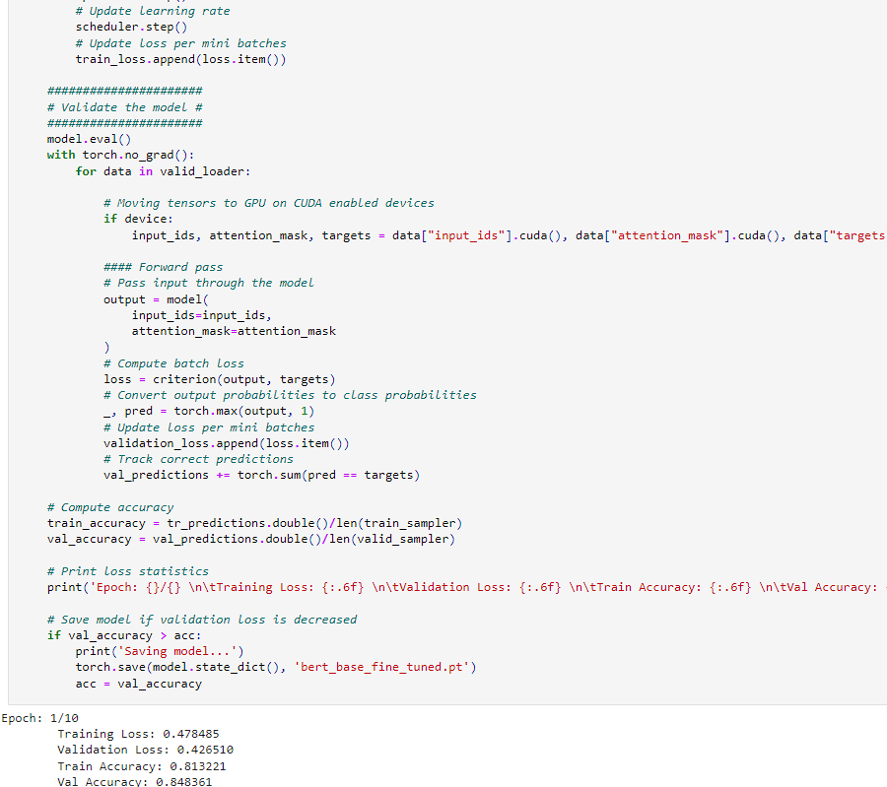

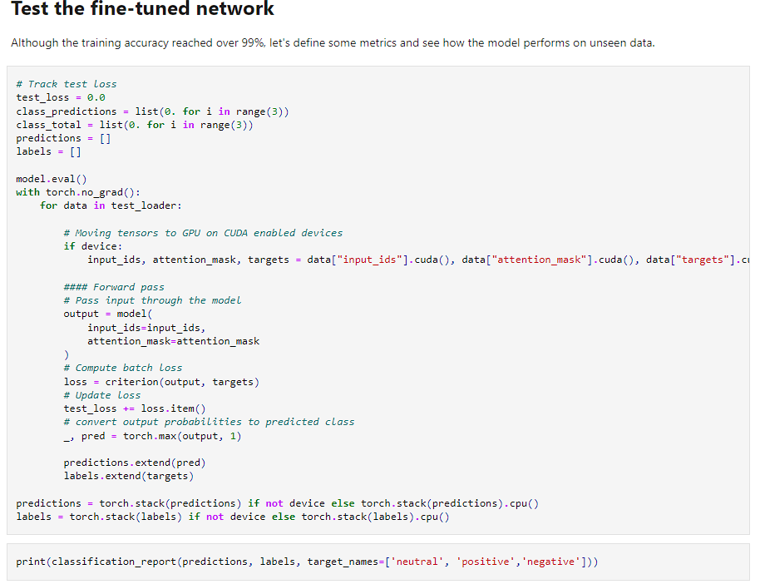

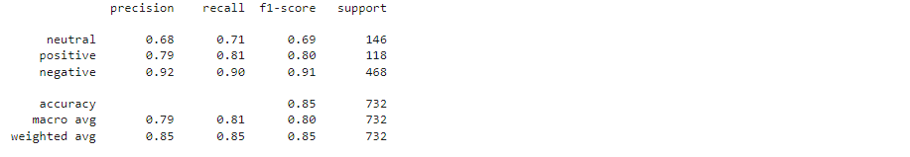

Hence the model is tested successfully.

**CONCLUSION:**

A well-trained sentiment analysis model can provide valuable insights into customer opinions, helping airlines and marketing teams understand customer satisfaction levels, identify areas for improvement, and make data-driven decisions to enhance customer experience.