## 21-03-25

## Create News Room Page Component Using Base Page Component

Develop a `News Room Page Component` that extends the existing base page component to maintain consistency in structure and metadata.

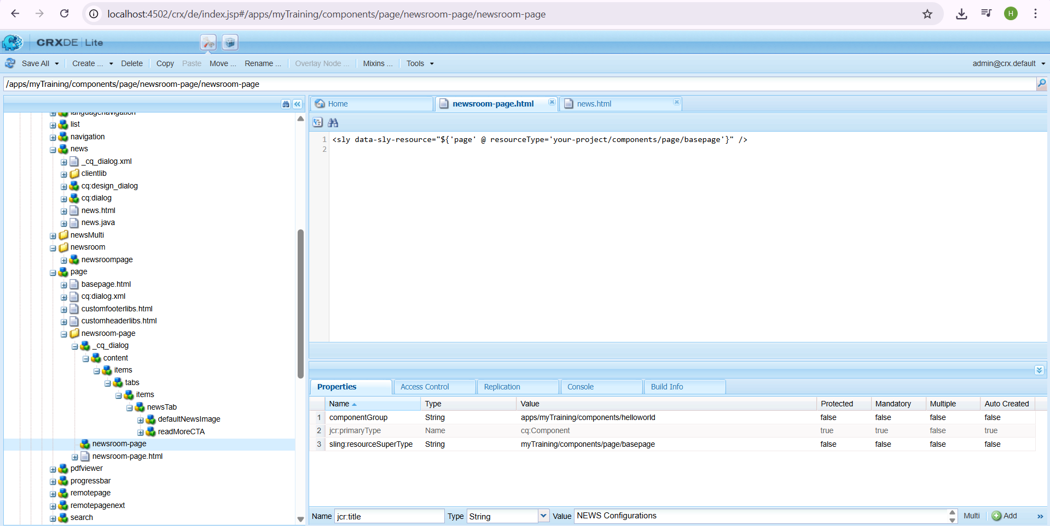

## Create Custom Page Property - NEWS Configurations

Develop a custom page property named 'NEWS Configurations' where users can:  
- Author the default news image.  
- Set a 'Read More' CTA for news articles.

## Create News Room Template Type Using News Room Page Component

Develop a template type that utilizes the `News Room Page Component`, allowing content authors to create standardized news room pages.

newsroom-page.html

<sly data-sly-resource="${'page' @ resourceType='your-project/components/page/basepage'}" />

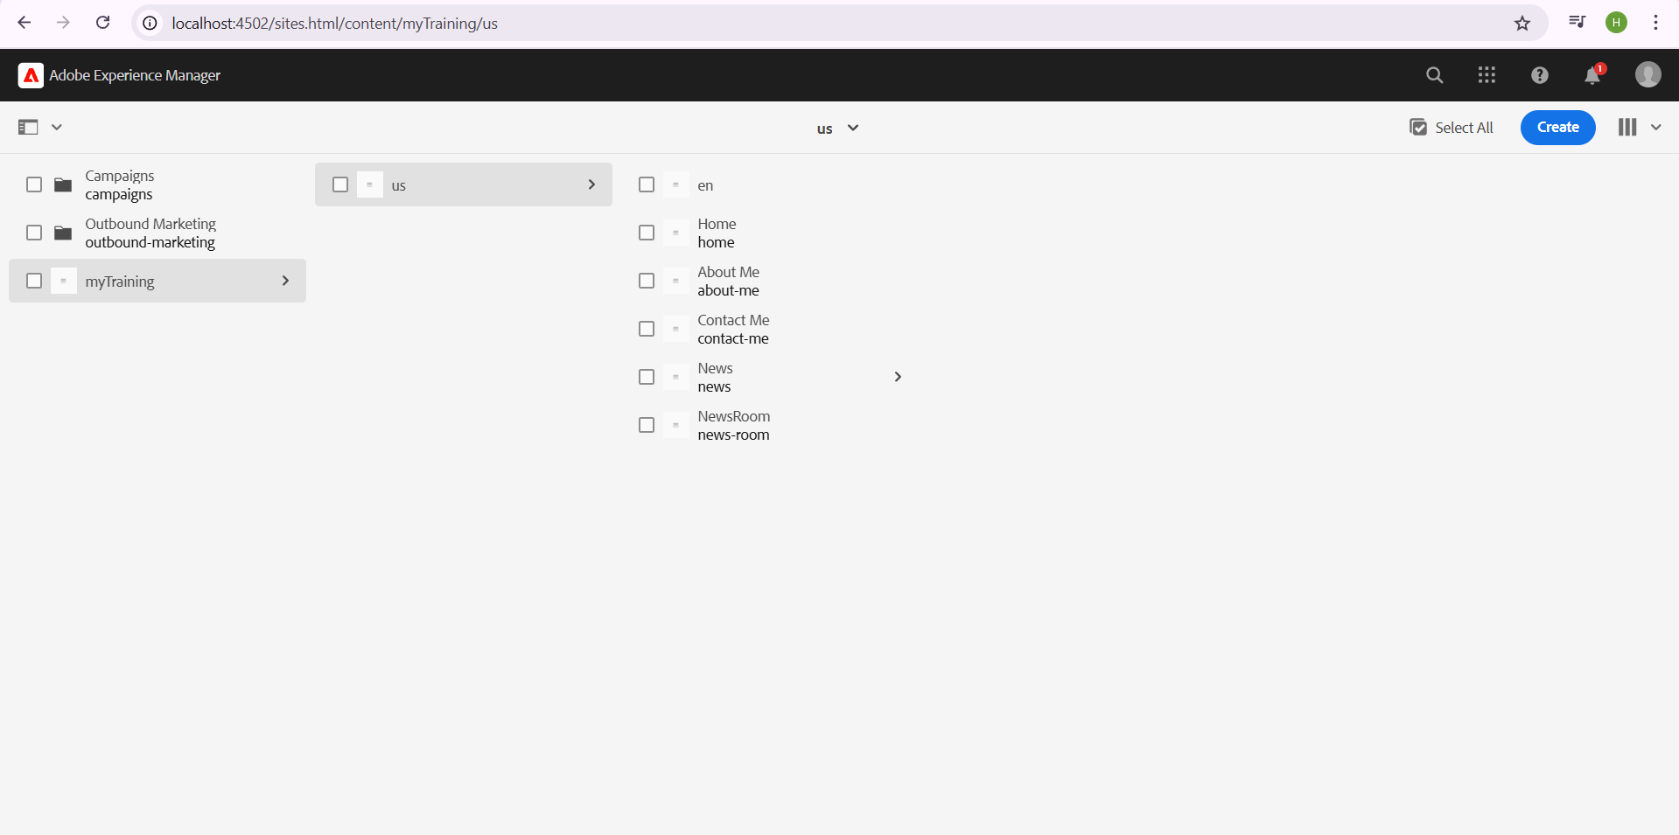

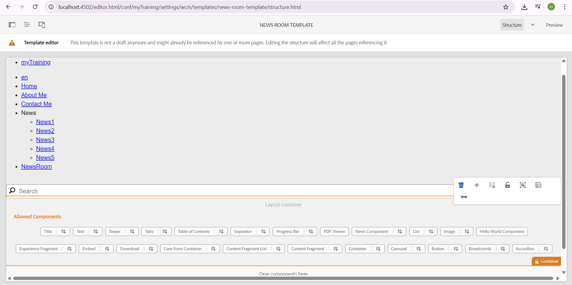

Develop a News Room template by utilizing the previously created News Room Template Type. This template will serve as a blueprint for all news-related pages.

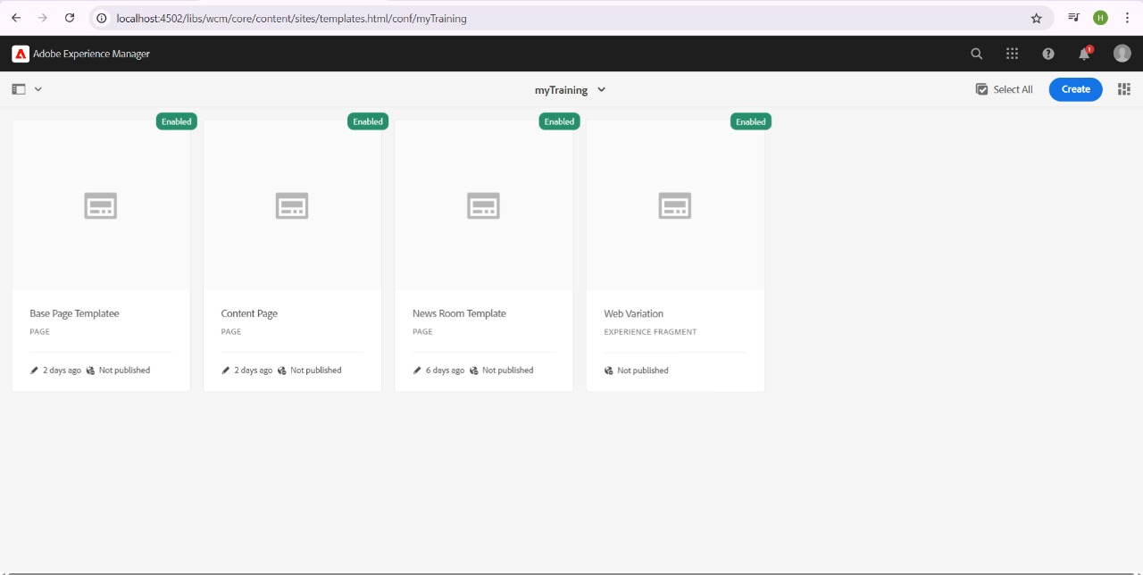

## Apply Styling to News/Hello World Component from ui.frontend Folder

Ensure that the styles for the `News` and `Hello World` components are applied from the `ui.frontend` folder.

1. Go to ui.frontend/src/main/webpack/components/news/news.sccss

News.sccs

.cop-news-component {

h2 { color: green; }

p { color: yellow; }

.date { color: black; }

}

Add this class in your news.html component:

News.html

<div class="cop-news-component">

<h2>${properties.title}</h2>

<p>${properties.detail}</p>

<span class="date">${properties.publishedDate}</span>

</div>

## Create Custom Styles for News or Hello World Component

Develop additional custom styles that can be applied dynamically to the `Hello World` or `News` components, allowing flexibility in appearance.

**news.css**

.news-component h2 {

color: green;

font-size: 24px;

}

.news-component p {

color: yellow;

font-size: 16px;

}

.news-component .date {

color: black;

font-size: 14px;

}

.hello-world {

color: blue;

font-size: 20px;

}

**hello-world.css**

.hello-world {

color: red;

font-size: 18px;

}

**clientlib-news**

<jcr:root xmlns:jcr="http://www.jcp.org/jcr/1.0"

xmlns:cq="http://www.day.com/jcr/cq/1.0"

jcr:primaryType="cq:ClientLibraryFolder"

categories="[training.news]"

dependencies="[training.base]"

css="[news.css, hello-world.css]"/>

Add the client library reference in the base page component.

<link rel="stylesheet" href="/etc.clientlibs/training.news.css" type="text/css">