**AEM MSM and Dispatcher Setup Task Document**

**Date: 27-03-2025**

# 1. What is MSM, Blueprint, Live Copy, and Rollout?

MSM (Multi Site Manager):  
Multi Site Manager in AEM allows you to manage and maintain multiple websites that share common content. It helps manage multilingual, multi-regional websites from a single source site.  
  
Blueprint:  
A blueprint is the source website or content that serves as the master copy. Changes made here can be rolled out to live copies.  
  
Live Copy:  
Live copy is the replicated version of the blueprint. It inherits content and structure from the blueprint and can also have localized/custom content.  
  
Rollout:  
Rollout is the process of pushing changes from the blueprint to the live copies. It can be manual or automatic based on rollout configurations.

# 2. What is a Language Copy?

A language copy is a version of the website/content created specifically for a different language. It does not maintain a live connection with the original (unlike Live Copy). It's typically used for translation purposes.

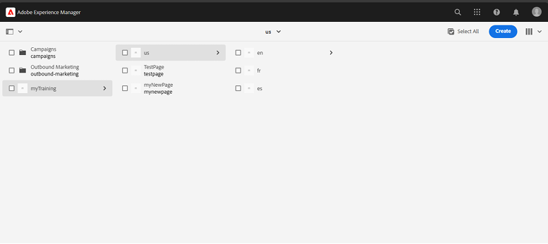

# 3. Create a Site using MSM with us/en as the Source

Reference: https://medium.com/@toimrank/aem-multi-site-manager-cd73a9077cba

Steps:  
1. Navigate to Sites > Create > Site.  
2. Select a language structure starting with us/en as your base.  
3. Create a Blueprint Configuration pointing to us/en.  
4. Under the Blueprint tab, enable rollout configurations.  
5. Create Live Copies for other regions (e.g., ca/en, uk/en, au/en).  
6. Use MSM tools to rollout changes from us/en to the live copies.  
7. Test inheritance, breaking inheritance, and reapplying rollout.  
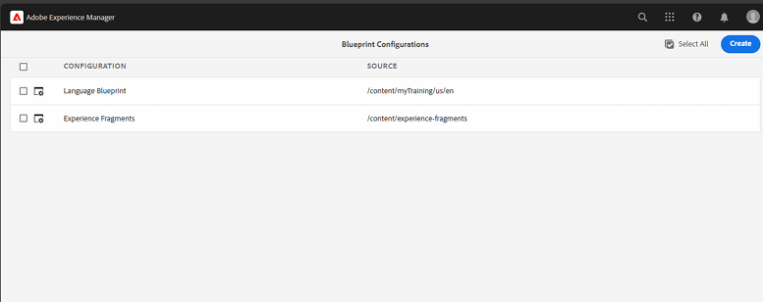

# 4. Create and Author This Page:

URL: https://www.mcdonalds.com/us/en-us/about-our-food.html

Task:  
- Create a new page in AEM using the us/en site structure.  
- Use editable templates and core components to author the page.  
- Include:  
 - Page title and banner image.  
 - Sections: "What Makes Our Food Different", "Our Ingredients", "Meet Our Suppliers".  
 - Use content and images from the provided McDonald's URL.  
- Save and preview the page to match the layout and styling closely.

# 5. Setup the Dispatcher on Your Local

References:  
- http://aemtutorials.com/dispatcher-setup-in-aem-6-4/  
- https://www.youtube.com/watch?v=OtIBRyKxhzY&list=PLEaEQSM_Y4tnHRdMB9PRXgP_AmbeUJkXG&index=3

Steps:  
1. Install Apache HTTP Server on your local system.  
2. Download and configure the AEM Dispatcher module.  
3. Create and configure dispatcher.any and related .conf files.  
4. Configure farm files to point to AEM publisher instance.  
5. Enable cache rules and filters.  
6. Test local dispatcher by hitting content through localhost port (e.g., http://localhost:8080/content/us/en.html).  
7. Validate caching and content invalidation rules.

# Deliverables:

- AEM site structure with MSM (us/en as blueprint).  
- Authored About Our Food page using core components.  
- Dispatcher setup locally and functional.