# Newsroom Portfolio Website Implementation in AEM

This document provides step-by-step instructions for implementing a Newsroom Portfolio Website in Adobe Experience Manager (AEM).

## 1. Header Implementation

• Use the OOTB (Out-of-the-Box) Header Component.  
• Add navigation links for:  
 - Home  
 - News (Dropdown with 5 news articles)  
 - About Me  
 - Contact Me  
• Style the header using Clientlibs to ensure proper layout and dropdown functionality.

## 2. Footer Implementation

• Include sections:  
 - About Me  
 - Contact Me  
 - Latest 5 News (Fetch dynamically and open in a new tab)  
 - Social Media Links

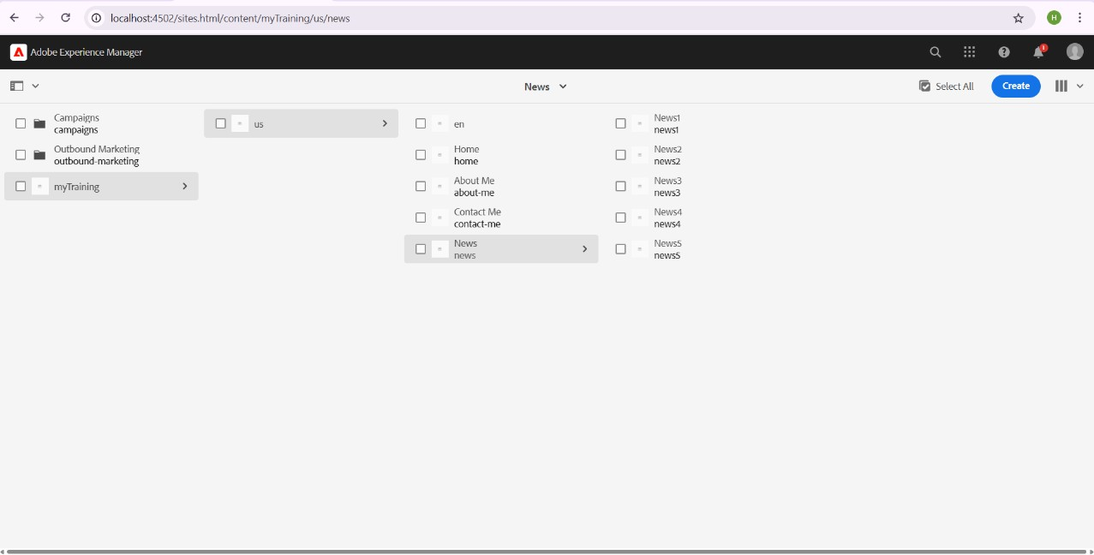

## 3. Home Page Implementation

• Use the OOTB Teaser Component to showcase an award ceremony for journalists.  
• The Teaser Component should include:  
 - Image  
 - Title  
 - Description  
 - CTA Button linking to the full news page.

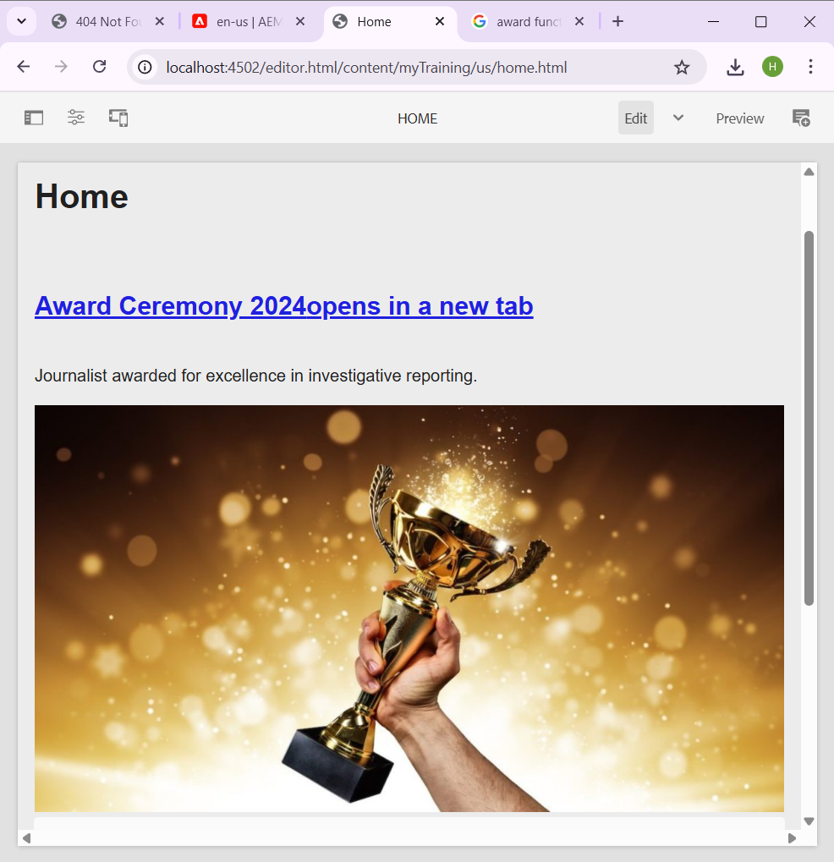

## 4. News Page Implementation

• Create a NewsRoom Component that fetches news articles from /content/news.  
• Each news article page should contain:  
 - Title  
 - News Details  
 - Image  
• The NewsRoom Component will:  
 - Fetch all news articles under /content/news.  
 - Display them as news cards with title, image, and description.

## 5. News Article Pages Implementation

• Create news articles under /content/news/ hierarchy.  
• Author each page using:  
 - Title Component  
 - Image Component  
 - Text Component  
• These pages will be dynamically fetched by the NewsRoom Component.

newsroom.html

<div class="newsroom">

<sly data-sly-list.item="${newsroom.items}">

<div class="news-card">

<img src="${item.image}" />

<h3>${item.title}</h3>

<p>${item.description}</p>

<a href="${item.path}">Read more</a>

</div>

</sly>

</div>

Newsroommodel.java

@Model(adaptables = Resource.class)

public class NewsroomModel {

@ValueMapValue

private String parentPath;

@Inject

private ResourceResolver resourceResolver;

public List<NewsItem> getItems() {

List<NewsItem> items = new ArrayList<>();

PageManager pageManager = resourceResolver.adaptTo(PageManager.class);

Page parentPage = pageManager.getPage(parentPath);

if (parentPage != null) {

for (Page child : parentPage.listChildren()) {

String title = child.getTitle();

String desc = child.getProperties().get("jcr:description", "");

String image = child.getContentResource().getChild("image").getValueMap().get("fileReference", "");

items.add(new NewsItem(title, desc, image, child.getPath()));

}

}

return items;

}

public class NewsItem {

String title, description, image, path;

}

}

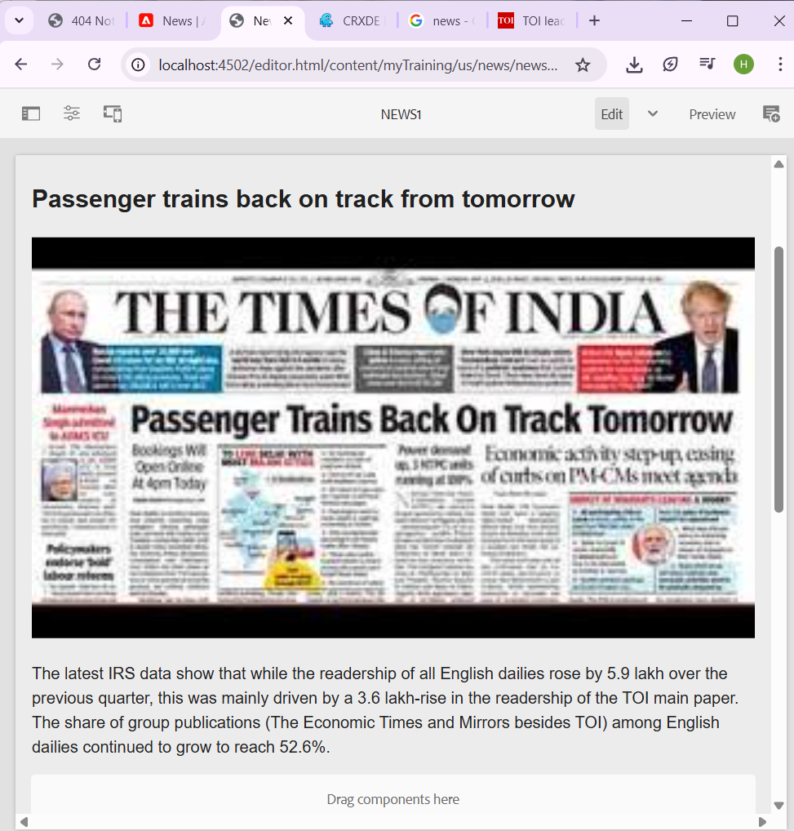

## 6. About Me Page Implementation

• Use a custom Journalist Component to display the journalist’s information.

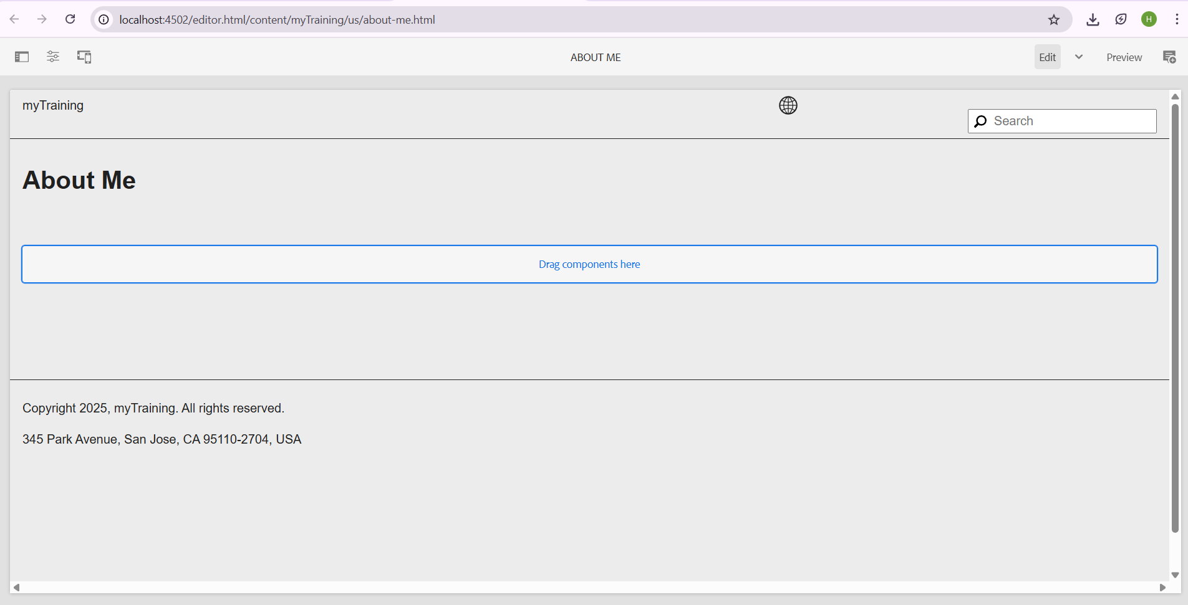

## 7. Contact Me Page Implementation

• Use Text or Teaser Components to provide contact details and social media links.

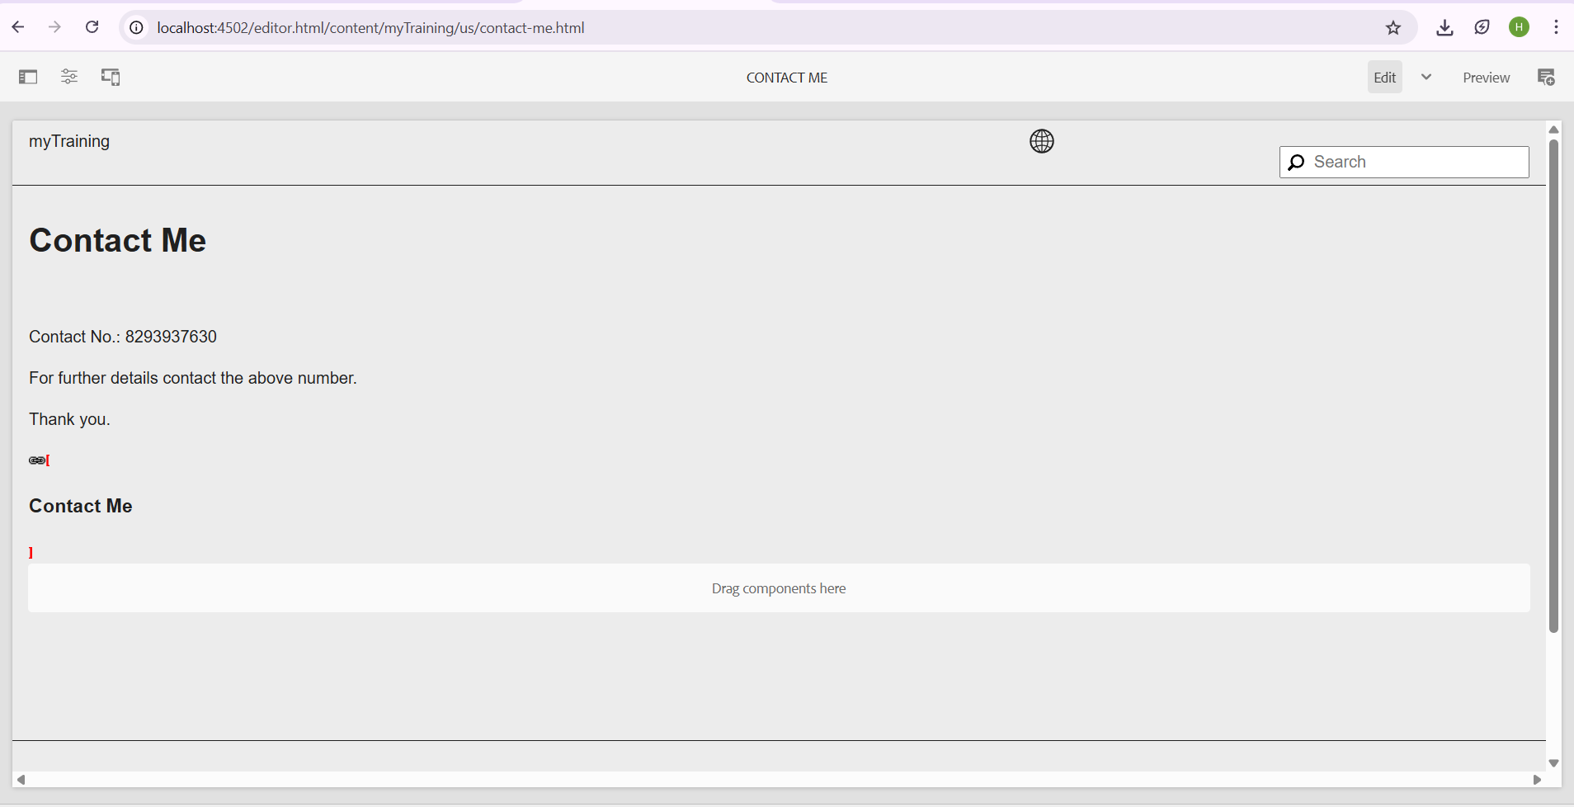

## 8. Template-Level Configuration

• The Header and Footer should be part of the Base Page Template to ensure they appear on every page.  
• Use the OOTB Content Page Template for the homepage.  
• Use the Book Page Template for the books/news section as per assignment requirements.