1. Create the following directories and files following the hierarchy structure

HR, Operations, Finance (create directories) Test1, Test2, Test3, Operation1, Operation2, Finance1, Finance2 (create files)

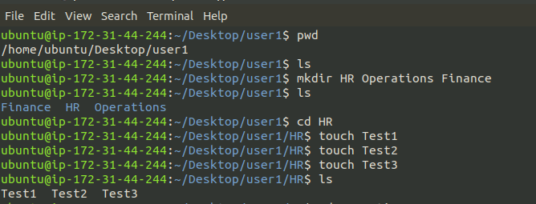

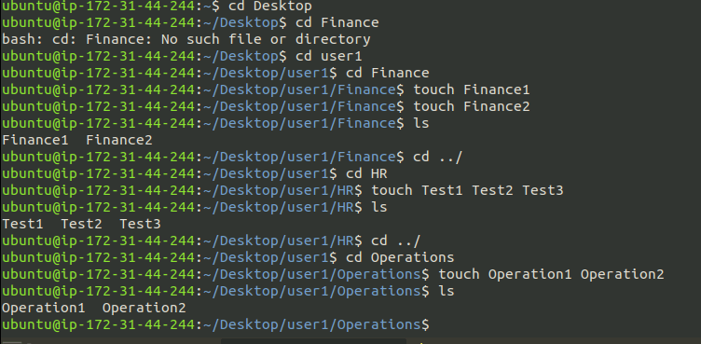

2. Copy the test1 file from HR directories to Finance directories

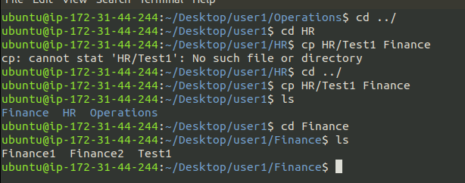

3. Create a directory called Account under the Finance directory

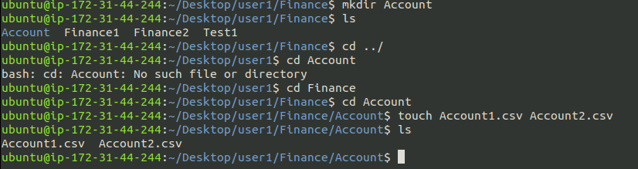

4. a. Write below content (Account1.csv)

b. Write below content (Account2.csv)

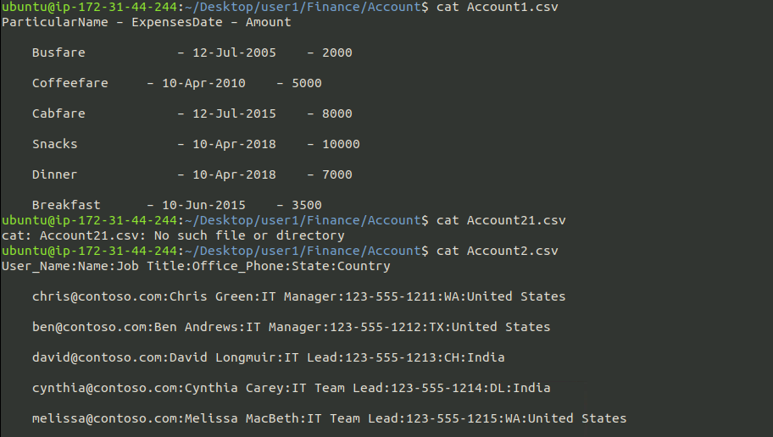

5. Copy all the entire structure of Finance directory to Operation directory

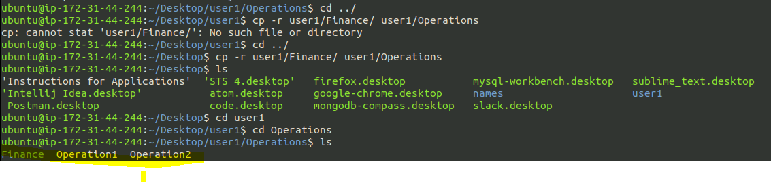

6. Rename Account2.csv to Employee.csv

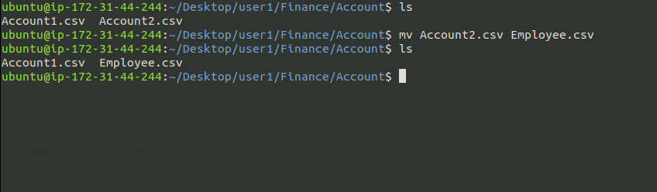

7. Move the file Test1 to Operations

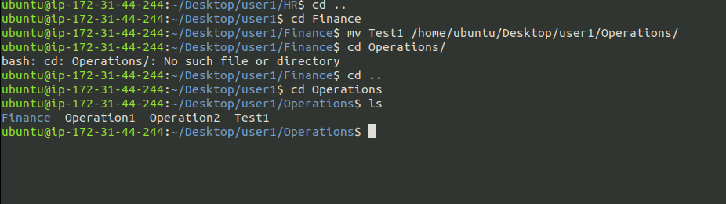

8. Move all the files from HR directory Operation directory

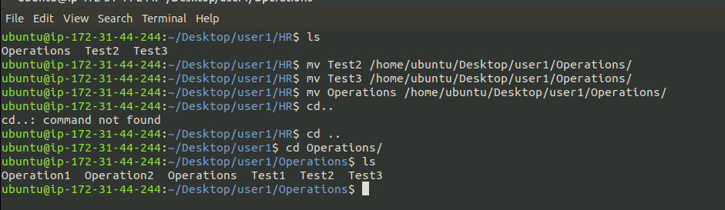

9. Delete all the files which is present in HR directory

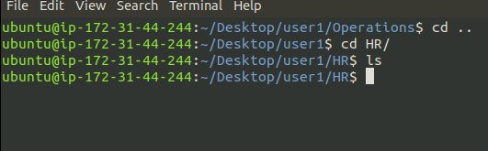

10. Remove the entire Finance directory from Operation directory

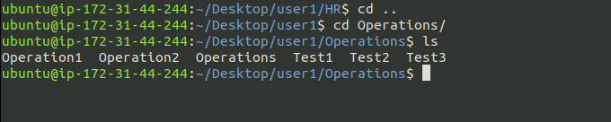

11. Display the content of Account2.csv

(as per step 6 Account2.csv has been renamed to Employee.csv)

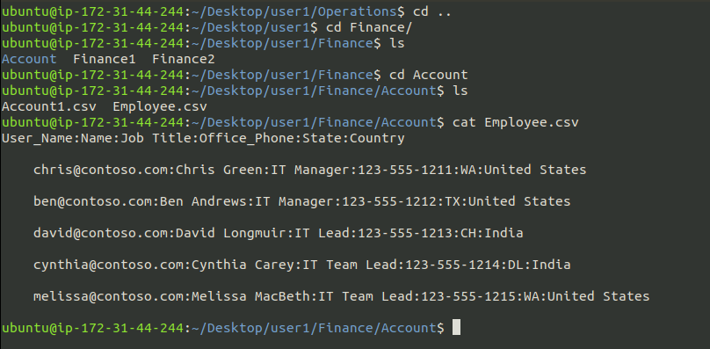

12. List all the files which is present in Finance directory except directory

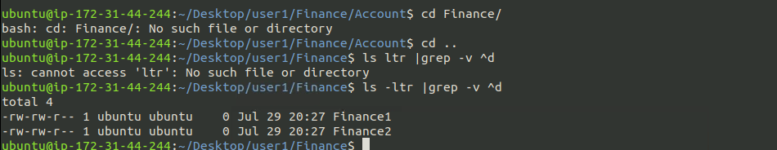

13. Display all the users connected to Ubuntu

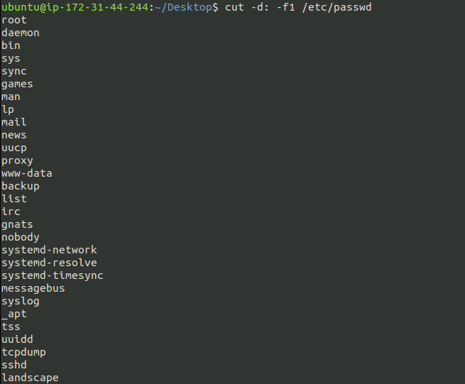

14. Search for all the files starting with T from the home directory

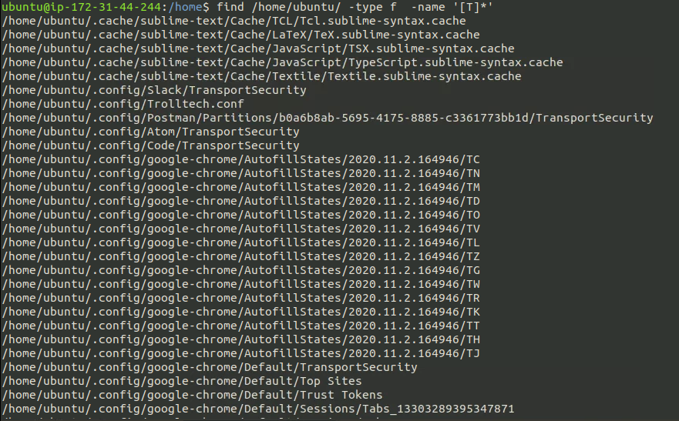

15. Create hidden file called “Test” under Finance directory

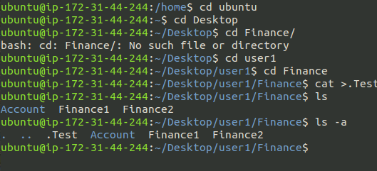

17. Display all the process running in the Ubuntu system

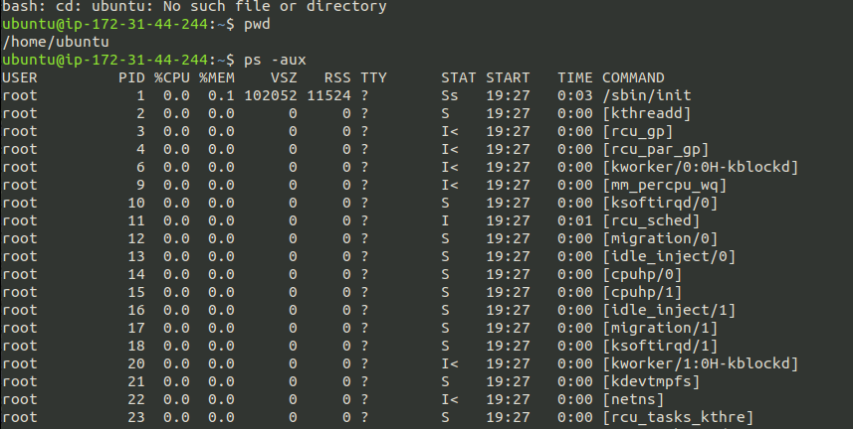

18. Create two files under HR directory

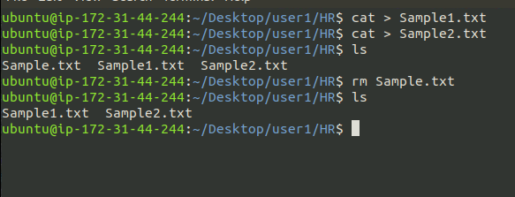

19. Permissions

a. Give read only permission for all the files which is in Operation directory

b. Remove all the permission for the files which is in Finance directory

c. Give write and execute for all the files which is in HR directory

d. Change the owner of Sample1.txt to Test2 user

e. Change the group of Sample2.txt to Test1 user

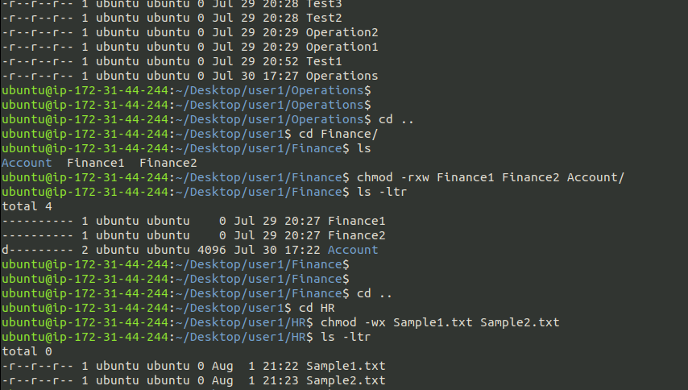

20. Create users

a. Test1

b. Test2

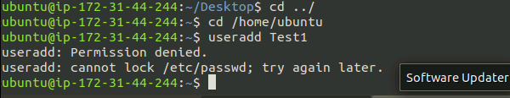

20. Create users

21. Display the command to view all the users which is existing in the system

22. Create a compressed file for the Finance directory