**MACHINE LEARNING ASSIGNMENT-1**

**Subha Sri Lakshmi Achyutha**

**700766668**

**Video Link:** <https://drive.google.com/file/d/1pLA2XbeIBNCw_B_a4mBcUtrrWZtLhiSt/view?usp=share_link>

**--------------------------------------------------------------------------------------------------------------------------**

**1)CODE:**

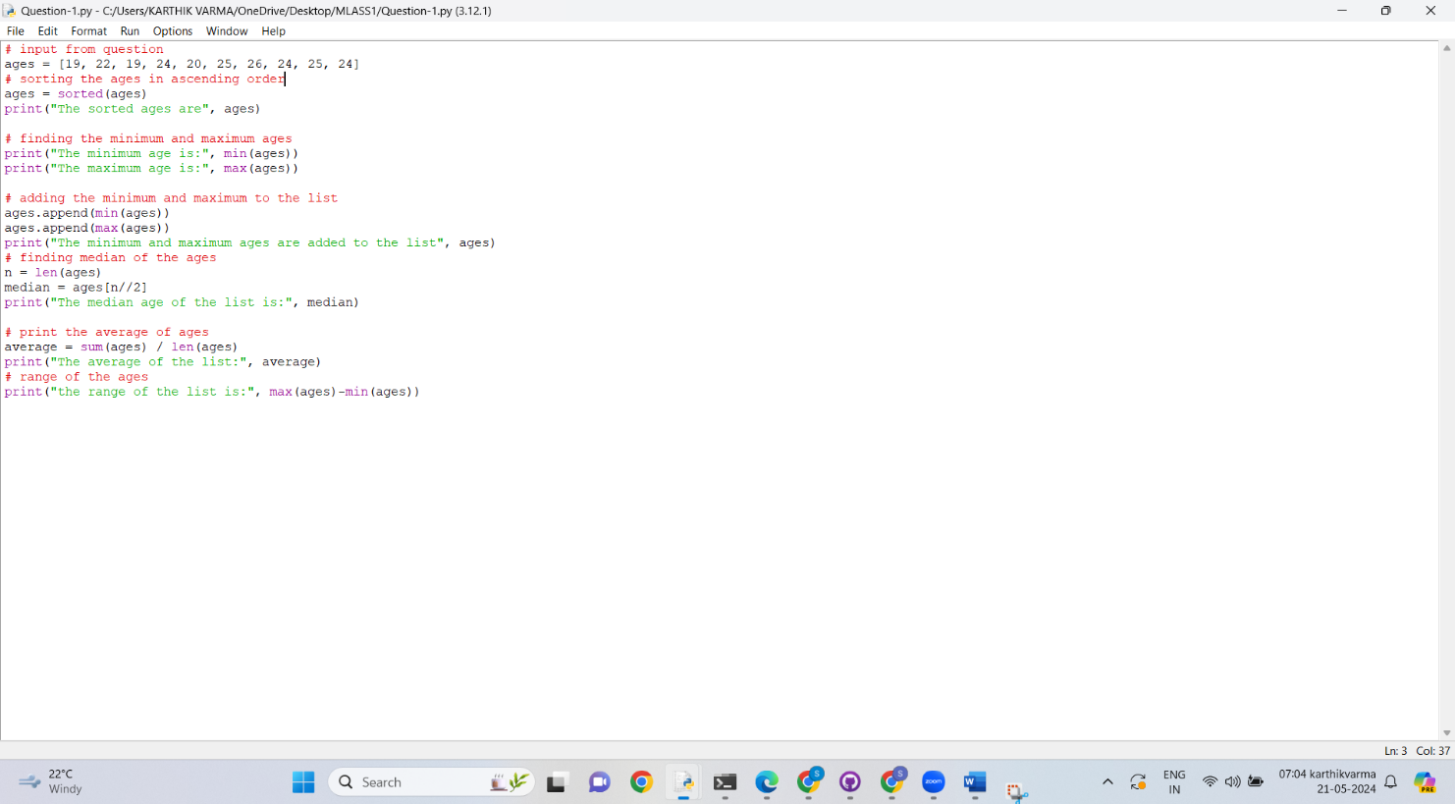

**EXPLANATION:**

1. Took input from question and sorted the ages by using sorted() function.
2. By using max() and min() function printed the maximum and minimum of the list.
3. append() function is used to add items to the list.
4. len() function is used to return the number of elements in the list
5. used len() function for calculation median as median is equal to n/2 and also to calculate average age of the given list.
6. For getting the range of the given ages I used the max() and min() functions again as we can calculate it with max minus min**.**

**OUTPUT:**

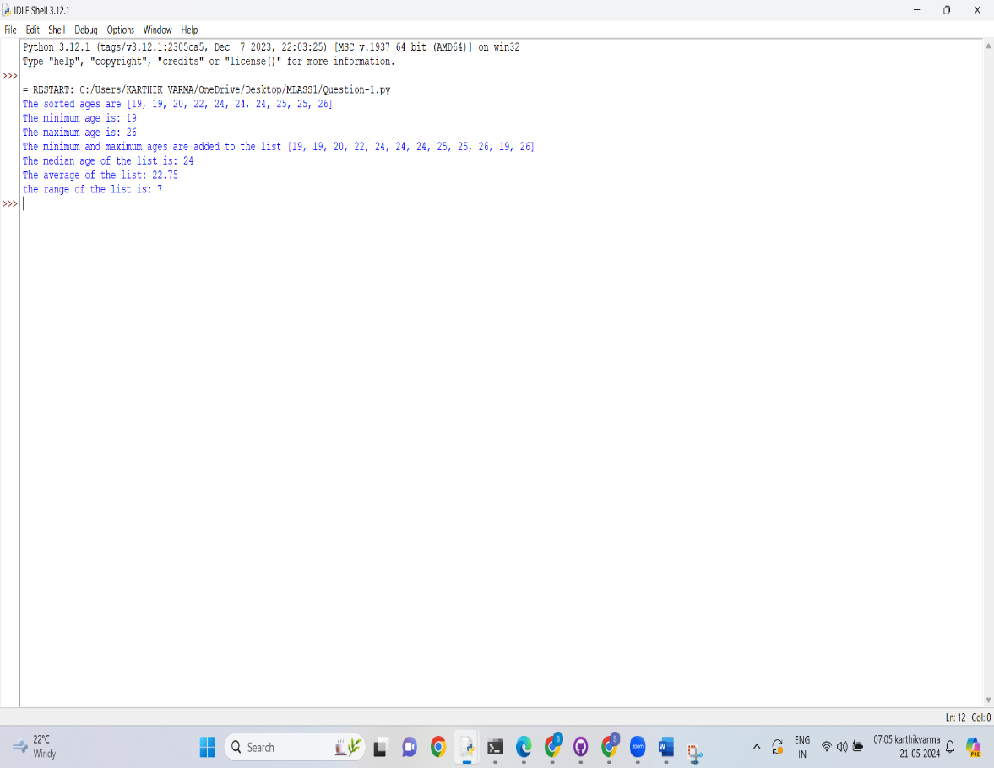

**2)CODE:**

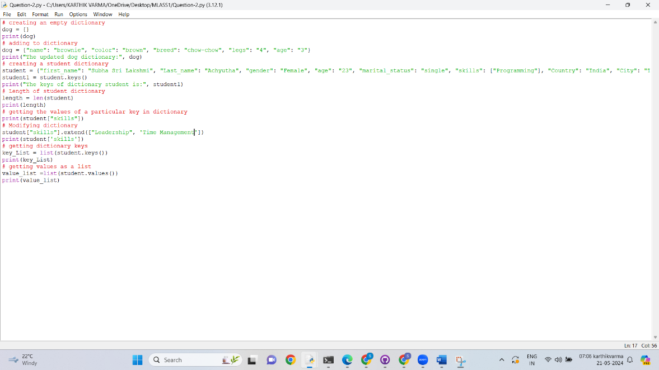

**EXPLANATION:**

1. Created an empty dictionary dog = {}
2. Added given parameters to the dictionary.
3. Created another dictionary student{} with some given parameters.
4. Used len() function to determine the length of the dictionary.
5. To get the value of a particular key I used student[‘’””] function to trigger a particular key.
6. To add few other values to the key I used .extend() function. .extend() function adds items to the current list.
7. To get the dictionary keys as list I used list(student.keys()) function.
8. To get the dictionary values as list I used list(student.keys()) function.

**OUTPUT:**

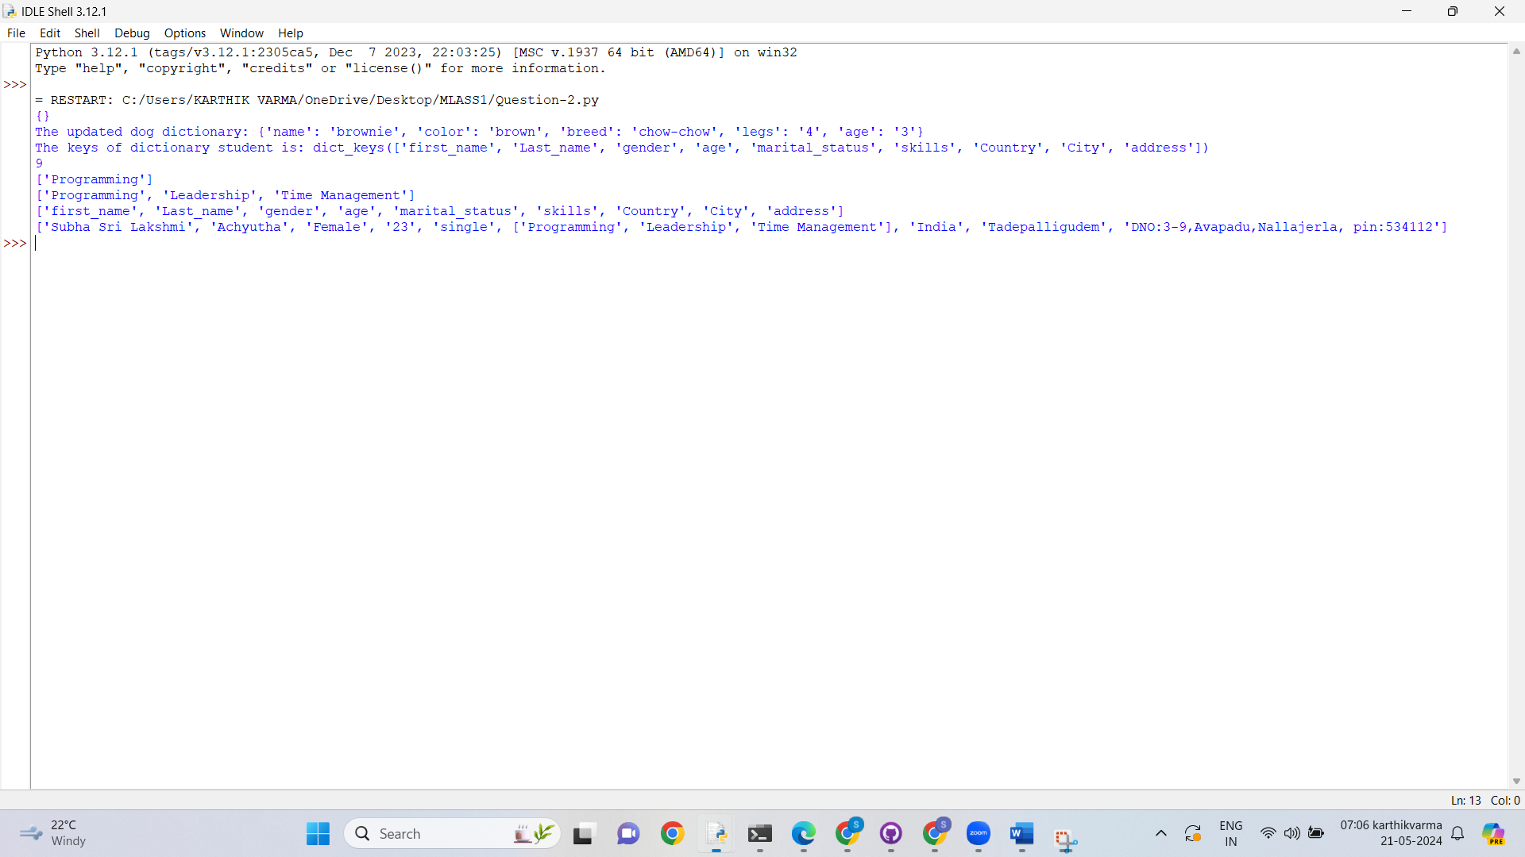

**3)CODE:**

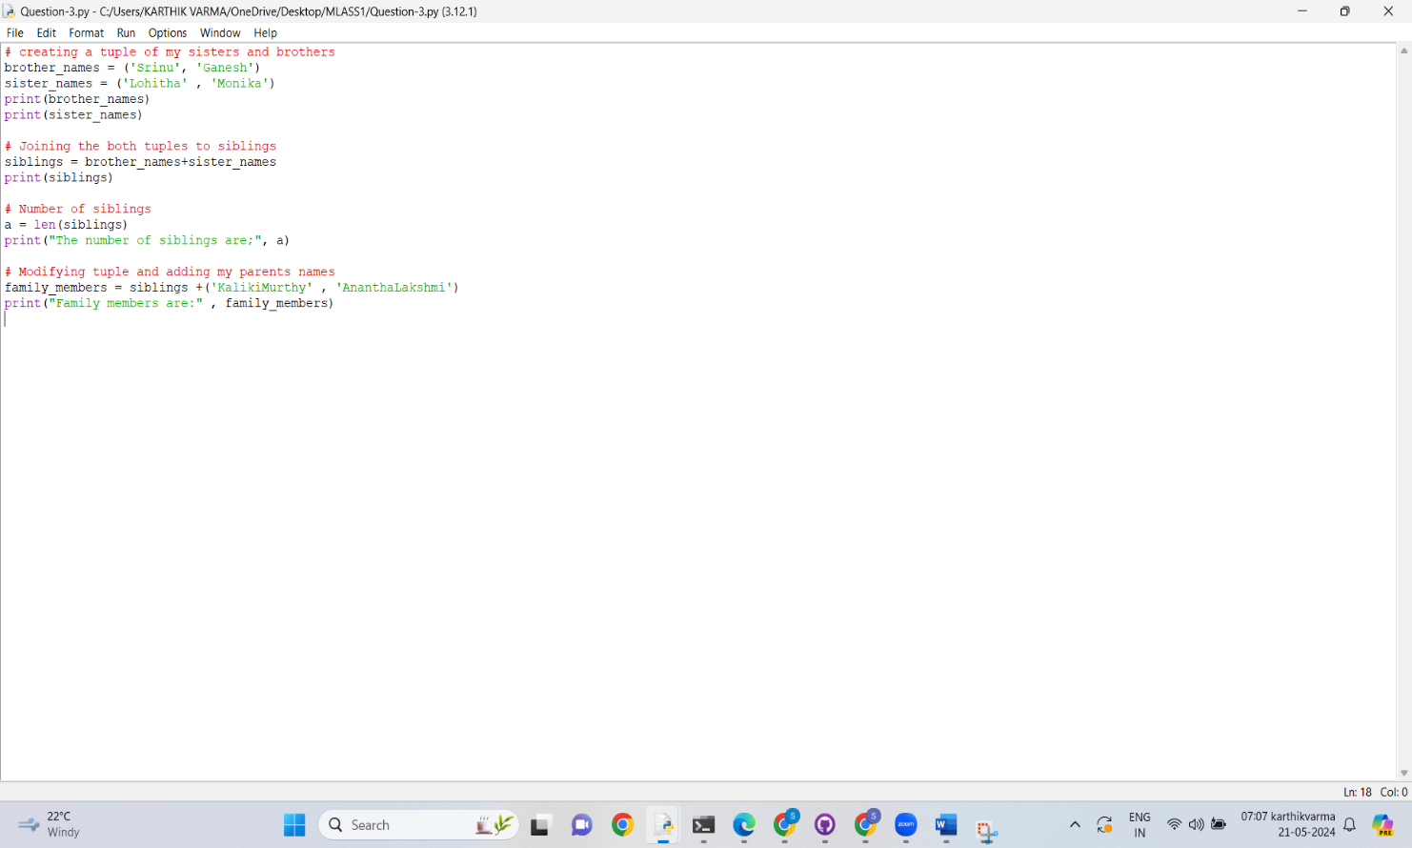

**EXPLANATION:**

1. two separate tuples brother_names and sister_names
2. For joining two tuples and assigning to another tuples we can do it by siblings = brother_names+sister_names.
3. To find the length of the siblings I used len() function
4. To create a new tuple family members and modify it with siblings tuple I did it by adding few other names to family_members tuple=siblings +(‘’ ,’’’)\

**OUTPUT:**

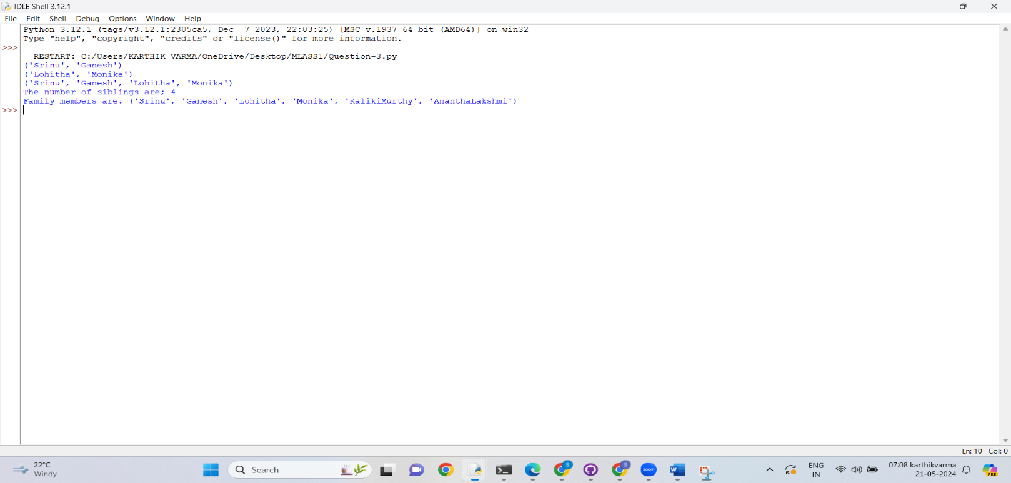

**4)CODE:**

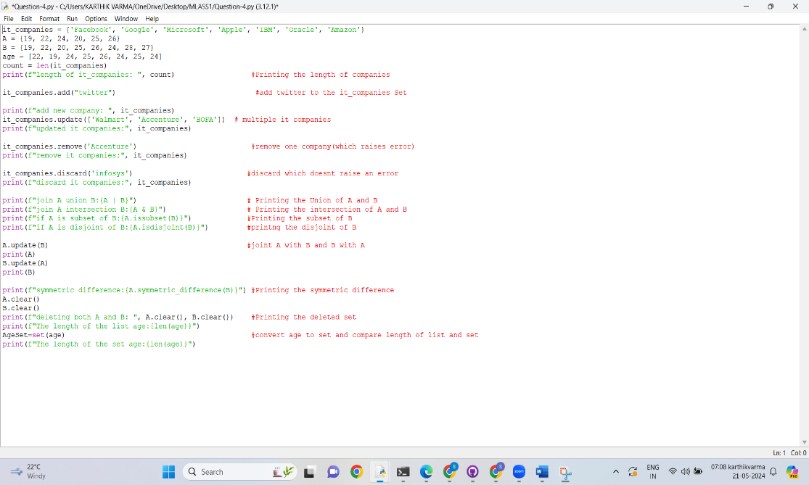

**EXPLANATION:**

1. Used len() function to determine the length of the set.
2. To add another item to set I used .add function()
3. To insert multiple items to the list I used .update () function
4. To remove one IT company from the set I used .remove function.
5. The difference between remove and discard function is the remove function will display an error if specified item doesn’t exist but discard() function won’t pop any error.
6. To add two sets A and B I used .union() function and assigned the value to C.
7. To find the common items between two sets I used .intersection() function.
8. .issubset() function is used to determine if all set A elements are presents in set B.
9. .disjoint() function is used to check whether if none of the items are present in each set are same.
10. Symmetric_difference() function returns the items present in given sets, except the items for intersection
11. To delete the data in a set .clear() function is used’.
12. To determine the length of list and set used len() function and compared it with using if-else loop.

**OUTPUT:**

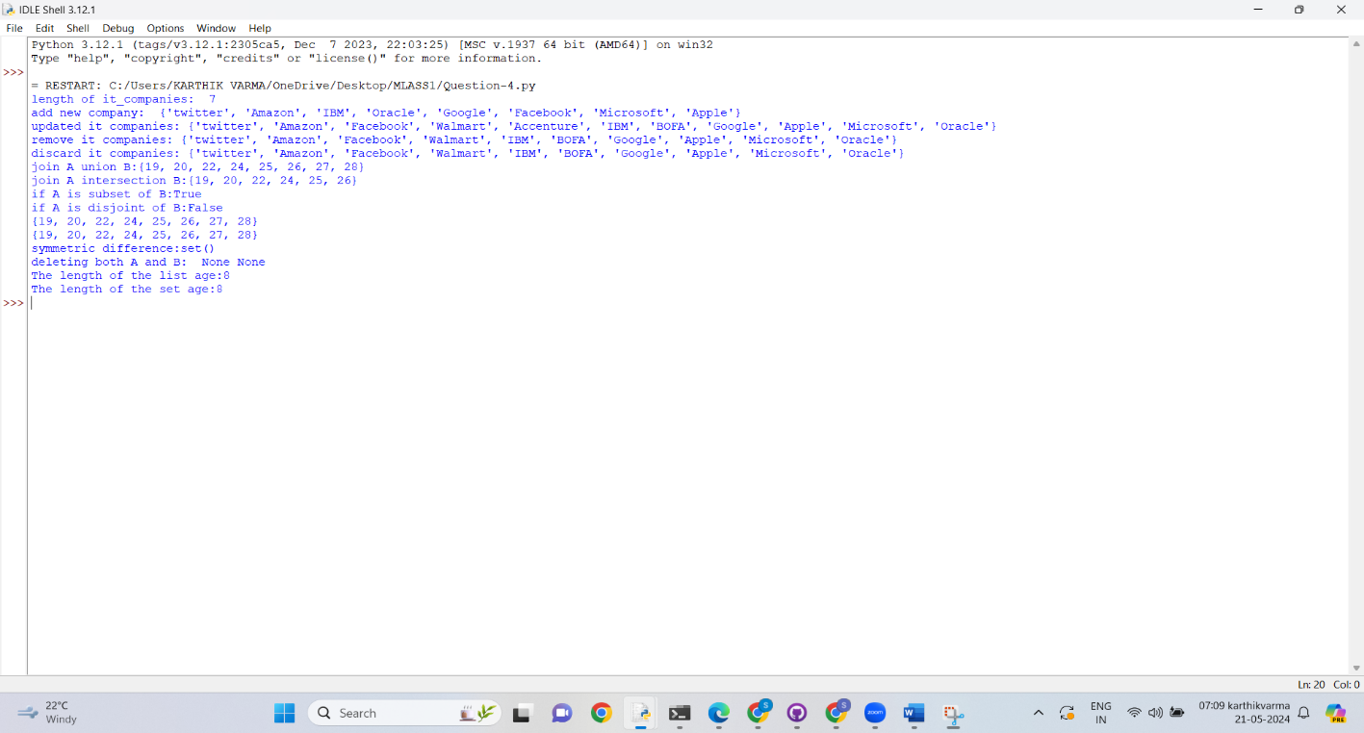

**5)CODE:**

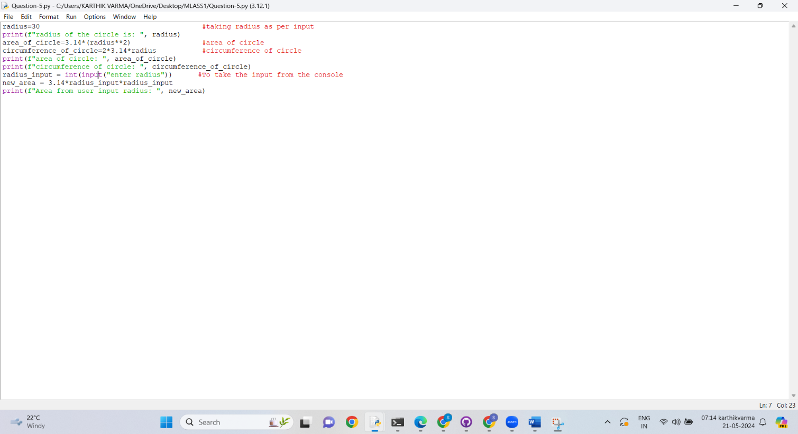

**EXPLANATION:**

1. Calculated the area of circle with given radius.
2. Also calculated the circumference of circle with formula 2*Pi*r
3. For determining user input I took input from the user by using int(input(‘’ “)) function.

**OUTPUT:**

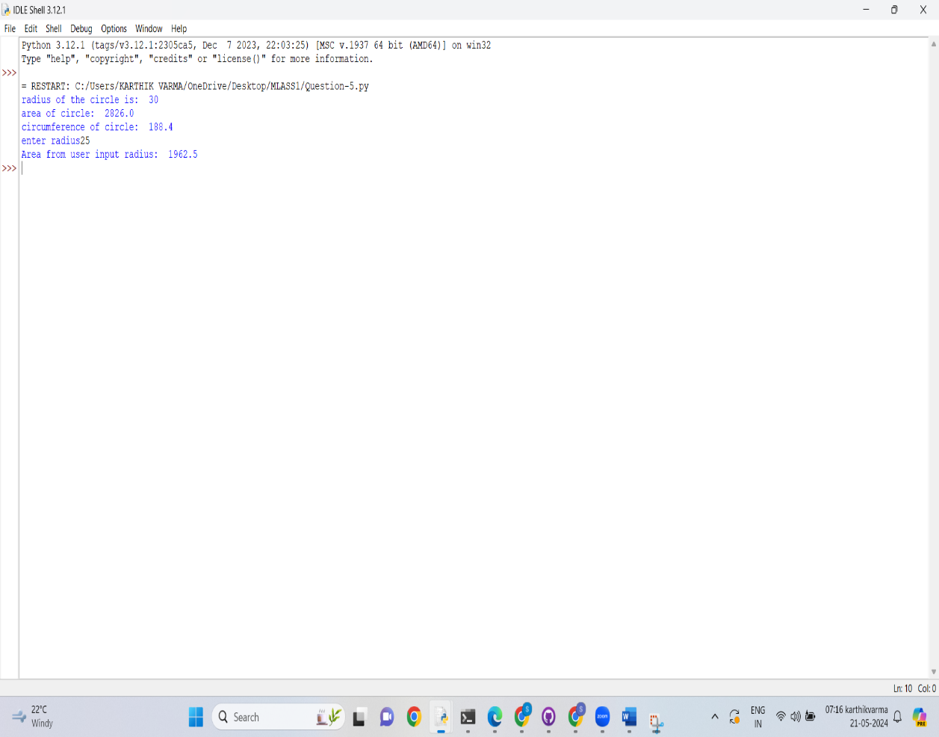

**6)CODE:** 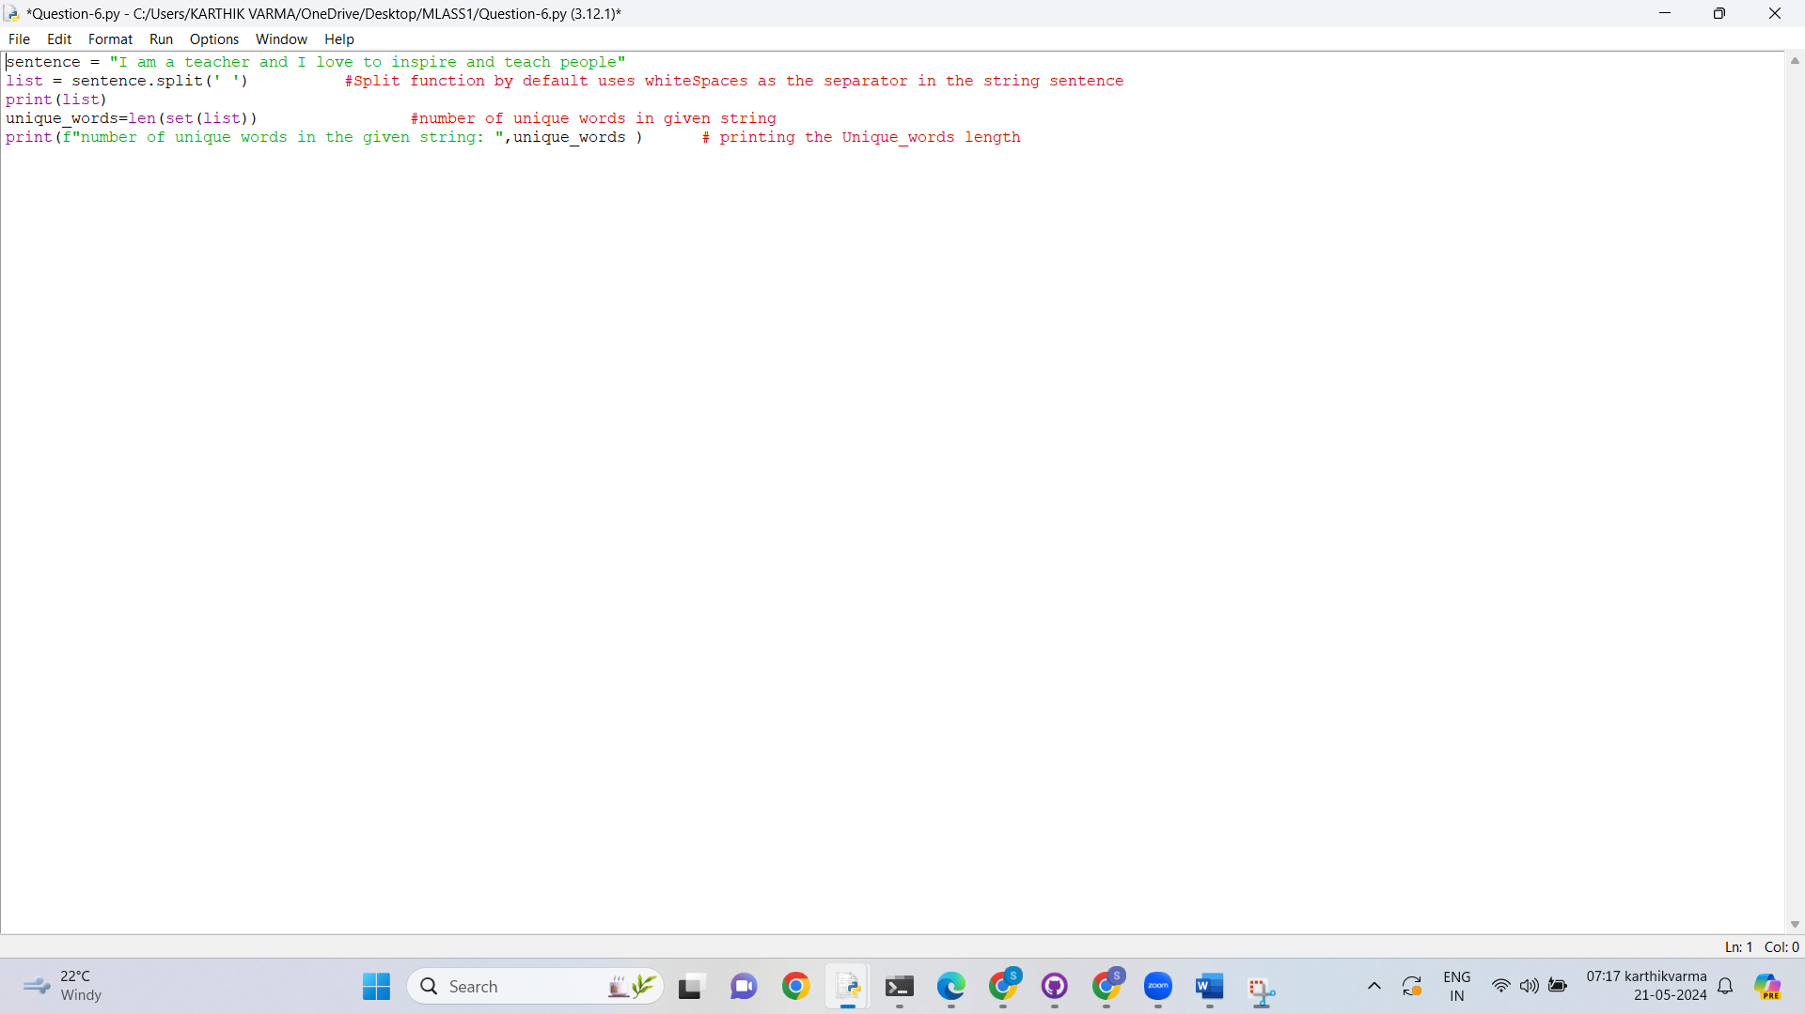

**EXPLANATION:**

Used .split function to get the non repeated words as set and later assigned it to words set and to get the unique words used the unique.sort() function.

**OUTPUT:**

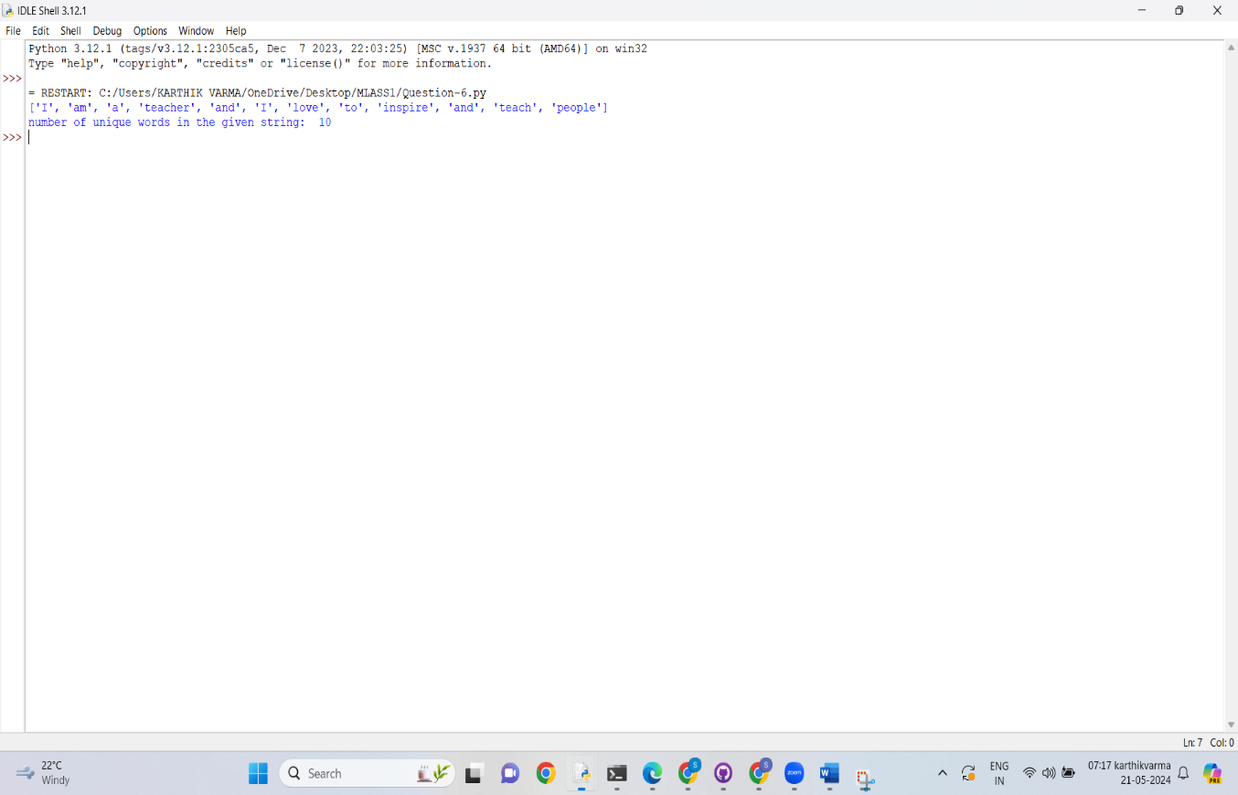

**7)CODE:**

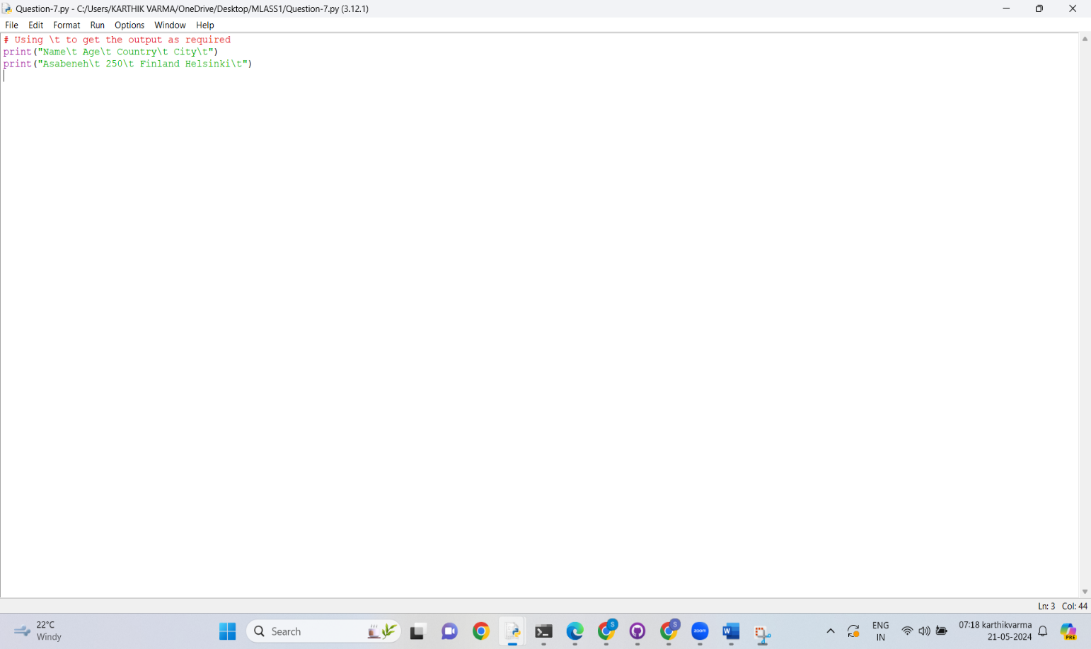

**EXPLANATION:**

“\” Backsplash is special function in python which is also called escape character. It is used in representing white-space character.

**OUTPUT:**

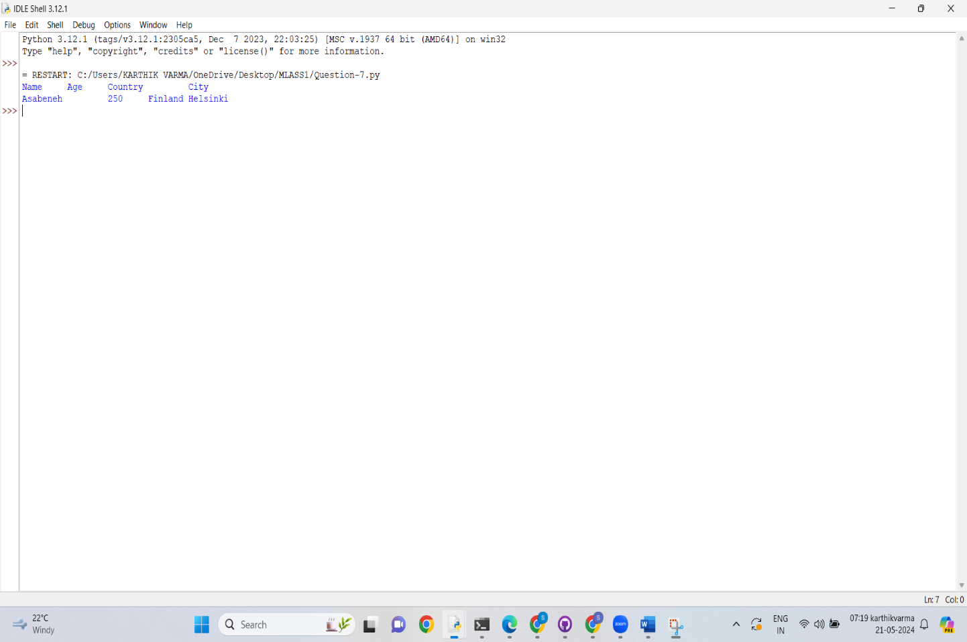

**8)CODE:**

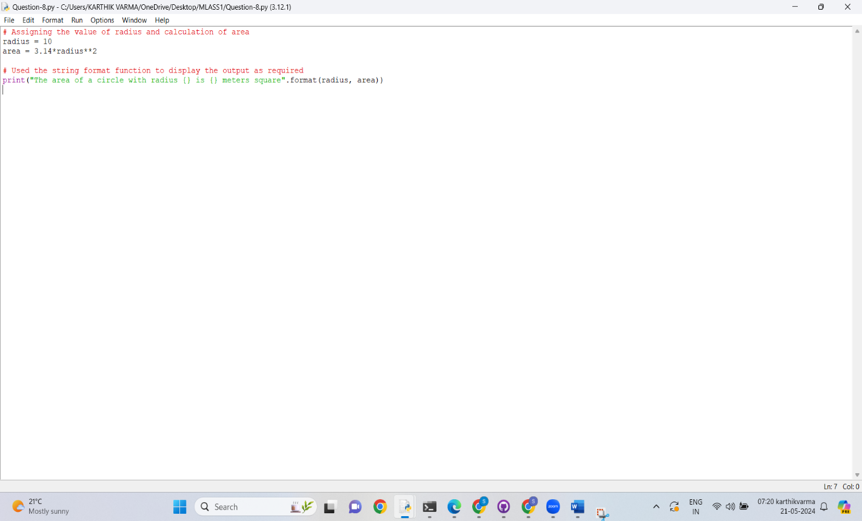

**EXPLANATION:**

There are many methods for string formatting. Here I used {}, .method method for getting the output as required.

**OUTPUT:**

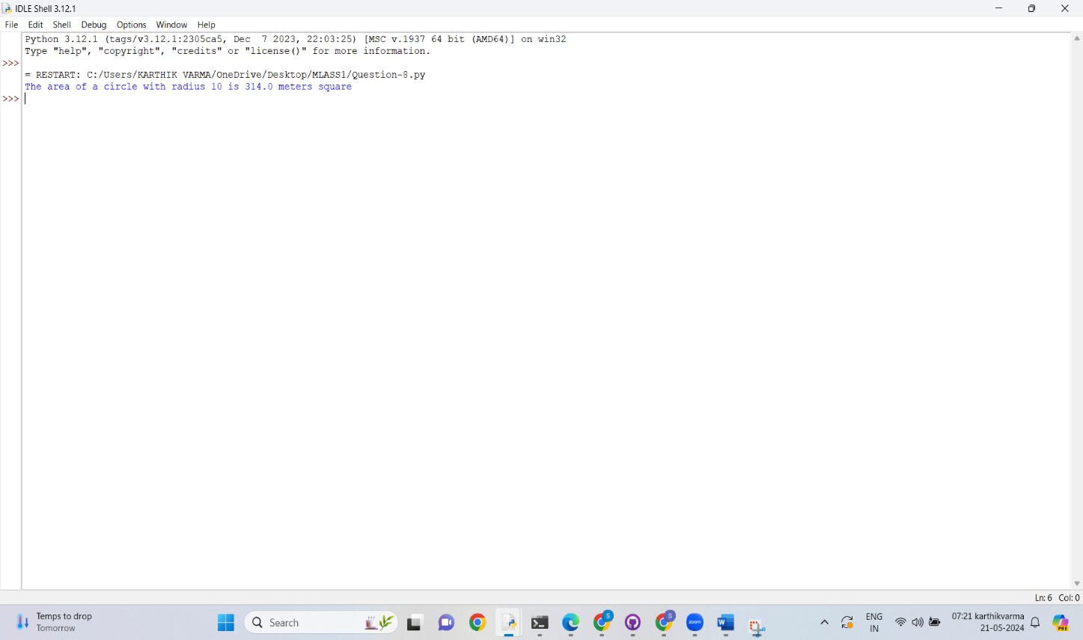

**9)CODE:**

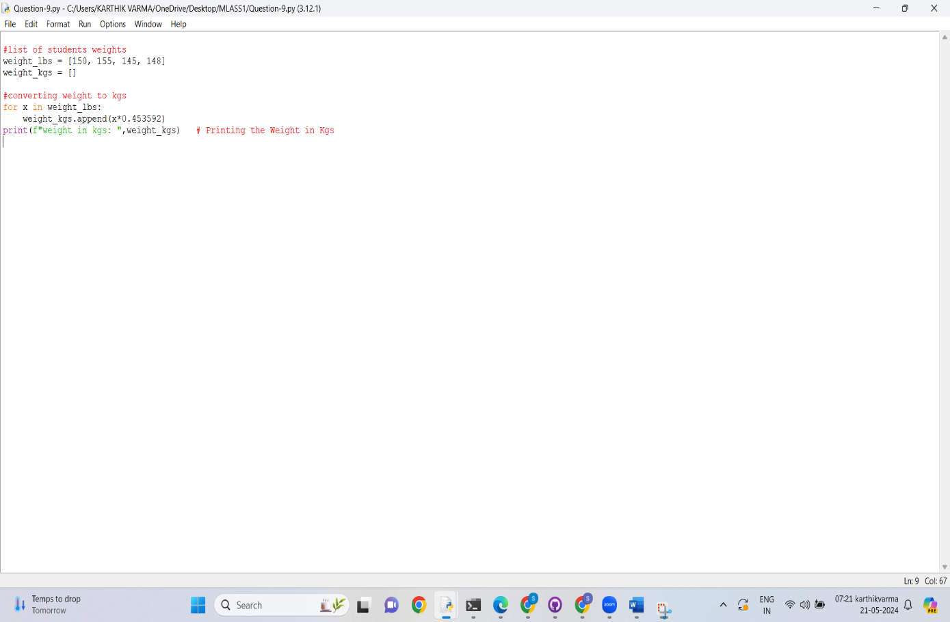

**EXPLANATION:**

1. Took input from the user to know how inputs they want to enter
2. Used for loop to take input that exact number of students from the user
3. To create a list for for lbs weights I used the .append() function to get the weights from user input
4. Created a empty list for weight_in_kgs
5. The multiplied lbs weights *0.453592 to get the weights in kgs

