[How to load a predefined rule set(xml file) to a sonar profile](http://stackoverflow.com/questions/26762506/how-can-i-load-a-predefined-rule-set-to-a-sonar-profile)

1. Log into Sonar(localhost:9000 with admin/admin as userid and pwd).

2. Click on Quality Profiles in the top navigation bar, then click on "Restore Profile" on the right hand side under the search bar.

3. Choose the rule file and click "Restore"

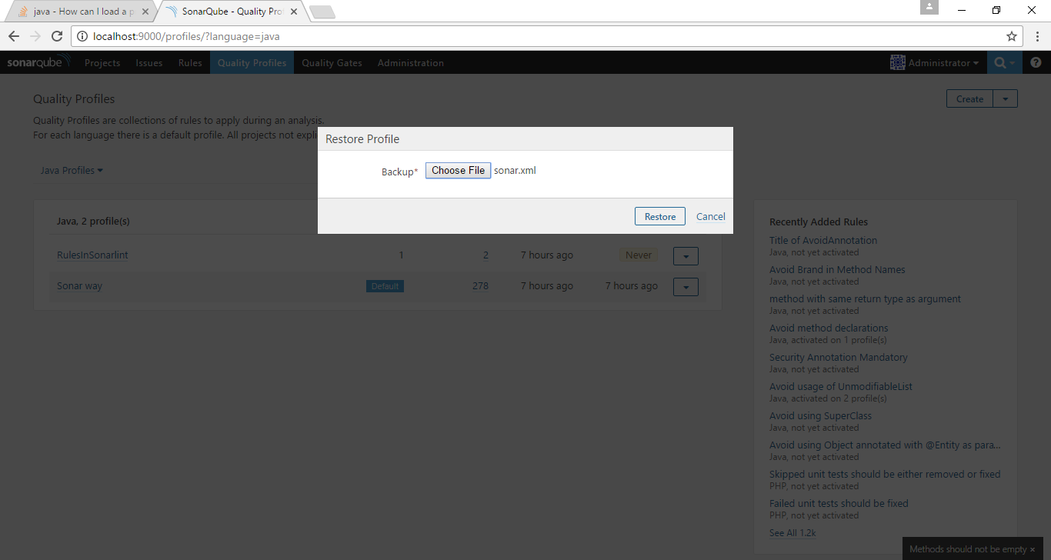

How to set the profile created above as default?

Choose the down arrow drop down and select "Set as Default"

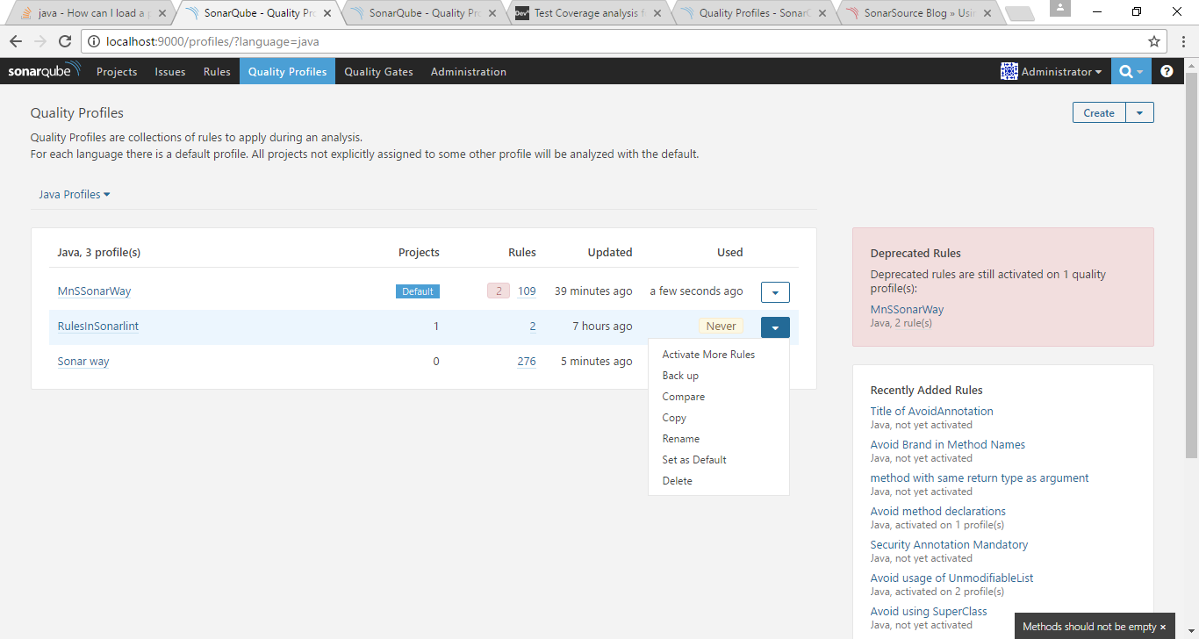

How to set Sonarqube rules to a Spring boot Project?

C:\Endeca\Project\sonarqubedemo>mvn sonar:sonar -Dsonar.scm.provider=svn

[INFO] Scanning for projects...

[INFO]

[INFO] ------------------------------------------------------------------------

[INFO] Building sonarqubedemo 0.0.1-SNAPSHOT

[INFO] ------------------------------------------------------------------------

[INFO]

[INFO] --- sonar-maven-plugin:2.7:sonar (default-cli) @ soanrqubedemo ---

[INFO] User cache: C:\Users\Subha\.sonar\cache

[INFO] Load global settings

[INFO] Load global settings (done) | time=93ms

[INFO] User cache: C:\Users\Subha\.sonar\cache

[INFO] Load plugins index

[INFO] Load plugins index (done) | time=12ms

[INFO] SonarQube version: 6.3.1

[INFO] Default locale: "en_US", source code encoding: "UTF-8"

[INFO] Process project properties

[INFO] Load project repositories

[INFO] Load project repositories (done) | time=96ms

[INFO] Load quality profiles

[INFO] Load quality profiles (done) | time=18ms

[INFO] Load active rules

[INFO] Load active rules (done) | time=302ms

[INFO] Load metrics repository

[INFO] Load metrics repository (done) | time=66ms

[INFO] Publish mode

[INFO] Project key: com.example:soanrqubedemo

[INFO] ------------- Scan sonarqubedemo

[INFO] Load server rules

[INFO] Load server rules (done) | time=120ms

[INFO] Initializer GenericCoverageSensor

[INFO] Initializer GenericCoverageSensor (done) | time=1ms

[INFO] Base dir: C:\Endeca\Project\sonarqubedemo

[INFO] Working dir: C:\Endeca\Project\sonarqubedemo\target\sonar

[INFO] Source paths: pom.xml, src/main/java

[INFO] Test paths: src/test/java

[INFO] Source encoding: UTF-8, default locale: en_US

[INFO] Index files

[INFO] 3 files indexed

[INFO] Quality profile for java: MnSSonarWay

[INFO] Sensor JavaSquidSensor [java]

[INFO] Configured Java source version (sonar.java.source): none

[INFO] JavaClasspath initialization

[INFO] JavaClasspath initialization (done) | time=11ms

[INFO] JavaTestClasspath initialization

[INFO] JavaTestClasspath initialization (done) | time=4ms

[INFO] Java Main Files AST scan

[INFO] 1 source files to be analyzed

[INFO] Java Main Files AST scan (done) | time=298ms

[INFO] 1/1 source files have been analyzed

[INFO] Java Test Files AST scan

[INFO] 1 source files to be analyzed

[INFO] Java Test Files AST scan (done) | time=104ms

[INFO] 1/1 source files have been analyzed

[INFO] Sensor JavaSquidSensor [java] (done) | time=698ms

[INFO] Sensor NoSonar Sensor [php]

[INFO] Sensor NoSonar Sensor [php] (done) | time=1ms

[INFO] Sensor Coverage Report Import [csharp]

[INFO] Sensor Coverage Report Import [csharp] (done) | time=1ms

[INFO] Sensor Coverage Report Import [csharp]

[INFO] Sensor Coverage Report Import [csharp] (done) | time=1ms

[INFO] Sensor Unit Test Results Import [csharp]

[INFO] Sensor Unit Test Results Import [csharp] (done) | time=1ms

[INFO] Sensor SurefireSensor [java]

[INFO] parsing C:\Endeca\Project\sonarqubedemo\target\surefire-reports

[INFO] Sensor SurefireSensor [java] (done) | time=6ms

[INFO] Sensor JaCoCoSensor [java]

[INFO] Sensor JaCoCoSensor [java] (done) | time=2ms

[INFO] Sensor XmlFileSensor [java]

[INFO] 1 source files to be analyzed

[INFO] Sensor XmlFileSensor [java] (done) | time=344ms

[INFO] 1/1 source files have been analyzed

[INFO] Sensor Analyzer for "php.ini" files [php]

[INFO] Sensor Analyzer for "php.ini" files [php] (done) | time=3ms

[INFO] Sensor Zero Coverage Sensor

[INFO] Sensor Zero Coverage Sensor (done) | time=14ms

[INFO] Sensor Code Colorizer Sensor

[INFO] Sensor Code Colorizer Sensor (done) | time=2ms

[INFO] Sensor CPD Block Indexer

[INFO] org.sonar.scanner.cpd.deprecated.JavaCpdBlockIndexer@320ba79f is used for java

[INFO] Sensor CPD Block Indexer (done) | time=15ms

[INFO] SCM provider for this project is: svn

[INFO] 2 files to be analyzed

[INFO] 0/2 files analyzed

[WARNING] Missing blame information for the following files:

[WARNING] * C:/Endeca/Project/sonarqubedemo/src/test/java/com/example/SonarqubedemoApplicationTests.java

[WARNING] * C:/Endeca/Project/sonarqubedemo/src/main/java/com/example/SonarqubedemoApplication.java

[WARNING] This may lead to missing/broken features in SonarQube

[INFO] Calculating CPD for 1 files

[INFO] CPD calculation finished

[INFO] Analysis report generated in 337ms, dir size=35 KB

[INFO] Analysis reports compressed in 21ms, zip size=10 KB

[INFO] Analysis report uploaded in 31ms

[INFO] ANALYSIS SUCCESSFUL, you can browse http://localhost:9000/dashboard/index/com.example:soanrqubedemo

[INFO] Note that you will be able to access the updated dashboard once the server has processed the submitted analysis report

[INFO] More about the report processing at http://localhost:9000/api/ce/task?id=AVvvscoQ8IDjvCBNl1Tg

[INFO] Task total time: 3.995 s

[INFO] ------------------------------------------------------------------------

[INFO] BUILD SUCCESS

[INFO] ------------------------------------------------------------------------

[INFO] Total time: 8.191 s

[INFO] Finished at: 2017-05-10T05:40:58+05:30

[INFO] Final Memory: 30M/733M

[INFO] ------------------------------------------------------------------------

C:\Endeca\Project\sonarqubedemo>

Go to windows -> preferences-> Sonarqube - > servers

