**Name:** Akhi Kar.

**Registration No:** 243002410618

**Department:** BSc IT Cyber Security(2024-2028)

**Roll Number:** 30085324012

Subject: Software tools and technology.

Q.2. Create a sample resume in LaTex by giving your basic details in it with five different sections as follows

● Name, address, telephone number, and/or e-mail address

● Degrees, institutions, and degree dates (must put in table.)

● Awards and Achievements

● Language, computer, and/or other skills

● Activities and/or interests (optional)

● Include passport size photograph in right most corner.

The code is:

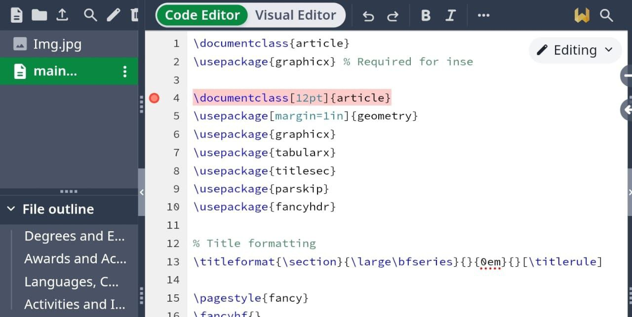

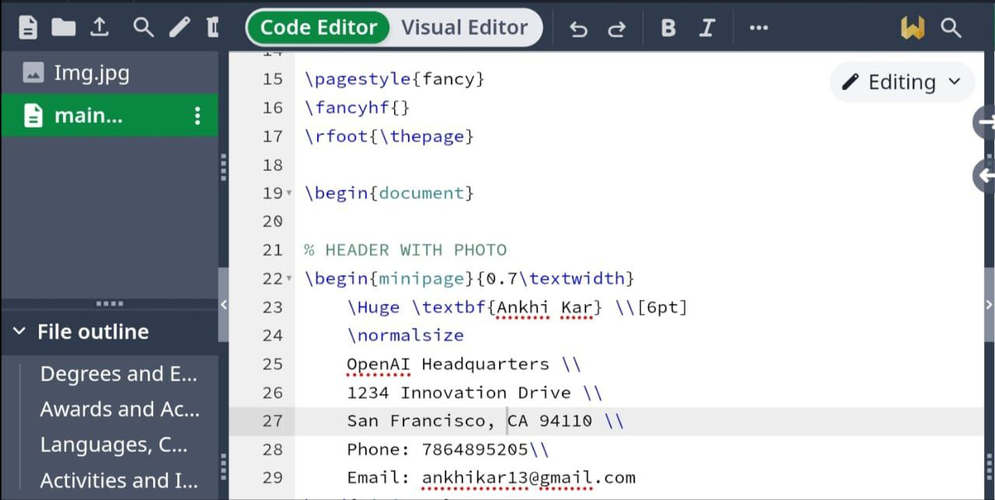



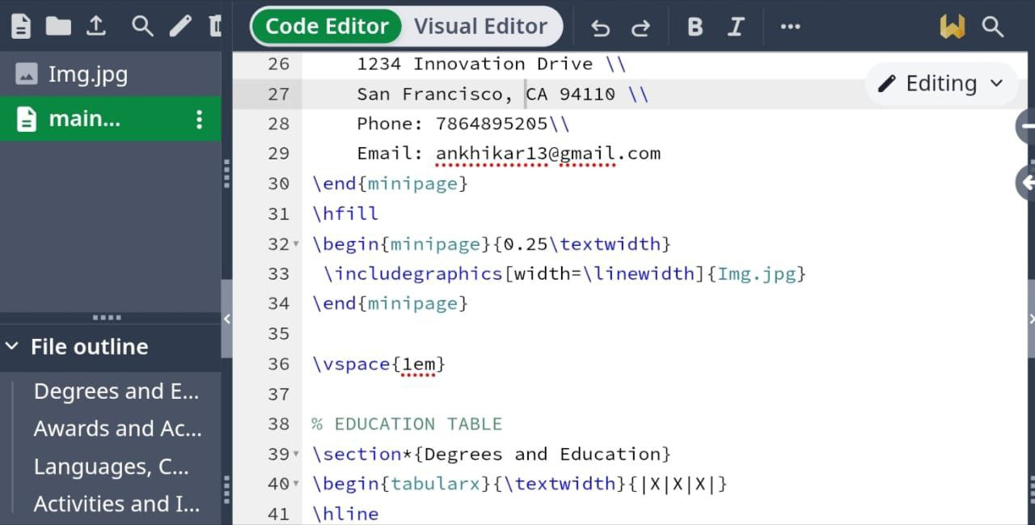

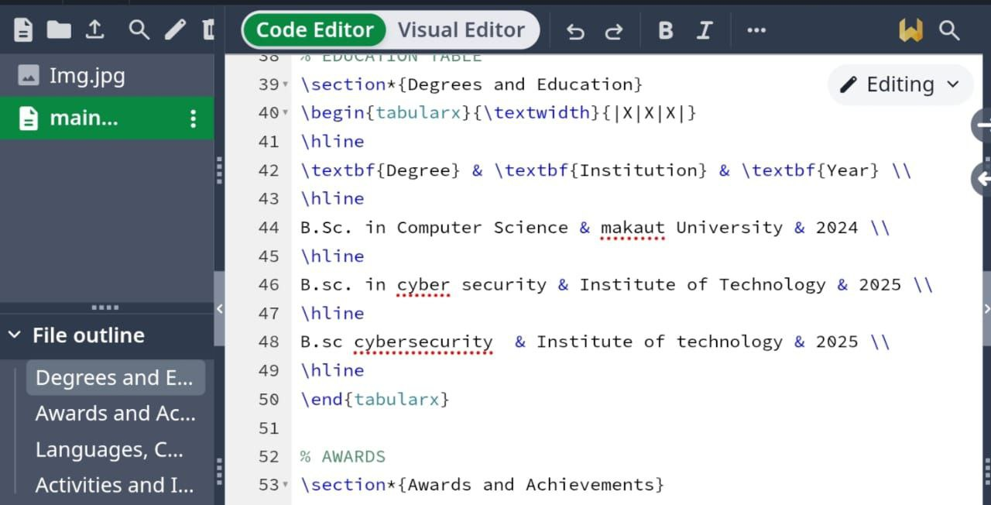

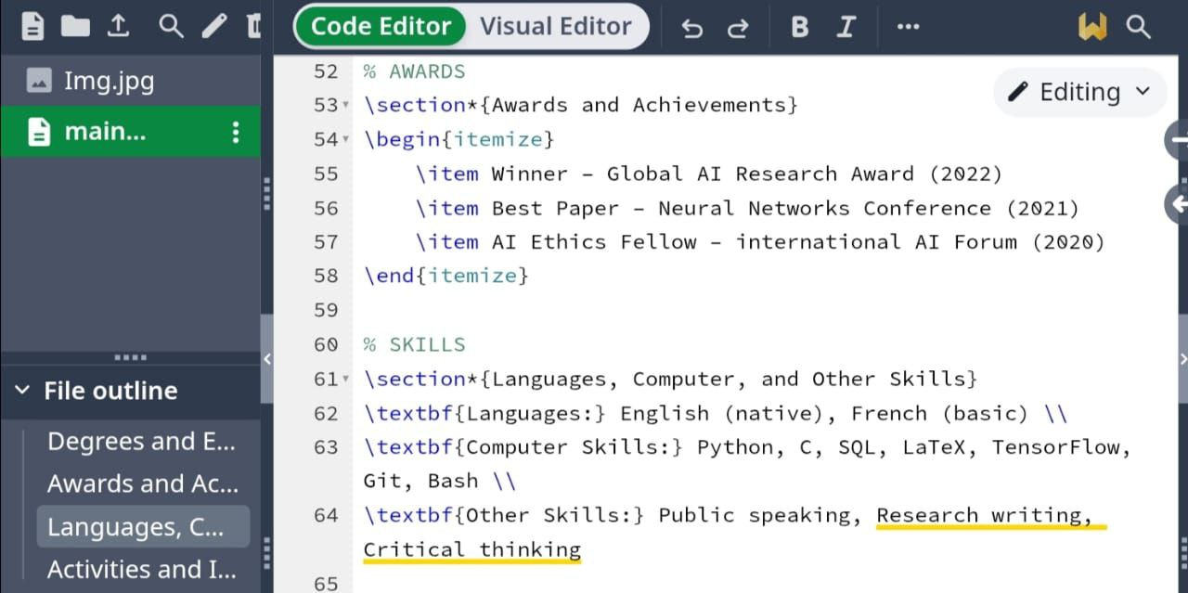

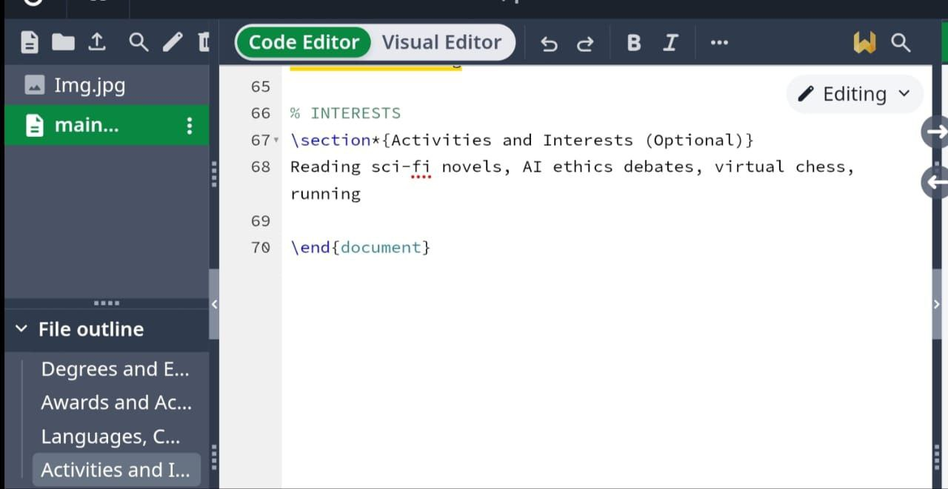

Output:

