Coffee Orders Data Analysis Project

1. Project Overview
This project analyzes coffee sales data to uncover trends, customer behavior, and product performance. It uses Excel-based dashboards and visualizations to support business decision-making.

2. Files Included

File Name | Description
 | Raw dataset containing detailed coffee orders.
 | Processed and analyzed data including charts, pivot tables, and insights.

3. Tools Used
- Microsoft Excel
• Pivot Tables
• Power Query
- Pivot charts
- Data Cleaning & Wrangling
- Exploratory Data Analysis (EDA)

4. Key Insights
• United States generates the highest revenue.
• Peak sales observed during specific months.
• Arabica coffee has strong sales performance.
• Loyal customers contribute significantly to revenue.
• Top customers identified for targeted marketing.

5. Dashboard Screenshots
Main Dashboard View:
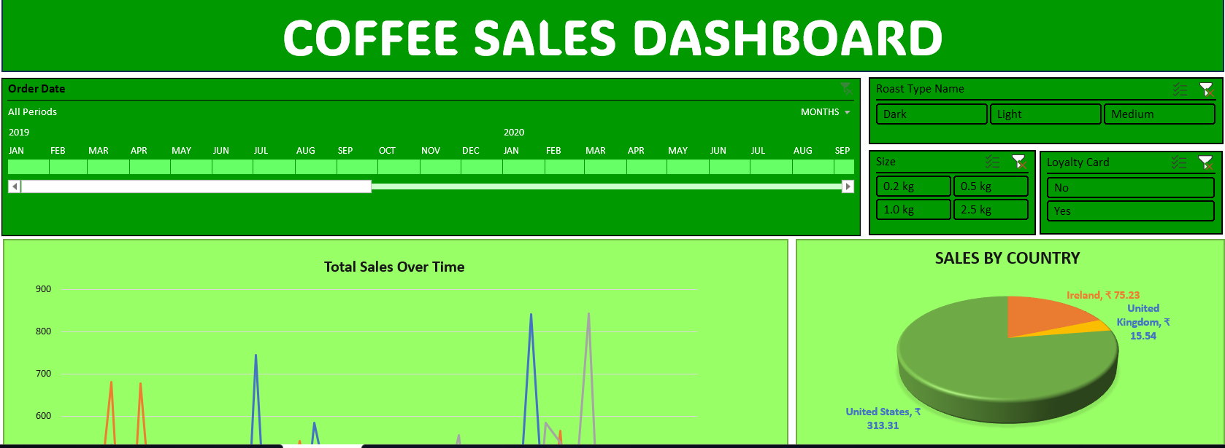
Detailed Sales Analysis:
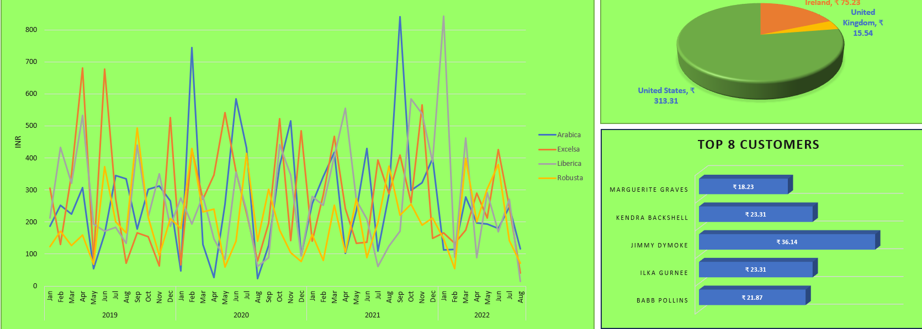

6. How to Explore
• Open the Excel dashboard file
• Use filters (date, roast type, size, loyalty card)
• Analyze charts and trends
• Interact with slicers for dynamic insights

